2458. Height of Binary Tree After Subtree Removal Queries
You are given the root of a binary tree with n nodes. Each node is assigned a unique value from 1 to n. You are also given an array queries of size m.
You have to perform m independent queries on the tree where in the ith query you do the following:
- Remove the subtree rooted at the node with the value queries[i] from the tree. It is guaranteed that queries[i] will not be equal to the value of the root.
Return an array answer of size m where answer[i] is the height of the tree after performing the ith query.
Note:
- The queries are independent, so the tree returns to its initial state after each query.
- The height of a tree is the number of edges in the longest simple path from the root to some node in the tree.
Example 1:
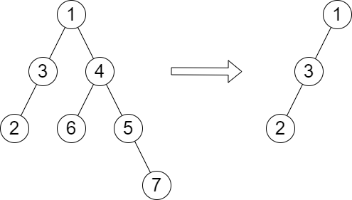 | Input: root = [1,3,4,2,null,6,5,null,null,null,null,null,7], queries = [4]  Output: [2]  Explanation: The diagram above shows the tree after removing the subtree rooted at node with value 4.  The height of the tree is 2 (The path 1 -> 3 -> 2).
Example 2:
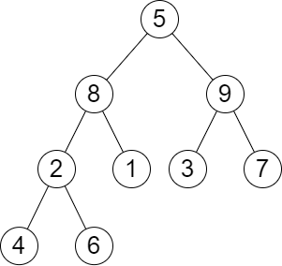 | Input: root = [5,8,9,2,1,3,7,4,6], queries = [3,2,4,8]  Output: [3,2,3,2]  Explanation: We have the following queries:  - Removing the subtree rooted at node with value 3. The height of the tree becomes 3 (The path 5 -> 8 -> 2 -> 4).  - Removing the subtree rooted at node with value 2. The height of the tree becomes 2 (The path 5 -> 8 -> 1).  - Removing the subtree rooted at node with value 4. The height of the tree becomes 3 (The path 5 -> 8 -> 2 -> 6).  - Removing the subtree rooted at node with value 8. The height of the tree becomes 2 (The path 5 -> 9 -> 3).

Constraints:
- The number of nodes in the tree is n.
- 2 <= n <= 10⁵
- 1 <= Node.val <= n
- All the values in the tree are unique.
- m == queries.length
- 1 <= m <= min(n, 10⁴)
- 1 <= queries[i] <= n
- queries[i] != root.val

2458. Height of Binary Tree After Subtree Removal Queries
/*
DFS+prefix max+suffix max
Time complexity: O(n+q)
Space complexity: O(5n)
n: number of nodes in the tree
*/

typedef std::vector<int> vi;
class Solution {
public:
vi treeQueries(TreeNode* root, vi& queries){
vi heights;
std::unordered_map<int,int> node_index,sub_tree_size;
int index=0;

/*
preorder traversal to map each node to its index(0 to n-1),
and to compute the height of each node.

postorder traversal to compute each node size

Time complexity: O(n)
Space complexity: O(n)
n: number of nodes in the tree
*/
auto dfs=[&](TreeNode* node,int height,auto& self)->int{
if(!node) return 0;

node_index[node->val]=index++;
heights.push_back(height);

int left=self(node->left,height+1,self);
int right=self(node->right,height+1,self);

int total=left+right+1;
sub_tree_size[node->val]=total;

return total;
};

dfs(root,0,dfs);

int n=heights.size();

/*
prefix_max_height[i] stores the maximum height from the root up to the i-th node in the DFS traversal order.
This array allows us to quickly find the maximum height among nodes visited before a specified node in the DFS traversal.

suffix_max_height[i] stores the maximum height from the i-th node in the DFS traversal up to the last node.
This array lets us find the maximum height among nodes visited after a specified node in the DFS traversal.

*/
vi prefix_max_height(n),suffix_max_height(n);
prefix_max_height[0]=heights[0];
suffix_max_height[n-1]=heights[n-1];
for(int i=1;i<n;++i){
prefix_max_height[i]=std::max(prefix_max_height[i-1],heights[i]);
}
for(int i=n-2;i>=0;--i){
suffix_max_height[i]=std::max(suffix_max_height[i+1],heights[i]);
}

/*
By precomputing these arrays, for each query we can exclude the subtree rooted
at the node in question and quickly look up the maximum heights to the left and right of this subtree.
*/
vi ans;
for(auto& node: queries){
int i=node_index[node]-1;
int j=i+sub_tree_size[node]+1;
int max_height=prefix_max_height[i];
if(j<n) max_height=std::max(max_height,suffix_max_height[j]);
ans.push_back(max_height);
}

return ans;
}
};

