1277. Count Square Submatrices with All Ones
Given a m * n matrix of ones and zeros, return how many square submatrices have all ones.

Example 1:
Input: matrix =
[
[0,1,1,1],
[1,1,1,1],
[0,1,1,1]
]
Output: 15
Explanation:
There are 10 squares of side 1.
There are 4 squares of side 2.
There is 1 square of side 3.
Total number of squares = 10 + 4 + 1 = 15.
Example 2:
Input: matrix =
[
[1,0,1],
[1,1,0],
[1,1,0]
]
Output: 7
Explanation:
There are 6 squares of side 1.
There is 1 square of side 2.
Total number of squares = 6 + 1 = 7.

Constraints:
- 1 <= arr.length <= 300
- 1 <= arr[0].length <= 300
- 0 <= arr[i][j] <= 1

1277. Count Square Submatrices with All Ones
/*
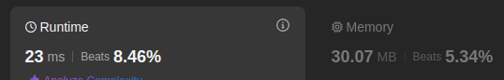
Recursion+Memoization
Time compelxity: O(m.n)
Space compelxity: O(m.n)
*/
class Solution {
public:
int countSquares(std::vector<std::vector<int>>& matrix) {
int m=matrix.size();
int n=matrix[0].size();
std::vector<std::vector<int>> memo(m,std::vector<int>(n,-1));
auto solve=[&](int row,int col,auto& self)->int{
if(row==m || col==n || matrix[row][col]==0) return 0;
if(memo[row][col]!=-1) return memo[row][col];
return memo[row][col]=1+std::min
({
self(row+1,col,self),
self(row,col+1,self),
self(row+1,col+1,self),
});
};

int ans=0;
for(int i=0;i<m;++i){
for(int j=0;j<n;++j){
ans+=solve(i,j,solve);
}
}
return ans;
}
};

1277. Count Square Submatrices with All Ones
/*
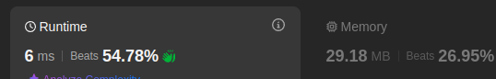
Bottom up with 2D array
Time compelxity: O(m.n)
Space compelxity: O(m.n)
*/
class Solution {
public:
int countSquares(std::vector<std::vector<int>>& matrix) {
int m=matrix.size();
int n=matrix[0].size();
std::vector<std::vector<int>> dp(m+1,std::vector<int>(n+1,0));
int ans=0;
for(int row=1;row<=m;++row){
for(int col=1;col<=n;++col){
if(matrix[row-1][col-1]){
dp[row][col]=1+std::min
({
dp[row-1][col],
dp[row][col-1],
dp[row-1][col-1]
});
ans+=dp[row][col];
}
}
}

return ans;
}
};

1277. Count Square Submatrices with All Ones
/*
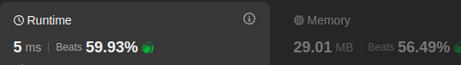
Bottom up with 2x1D array
Time compelxity: O(m.n)
Space compelxity: O(n)
*/
class Solution {
public:
int countSquares(std::vector<std::vector<int>>& matrix) {
int m=matrix.size();
int n=matrix[0].size();
std::vector<int> prev_row(n+1,0);
int ans=0;
for(int row=1;row<=m;++row){
std::vector<int> cur_row(n+1,0);
for(int col=1;col<=n;++col){
if(matrix[row-1][col-1]==1){
cur_row[col]=1+std::min
({
prev_row[col],
prev_row[col-1],
cur_row[col-1]
});
ans+=cur_row[col];
}
}
prev_row=cur_row;
}

return ans;
}
};

1277. Count Square Submatrices with All Ones
/*
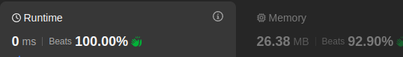
Bottom up without extra space
Time compelxity: O(m.n)
Space compelxity: O(1)
*/
class Solution {
public:
int countSquares(std::vector<std::vector<int>>& matrix) {
int m=matrix.size();
int n=matrix[0].size();

int ans=std::count(matrix[0].begin(),matrix[0].end(),1);
for(int row=1;row<m;++row) ans+=matrix[row][0];

for(int row=1;row<m;++row){
for(int col=1;col<n;++col){
if(matrix[row][col]==1){
matrix[row][col]=1+std::min
({
matrix[row-1][col],
matrix[row-1][col-1],
matrix[row][col-1]
});
ans+=matrix[row][col];
}
}
}

return ans;
}
};

