2501. Longest Square Streak in an Array
You are given an integer array nums. A subsequence of nums is called a square streak if:
- The length of the subsequence is at least 2, and
- after sorting the subsequence, each element (except the first element) is the square of the previous number.
Return the length of the longest square streak in nums, or return -1 if there is no square streak.
A subsequence is an array that can be derived from another array by deleting some or no elements without changing the order of the remaining elements.
Example 1:
Input: nums = [4,3,6,16,8,2]
Output: 3
Explanation: Choose the subsequence [4,16,2]. After sorting it, it becomes [2,4,16].
- 4 = 2 * 2.
- 16 = 4 * 4.
Therefore, [4,16,2] is a square streak.
It can be shown that every subsequence of length 4 is not a square streak.
Example 2:
Input: nums = [2,3,5,6,7]
Output: -1
Explanation: There is no square streak in nums so return -1.
Constraints:
- 2 <= nums.length <= 10⁵
- 2 <= nums[i] <= 10⁵

2501. Longest Square Streak in an Array
/*
Binary search without knowledge of processed elements
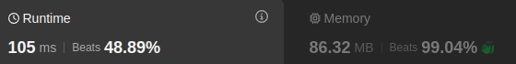
Time complexity: O(nlogn)
Space complexity: O(1)
*/
class Solution {
public:
int longestSquareStreak(std::vector<int>& nums) {
int n=nums.size();
std::sort(nums.begin(),nums.end());
int ans=0;
for(auto& e: nums){
int i=std::lower_bound(nums.begin(),nums.end(),e)-nums.begin();
int cnt=0;
long long x=e;
while(i<n && x==nums[i]){
x*=x;
i=std::lower_bound(nums.begin(),nums.end(),x)-nums.begin();
cnt++;
}
ans=std::max(ans,cnt);
}
return ans>1?ans:-1;
}
};

2501. Longest Square Streak in an Array
/*
Binary search with knowledge of processed elements
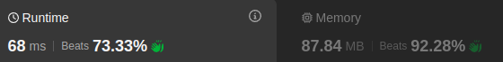
Time complexity: O(nlogn)
Space complexity: O(n)
*/
class Solution {
public:
int longestSquareStreak(std::vector<int>& nums) {
int n=nums.size();
std::sort(nums.begin(),nums.end());
int ans=0;
std::vector<bool> processed(100001,false);
for(auto& e: nums){
if(processed[e]) continue;
int i=std::lower_bound(nums.begin(),nums.end(),e)-nums.begin();
int cnt=0;
long long x=e;
while(i<n && !processed[x] && x==nums[i]){
processed[x]=true;
x*=x;
i=std::lower_bound(nums.begin(),nums.end(),x)-nums.begin();
cnt++;
}
ans=std::max(ans,cnt);
}
return ans>1?ans:-1;
}
};

2501. Longest Square Streak in an Array
/*
Unordered Set
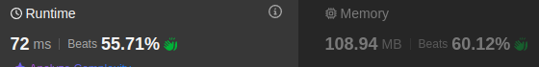
Time complexity:
Space complexity: O(n)
*/
class Solution {
public:
int longestSquareStreak(std::vector<int>& nums) {
int n=nums.size();
int mx=*std::max_element(nums.begin(),nums.end());
std::unordered_set<int> numbers(nums.begin(),nums.end());
int ans=0;
for(auto& e: numbers){
int cnt=0;
long long x=e;
while(x<=mx && numbers.find(x)!=numbers.end()){
x*=x;
cnt++;
}
ans=std::max(ans,cnt);
}
return ans>1?ans:-1;
}
};

