2684. Maximum Number of Moves in a Grid
You are given a 0-indexed m x n matrix grid consisting of positive integers.
You can start at any cell in the first column of the matrix, and traverse the grid in the following way:
- From a cell (row, col), you can move to any of the cells: (row - 1, col + 1), (row, col + 1) and (row + 1, col + 1) such that the value of the cell you move to, should be strictly bigger than the value of the current cell.
Return the maximum number of moves that you can perform.
Example 1:
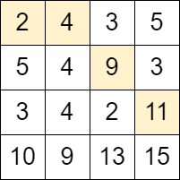 | Input: grid = [[2,4,3,5],[5,4,9,3],[3,4,2,11],[10,9,13,15]]  Output: 3  Explanation: We can start at the cell (0, 0) and make the following moves:  - (0, 0) -> (0, 1).  - (0, 1) -> (1, 2).  - (1, 2) -> (2, 3).  It can be shown that it is the maximum number of moves that can be made.
Example 2:
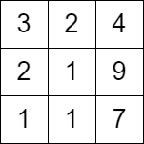 | Input: grid = [[3,2,4],[2,1,9],[1,1,7]]  Output: 0  Explanation: Starting from any cell in the first column we cannot perform any moves.
Constraints:
- m == grid.length
- n == grid[i].length
- 2 <= m, n <= 1000
- 4 <= m * n <= 105
- 1 <= grid[i][j] <= 106

2684. Maximum Number of Moves in a Grid
/*
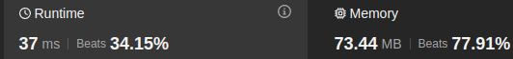
BFS
Time complexity: O(mn)
Space compexity:O(mn)
*/
class Solution {
public:
int maxMoves(std::vector<std::vector<int>>& grid){
int m=grid.size();
int n=grid[0].size();
std::vector<std::vector<bool>> visited(m,std::vector<bool>(n,false));
std::queue<std::tuple<int,int,int>> q;
for(int row=0;row<m;++row) {
q.push({row,0,0});
visited[row][0]=true;
}
int ans=0;
while(!q.empty()){
auto [row,col,cnt]=q.front();
q.pop();
ans=std::max(ans,cnt);
if(row-1>=0 && col+1<n && !visited[row-1][col+1] && grid[row][col]<grid[row-1][col+1]){
visited[row-1][col+1]=true;
q.push({row-1,col+1,cnt+1});
}
if(col+1<n && !visited[row][col+1] && grid[row][col]<grid[row][col+1]){
visited[row][col+1]=true;
q.push({row,col+1,cnt+1});
}
if(row+1<m && col+1<n && !visited[row+1][col+1] && grid[row][col]<grid[row+1][col+1]){
visited[row+1][col+1]=true;
q.push({row+1,col+1,cnt+1});
}
}
return ans;
}
};

2684. Maximum Number of Moves in a Grid
/*
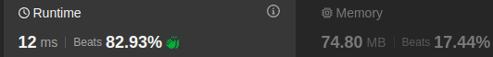
Recursion+memoization
Time complexity: O(mn)
Space compexity:O(mn)
*/
class Solution {
public:
int maxMoves(std::vector<std::vector<int>>& grid){
int m=grid.size();
int n=grid[0].size();
std::vector<std::vector<int>> memo(m,std::vector<int>(n,-1));
auto solve=[&](int row,int col,auto& self)->int{
if(row>=m || col>=n) return 0;
if(memo[row][col]!=-1) return memo[row][col];
int up=0,down=0,right=0;
if(row-1>=0 && col+1<n && grid[row][col]<grid[row-1][col+1]){
up=self(row-1,col+1,self);
}
if(col+1<n && grid[row][col]<grid[row][col+1]){
right=self(row,col+1,self);
}
if(row+1<m && col+1<n && grid[row][col]<grid[row+1][col+1]){
down=self(row+1,col+1,self);
}
return memo[row][col]=1+std::max({up,right,down});
};
int ans=0;
for(int row=0;row<m;++row){
ans=std::max(ans,solve(row,0,solve));
}

return ans-1;
}
};

2684. Maximum Number of Moves in a Grid
/*
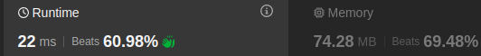
Bottom up with 2D array
Time complexity: O(mn)
Space compexity:O(mn)
*/
class Solution {
public:
int maxMoves(std::vector<std::vector<int>>& grid){
int m=grid.size();
int n=grid[0].size();

std::vector<std::vector<int>> dp(m,std::vector<int>(n,0));

for(int row=0;row<m;++row) dp[row][0]=1;

int ans=0;

for(int col=1;col<n;++col){
for(int row=0;row<m;++row){
if(row-1>=0 && grid[row][col]>grid[row-1][col-1] && dp[row-1][col-1]>0)
dp[row][col]=std::max(dp[row][col],dp[row-1][col-1]+1);
if(grid[row][col]>grid[row][col-1] && dp[row][col-1]>0)
dp[row][col]=std::max(dp[row][col],dp[row][col-1]+1);
if(row+1<m && grid[row][col]>grid[row+1][col-1] && dp[row+1][col-1]>0)
dp[row][col]=std::max(dp[row][col],dp[row+1][col-1]+1);

ans=std::max(ans,dp[row][col]-1);
}
}

return ans;
}
};

2684. Maximum Number of Moves in a Grid
/*
Bottom up with 1D array
Time complexity: O(mn)
Space compexity:O(m)
*/
class Solution {
public:
int maxMoves(std::vector<std::vector<int>>& grid){
int m=grid.size();
int n=grid[0].size();
std::vector<int> prev_col(m,1);
int ans=0;
for(int col=1;col<n;++col){
std::vector<int> cur_col(m,0);
for(int row=0;row<m;++row){
if(row-1>=0 && grid[row][col]>grid[row-1][col-1] && prev_col[row-1]>0)
cur_col[row]=std::max(cur_col[row],prev_col[row-1]+1);
if(grid[row][col]>grid[row][col-1] && prev_col[row]>0)
cur_col[row]=std::max(cur_col[row],prev_col[row]+1);
if(row+1<m && grid[row][col]>grid[row+1][col-1] && prev_col[row+1]>0)
cur_col[row]=std::max(cur_col[row],prev_col[row+1]+1);
ans=std::max(ans,cur_col[row]-1);
}
prev_col=cur_col;
}
return ans;
}
};

