2463. Minimum Total Distance Traveled
There are some robots and factories on the X-axis. You are given an integer array robot where robot[i] is the position of the ith robot. You are also given a 2D integer array factory where factory[j] = [positionj, limitj] indicates that positionj is the position of the jth factory and that the jth factory can repair at most limitj robots.
The positions of each robot are unique. The positions of each factory are also unique. Note that a robot can be in the same position as a factory initially.
All the robots are initially broken; they keep moving in one direction. The direction could be the negative or the positive direction of the X-axis. When a robot reaches a factory that did not reach its limit, the factory repairs the robot, and it stops moving.
At any moment, you can set the initial direction of moving for some robot. Your target is to minimize the total distance traveled by all the robots.
Return the minimum total distance traveled by all the robots. The test cases are generated such that all the robots can be repaired.
Note that
- All robots move at the same speed.
- If two robots move in the same direction, they will never collide.
- If two robots move in opposite directions and they meet at some point, they do not collide. They cross each other.
- If a robot passes by a factory that reached its limits, it crosses it as if it does not exist.
- If the robot moved from a position x to a position y, the distance it moved is |y - x|.

Example 1:
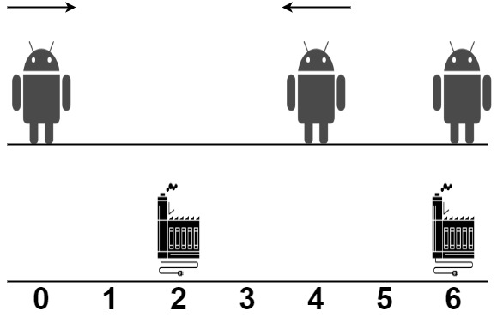

Input: robot = [0,4,6], factory = [[2,2],[6,2]]
Output: 4
Explanation: As shown in the figure:
- The first robot at position 0 moves in the positive direction. It will be repaired at the first factory.
- The second robot at position 4 moves in the negative direction. It will be repaired at the first factory.
- The third robot at position 6 will be repaired at the second factory. It does not need to move.
The limit of the first factory is 2, and it fixed 2 robots.
The limit of the second factory is 2, and it fixed 1 robot.
The total distance is |2 - 0| + |2 - 4| + |6 - 6| = 4. It can be shown that we cannot achieve a better total distance than 4.

Example 2:
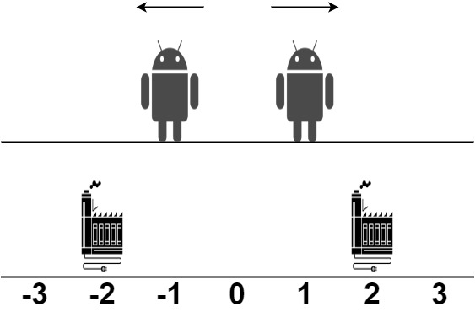

Input: robot = [1,-1], factory = [[-2,1],[2,1]]
Output: 2
Explanation: As shown in the figure:
- The first robot at position 1 moves in the positive direction. It will be repaired at the second factory.
- The second robot at position -1 moves in the negative direction. It will be repaired at the first factory.
The limit of the first factory is 1, and it fixed 1 robot.
The limit of the second factory is 1, and it fixed 1 robot.
The total distance is |2 - 1| + |(-2) - (-1)| = 2. It can be shown that we cannot achieve a better total distance than 2.
Constraints:
- 1 <= robot.length, factory.length <= 100
- factory[j].length == 2
- -109 <= robot[i], positionj <= 109
- 0 <= limitj <= robot.length
- The input will be generated such that it is always possible to repair every robot.

2463. Minimum Total Distance Traveled
/*
Include/Exclude: Recursion+Memoization
Time complexity: O(nlogn+mlogm+nm)=O(mn)
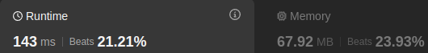
Space complexity: O(mn)+O(m+n)
*/
typedef long long ll;
typedef std::vector<int> vi;
typedef std::vector<vi> vvi;
class Solution {
public:
ll minimumTotalDistance(vi& robot,vvi& factory){
// To ensure that the robot goes the the nearest factory
std::sort(robot.begin(),robot.end());
std::sort(factory.begin(),factory.end());
/*
having 1 factory of k limits <=> having k factories of limit 1
(at the same position)
*/
vi factories;
for(auto& f: factory){
for(int i=1;i<=f[1];++i) factories.push_back(f[0]);
}
int n=robot.size();
int m=factories.size();
std::vector<std::vector<ll>> memo(n,std::vector<ll>(m,-1));
auto solve=[&](int robot_index,int factory_index,auto& self)->ll{
// All robots are repaired
//(Must be called first)
if(robot_index==n) return 0;
// If we still have broken robots and not no more factories
if(factory_index==m) return LONG_MAX/2;
if(memo[robot_index][factory_index]!=-1) return memo[robot_index][factory_index];
ll include=
abs(robot[robot_index]-factories[factory_index]) // current robot moves to current factory
+self(robot_index+1,factory_index+1,self); // Pass the the next robot and next factory
// This is why sorting is important
// Current robot skip the current factory
// and go the next nearest factoty
// This is why sorting is important
ll exclude=self(robot_index,factory_index+1,self);
return memo[robot_index][factory_index]=std::min(include,exclude);
};
return solve(0,0,solve); }};

2463. Minimum Total Distance Traveled
/*
Include/Exclude: bottom up
Time complexity: O(nlogn+mlogm+nm)=O(mn)
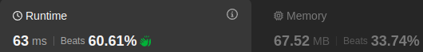
Space complexity: O(m+mn)
*/
typedef long long ll;
typedef std::vector<int> vi;
typedef std::vector<vi> vvi;
class Solution {
public:
ll minimumTotalDistance(vi& robot,vvi& factory){
// To ensure that the robot goes the the nearest factory
std::sort(robot.begin(),robot.end());
std::sort(factory.begin(),factory.end());
vi factories;
for(auto& f: factory){
for(int i=1;i<=f[1];++i) factories.push_back(f[0]);
}

int n=robot.size();
int m=factories.size();

std::vector<std::vector<ll>> dp(n+1,std::vector<ll>(m+1,0));

for(int robot_index=1;robot_index<=n;++robot_index)
dp[robot_index][0]=LONG_MAX/2;

for(int robot_index=1;robot_index<=n;++robot_index){
for(int factory_index=1;factory_index<=m;++factory_index){

ll include=abs(robot[robot_index-1]-factories[factory_index-1])
+dp[robot_index-1][factory_index-1];

ll exclude=dp[robot_index][factory_index-1];

dp[robot_index][factory_index]=std::min(include,exclude);
}
}

return dp[n][m];
}
};

2463. Minimum Total Distance Traveled
/*
Include/Exclude: bottom up: space optimization
Time complexity: O(nlogn+mlogm+nm)=O(mn)
Space complexity: O(m)
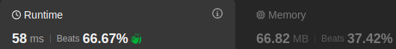
*/
typedef long long ll;
typedef std::vector<int> vi;
typedef std::vector<vi> vvi;
class Solution {
public:
ll minimumTotalDistance(vi& robot,vvi& factory){
std::sort(robot.begin(),robot.end());
std::sort(factory.begin(),factory.end());

vi factories;
for(auto& f: factory){
for(int i=1;i<=f[1];++i) factories.push_back(f[0]);
}

int n=robot.size();
int m=factories.size();

std::vector<ll> prev_row(m+1,0);

for(int robot_index=1;robot_index<=n;++robot_index){
std::vector<ll> cur_row(m+1,LONG_MAX/2);
for(int factory_index=1;factory_index<=m;++factory_index){

ll include=abs(robot[robot_index-1]-factories[factory_index-1])
+prev_row[factory_index-1];

ll exclude=cur_row[factory_index-1];

cur_row[factory_index]=std::min(include,exclude);
}
prev_row=cur_row;
}

return prev_row[m];
}
};

