group:
21 | 1 | 1 | 1 | 1 | 1 | 1 | 1 | 1 | 1 | 1 | 1 | 1 | 1 | 4 | 1 | 1 | 1 | 1 | 1 | 1 | 1 | 1 | 1 | 1 | 1 | 1 | 1 | 1 | 1 | 1 | 1 | 1 | 1 | 1 | 1
0 | 1 | 2 | 3 | 4 | 5 | 6 | 7 | 8 | 9 | 10 | 11 | 12 | 13 | 14 | 15 | 16 | 17 | 18 | 19 | 20 | 21 | 22 | 23 | 24 | 25 | 26 | 27 | 28 | 29 | 30 | 31 | 32 | 33 | 34 | 35
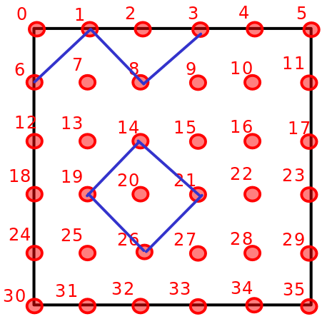
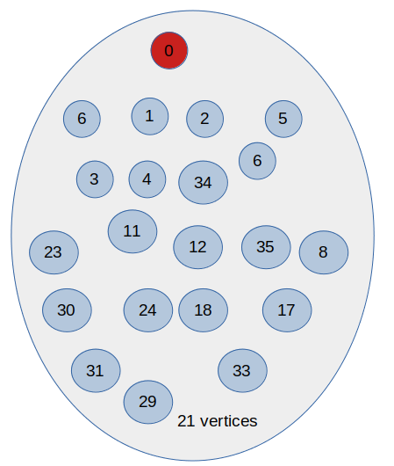
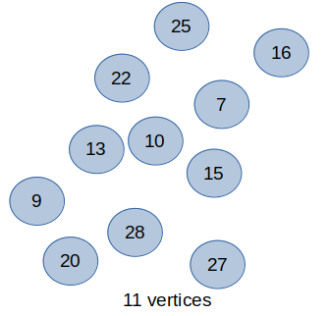

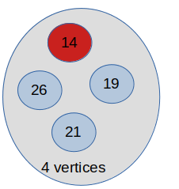

Pseudo code:
//C1: The number of connected components formed by the X vertices
int C1=0,X=0;
for each group value g in group{
if(g>1) {
C1=C1+1;
X=X+g;
}
}
int C=C1+(V-X)-1; // -1: Note that if G is connected, then C = 1 (already computed)

