1568. Minimum Number of Days to Disconnect Island
You are given an m x n binary grid grid where 1 represents land and 0 represents water. An island is a maximal 4-directionally (horizontal or vertical) connected group of 1's.
The grid is said to be connected if we have exactly one island, otherwise is said disconnected.
In one day, we are allowed to change any single land cell (1) into a water cell (0).
Return the minimum number of days to disconnect the grid.
Example 1:
Input: grid = [[0,1,1,0],[0,1,1,0],[0,0,0,0]]

Output: 2
Explanation: We need at least 2 days to get a disconnected grid.
Change land grid[1][1] and grid[0][2] to water and get 2 disconnected island.
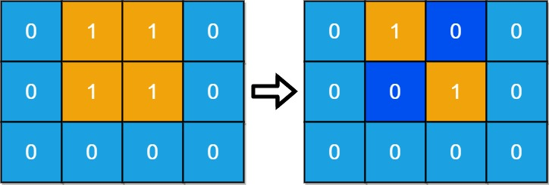
Example 2:
Input: grid = [[1,1]]
Output: 2
Explanation: Grid of full water is also disconnected ([[1,1]] -> [[0,0]]), 0 islands.

Constraints:
- m == grid.length
- n == grid[i].length
- 1 <= m, n <= 30
- grid[i][j] is either 0 or 1.

1568. Minimum Number of Days to Disconnect Island
/*
Brute force approach
Time complexity: O( (nm)^2)
Space complexity: O((nm)^2)
*/
class Solution {
public:
int n;
int m;
pair<int,int> moves[4] = {
{-1,0},
{1,0},
{0,-1},
{0,1}
};
public:
bool is_in_grid(int x,int y){
return x>=0 && x<=m-1 && y>=0 && y<=n-1;
}

void DFS(vector<vector<int>>& grid,std::vector<vector<bool>>& visited,int x,int y){
if(visited[x][y]) return;
visited[x][y]=true;
for(int i=0;i<4;++i){
int move_x=x+moves[i].first;
int move_y=y+moves[i].second;
if(!is_in_grid(move_x,move_y)) continue;
if(grid[move_x][move_y]==0) continue;
DFS(grid,visited,move_x,move_y);
}
}

int count_islands(vector<vector<int>>& grid) {
std::vector<vector<bool>> visited(m,std::vector<bool>(n,false));
int cnt=0;
for(int i=0;i<m;++i){
for(int j=0;j<n;++j){
if(grid[i][j]==0 || visited[i][j]) continue;
cnt++;
DFS(grid,visited,i,j);
}
}
return cnt;
}

int minDays(vector<vector<int>>& grid) {
m=grid.size();
n=grid[0].size();

int nb_inslands=count_islands(grid);
if(nb_inslands!=1) return 0;

for(int i=0;i<m;++i){
for(int j=0;j<n;++j){
if(grid[i][j]==1) {
grid[i][j]=0;
nb_inslands=count_islands(grid);
if(nb_inslands!=1) return 1;
grid[i][j]=1;
}
}
}
return 2;
}
};

