54. Spiral Matrix
Given an m x n matrix, return all elements of the matrix in spiral order.
Example 1:
Input: matrix = [[1,2,3],[4,5,6],[7,8,9]]  Output: [1,2,3,6,9,8,7,4,5] | 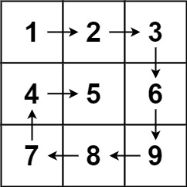
Example 2:
Input: matrix = [[1,2,3,4],[5,6,7,8][9,10,11,12]]  Output: [1,2,3,4,8,12,11,10,9,5,6,7] | 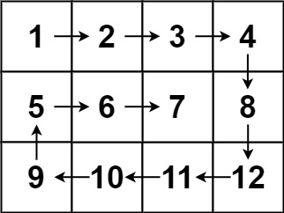

54. Spiral Matrix
/*
Time complexity: O(n^2)
Space complexity: O(1)
*/
class Solution {
public:
std::vector<int> spiralOrder(std::vector<std::vector<int>>& matrix) {
int m=matrix.size();
int n=matrix[0].size();

std::vector<int> ans;

int left=0,right=n-1,top=0,bottom=m-1;
bool ok=left<=right && top<=bottom;

while(ok){
if(ok){
// Get all values in the top row
for(int col=left;col<=right;++col) ans.push_back(matrix[top][col]);
top++;

// Get all values in the right column
for(int row=top;row<=bottom;++row) ans.push_back(matrix[row][right]);
right--;
}

ok=left<=right && top<=bottom;

if(ok){
// Get all values in the bottom row (reversed order)
for(int col=right;col>=left;--col) ans.push_back(matrix[bottom][col]);
bottom--;

// Get all values in the left column (reversed order)
for(int row=bottom;row>=top;--row) ans.push_back(matrix[row][left]);
left++;
}

ok=left<=right && top<=bottom;

}
return ans;
}
};

