590. N-ary Tree Postorder Traversal
Given the root of an n-ary tree, return the postorder traversal of its nodes' values.
Nary-Tree input serialization is represented in their level order traversal. Each group of children is separated by the null value (See examples)
Example 1:
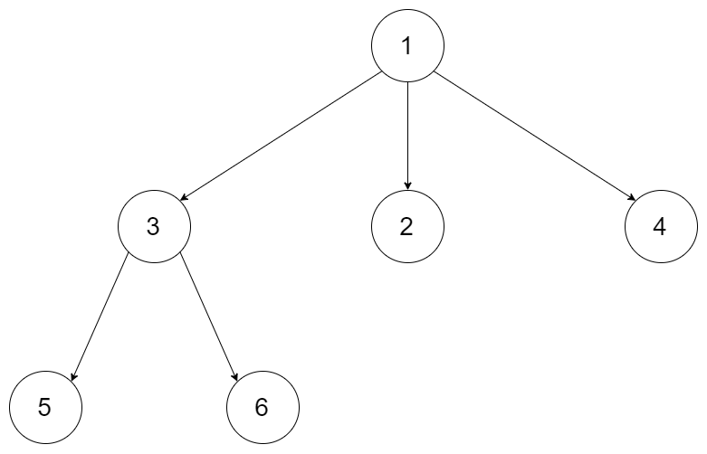 | Input: root = [1,null,3,2,4,null,5,6]  Output: [5,6,3,2,4,1]
Example 2:
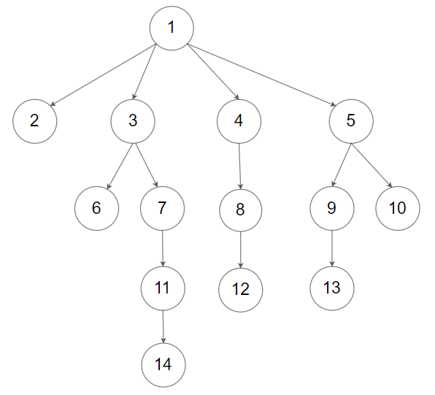 | Input: root = [1,null,2,3,4,5,null,null,6,7,null,8,null,9,10,null,null,11,null,12,null,13,null,null,14]  Output: [2,6,14,11,7,3,12,8,4,13,9,10,5,1]
Constraints:
- The number of nodes in the tree is in the range [0, 104].
- 0 <= Node.val <= 104
- The height of the n-ary tree is less than or equal to 1000.

Follow up: Recursive solution is trivial, could you do it iteratively?

590. N-ary Tree Postorder Traversal

Node definition
/*
// Definition for a Node.
class Node {
public:
int val;
vector<Node*> children;

Node() {}

Node(int _val) {
val = _val;
}

Node(int _val, vector<Node*> _children) {
val = _val;
children = _children;
}
};

590. N-ary Tree Postorder Traversal
/*
Recursive DFS
Time complexity: O(n)
space complexity: O(n)
n=#nodes in the N-ary tree
*/
typedef std::vector<int> vi;
class Solution {
public:
vi ans;
public:
vi postorder(Node* root) {
if (!root) return {};
for(auto& child: root->children){
postorder(child);
}
ans.push_back(root->val);
return ans;
}
};

590. N-ary Tree Postorder Traversal
/*
Iterative DFS
Time complexity: O(n)
space complexity: O(n)
n=#nodes in the N-ary tree
*/
typedef std::vector<int> vi;
class Solution {
public:
vi ans;
public:
vi postorder(Node* root) {
std::stack<Node*> st;
st.push(root);
while(!st.empty()){
Node* cur=st.top();
st.pop();
if(cur){
ans.push_back(cur->val);
for(auto& child: cur->children) st.push(child);
}
}
std::reverse(ans.begin(),ans.end());
return ans;
}
};

