1905. Count Sub Islands
You are given two m x n binary matrices grid1 and grid2 containing only 0's (representing water) and 1's (representing land). An island is a group of 1's connected 4-directionally (horizontal or vertical). Any cells outside of the grid are considered water cells.
An island in grid2 is considered a sub-island if there is an island in grid1 that contains all the cells that make up this island in grid2.
Return the number of islands in grid2 that are considered sub-islands.
Example 1:
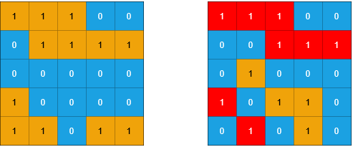

Input:
grid1 = [[1,1,1,0,0],[0,1,1,1,1],[0,0,0,0,0],[1,0,0,0,0],[1,1,0,1,1]]
grid2 = [[1,1,1,0,0],[0,0,1,1,1],[0,1,0,0,0],[1,0,1,1,0],[0,1,0,1,0]]
Output: 3
Explanation: In the picture above, the grid on the left is grid1 and the grid on the right is grid2.
The 1s colored red in grid2 are those considered to be part of a sub-island. There are three sub-islands.

Example 2:
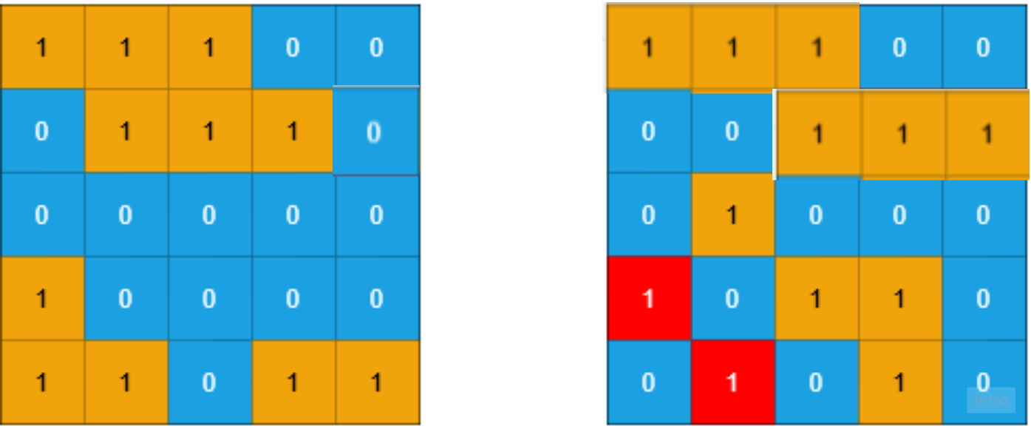
Input:
grid1 = [[1,1,1,0,0],[0,1,1,1,0],[0,0,0,0,0],[1,0,0,0,0],[1,1,0,1,1]]
grid2 = [[1,1,1,0,0],[0,0,1,1,1],[0,1,0,0,0],[1,0,1,1,0],[0,1,0,1,0]]
Output: 2

Example 3:
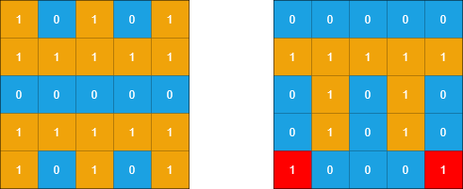

Input:
grid1 = [[1,0,1,0,1],[1,1,1,1,1],[0,0,0,0,0],[1,1,1,1,1],[1,0,1,0,1]]
grid2 = [[0,0,0,0,0],[1,1,1,1,1],[0,1,0,1,0],[0,1,0,1,0],[1,0,0,0,1]]
Output: 2
Explanation: In the picture above, the grid on the left is grid1 and the grid on the right is grid2.
The 1s colored red in grid2 are those considered to be part of a sub-island. There are two sub-islands.

Example 4:
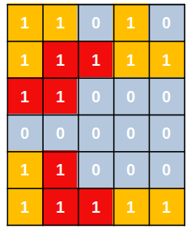
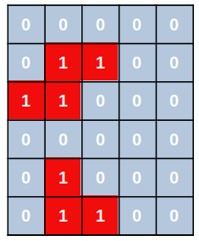

Input:
grid1 = [[1,1,0,1,0],[1,1,1,1,1],[1,1,0,0,0],[0,0,0,0,0],[1,1,0,0,0],[1,1,1,1,1]]
grid2 = [[0,0,0,0,0],[0,1,1,0,0],[1,1,0,0,0],[0,0,0,0,0],[0,1,0,0,0],[0,1,1,0,0]]
Output: 2

Constraints:
- m == grid1.length == grid2.length
- n == grid1[i].length == grid2[i].length
- 1 <= m, n <= 500
- grid1[i][j] and grid2[i][j] are either 0 or 1.

1905. Count Sub Islands
/*
DFS
Time complexity:
nested for loops: O(mn)
DFS: O(V+E)=O(mn+V)
Overall: O(mn*(mn+V))
If all cells are 1:
nested for loops: O(1)
DFS: O(V+E)=O(mn+V)
Overall: O(mn+V)=O(mn)
Space complexity:
Recurion stack calls: O(mn)
*/
typedef std::pair<int,int> ii;
typedef std::vector<ii> vii;
typedef vector<int> vi;
typedef vector<vi> vvi;
class Solution {
public:
vii moves={
{-1,0}, // Up
{1,0}, // Down
{0,1}, // Right
{0,-1} // Left
};

int m; // Number of rows
int n; // Number of columns

public:
bool is_in_grid(int x,int y){
return x>=0 && x<=m-1 && y>=0 && y<=n-1;
}

bool dfs(int i, int j,vvi& grid1, vvi& grid2){
// If out of grid or visited or cell in grid2 is water
if(!is_in_grid(i,j) || grid2[i][j]==0) return true;

grid2[i][j]=0; // Mark cell as visited

bool is_sub_island=grid1[i][j]==1;

for(auto& move: moves){
int x=i+move.first;
int y=j+move.second;
is_sub_island = dfs(x,y,grid1,grid2) && is_sub_island ;
}
return is_sub_island;
}

int countSubIslands(vvi& grid1, vvi& grid2) {
m=grid1.size();
n=grid1[0].size();

int ans=0;
for(int i=0;i<m;++i){
for(int j=0;j<n;++j){
if(grid1[i][j]==0 || grid2[i][j]==0) continue;
ans+=dfs(i,j,grid1,grid2);
}
}
return ans;
}
};

1905. Count Sub Islands
/*
Union Find
Time complexity:
nested for loops: O(mn)
DSU: O(α(mn))
Overall: O(α(mn)mn),
where α is the inverse Ackermann function
Space complexity:
Recurion stack calls: O(mn)
*/

typedef vector<int> vi;
typedef vector<vi> vvi;

class DSU{
public:
vi parent;
public:
DSU(int _N){
parent.resize(_N);
for(int i=0;i<_N;++i) parent[i]=i;
}

int find(int p){
if(p==parent[p]) return p;
return parent[p]=find(parent[p]); // Path compression
}

int unify(int p,int q){
int parent_p=find(p);
int parent_q=find(q);
if(parent_p==parent_q) return 0;
parent[parent_q]=parent_p;
return 1;
}
};

class Solution {
public:
int m; // Number of rows
int n; // Number of columns

public:
int cell_id(int i,int j){return i*n+j;}
int countSubIslands(vvi& grid1, vvi& grid2) {
m=grid1.size();
n=grid1[0].size();

int _N=m*n;
//+1, water source to flood non valid sub-island in grid2
DSU dsu=DSU(_N+1);

int ans=0;
for(int i=0;i<m;++i){
for(int j=0;j<n;++j){

if(grid2[i][j]==0) continue;

int cur=cell_id(i,j);
int down=cell_id(i+1,j);
int right=cell_id(i,j+1);

ans++;
// Flood the current island in grid2 by water
if(grid1[i][j]==0) ans-=dsu.unify(cur,_N);
// Count the number of islands in grid2
if(i+1<m && grid2[i+1][j]==1) ans-=dsu.unify(cur,down);
if(j+1<n && grid2[i][j+1]==1) ans-=dsu.unify(cur,right);
}
}

return ans;
}
};

