1937. Maximum Number of Points with Cost
you are given an m x n integer matrix points (0-indexed). Starting with 0 points, you want to maximize the number of points you can get from the matrix.
To gain points, you must pick one cell in each row. Picking the cell at coordinates (r, c) will add points[r][c] to your score.
However, you will lose points if you pick a cell too far from the cell that you picked in the previous row. For every two adjacent rows r and r + 1 (where 0 <= r < m - 1), picking cells at coordinates (r, c1) and (r + 1, c2) will subtract abs(c1 - c2) from your score.
Return the maximum number of points you can achieve.
abs(x) is defined as:
- x for x >= 0.
- -x for x < 0.
Example 1:
Input: points = [[1,2,3],[1,5,1],[3,1,1]]  Output: 9  Explanation:  The blue cells denote the optimal cells to pick, which have coordinates (0, 2), (1, 1), and (2, 0).  You add 3 + 5 + 3 = 11 to your score.  However, you must subtract abs(2 - 1) + abs(1 - 0) = 2 from your score.  Your final score is 11 - 2 = 9. | 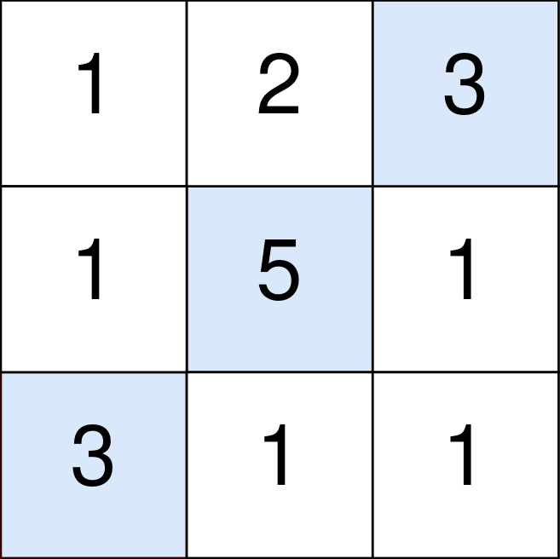
Example 2:
Input: points = [[1,5],[2,3],[4,2]]  Output: 11  Explanation:  The blue cells denote the optimal cells to pick, which have coordinates (0, 1), (1, 1), and (2, 0).  You add 5 + 3 + 4 = 12 to your score.  However, you must subtract abs(1 - 1) + abs(1 - 0) = 1 from your score.  Your final score is 12 - 1 = 11. | 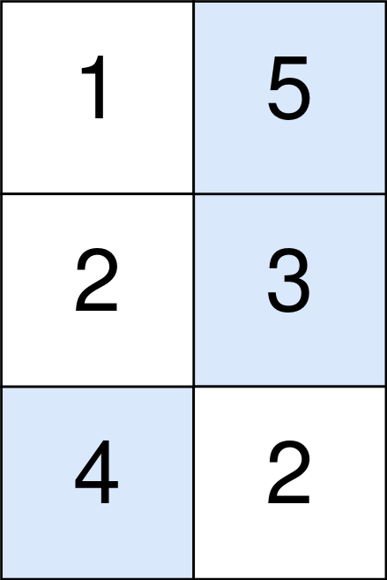
Constraints:
- m == points.length
- n == points[r].length
- 1 <= m, n <= 105
- 1 <= m * n <= 105
- 0 <= points[r][c] <= 105

1937. Maximum Number of Points with Cost

/*

Dynamic programming: Memoization

Time complexity: o(n.mn)=O(mn^2) (TLE)

Space complexity: O(2mn)=O(mn)

*/

typedef vector<long long> vi;

typedef vector<vi> vvi;

class Solution {

public:

long long maxPoints(std::vector<std::vector<int>>& points) {

int m=points.size();

int n=points[0].size();

vvi memo(m,vi(n,-1));

auto solve=[&](int i, int j, auto& self)->long long{

if(i>=m) return 0;

if(memo[i][j]!=-1) return memo[i][j];

long long ans=0;

for(int k=0;k<n;++k) {

long long val=points[i][k]-abs(k-j)+self(i+1,k,self);

ans=std::max(ans,val);

}

return memo[i][j]=ans;

};

long long ans=0;

for(int i=0;i<n;++i) {

long long val=(long long)points[0][i]+solve(1,i,solve);

ans=std::max(ans,val);

}

return ans;

}

};

1937. Maximum Number of Points with Cost
/*
Dynamic programming: Tabulation
Time complexity: O(n+m(n+n^2)+n)=O(2n+mn+mn^2)=O(mn^2) (TLE)
Space complexity: O(n)
*/
typedef vector<long long> vi;
typedef vector<vi> vvi;
class Solution {
public:
long long maxPoints(std::vector<std::vector<int>>& points) {
int m=points.size();
int n=points[0].size();

vi dp(points[0].begin(),points[0].end());

for(int i=1;i<m;++i){
vi tmp=dp;
for(int j=0;j<n;++j){
long long mx=-1;
for(int k=0;k<n;++k){
mx=std::max(mx,tmp[k]+points[i][j]-(abs(k-j)));
}
dp[j]=mx;
}
}

long long ans=*std::max_element(dp.begin(),dp.end());

return ans;
}
};

1937. Maximum Number of Points with Cost
/*
Dynamic programming: Tabulation+prefix,suffix max
Time complexity: O(n+m.6n+n)=O(2n+6mn)=O(m.n) (AC)
Space complexity: O(3n)=O(n)
*/
typedef vector<long long> vi;
typedef vector<vi> vvi;

class Solution {
public:
long long maxPoints(std::vector<std::vector<int>>& points) {
int m=points.size();
int n=points[0].size();

vi dp(points[0].begin(),points[0].end());

for(int i=1;i<m;++i){
vi prefix_max(n,0),suffix_max(n,0);
prefix_max[0]=dp[0];
for(int j=1;j<n;++j){
prefix_max[j]=std::max(dp[j],prefix_max[j-1]-1);
}

suffix_max[n-1]=dp[n-1];
for(int j=n-2;j>=0;--j){
suffix_max[j]=std::max(dp[j],suffix_max[j+1]-1);
}

// dp=points[i]
std::transform(points[i].begin(),points[i].end(),dp.begin(),[](int x) {return (long long)x;});

for(int j=0;j<n;++j){
dp[j]+=std::max(prefix_max[j],suffix_max[j]);
}
}

long long ans=*std::max_element(dp.begin(),dp.end());

return ans;
}
};

