840. Magic Squares In Grid
A 3 x 3 magic square is a 3 x 3 grid filled with distinct numbers from 1 to 9 such that each row, column, and both diagonals all have the same sum.
Given a row x col grid of integers, how many 3 x 3 contiguous magic square subgrids are there?
Note: while a magic square can only contain numbers from 1 to 9, grid may contain numbers up to 15.
Example 1:
Input: grid = [[4,3,8,4],[9,5,1,9],[2,7,6,2]]  Output: 1  Explanation:  The following subgrid is a 3 x 3 magic square:  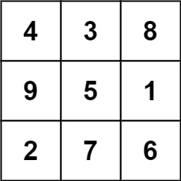  while this one is not:  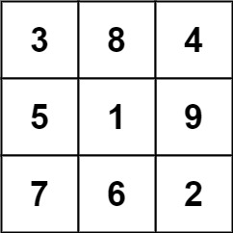  In total, there is only one magic square inside the given grid. | 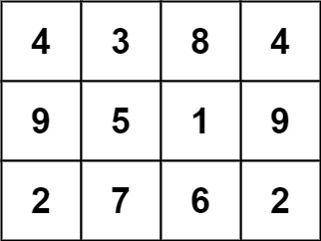
Example 2:
Input: grid = [[8]]
Output: 0
Constraints:
- row == grid.length
- col == grid[i].length
- 1 <= row, col <= 10
- 0 <= grid[i][j] <= 15

840. Magic Squares In Grid
/*
Brute force
Time complexity: O(nm*(9+9+9+3+9+9))=O(48nm)=O(nm)  Space complexity: O(9+9)=O(1) | 
*/
class Solution {
public:
bool is_magic_square(std::vector<std::vector<int>>& square){
// Check if digits from 1 to 9 are distinct
bool exists[10]={false};
for(int i=0;i<3;++i){
for(int j=0;j<3;++j){
int x=square[i][j];
if(x>9 || exists[x]) return false;
exists[x]=true;
}
}

// Check if all digits from 1 to 9 exist
for(int i=1;i<=9;++i) if(!exists[i]) return false;

// Check sums
// Compute first sum
int row_sum=0;
for(int i=0;i<3;++i) row_sum+=square[0][i];
// Sum of each row
for(int i=0;i<3;++i){
int s=0;
for(int j=0;j<3;++j){
s+=square[i][j];
}
if(s!=row_sum) return false;
}

// Sum of each column
for(int i=0;i<3;++i){
int s=0;
for(int j=0;j<3;++j){
s+=square[j][i];
}
if(s!=row_sum) return false;
}
// Sum of the diagonal
int sd1=square[0][0]+square[1][1]+square[2][2];
// Sum of the anti-diagonal
int sd2=square[0][2]+square[1][1]+square[2][0];
if(sd1!=row_sum || sd2!=row_sum) return false;
// If all checks are good
return true;
}
int numMagicSquaresInside(std::vector<std::vector<int>>& grid) {
int n=grid.size();
int m=grid[0].size();
int ans=0;
for(int i=0;i<=n-3;++i){
for(int j=0;j<=m-3;++j){
if(j+2>m-1) break;
if(i+2>n-1) return ans;
std::vector<std::vector<int>> square(3,std::vector<int>(3));
for(int k=0;k<3;++k){
for(int l=0;l<3;++l){
square[k][l]=grid[i+k][j+l];
}
}
if (is_magic_square(square)) ans++;
}
}
return ans;
}
};

840. Magic Squares In Grid
/*  Use 3x3 magic square properties  Time complexity: O(nm*(9+9))=O(18nm)=O(nm)  Space complexity: O(9+3+3)=O(1)  */ | 

class Solution {
public:
bool is_magic_square(std::vector<std::vector<int>>& square){
// If 5 is not in middle, it can not be a magic square
if(square[1][1] != 5) return false;

// Computes sums, and check if digits from 1 to 9
// are all present once.
int row_sum[3]={0},col_sum[3]={0};
int mask=511;
for(int i=0;i<3;++i){
for(int j=0;j<3;++j){
int x=square[i][j];
if(x<=0 || x>9) return false;
row_sum[i]+=x;
col_sum[j]+=x;
mask=(mask & (~(1<<(x-1))));
}
}
// mask !=0, means it exists a digit that exists than one, or
// it exists a digit that does not a exist.
if(mask!=0) return false;

// sums of all rows, and all columns must be 15
if (!all_of(row_sum, row_sum+3,[](int sum){return sum==15;})) return false;
if (!all_of(col_sum, col_sum+3,[](int sum){return sum==15;})) return false;

// It all checks above ar good
return true;
}

int numMagicSquaresInside(std::vector<std::vector<int>>& grid) {
int n=grid.size();
int m=grid[0].size();

int ans=0;
for(int i=0;i<=n-3;++i){
for(int j=0;j<=m-3;++j){
if(j+2>m-1) break;
if(i+2>n-1) return ans;
std::vector<std::vector<int>> square(3,std::vector<int>(3));
for(int k=0;k<3;++k){
for(int l=0;l<3;++l){
square[k][l]=grid[i+k][j+l];
}
}
if (is_magic_square(square)) ans++;
}
}
return ans;
}
};

840. Magic Squares In Grid
/*  Use 3x3 magic square properties+Math observation  Time complexity: O(nm*(9+15+15))=O(39nm)=O(nm)  Space complexity: O(9+15+15)=O(1)  */ | 

class Solution {
public:
bool is_magic_square(std::vector<std::vector<int>>& square){
if(square[1][1] != 5) return false;

std::string spiral1="438167294381672";
std::string spiral2="927618349276183";

std::string s=std::to_string(square[0][0])+std::to_string(square[0][1])+std::to_string(square[0][2])
+std::to_string(square[1][2])+std::to_string(square[2][2])
+std::to_string(square[2][1])+std::to_string(square[2][0])
+std::to_string(square[1][0]);

if(spiral1.find(s)==std::string::npos && spiral2.find(s)==std::string::npos) return false;

return true;
}

int numMagicSquaresInside(std::vector<std::vector<int>>& grid) {
int n=grid.size();
int m=grid[0].size();

int ans=0;
for(int i=0;i<=n-3;++i){
for(int j=0;j<=m-3;++j){
if(j+2>m-1) break;
if(i+2>n-1) return ans;
std::vector<std::vector<int>> square(3,std::vector<int>(3));
for(int k=0;k<3;++k){
for(int l=0;l<3;++l){
square[k][l]=grid[i+k][j+l];
}
}
if (is_magic_square(square)) ans++;
}
}
return ans;
}
};

