3042. Count Prefix and Suffix Pairs I
You are given a 0-indexed string array words.
Let's define a boolean function isPrefixAndSuffix that takes two strings, str1 and str2:
- isPrefixAndSuffix(str1, str2) returns true if str1 is both a prefix and a suffix of str2, and false otherwise.
For example, isPrefixAndSuffix("aba", "ababa") is true because "aba" is a prefix of "ababa" and also a suffix, but isPrefixAndSuffix("abc", "abcd") is false.
Return an integer denoting the number of index pairs (i, j) such that i < j, and isPrefixAndSuffix(words[i], words[j]) is true.
Example 1:
Input: words = ["a","aba","ababa","aa"]
Output: 4
Explanation: In this example, the counted index pairs are:
i = 0 and j = 1 because isPrefixAndSuffix("a", "aba") is true.
i = 0 and j = 2 because isPrefixAndSuffix("a", "ababa") is true.
i = 0 and j = 3 because isPrefixAndSuffix("a", "aa") is true.
i = 1 and j = 2 because isPrefixAndSuffix("aba", "ababa") is true.
Therefore, the answer is 4.
Example 2:
Input: words = ["pa","papa","ma","mama"]
Output: 2
Explanation: In this example, the counted index pairs are:
i = 0 and j = 1 because isPrefixAndSuffix("pa", "papa") is true.
i = 2 and j = 3 because isPrefixAndSuffix("ma", "mama") is true.
Therefore, the answer is 2.
Example 3:
Input: words = ["abab","ab"]
Output: 0
Explanation: In this example, the only valid index pair is i = 0 and j = 1, and isPrefixAndSuffix("abab", "ab") is false.
Therefore, the answer is 0.
Constraints:
- 1 <= words.length <= 50
- 1 <= words[i].length <= 10
- words[i] consists only of lowercase English letters.

3042. Count Prefix and Suffix Pairs I
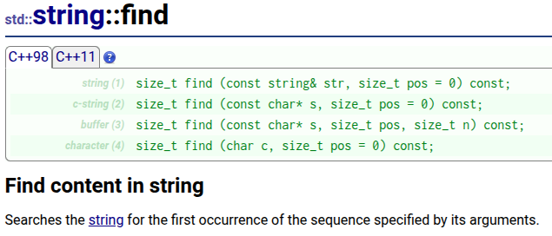
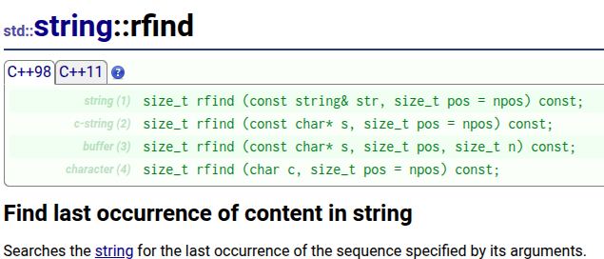

3042. Count Prefix and Suffix Pairs I
/*
STLs find and rfind
Time compelxity:
Space compelxity: O(1)
n: size of the words's list
m: size of a word in the list of words

*/
class Solution {
public:
int countPrefixSuffixPairs(std::vector<std::string>& words) {
int n=words.size();

auto is_prefix_and_suffix=[&](std::string& needle,std::string& haystack)->bool{
int n=haystack.size();
int m=needle.size();
if(n<m) return false;
auto it1=haystack.find(needle);
auto it2=haystack.rfind(needle);
return it1==0 && it2==n-m;
};

int ans=0;
for(int i=0;i<n-1;++i){
for(int j=i+1;j<n;++j){
if(is_prefix_and_suffix(words[i],words[j])) ans++;
}
}

return ans;
}
};

3042. Count Prefix and Suffix Pairs I
/*
Three pointers
Time compelxity:
Space compelxity: O(1)
n: size of the words's list
m: size of a word in the list of words

*/
class Solution {
public:
int countPrefixSuffixPairs(std::vector<std::string>& words) {
int n=words.size();

auto is_prefix_and_suffix=[&](std::string& needle,std::string& haystack)->bool{
int n=haystack.size();
int m=needle.size();
if(n<m) return false;
int i=0,j=n-m,k=0;
while(k<m && haystack[i]==needle[k] && haystack[j]==needle[k]){
i++;
j++;
k++;
}
return k==m;
};

int ans=0;
for(int i=0;i<n-1;++i){
for(int j=i+1;j<n;++j){
if(is_prefix_and_suffix(words[i],words[j])) ans++;
}
}

return ans;
}
};

3045. Count Prefix and Suffix Pairs II
Constraints:
- 1 <= words.length <=
- 1 <= words[i].length <=
- words[i] consists only of lowercase English letters.
- The sum of the lengths of all words[i] does not exceed 5 * 105.

3045. Count Prefix and Suffix Pairs II
/*
Prefix tree (Trie)
Time compelxity: O(n.m)
Space compelxity: O(n.m)
*/
class Trie{
public:
class TrieNode{
public:
std::unordered_map<int,TrieNode*> children;
long long count=0;
};
TrieNode* root;
public:
Trie(){
root=new TrieNode();
}

~Trie(){delete_trie(root);}

// Delete the try to avoid memory leaks
void delete_trie(TrieNode* root){
if(!root) return;
for(auto& [_,node]: root->children){
delete_trie(node);
}
delete root;
}
long long solve(std::vector<std::string>& words){
int n=words.size();
long long ans=0;
for(auto& word: words){
TrieNode* cur=root;
int m=word.size();
for(int i=0;i<m;++i){
int hash=(word[i]-'a')*26+word[m-i-1]-'a';
TrieNode* node=cur->children[hash];
if(!node){
node=new TrieNode();
cur->children[hash]=node;
}
ans+=cur->children[hash]->count;
cur=node;
}
// The word is completely processed, it could be a prefix and a suffix for another word,
// so increment its count
cur->count++;
}
return ans;
}
};

class Solution {
public:
long long countPrefixSuffixPairs(std::vector<std::string>& words) {
Trie trie=Trie();
return trie.solve(words);
}
};

