2064. Minimized Maximum of Products Distributed to Any Store
You are given an integer n indicating there are n specialty retail stores. There are m product types of varying amounts, which are given as a 0-indexed integer array quantities, where quantities[i] represents the number of products of the ith product type.
You need to distribute all products to the retail stores following these rules:
- A store can only be given at most one product type but can be given any amount of it.
- After distribution, each store will have been given some number of products (possibly 0). Let x represent the maximum number of products given to any store. You want x to be as small as possible, i.e., you want to minimize the maximum number of products that are given to any store.
Return the minimum possible x.
Example 1:
Input: n = 6, quantities = [11,6]
Output: 3
Explanation: One optimal way is:
- The 11 products of type 0 are distributed to the first four stores in these amounts: 2, 3, 3, 3
- The 6 products of type 1 are distributed to the other two stores in these amounts: 3, 3
The maximum number of products given to any store is max(2, 3, 3, 3, 3, 3) = 3.
Example 2:
Input: n = 7, quantities = [15,10,10]
Output: 5
Explanation: One optimal way is:
- The 15 products of type 0 are distributed to the first three stores in these amounts: 5, 5, 5
- The 10 products of type 1 are distributed to the next two stores in these amounts: 5, 5
- The 10 products of type 2 are distributed to the last two stores in these amounts: 5, 5
The maximum number of products given to any store is max(5, 5, 5, 5, 5, 5, 5) = 5.
Example 3:
Input: n = 1, quantities = [100000]
Output: 100000
Explanation: The only optimal way is:
- The 100000 products of type 0 are distributed to the only store.
The maximum number of products given to any store is max(100000) = 100000.
Constraints:
- m == quantities.length
- 1 <= m <= n <= 10⁵
- 1 <= quantities[i] <= 10⁵

2064. Minimized Maximum of Products Distributed to Any Store
/*
Linear search
Time complexity: O(m * hi)
Space complexity: O(1)
hi: maximum quantitites
m: number of products
*/
class Solution {
public:
int minimizedMaximum(int n, std::vector<int>& quantities){
// Get max quantity
int hi=*std::max_element(quantities.begin(),quantities.end());
// Linear search for the minimum quantity
// that we can distribute to stores.
for(int limit=1;limit<=hi;++limit){
// Determine the maximum number of stores that we can
// distribute to them `limit` amounts of product
long long nb_stores=0;
for(auto& qte: quantities){
nb_stores+=(qte/limit+int(qte%limit!=0));
}
// if is possible to distribute `limit` product to
// the stores, return that limit which represent
// the best we can do
if(nb_stores<=n) return limit;
}

return 0; // Never reached
}
};

2064. Minimized Maximum of Products Distributed to Any Store
/*
Binary search
Time complexity: O(m log hi)
Space complexity: O(1)
hi: maximum quantitites
m: number of products
*/
class Solution {
public:
int minimizedMaximum(int n, std::vector<int>& quantities){
// Get max quantity
int hi=*std::max_element(quantities.begin(),quantities.end());
int lo=1;
int ans=0;
// Binary search for the minimum quantity
// that we can distribute to stores.
while(lo<=hi){
int limit=(lo+hi)/2;
// Determine the maximum number of stores that we can
// distribute to them `limit` amounts of product
long long nb_stores=0;
for(auto& qte: quantities){
nb_stores+=(qte/limit+int(qte%limit!=0));
}
// if is possible to distribute `limit` product to
// the stores, return that limit which represent
// the best we can do
if(nb_stores<=n){
ans=limit;
hi=limit-1;
}
else lo=limit+1;
}

return ans; // Never reached
}
};

Approach 2: Greedy Approach Using a Heap

Intuition
The key idea of this approach is to assign stores to product types in an optimal way, rather than assigning products to stores. Initially, each product type is assigned one store, which is guaranteed by the constraint . After this, we focus on which product types should receive additional stores. The algorithm greedily selects the product type with the highest ratio of to , assigning the next available store to that product type.
Since we need to repeatedly access the product type with the highest ratio and update the ratios as stores are assigned, a priority queue (max-heap) is useful for efficiently managing these operations.
Consider an arbitrary distribution of stores to products, represented as , where ​ denotes the number of stores assigned to the product type. The specific indices of stores assigned or the order of assignment don’t affect the result.
To minimize the load on any single store, the products of type should be distributed as evenly as possible across its ​ assigned stores. This ensures that each store handling products of type will have no more than products
Thus, our objective is to minimize the maximum number of products any store receives. The function should return:

Now, consider the greedy approach: If at any point in the algorithm, we fail to assign the next available store to the product type with the highest ratio to , that ratio will remain the largest, leading to a non-optimal distribution. This would cause the highest ratio to dominate, violating our goal of minimizing the maximum number of products per store.

To gain a better understanding of the algorithm, let’s revisit our initial example with and .
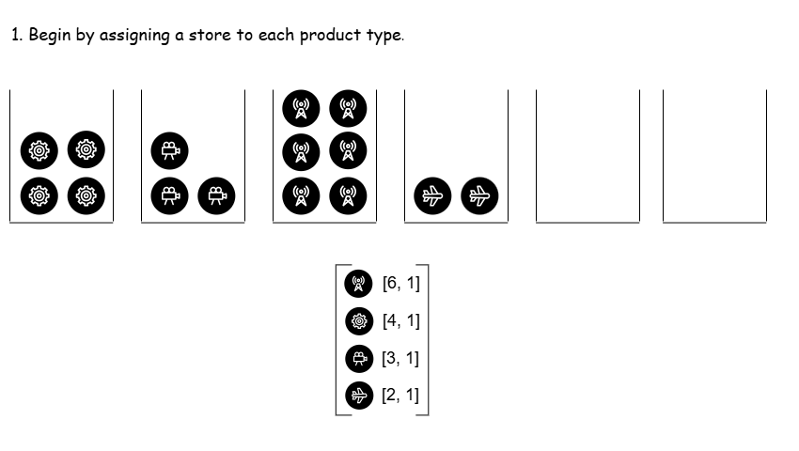
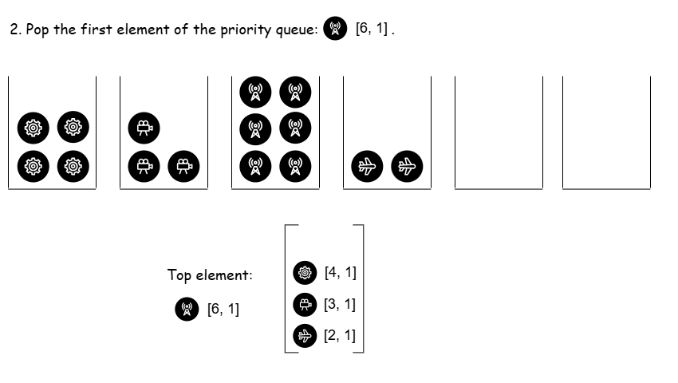
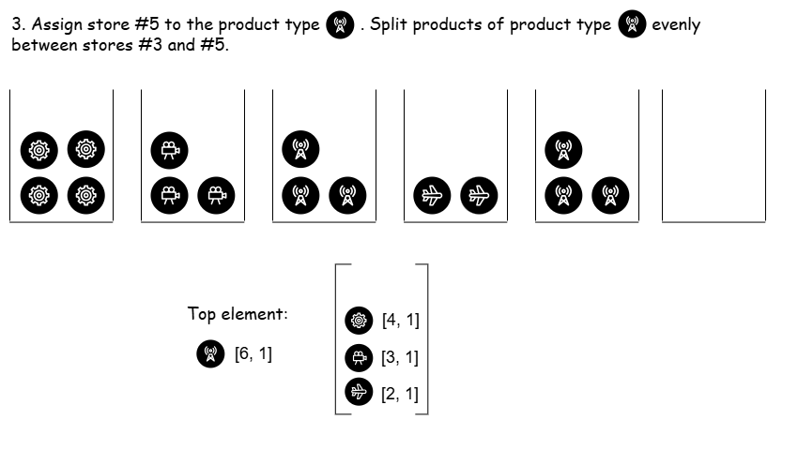
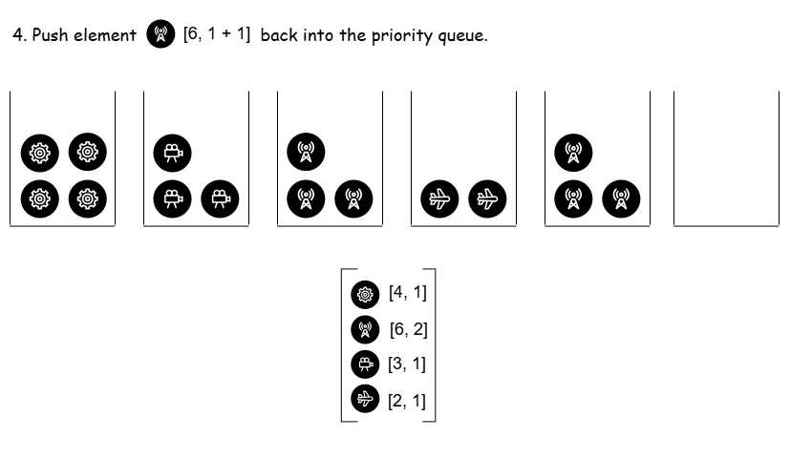

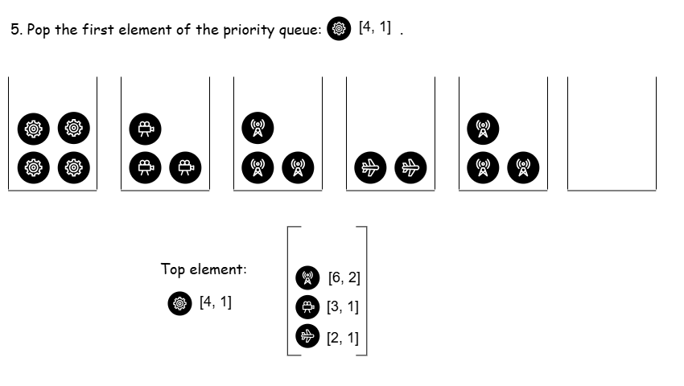
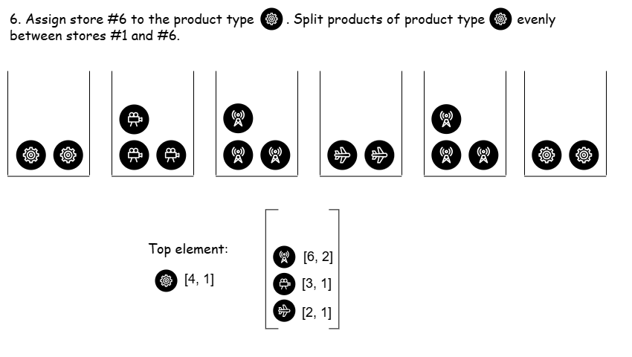

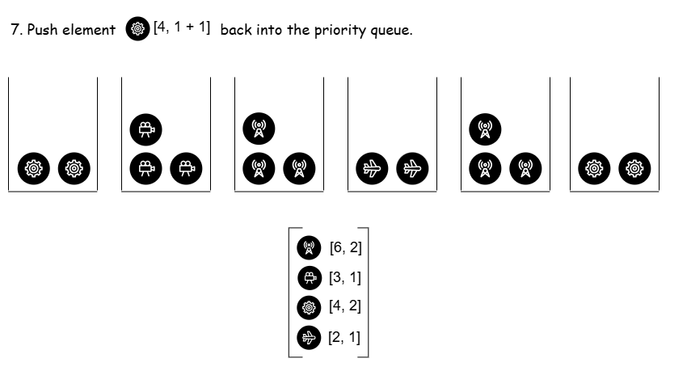
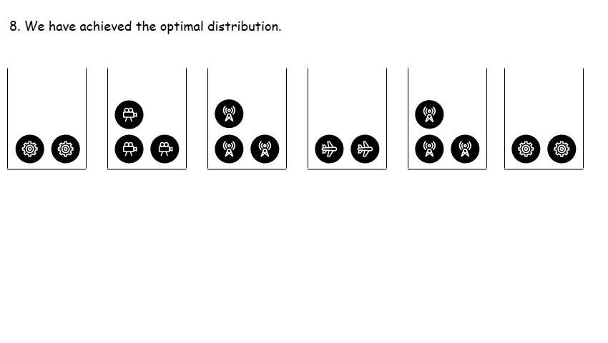

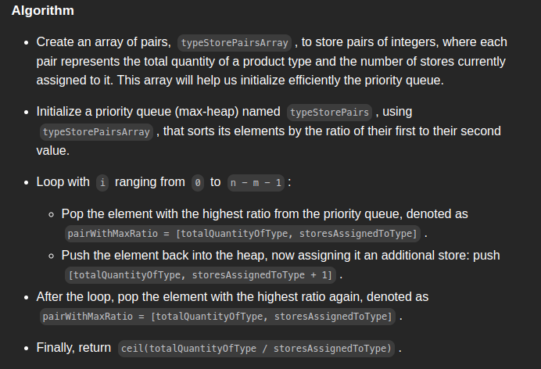

class Solution {
public:
int minimizedMaximum(int n, vector<int>& quantities) {
int m = quantities.size();

// Define a custom comparator for the priority queue
// It sorts the pairs based on the ratio of their first to their second
// element
auto compareTypeStorePairs = [](pair<int, int>& a, pair<int, int>& b) {
return (long long)a.first * b.second <
(long long)a.second * b.first;
};

// Helper array - useful for the efficient initialization of the
// priority queue
vector<pair<int, int>> typeStorePairsArray;

// Push all product types to the array, after assigning one store to
// each of them
for (int i = 0; i < m; i++) {
typeStorePairsArray.push_back({quantities[i], 1});
}

// Initialize the priority queue
priority_queue<pair<int, int>, vector<pair<int, int>>,
decltype(compareTypeStorePairs)>
typeStorePairs(typeStorePairsArray.begin(),
typeStorePairsArray.begin() + m);

// Iterate over the remaining n - m stores.
for (int i = 0; i < n - m; i++) {
// Pop first element
pair<int, int> pairWithMaxRatio = typeStorePairs.top();
int totalQuantityOfType = pairWithMaxRatio.first;
int storesAssignedToType = pairWithMaxRatio.second;
typeStorePairs.pop();

// Push same element after assigning one more store to its product
// type
typeStorePairs.push(
{totalQuantityOfType, storesAssignedToType + 1});
}

// Pop first element
pair<int, int> pairWithMaxRatio = typeStorePairs.top();
int totalQuantityOfType = pairWithMaxRatio.first;
int storesAssignedToType = pairWithMaxRatio.second;

// Return the maximum minimum ratio
return ceil((double)totalQuantityOfType / storesAssignedToType);
}
};

Complexity Analysis
- Time complexity:
We first iterate over the array, pushing each value as the first element of a pair into the helper array. This operation takes time.
We then initialize a priority queue (heap) using the elements from the array. Building the heap takes time because heapify is performed in linear time.
After that, we enter a second loop that runs times. In each iteration, we perform one pop and one push operation on the priority queue. Both operations take time, so this loop has a total time complexity of .
Combining the time complexities of the initialization, heap construction, and store allocation, the overall time complexity of the algorithm is: .
- Space complexity:
The priority queue has a size of m since each value of the array is inserted as the first element of exactly one .

