2257. Count Unguarded Cells in the Grid
You are given two integers m and n representing a 0-indexed m x n grid. You are also given two 2D integer arrays guards and walls where guards[i] = [rowi, coli] and walls[j] = [rowj, colj] represent the positions of the ith guard and jth wall respectively.
A guard can see every cell in the four cardinal directions (north, east, south, or west) starting from their position unless obstructed by a wall or another guard. A cell is guarded if there is at least one guard that can see it.
Return the number of unoccupied cells that are not guarded.
Example 1:
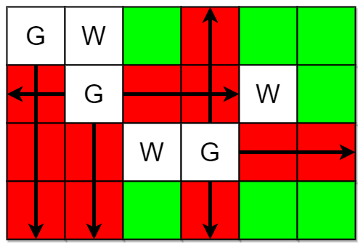 | Input: m = 4, n = 6, guards = [[0,0],[1,1],[2,3]], walls = [[0,1],[2,2],[1,4]]  Output: 7  Explanation: The guarded and unguarded cells are shown in red and green respectively in the above diagram.  There are a total of 7 unguarded cells, so we return 7.
Example 2:
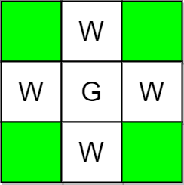 | Input: m = 3, n = 3, guards = [[1,1]], walls = [[0,1],[1,0],[2,1],[1,2]]  Output: 4  Explanation: The unguarded cells are shown in green in the above diagram.  There are a total of 4 unguarded cells, so we return 4.

Constraints:
- 1 <= m, n <= 10⁵
- 2 <= m * n <= 10⁵
- 1 <= guards.length, walls.length <= 5 * 10⁴
- 2 <= guards.length + walls.length <= m * n
- guards[i].length == walls[j].length == 2
- 0 <= rowi, rowj < m
- 0 <= coli, colj < n
- All the positions in guards and walls are unique.

2257. Count Unguarded Cells in the Grid
/*
Straight forward Simualation
Time compelxity: O(g+w+min(g(m+n),4.m.n)+m.n)
Space complexity: O(m.n)
*/
typedef std::vector<int> vi;
typedef std::vector<vi> vvi;
class Solution {
public:
int countUnguarded(int m, int n, vvi& guards, vvi& walls){
vvi grid(m,vi(n,0));

// Fill the grid as describe in guards and walls
for(auto& g: guards){
grid[g[0]][g[1]]=1;
}
for(auto& w: walls){
grid[w[0]][w[1]]=-1;
}

// For each guard
for(auto& g: guards){
int i=g[0];
int j=g[1];
// see west
int k=j-1;
while(k>=0 && grid[i][k]!=1 && grid[i][k]!=-1) grid[i][k]=2,k--;

// see east
k=j+1;
while(k<n && grid[i][k]!=1 && grid[i][k]!=-1) grid[i][k]=3,k++;

// see north
k=i-1;
while(k>=0 && grid[k][j]!=1 && grid[k][j]!=-1) grid[k][j]=4,k--;

// see south
k=i+1;
while(k<m && grid[k][j]!=1 && grid[k][j]!=-1) grid[k][j]=5,k++;

}

// Count not guarded cells (with value equal to 0)
int ans=0;
for(int i=0;i<m;++i){
for(int j=0;j<n;++j){
ans+=int(grid[i][j]==0);
}
}

return ans;
}
};

