1861. Rotating the Box
You are given an m x n matrix of characters box representing a side-view of a box. Each cell of the box is one of the following:
- A stone '#'
- A stationary obstacle '*'
- Empty '.'
The box is rotated 90 degrees clockwise, causing some of the stones to fall due to gravity. Each stone falls down until it lands on an obstacle, another stone, or the bottom of the box. Gravity does not affect the obstacles' positions, and the inertia from the box's rotation does not affect the stones' horizontal positions.
It is guaranteed that each stone in box rests on an obstacle, another stone, or the bottom of the box.
Return an n x m matrix representing the box after the rotation described above.
Example 1:
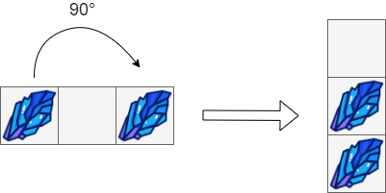 | Input: box = [["#",".","#"]]  Output: [["."],  ["#"],  ["#"]]
Example 2:
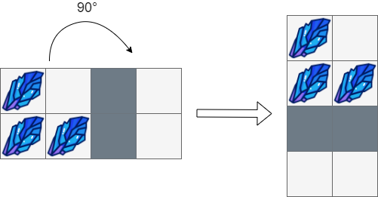 | Input: box = [["#",".","*","."],  ["#","#","*","."]]  Output: [["#","."],  ["#","#"],  ["*","*"],  [".","."]]

Example 3:
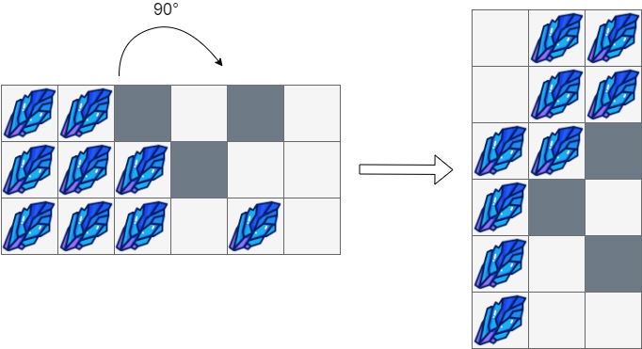 | Input: box = [["#","#","*",".","*","."], ["#","#","#","*",".","."], ["#","#","#",".","#","."]]  Output: [[".","#","#"],  [".","#","#"],  ["#","#","*"],  ["#","*","."],  ["#",".","*"],  ["#",".","."]]

Constraints:
- m == box.length
- n == box[i].length
- 1 <= m, n <= 500
- box[i][j] is either '#', '*', or '.'.

1861. Rotating the Box
/*
Brute Force: Two pointers to identify the sequence of stones that will fall
Double passes:gravity effect+Rotation
Time complexity:
Space complexity: O(n.m)
*/
typedef std::vector<char> vc;
typedef std::vector<vc> vvc;
class Solution {
public:
vvc rotateTheBox(vvc& box){
int m=box.size();
int n=box[0].size();
// Gravity
for(auto& cur_row: box){
// Two pointers to identify the sequence of rocks that will fall
int start=-1,end=-1;
for(int i=0;i<n;++i){
// Stone: Mark the start of the sequence
if(cur_row[i]=='#' && start==-1) start=i;

// Empty cell: Mark the end of the sequence
if(cur_row[i]=='.' && end==-1) end=i;

// Obstacle:
if(cur_row[i]=='*') start=-1,end=-1;

// Not valid sequence: ..###
if(start!=-1 && end!=-1 && start>end) end=-1;

// Valid sequence
if(start!=-1 && end!=-1 && end>start){
// Empty cell will be on the top
cur_row[start]='.';

// All stone will go right (fall)
for(int j=start+1;j<=end;++j) cur_row[j]='#';
// Mark the start of the new sequence
start++;

// Don't know its end
end=-1;
}
}
}

// Rotation
vvc rot(n,vc(m));

for(int i=0;i<n;++i){
for(int j=m-1;j>=0;--j){
rot[i][m-j-1]=box[j][i];
}
}

return rot;
}
};

1861. Rotating the Box
/*
One pointer: Mark the lowest empty cell
Double passes:gravity effect+Rotation
Time complexity: O(m.n)
Space complexity: O(n.m)
*/
typedef std::vector<char> vc;
typedef std::vector<vc> vvc;
class Solution {
public:
vvc rotateTheBox(vvc& box){
int m=box.size();
int n=box[0].size();
// Gravity
for(int i=0;i<m;++i){
// Lowest empty cell: by default last cell
int lowest_empty_cell_idx=n-1;
// Process each cell in row `j` from left to right (bottom to top)
for(int j=n-1;j>=0;--j){
// Stone: let it fall to the lowest empty cell
if(box[i][j]=='#'){
box[i][j]='.';
box[i][lowest_empty_cell_idx]='#';
lowest_empty_cell_idx--;
}
// Obstacle: reset `lowest_empty_cell_idx` to the cell
// directly on its left (above it)
if(box[i][j]=='*') lowest_empty_cell_idx=j-1;
}
}
// Rotation
vvc rot(n,vc(m));
for(int i=0;i<n;++i){
for(int j=m-1;j>=0;--j){
rot[i][m-j-1]=box[j][i];
}
}
return rot;}};

1861. Rotating the Box
/*
One pointer: Mark the lowest empty cell
Single pass:gravity effect+Rotation
Time complexity: O(m.n)
Space complexity: O(n.m)
*/
typedef std::vector<char> vc;
typedef std::vector<vc> vvc;
class Solution {
public:
vvc rotateTheBox(vvc& box){
int m=box.size();
int n=box[0].size();

// Gravity and rotation
vvc rot(n,vc(m,'.'));
for(int i=0;i<m;++i){
int lowest_empty_cell_idx=n-1;
for(int j=n-1;j>=0;--j){
if(box[i][j]=='#'){
rot[lowest_empty_cell_idx][m-i-1]='#';
lowest_empty_cell_idx--;
}
if(box[i][j]=='*'){
rot[j][m-i-1]='*';
lowest_empty_cell_idx=j-1;
}
}
}

return rot;
}
};

