2924. Find Champion II

There are n teams numbered from 0 to n - 1 in a tournament; each team is also a node in a DAG.
You are given the integer n and a 0-indexed 2D integer array edges of length m representing the DAG, where edges[i] = [ui, vi] indicates that there is a directed edge from team ui to team vi in the graph.
A directed edge from a to b in the graph means that team a is stronger than team b and team b is weaker than team a.
Team a will be the champion of the tournament if there is no team b that is stronger than team a.
Return the team that will be the champion of the tournament if there is a unique champion, otherwise, return -1.
Notes
- A cycle is a series of nodes a1, a2, ..., an, an+1 such that node a1 is the same node as node an+1, the nodes a1, a2, ..., an are distinct, and there is a directed edge from the node ai to node ai+1 for every i in the range [1, n].
- A DAG is a directed graph that does not have any cycle.
Example 1:
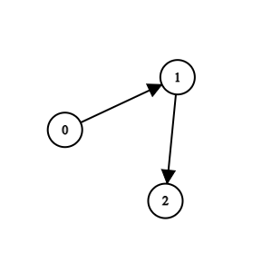 | Input: n = 3, edges = [[0,1],[1,2]]  Output: 0  Explanation: Team 1 is weaker than team 0. Team 2 is weaker than team 1. So the champion is team 0.

Example 2:
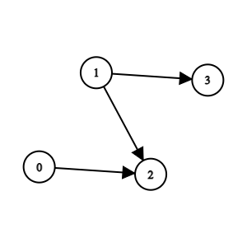 | Input: n = 4, edges = [[0,2],[1,3],[1,2]]  Output: -1  Explanation: Team 2 is weaker than team 0 and team 1. Team 3 is weaker than team 1. But team 1 and team 0 are not weaker than any other teams. So the answer is -1.

Constraints:
- 1 <= n <= 100
- m == edges.length
- 0 <= m <= n * (n - 1) / 2
- edges[i].length == 2
- 0 <= edge[i][j] <= n - 1
- edges[i][0] != edges[i][1]
- The input is generated such that if team a is stronger than team b, team b is not stronger than team a.
- The input is generated such that if team a is stronger than team b and team b is stronger than team c, then team a is stronger than team c.

2924. Find Champion II
/*
In degree count
Time compelxity: O(n)
Space compelxity: O(n)
*/
typedef std::vector<int> vi;
typedef std::vector<vi> vvi;
class Solution {
public:
int findChampion(int n,vvi& edges){
vi indegree(n,0);
for(auto& edge: edges){
indegree[edge[1]]++;
}

int cnt=0;
int ans;
for(int node=0;node<n;++node){
if(indegree[node]==0){
cnt++;
ans=node;
}
}

return cnt==1?ans:-1;
}
};

