3243. Shortest Distance After Road Addition Queries I
You are given an integer n and a 2D integer array queries.
There are n cities numbered from 0 to n - 1. Initially, there is a unidirectional road from city i to city i + 1 for all 0 <= i < n - 1.
queries[i] = [ui, vi] represents the addition of a new unidirectional road from city ui to city vi. After each query, you need to find the length of the shortest path from city 0 to city n - 1.
Return an array answer where for each i in the range [0, queries.length - 1], answer[i] is the length of the shortest path from city 0 to city n - 1 after processing the first i + 1 queries.
Example 1:
Input: n = 5, queries = [[2,4],[0,2],[0,4]]
Output: [3,2,1]
Explanation:
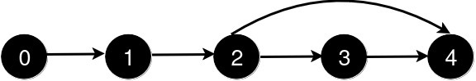
After the addition of the road from 2 to 4, the length of the shortest path from 0 to 4 is 3.
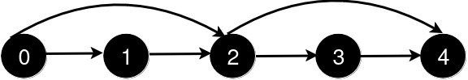
After the addition of the road from 0 to 2, the length of the shortest path from 0 to 4 is 2.
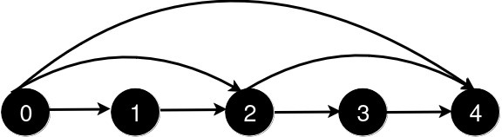
After the addition of the road from 0 to 4, the length of the shortest path from 0 to 4 is 1.
Example 2:
Input: n = 4, queries = [[0,3],[0,2]]
Output: [1,1]
Explanation:
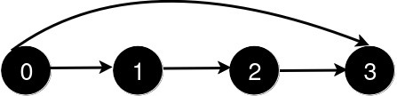

After the addition of the road from 0 to 3, the length of the shortest path from 0 to 3 is 1.
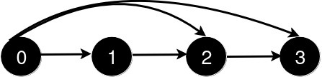

After the addition of the road from 0 to 2, the length of the shortest path remains 1.
Constraints:
- 3 <= n <= 500
- 1 <= queries.length <= 500
- queries[i].length == 2
- 0 <= queries[i][0] < queries[i][1] < n
- 1 < queries[i][1] - queries[i][0]
- There are no repeated roads among the queries.

3243. Shortest Distance After Road Addition Queries I
/*
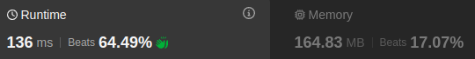
BFS
Time complexity: O(V+Q.(E+V))
Space compelxity: O(V)
*/
typedef std::vector<int> vi;
typedef std::vector<vi> vvi;
typedef std::pair<int,int> ii;
typedef std::vector<ii> vii;
class Solution{
private:
vvi graph;
public:
// Build the adjacency matrix of graph G(V,E)
// Time compelxity: O(V)
// Space compelxity: O(V)
void build_graph(int n,vvi& edges){
graph.resize(n);
for(int i=0;i<n-1;++i){
graph[i].push_back(i+1);
}
}

// Time complexity: O(V+E)
// Space compelxity: O(V)
int bfs(int start, int target){
vi visited(target+1,false);
vi distances(target+1,INT_MAX);
distances[0]=0;
std::queue<int> q;
q.push(0);
int dist=0;
while(!q.empty()){
int cur_node=q.front();
q.pop();

if(cur_node==target) return distances[target];

if(visited[cur_node]) continue;
visited[cur_node]=true;

for(auto& neighbor: graph[cur_node]){
if(distances[neighbor]!=INT_MAX) continue;
distances[neighbor]=distances[cur_node]+1;
q.push(neighbor);
}
}
return distances[target];
}

// Overall time complexity: O(V+Q.(V+E))
// Overall space compelxity: O(V)
vi shortestDistanceAfterQueries(int n, vvi& queries) {
build_graph(n,queries);

vi ans;

for(auto& query: queries){
int u=query[0];
int v=query[1];
graph[u].push_back(v);

int shortest_path_lenght=bfs(0,n-1);
ans.push_back(shortest_path_lenght);

}
return ans;
}
};

3243. Shortest Distance After Road Addition Queries I
/*
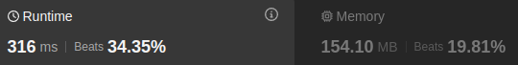
Dijkstra
Time complexity: O(V+Q.(E log V))
Space compelxity: O(V)
*/

typedef std::vector<int> vi;
typedef std::vector<vi> vvi;
typedef std::pair<int,int> ii;
typedef std::vector<ii> vii;

class Solution{
private:
vvi graph;
public:
// Build the adjacency matrix of graph G(V,E)
// Time compelxity: O(V)
// Space compelxity: O(V)
void build_graph(int n,vvi& edges){
graph.resize(n);
for(int i=0;i<n-1;++i){
graph[i].push_back(i+1);
}
}

// Time complexity: O(E log V)
// Space compelxity: O(V)
int dijkstra(int start, int target){
vi visited(target+1,false);
vi distances(target+1,INT_MAX);
distances[start]=0;
std::priority_queue<ii,vii,std::greater<ii>> min_heap;
min_heap.push({0,start});
while(!min_heap.empty()){
auto [dist,cur_node]=min_heap.top();
min_heap.pop();
if(visited[cur_node]) continue;
visited[cur_node]=true;
if(cur_node==target) return distances[target];
for(auto& neighbor: graph[cur_node]){
if(distances[neighbor]>distances[cur_node]+1){
distances[neighbor]=distances[cur_node]+1;
min_heap.push({distances[neighbor],neighbor});
}
}
}
return distances[target];
}

// Overall time complexity: O(V+Q.(E log V))
// Overall space compelxity: O(V)
vi shortestDistanceAfterQueries(int n, vvi& queries) {
build_graph(n,queries);

vi ans;
for(auto& query: queries){
int u=query[0];
int v=query[1];
graph[u].push_back(v);
int shortest_path_lenght=dijkstra(0,n-1);
ans.push_back(shortest_path_lenght);
}
return ans;
}
};

3244. Shortest Distance After Road Addition Queries II
You are given an integer n and a 2D integer array queries.
There are n cities numbered from 0 to n - 1. Initially, there is a unidirectional road from city i to city i + 1 for all 0 <= i < n - 1.
queries[i] = [ui, vi] represents the addition of a new unidirectional road from city ui to city vi. After each query, you need to find the length of the shortest path from city 0 to city n - 1.
There are no two queries such that queries[i][0] < queries[j][0] < queries[i][1] < queries[j][1].
Return an array answer where for each i in the range [0, queries.length - 1], answer[i] is the length of the shortest path from city 0 to city n - 1 after processing the first i + 1 queries.

Example 1:
Input: n = 5, queries = [[2,4],[0,2],[0,4]]
Output: [3,2,1]
Explanation:
After the addition of the road from 2 to 4, the length of the shortest path from 0 to 4 is 3.
After the addition of the road from 0 to 2, the length of the shortest path from 0 to 4 is 2.

After the addition of the road from 0 to 4, the length of the shortest path from 0 to 4 is 1.

Example 2:
Input: n = 4, queries = [[0,3],[0,2]]
Output: [1,1]
Explanation:

After the addition of the road from 0 to 3, the length of the shortest path from 0 to 3 is 1.

After the addition of the road from 0 to 2, the length of the shortest path remains 1.
Constraints:
- 3 <= n <= 105
- 1 <= queries.length <= 105
- queries[i].length == 2
- 0 <= queries[i][0] < queries[i][1] < n
- 1 < queries[i][1] - queries[i][0]
- There are no repeated roads among the queries.
- There are no two queries such that i != j and queries[i][0] < queries[j][0] < queries[i][1] < queries[j][1].

3244. Shortest Distance After Road Addition Queries II
/*
Ordered set
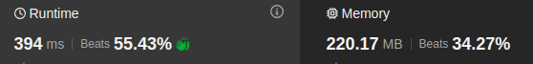
Time complexity: O(nlogn+Q.n.logn)
Space complexity: O(n)
*/

typedef std::vector<int> vi;
typedef std::vector<vi> vvi;

class Solution{
public:
std::vector<int> shortestDistanceAfterQueries(int n,vvi & queries){
std::set<int> s;
for(int i=0;i<n;++i) s.insert(i);
vi ans;
for(auto& query: queries){
int u=query[0];
int v=query[1];
auto u_it=s.lower_bound(u+1);
auto v_it=s.upper_bound(v-1);
if(*v_it>=*u_it) s.erase(u_it,v_it);
ans.push_back(s.size()-1);
}
return ans;
}
};

3244. Shortest Distance After Road Addition Queries II
/*
Array

Time complexity: O(Q.n)
Space complexity: O(n)
*/

typedef std::vector<int> vi;
typedef std::vector<vi> vvi;

class Solution{
public:
std::vector<int> shortestDistanceAfterQueries(int n,vvi & queries){
vi cities(n, 0), ans;
for(int i=0;i<n-1;++i) cities[i]=i+1;
int dist=n-1;
for(auto &query: queries){
int u=query[0];
int v=query[1];
if (cities[u]!=INT_MIN){
for(int i=cities[u];i<v;++i){
if (cities[i]!=INT_MIN){
cities[i]=INT_MIN;
dist--;
}
}
cities[u]=v;
}
ans.push_back(dist);
}
return ans;
}
};

