2579. Count Total Number of Colored Cells
There exists an infinitely large two-dimensional grid of uncolored unit cells. You are given a positive integer n, indicating that you must do the following routine for n minutes:
- At the first minute, color any arbitrary unit cell blue.
- Every minute thereafter, color blue every uncolored cell that touches a blue cell.
Below is a pictorial representation of the state of the grid after minutes 1, 2, and 3.
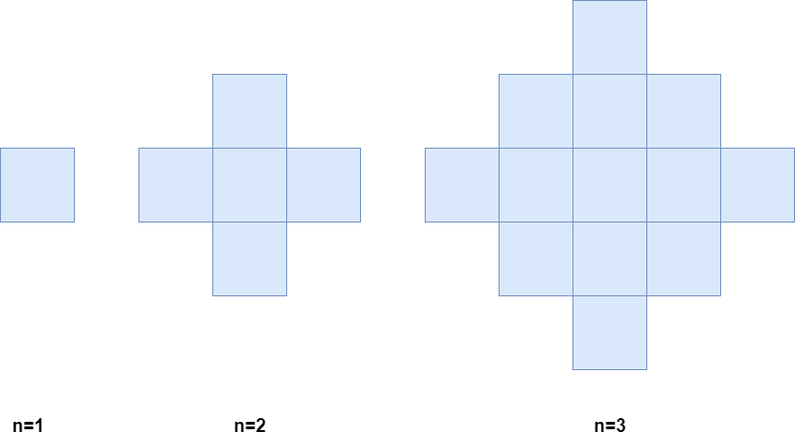
Return the number of colored cells at the end of n minutes.
Example 1:
Input: n = 1
Output: 1
Explanation: After 1 minute, there is only 1 blue cell, so we return 1.
Example 2:
Input: n = 2
Output: 5
Explanation: After 2 minutes, there are 4 colored cells on the boundary and 1 in the center, so we return 5.
Constraints:

2579. Count Total Number of Colored Cells

Overview
We are given a positive integer n, representing the number of minutes. At each minute, the following is performed in a grid:
- Minute One: Color a unit cell blue.
- Every Minute Thereafter: Color every uncolored cell that touches a blue cell.
Our task is to determine how many cells are colored after minutes.

2579. Count Total Number of Colored Cells
/*
Math
Time compelxity: O(1)
Space compelxity: O(1)
*/
class Solution {
public:
long long coloredCells(int n) {
return 2*n*1ll*n*1ll-2*n*1ll+1ll;
}
};

