1004. Max Consecutive Ones III
Given a binary array nums and an integer k, return the maximum number of consecutive 1's in the array if you can flip at most k 0's.
Example 1:
Input: nums = [1,1,1,0,0,0,1,1,1,1,0], k = 2
Output: 6
Explanation: [1,1,1,0,0,1,1,1,1,1,1]
Bolded numbers were flipped from 0 to 1. The longest subarray is underlined.
Example 2:
Input: nums = [0,0,1,1,0,0,1,1,1,0,1,1,0,0,0,1,1,1,1], k = 3
Output: 10
Explanation: [0,0,1,1,1,1,1,1,1,1,1,1,0,0,0,1,1,1,1]
Bolded numbers were flipped from 0 to 1. The longest subarray is underlined.

Constraints:

- nums[i] is either 0 or 1.
- 0 <= k <= nums.length

1004. Max Consecutive Ones III

Brute force approach
Try all possible windows (subarrays)
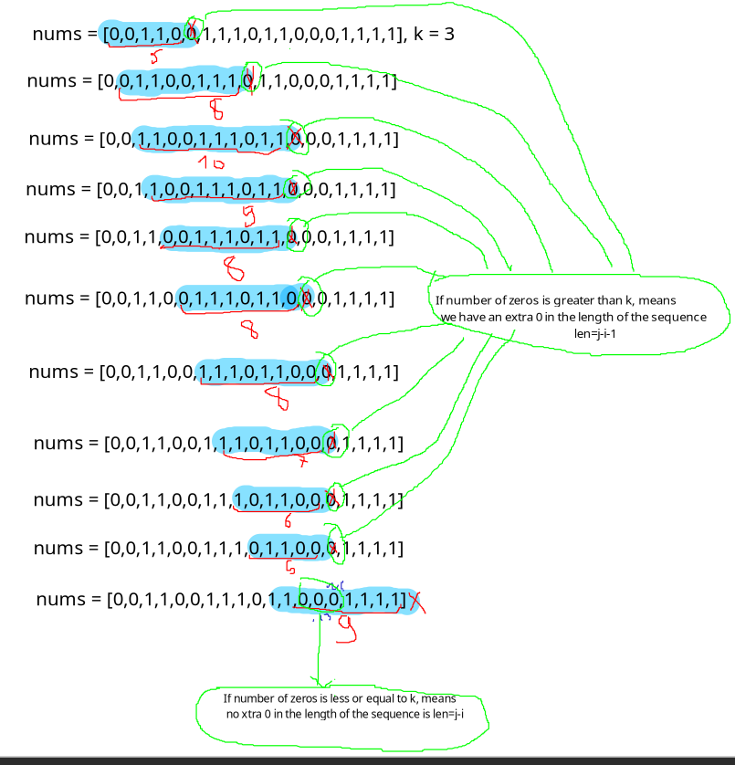

1004. Max Consecutive Ones III
/*
Brute Force: try all possibilities
Time complexity: (TLE)
Space complexity: O(1)
*/
class Solution {
public:
int longestOnes(vector<int>& nums, int k) {
int n=nums.size();
int ans=INT_MIN;
// For each window
for(int i=0;i<n;++i){
int j=i; // starting from i
// Expand it to the right, while counting the numbers of zeros
int cnt_zero=0; // Initialize the number of zeros to 0
// While the end of the array is not reached and the number of zeros is
// not out of the limit k
// Otherwise, the actual window can not be expanded any more
while(j<n && cnt_zero<=k){
cnt_zero+=(nums[j]==0); // Update the number of zeros
j++; // Expand it to the right
}

// If number of zeros is greater than k, means
// we have an extra 0 in the length of the sequence
// If number of zeros is less or equal to k, means
// no xtra 0 in the length of the sequence is len=j-i
int len=cnt_zero>k?j-i-1:j-i;
ans=std::max(ans,len); // Maximize the answer
}

return ans;
}
};

1004. Max Consecutive Ones III

Dynamic sliding window
Expand the window while number of zeros is less or equal to k, shrink it otherwise.
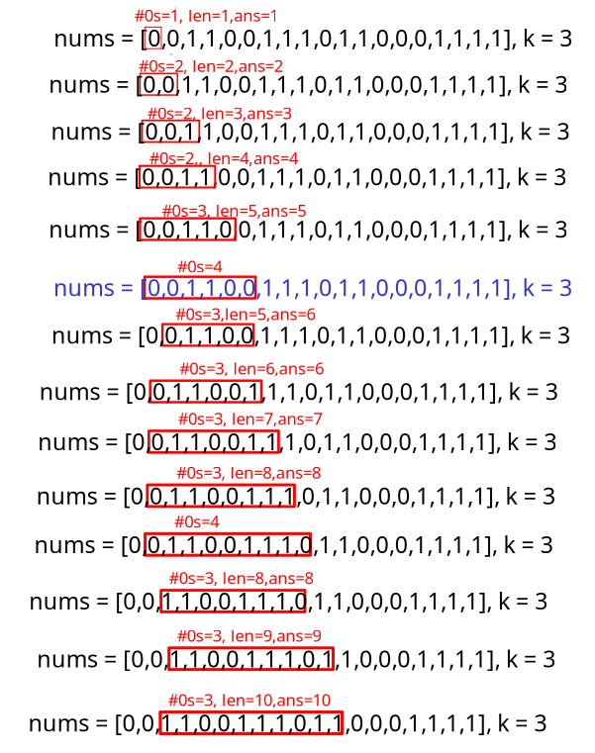
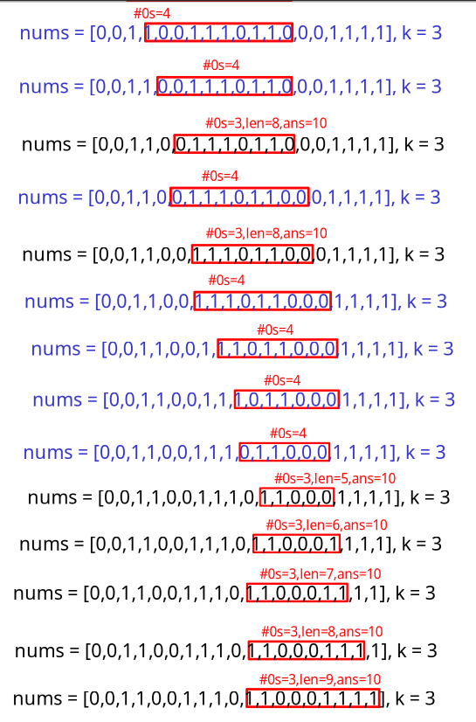

1004. Max Consecutive Ones III
/*
Dynamic sliding window
Time complexity: O(n) (AC)
Space complexity: O(1)
*/
class Solution {
public:
int longestOnes(vector<int>& nums, int k) {
int n=nums.size();
int ans=INT_MIN;
int cnt_zeros=0;

// Expand the window to the right
int l=0;
for(int r=0;r<n;++r){
cnt_zeros+=(nums[r]==0); // Add 1, if we encounter a 0

// While number of zeros is greater than k
while(cnt_zeros>k){
cnt_zeros-=(nums[l]==0); // Subtract 1, if we encounter a 0, while ...
l++; // ... shrinking the window from the left
}

ans=std::max(ans,r-l+1); // Maximize the answer
}
return ans;
}
};

