3208. Alternating Groups II
There is a circle of red and blue tiles. You are given an array of integers colors and an integer k. The color of tile i is represented by colors[i]:
- colors[i] == 0 means that tile i is red.
- colors[i] == 1 means that tile i is blue.
An alternating group is every k contiguous tiles in the circle with alternating colors (each tile in the group except the first and last one has a different color from its left and right tiles).
Return the number of alternating groups.
Note that since colors represents a circle, the first and the last tiles are considered to be next to each other.
Example 1: | Explanation:
Input: colors = [0,1,0,1,0], k = 3  Output: 3 | 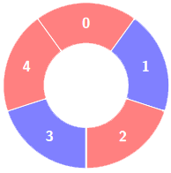
Alternating groups:
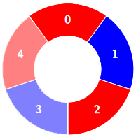
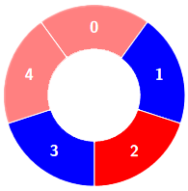
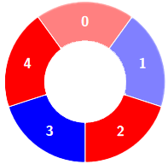

Example 2: | Explanation:
Input: colors = [0,1,0,0,1,0,1], k = 6  Output: 2 | 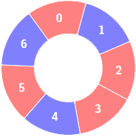
Alternating groups:
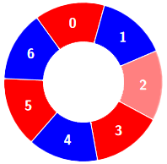
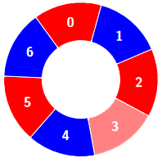

Example 3: | 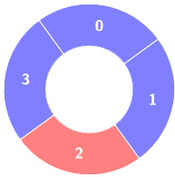  Explanation:
Input: colors = [1,1,0,1], k = 4
Output: 0

3208. Alternating Groups II
/*
Expand array+Dynamic sliding window
Time complexity: O(2n)
Space complexity:O(n)
*/

class Solution {
public:
int numberOfAlternatingGroups(std::vector<int>& colors, int k){
// Expand the given by the elements in range[0,k-2]
// to simulate the circularity
for(int i=0;i<k-1;++i) colors.push_back(colors[i]);
int n=colors.size();
int ans=0;
int i=0; // start of the window
int j=0; // end of the window

while(j<n-1){
// If the last tile in the actual window have the same
// color with the next tile
if(colors[j]==colors[j+1]){
// Start new window from the next tile
i=j+1;
j=i;
continue;
}
// Otherwise, expand the window
j++;
// If the length of the window reaches k
if(j-i+1==k){
ans++; // Count the current window in the answer
i++; // Shrink the window from the left
}
}
return ans;
}
};

3208. Alternating Groups II
/*
Circular array+Dynamic sliding window
Time complexity: O(2n)
Space complexity:O(1)
*/

class Solution {
public:
int numberOfAlternatingGroups(std::vector<int>& colors, int k){
int n=colors.size();
int ans=0;
int i = 0; // start of the window
int j = 0; // end of the window
// Expand the size to simulate circular array
while(j<n+k-2){
if(colors[j%n]==colors[(j+1)%n]){
i=j+1;
j=i;
continue;
}
j++;
if(j-i+1==k){
ans++;
i++;
}
}
return ans;
}
};

