3355. Zero Array Transformation I
You are given an integer array of length and a 2D array queries, where .
For each :
- Select a of indices within the range in .
- Decrement the values at the selected indices by .
A Zero Array is an array where all elements are equal to.
Return if it is possible to transform into a Zero Array after processing all the queries sequentially, otherwise return .
Example 1:
Input: ,
Output:
Explanation:
- For i = 0:
  - Select the subset of indices as and decrement the values at these indices by
  - The array will become , which is a Zero Array.
Example 2:
Input: ,
Output:
Explanation:
- For i = 0:
  - Select the subset of indices as and decrement the values at these indices by .
  - The array will become .
- For i = 1:
  - Select the subset of indices as and decrement the values at these indices by .
  - The array will become , which is not a Zero Array.

Constraints:

3355. Zero Array Transformation I
/*
Naive: Naively process the queries on the array
Time complexity: O(n.m) (TLE)
Space complexity: O(1)
*/
class Solution {
public:
bool isZeroArray(vector<int>& nums, vector<vector<int>>& queries) {
//int n=nums.size();
//int m=queries.size();

// For each query
for(auto& query: queries){
int l=query[0];
int r=query[1];
int val=query[2];

// Run over the array in range [l,r]
for(int i=l;i<=r;++i){
// if the current element is already equal to zero, pass to next
if(nums[i]==0) continue;

// Otherwise, decrement 1 from the current element
nums[i]--;
}
}

// After processing all queries, check il all elements in the given array
// are transformed to zero or not
for(auto& e: nums){
// If at least one element is not equal to zero, return false
if(e!=0) return false;
}

// If all elements are equal to zero
return true;
}
};

3355. Zero Array Transformation I

Difference array technique
It is a simple technique that can give you an end array after performing range queries of the form .
NOTE: means add to all the elements in an array within the range to . .

Difference array stores all the differences between the two elements

Lemma: The difference array work on a simple technique that when you add something to a range in an array the difference between two elements remains the same except for the boundary of the range.
Proof

Performing on :

so, difference array will be:

We have proved that updating from to by , is the same by updating the difference array at by and at by

Restoring final array after updates

….

3355. Zero Array Transformation I
/*
Difference array
Time complexity: O(n+m+n)=O(n+m)
Space complexity: O(n)
*/
class Solution {
public:
bool isZeroArray(std::vector<int>& nums, std::vector<std::vector<int>>& queries) {
int n=nums.size();
//int m=queries.size();
// Create the difference of size (n+1)
std::vector<int> diff(n+1,0);
// For each query
for(auto& query: queries){
int l=query[0];
int r=query[1];
int val=query[2];
// Update the difference array
diff[l]++;
diff[r+1]--;
}
// After processing all queries, check il all elements in the given array
// are transformed to zero or not
int pre=0;
for(int i=0;i<n;++i){
// pre=sum of all values in range[0,i] to decrement from nums[i]
pre+=diff[i];
// If at least one element is not equal to zero, return false
if(nums[i]-pre>0) return false;
}
// If all elements are equal to zero
return true;
}
};

3356. Zero Array Transformation II
You are given an integer array of length n and a 2D array s where.
Each represents the following action on :
- Decrement the value at each index in the range in by at most .
- The amount by which each value is decremented can be chosen independently for each index.
A Zero Array is an array with all its elements equal to .
Return the minimum possible non-negative value of , such that after processing the first queries in sequence, becomes a Zero Array. If no such exists, return .
Example 1:
Input: ,
Output:
Explanation:
- For i = 0 (l = 0, r = 2, val = 1):
  - Decrement values at indices [0, 1, 2] by [1, 0, 1] respectively.
  - The array will become [1, 0, 1].
- For i = 1 (l = 0, r = 2, val = 1):
  - Decrement values at indices [0, 1, 2] by [1, 0, 1] respectively.
  - The array will become [0, 0, 0], which is a Zero Array. Therefore, the minimum value of k is 2.
Example 2:
Input: ,
Output: -1
Explanation:
- For i = 0 (l = 1, r = 3, val = 2):
  - Decrement values at indices [1, 2, 3] by [2, 2, 1] respectively.
  - The array will become [4, 1, 0, 0].
- For i = 1 (l = 0, r = 2, val = 1):
  - Decrement values at indices [0, 1, 2] by [1, 1, 0] respectively.
  - The array will become [3, 0, 0, 0], which is not a Zero Array.
Constraints:

Overview
We are given an integer array nums of length n, and a list of queries that are each in the form [left, right, val]. For a given range [left, right], we can decrease each element in that range by at most val. Our task is to determine the earliest query that allows us to turn nums into an array of all zeroes. If it's not possible, we return -1.
We can look at an example of the queries being processed:

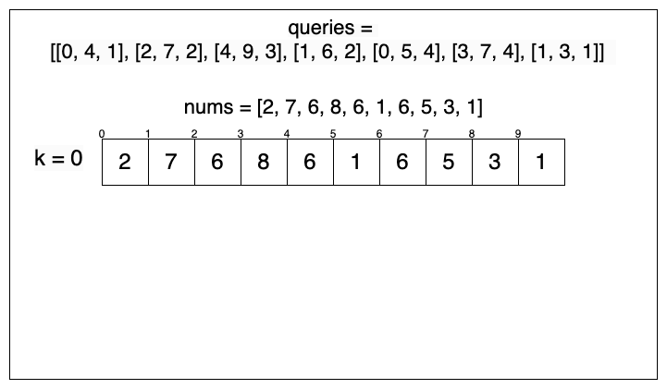

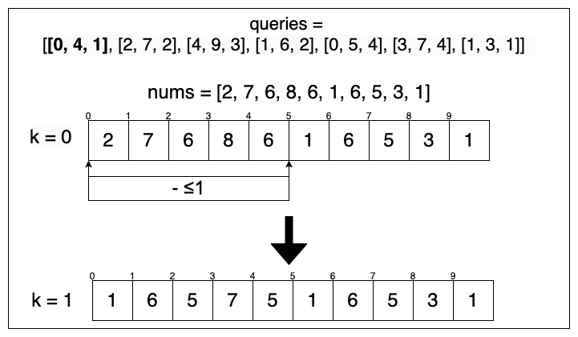
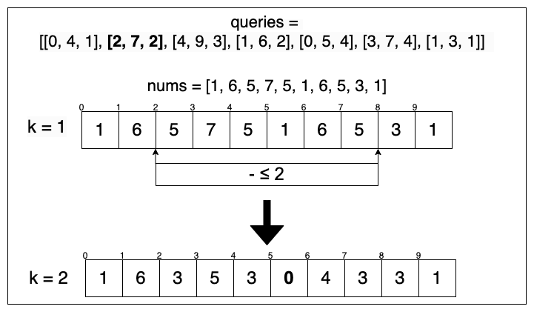

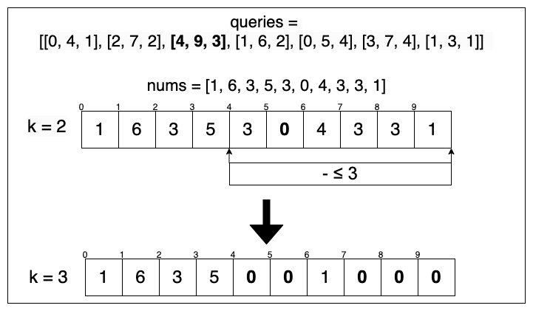
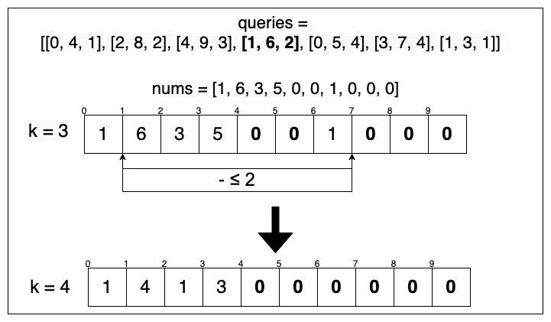

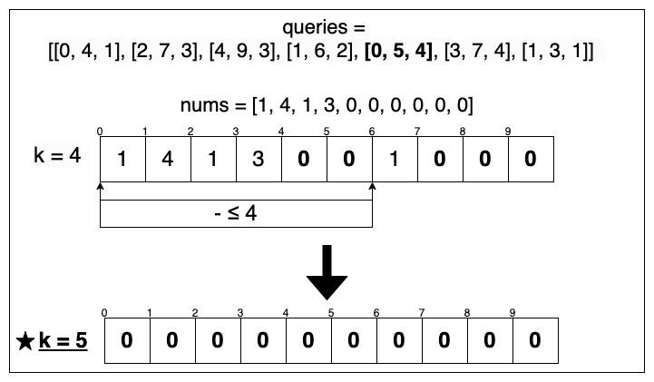
From this example, we can see that there are two main operations that will occur:
- Iterating through each element in queries.
- Applying the range and value of each query to nums.

3356. Zero Array Transformation II
/*
Brute force: Naively process the queries
Time complexity: O(n+2.m.n) (TLE)
Space complexity: O(1)
*/
class Solution {
public:
int minZeroArray(std::vector<int>& nums, std::vector<std::vector<int>>& queries){
int n=nums.size();
int m=queries.size();
// Check if an array is a zero array or not
auto is_zero_array=[&]()->bool{
for(auto& e: nums){
if(e!=0) return false;
}
return true;
};
if(is_zero_array()) return 0;
int k=0; // Minimum number of queries to process to transform all elements of the array to zero
// For each query
for(auto& query: queries){
int l=query[0];
int r=query[1];
int max_val=query[2];
// Perform the current query on the given array
for(int i=l;i<=r;++i) nums[i]=std::max(nums[i]-val,0);
// Query is performed, add it to the answer
k++;
// After processing the current query,if the array become a zero array,
//return the number of queries k and stop
if(is_zero_array()) return k;
}
// If all queries are performed, but the array is not transformed to zeros
return -1;
}
};

3356. Zero Array Transformation II

Difference array
To optimize the above solution, we need a more efficient way to apply queries to . Instead of modifying each element individually, we can take advantage of a difference array. This technique allows us to apply a range update in constant time. The key idea is to store the changes at the boundaries of the range rather than updating every element inside it. For a query , we add at index , and subtract at index . When we later compute the prefix sum of this difference array, it reconstructs the actual values efficiently. This way, instead of updating repeatedly, we can process all queries in an optimized manner and then traverse just once to check if all elements have become zero.
Let's look at how the difference array can be applied to this problem:
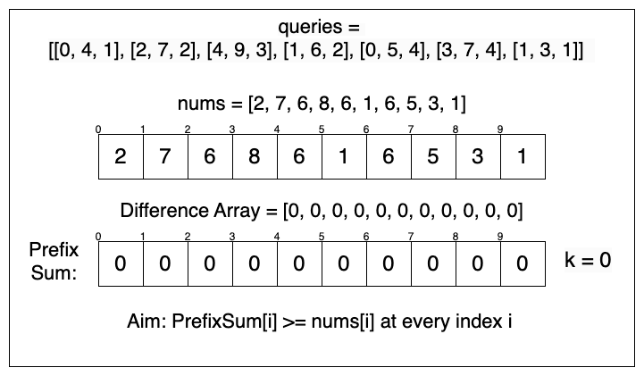

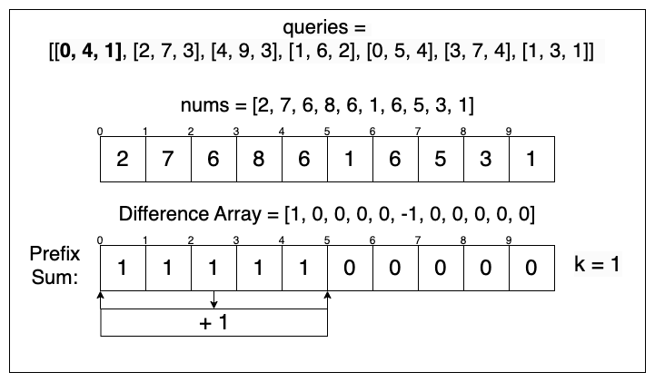
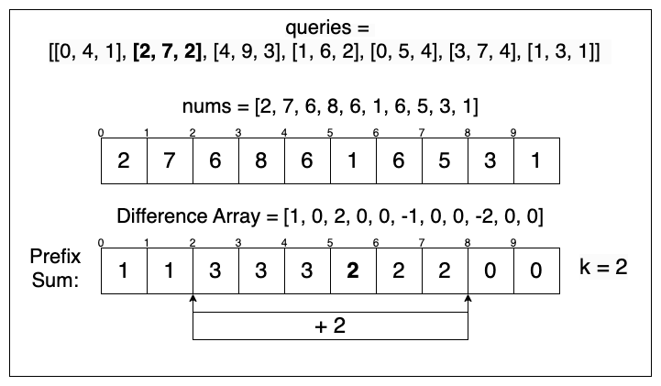

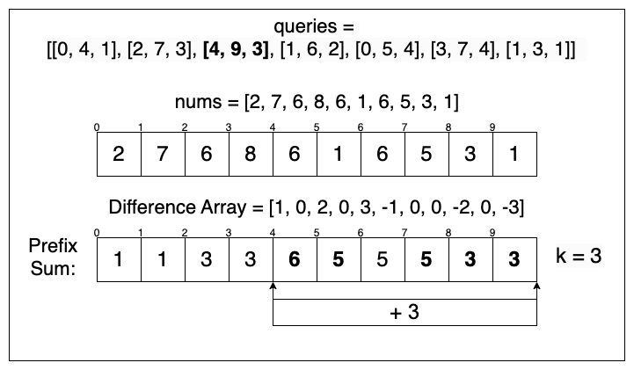
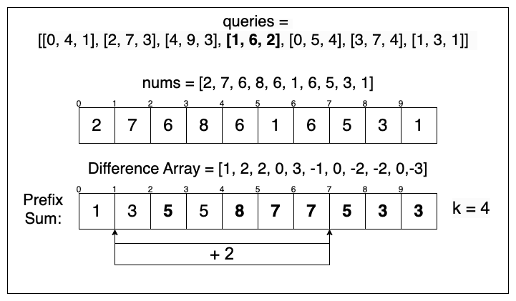

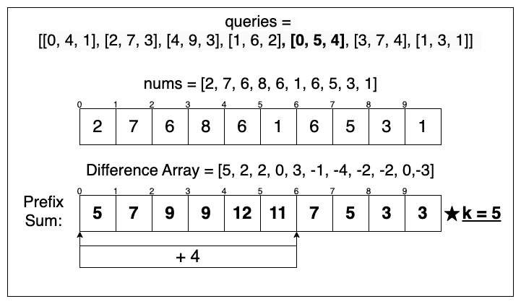

3356. Zero Array Transformation II
/*
Binary search on difference arrays
Time complexity: O(m+log m . (m+n))
Space complexity: O(n)
*/
class Solution {
public:
int minZeroArray(std::vector<int>& nums, std::vector<std::vector<int>>& queries){
int n=nums.size();
int m=queries.size();
// Check if it is possible to obtain a zero array after processing k queries
auto is_possible=[&](int k)->bool{
// Create difference array
std::vector<int> diff(n+1,0);
for(int i=0;i<k;++i){
int l=queries[i][0];
int r=queries[i][1];
int val=queries[i][2];
// Update difference array
diff[l]+=val;
diff[r+1]-=val;
}
// After processing all queries, check il all elements in the given array
// are transformed to zero or not
int pre=0;
for(int i=0;i<n;++i){
// pre=sum of all values in range[0,i] to decrement from nums[i]
pre+=diff[i];

// If at least one element is not equal to zero, return false
if(nums[i]-pre>0) return false;
}
// If all elements are equal to zero
return true;
};

// If is not possible to transform the array to a zero array after performing all the queries
if(!is_possible(m)) return -1;

// If it is possible to transform the array to a zero array after performing all the queries
// determine the minimum number of queries to achieve that:

// Do a binary search on the queries
// return the first met where is possible to transform the array to a zero array
int lo=0,hi=m-1;
while(lo<=hi){
int k=(lo+hi)>>1;
if(is_possible(k)) hi=k-1;
else lo=k+1;
}
return lo;
}
};

3355. Zero Array Transformation I
/*
Line sweep + Difference array: apply only the necessary queries at the right moment.
Time complexity: O(n+m+n)=O(n+m)
Space complexity: O(n)
*/
class Solution {
public:
bool isZeroArray(std::vector<int>& nums, std::vector<std::vector<int>>& queries) {
int n=nums.size();
int m=queries.size();
// Create the difference of size (n+1)
std::vector<int> diff(n+1,0);
int pre=0; // Prefix sum of difference array
int query=0; // Number of the current query
// For each element in the given array
for(int i=0;i<n;++i){
// While the current element in not zero
while(nums[i]-(pre+diff[i])>0){
query++; // Perform the current query
// If we have performed all queries
if(query>m) return false;
// Get range
int l=queries[query-1][0];
int r=queries[query-1][1];
// If the index of the current element is the range
if(i<=r){
diff[std::max(i,l)]++; // Update the start of the range
diff[r+1]--;
}
}
// Update the prefix sum at current index
pre+=diff[i];
}
// The original array transformed to a zero array
return true;
}
};

3356. Zero Array Transformation II
/*
Line sweep technique: apply only the necessary queries at the right moment.
Time complexity: O(n+m)
Space complexity: O(n)
*/
class Solution {
public:
int minZeroArray(std::vector<int>& nums, std::vector<std::vector<int>>& queries){
int n=nums.size();
int m=queries.size();

std::vector<int> diff(n+1,0);

int pre=0,k=0;

for(int i=0;i<n;++i){
while(nums[i]-(pre+diff[i])>0){
k++;

if(k>m) return -1;

int l=queries[k-1][0];
int r=queries[k-1][1];
int val=queries[k-1][2];

if(i<=r){
diff[std::max(i,l)]+=val;
diff[r+1]-=val;
}
}
pre+=diff[i];
}

return k;
}
};

