1261. Find Elements in a Contaminated Binary Tree
Given a binary tree with the following rules:
- root.val == 0
- For any treeNode:
  - If treeNode.val has a value x and treeNode.left != null, then treeNode.left.val == 2 * x + 1
  - If treeNode.val has a value x and treeNode.right != null, then treeNode.right.val == 2 * x + 2
Now the binary tree is contaminated, which means all treeNode.val have been changed to -1.
Implement the FindElements class:
- FindElements(TreeNode* root) Initializes the object with a contaminated binary tree and recovers it.
- bool find(int target) Returns true if the target value exists in the recovered binary tree.
Example 1:
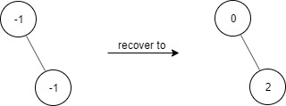 | Input  ["FindElements","find","find"]  [[[-1,null,-1]],[1],[2]]  Output  [null,false,true]  Explanation  FindElements findElements = new FindElements([-1,null,-1]);  findElements.find(1); // return False  findElements.find(2); // return True
Example 2:
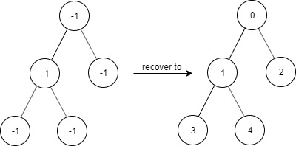 | Input  ["FindElements","find","find","find"]  [[[-1,-1,-1,-1,-1]],[1],[3],[5]]  Output  [null,true,true,false]  Explanation  FindElements findElements = new FindElements([-1,-1,-1,-1,-1]);  findElements.find(1); // return True  findElements.find(3); // return True  findElements.find(5); // return False

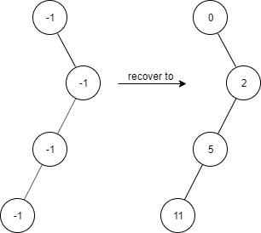 | Input  ["FindElements","find","find","find","find"]  [[[-1,null,-1,-1,null,-1]],[2],[3],[4],[5]]  Output  [null,true,false,false,true]  Explanation  FindElements findElements = new FindElements([-1,null,-1,-1,null,-1]);  findElements.find(2); // return True  findElements.find(3); // return False  findElements.find(4); // return False  findElements.find(5); // return True
Constraints:
- TreeNode.val == -1
- The height of the binary tree is less than or equal to 20
- The total number of nodes is between [1, 104]
- Total calls of find() is between [1, 104]
- 0 <= target <= 106

Overview
We are given a binary tree which follows the following rules:
- The value of the root node is always
- Given a node in the tree with value, the value of its left child (if it exists) is always
- Given a node in the tree with value, the value of its right child (if it exists) is always
This tree is then "contaminated", which means the values of all nodes are overwritten to. We now have to find out what values existed in the tree before it was contaminated. We do this by implementing two functions:
- is our constructor that gives us the contaminated binary tree, and recovers the tree.
- should return whether or notis one of the original values inbefore contamination

1261. Find Elements in a Contaminated Binary Tree
/*
DFS preorder traversal
*/
/**
* Definition for a binary tree node.
* struct TreeNode {
* int val;
* TreeNode *left;
* TreeNode *right;
* TreeNode() : val(0), left(nullptr), right(nullptr) {}
* TreeNode(int x) : val(x), left(nullptr), right(nullptr) {}
* TreeNode(int x, TreeNode *left, TreeNode *right) : val(x), left(left), right(right) {}
* };
*/
class FindElements {
private:
std::unordered_set<int> values;
public:
// Time complexity: O(n)
// Space complexity: O(2n)
FindElements(TreeNode* root) {
auto dfs=[&](TreeNode* node,int val,auto& self)->void{
if(!node) return;
node->val=val;
values.insert(val);
self(node->left,2*node->val+1,self);
self(node->right,2*node->val+2,self);
};
dfs(root,0,dfs);
}

// Time complexity: Ω(1),O(n)
// Space complexity: O(1)
bool find(int target) {
return values.find(target)!=values.end();
}
};
/**
* Your FindElements object will be instantiated and called as such:
* FindElements* obj = new FindElements(root);
* bool param_1 = obj->find(target);
*/

1261. Find Elements in a Contaminated Binary Tree
/*
BFS
*/
/**
* Definition for a binary tree node.
* struct TreeNode {
* int val;
* TreeNode *left;
* TreeNode *right;
* TreeNode() : val(0), left(nullptr), right(nullptr) {}
* TreeNode(int x) : val(x), left(nullptr), right(nullptr) {}
* TreeNode(int x, TreeNode *left, TreeNode *right) : val(x), left(left), right(right) {}
* };
*/
class FindElements {
private:
std::unordered_set<int> values;
public:
// Time complexity: O(n)
// Space complexity: O(3n)
FindElements(TreeNode* root) {
auto bfs=[&](TreeNode* node)->void{
std::queue<std::pair<TreeNode*,int>> q;
q.push({root,0});
while(!q.empty()){
auto [node,node_val]=q.front();
q.pop();
node->val=node_val;
values.insert(node_val);
if(node->left) q.push({node->left,2*node_val+1});
if(node->right) q.push({node->right,2*node_val+2});
}
};
bfs(root);
}

// Time complexity: Ω(1),O(n)
// Space complexity: O(1)
bool find(int target) {
return values.find(target)!=values.end();
}
};

/**
* Your FindElements object will be instantiated and called as such:
* FindElements* obj = new FindElements(root);
* bool param_1 = obj->find(target);
*/

