1028. Recover a Tree From Preorder Traversal
We run a preorder depth-first search (DFS) on the root of a binary tree.
At each node in this traversal, we output D dashes (where D is the depth of this node), then we output the value of this node. If the depth of a node is D, the depth of its immediate child is D + 1. The depth of the root node is 0.
If a node has only one child, that child is guaranteed to be the left child.
Given the output traversal of this traversal, recover the tree and return its root.
Example 1:
Input: traversal = "1-2--3--4-5--6--7" | Output: [1,2,5,3,4,6,7]  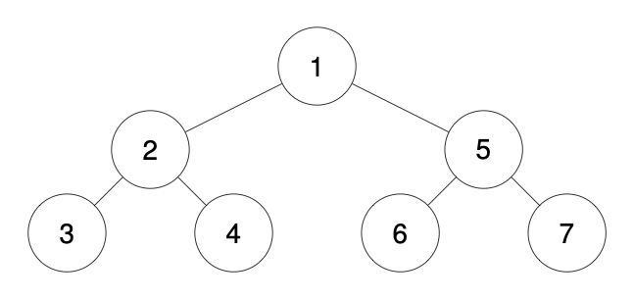
Example 2:
Input: traversal = "1-2--3---4-5--6---7" | Output: [1,2,5,3,null,6,null,4,null,7]  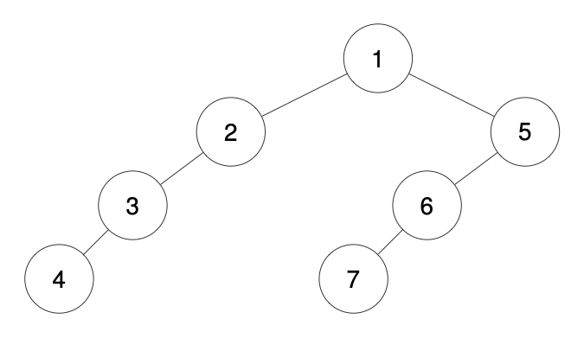

Input: traversal = "1-401--349---90--88" | Output: [1,401,null,349,88,90]  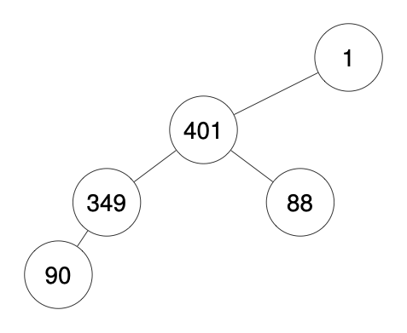
Constraints:
- The number of nodes in the original tree is in the range [1, 1000].
- 1 <= Node.val <= 109

Overview
We are given a string representation of a preorder traversal of a binary tree, where each node is represented as dashes followed by its value. The number of dashes indicates the depth of the node in the tree, with the root having depth . Each node may have one or two children, and if a node has only one child, it is always the left child. Our task is to reconstruct the original binary tree from this traversal string.
Since preorder traversal follows the root → left → right order, we process the nodes in sequence and assign them to their correct positions.
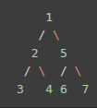
For example, given traversal = "1-2--3--4-5--6--7", we can break it down as follows:
1 (Root)  |- 2 (Depth 1, Left child of 1)  | |- 3 (Depth 2, Left child of 2)  | |- 4 (Depth 2, Right child of 2)  |- 5 (Depth 1, Right child of 1)  |- 6 (Depth 2, Left child of 5)  |- 7 (Depth 2, Right child of 5) | This means the tree structure is:  The output should be:[1, 2, 5, 3, 4, 6, 7].

Regardless of the approach, the core idea is the same: When we encounter a new node, we determine its depth. We find the next node at depth + 1 and attach current subtree root node to the new node. Then we ensure that the first child assigned to a parent is the left child, and the second (if present) is the right child.
/**
* Definition for a binary tree node.
* struct TreeNode {
* int val;
* TreeNode *left;
* TreeNode *right;
* TreeNode() : val(0), left(nullptr), right(nullptr) {}
* TreeNode(int x) : val(x), left(nullptr), right(nullptr) {}
* TreeNode(int x, TreeNode *left, TreeNode *right) : val(x), left(left), right(right) {}
* };
*/

1028. Recover a Tree From Preorder Traversal
/*
Preorder: With processing the traversal string
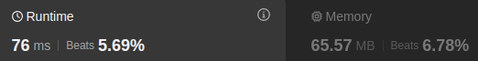
Time complexity:
Space complexity:
n: #nodes
*/
typedef std::vector<int> vi;
class Solution {
public:
// Process on the travsersal string
// We get an array values contains node values, and depths, where depths[i]
// contains the depths of values[i]
// traversal="1-401--349---90--88"
// values= { 88, 90, 349, 401, 1}
// depths { 2, 3, 2, 1, 0}
void process_input(std::string& traversal,vi& values,vi& depths){
traversal="-"+traversal;
int m=traversal.size();
int s=m-1,e=m-1;
while(s>0){
while(s>0 && traversal[s]!='-') s--;

values.push_back(std::stoi(traversal.substr(s+1,e)));

int depth=0;
while(s>0 && traversal[s]=='-'){
s--;
depth++;
}

depths.push_back(depth);

e=s;
}
}

TreeNode* recoverFromPreorder(std::string traversal){
// process node values and depths each in separate arrays
vi values,depths;
process_input(traversal,values,depths);

int n=values.size();
int i=n-1; // Root is at the end of the values array

// Recursive function to recover array from values and depths array in preoder traversal
// Because nodes appear before their children in preorder,
// we can sequentially assign them to their parents without needing to look ahead or
// backtrack significantly.
auto recover_tree=[&](TreeNode*& cur_node, int cur_depth,auto& self)->void{
// i<0: If we are at the end of the values or
// depths[i]!=cur_depth: The node at i does not belong to the current subtree
// rooted by cur_node.
// This ensures that we only create nodes that belong to the expected depth.
if(i<0 || depths[i]!=cur_depth) return;

// If the node belongs to the current subtree

cur_node=new TreeNode(values[i]); // Create the current node

i--; // Move to the next node in preorder sequence

// Start by creating the left subtree if the next node in preorder sequence has a depth
// greater than the current node by 1
if(i>=0 && depths[i]==cur_depth+1) self(cur_node->left,cur_depth+1,self);

// Otherwise, Create the right subtree
// or keep moving UP until finding the correct depth, and create the right subtree
self(cur_node->right,cur_depth+1,self);

};

TreeNode* root=nullptr;
recover_tree(root,0,recover_tree);
return root;
}
};

1028. Recover a Tree From Preorder Traversal
/*
Preorder: Without processing the traversal string
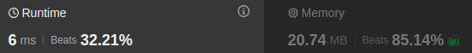
Time compelxity: O(n)
Space compelxity: O(n)
n: #nodes
*/
typedef std::vector<int> vi;
class Solution {
public:
TreeNode* recoverFromPreorder(std::string traversal){
int m=traversal.size();
int i=0;
// Recusive function to recover array from values and depths array in prepder traversal
auto recover_tree=[&](TreeNode*& cur_node, int cur_depth,auto& self)->void{
if(i>=m) return ;
// Extract the node depth
int depth=0;
while(i+depth<m && traversal[i+depth]=='-') depth++;
// depth od the node!=cur_depth: The node does not belong to the current
//subtree rooted by cur_node.
// This ensures that we only create nodes that belong to the expected depth.
if(depth!=cur_depth) return;
// Move index past the dashes
i+=depth;
// Extract the node value
int value=0;
while(i<m && traversal[i]!='-'){
value=value*10+(traversal[i]-'0');
i++;
}
cur_node=new TreeNode(value); // Create the current node
// Start by creating the left subtree
self(cur_node->left,cur_depth+1,self);
// Otherwise, keep moving UP until finding the correct depth, and create the right subtree
self(cur_node->right,cur_depth+1,self);
};
TreeNode* root=nullptr;
recover_tree(root,0,recover_tree);
return root;
}
};

