2349. Design a Number Container System
Design a number container system that can do the following:
- Insert or Replace a number at the given index in the system.
- Return the smallest index for the given number in the system.
Implement the NumberContainers class:
- NumberContainers() Initializes the number container system.
- void change(int index, int number) Fills the container at index with the number. If there is already a number at that index, replace it.
- int find(int number) Returns the smallest index for the given number, or -1 if there is no index that is filled by number in the system.

Example 1:
Input
["NumberContainers", "find", "change", "change", "change", "change", "find", "change", "find"]
[[], [10], [2, 10], [1, 10], [3, 10], [5, 10], [10], [1, 20], [10]]
Output
[null, -1, null, null, null, null, 1, null, 2]

Explanation
NumberContainers nc = new NumberContainers();
nc.find(10); // There is no index that is filled with number 10. Therefore, we return -1.
nc.change(2, 10); // Your container at index 2 will be filled with number 10.
nc.change(1, 10); // Your container at index 1 will be filled with number 10.
nc.change(3, 10); // Your container at index 3 will be filled with number 10.
nc.change(5, 10); // Your container at index 5 will be filled with number 10.
nc.find(10); // Number 10 is at the indices 1, 2, 3, and 5. Since the smallest index that is filled with 10 is 1, we return 1.
nc.change(1, 20); // Your container at index 1 will be filled with number 20. Note that index 1 was filled with 10 and then replaced with 20.
nc.find(10); // Number 10 is at the indices 2, 3, and 5. The smallest index that is filled with 10 is 2. Therefore, we return 2.

Constraints:
- 1 <= index, number <=
- At most calls will be made in total to change and find.

2349. Design a Number Container System

Overview
We need to design a number container system to efficiently manage and query numbers based on their indices. This system should support two primary operations:
- Inserting or Replacing a Number: We can insert a number at a specific index, or replace the number already present at that index.
- Finding the Smallest Index of a Number: We need to retrieve the smallest index where a given number is present. If the number doesn't exist in the system, we should return -1.
To achieve this, we need to implement a class NumberContainers with the following methods:
- NumberContainers(): Initializes the container system. This involves setting up the internal data structures to store the mappings between numbers and indices.
- void change(int index, int number): Updates the system by associating the given number with the provided index. If the index already contains a number, it should be replaced. If this operation introduces new data or modifies existing mappings, the system must ensure consistency for subsequent queries.
- int find(int number): Returns the smallest index where the specified number exists. If the number is not present, it returns -1.

Approach 1: Two Maps

Intuition
We need to focus on two main operations: change, which allows us to insert or replace a number at a specific index, and find, which retrieves the smallest index associated with a given number.
The key to implementing these operations efficiently lies in using map data structures:
- indexToNumber: This map holds the relationship between an index and the number currently stored at that index. It allows us to quickly check if an index already contains a number and enables efficient replacement during the change operation.
- numberToIndices: This map keeps track of the indices where each number is present. By using a set to store these indices, we ensure that they remain automatically sorted, enabling efficient insertion and retrieval of the smallest index for a number.
With these structures in mind, let’s break the solution into two parts: first, the change operation, and second, the find operation.

1. Change Operation (Insertion and Replacement)
The change operation begins by checking if the given index already holds a number. If the index does contain a number, we first remove this index from the set of indices associated with the old number in the numberToIndices map. This step ensures that the old number no longer references the index after the replacement. Once the index is removed, we check whether the set for the old number has become empty. If it has, we remove the old number entirely from the map to maintain a clean and efficient data structure.
After handling the removal, we proceed to insert the new number at the given index. This involves adding the index to the set of indices for the new number in numberToIndices. Because we are using a set, the indices remain sorted automatically, allowing us to avoid any additional effort to manage their order. This also prepares us for the find operation, where the smallest index will always be readily accessible.

2. Find Operation (Retrieve Smallest Index)
For the find operation, we need to return the smallest index that contains the given number. To achieve this, we check the numberToIndices map. If the number isn't found, we return -1, indicating that the number is not present. If the number exists, the smallest index will always be the first element in the set of indices (since sets store elements in ascending order). This allows us to quickly return the result with minimal effort.
The algorithm is visualized below:
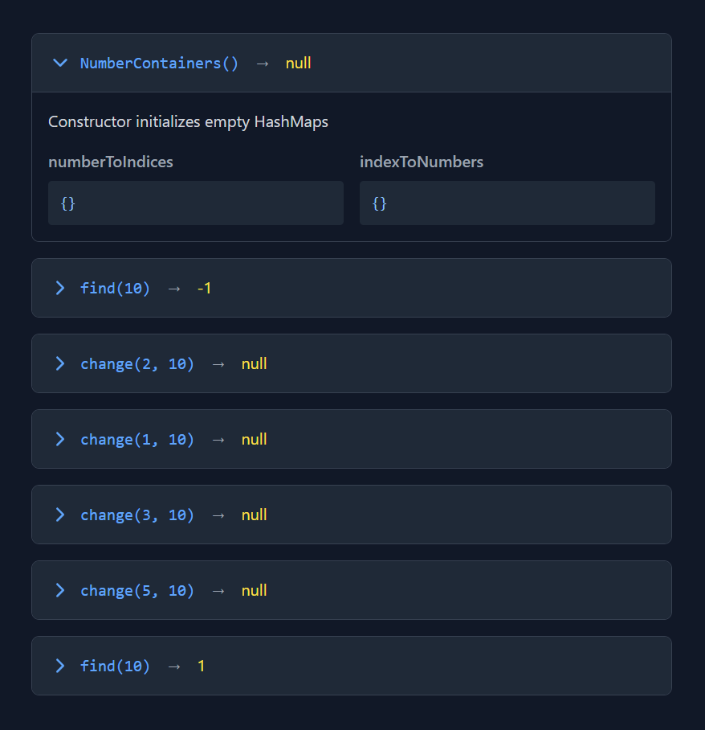

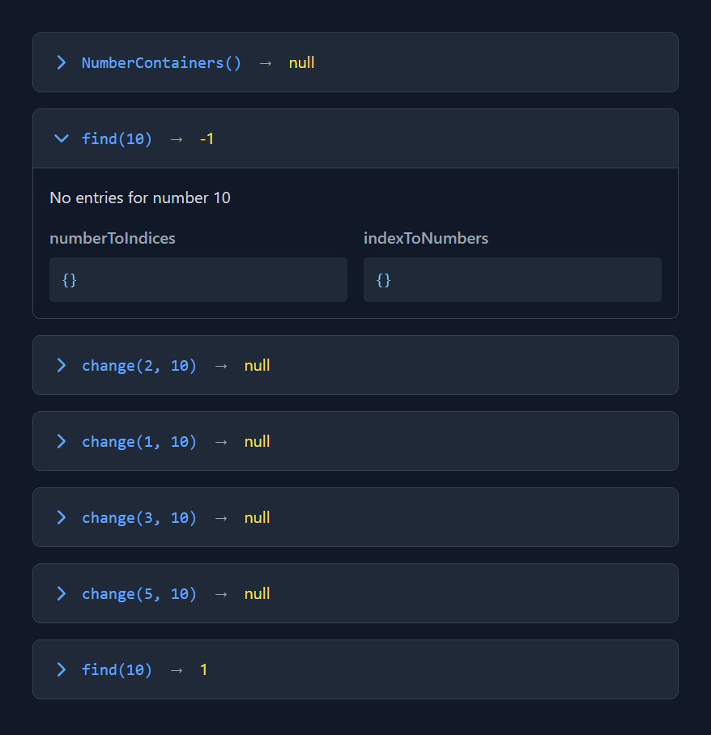

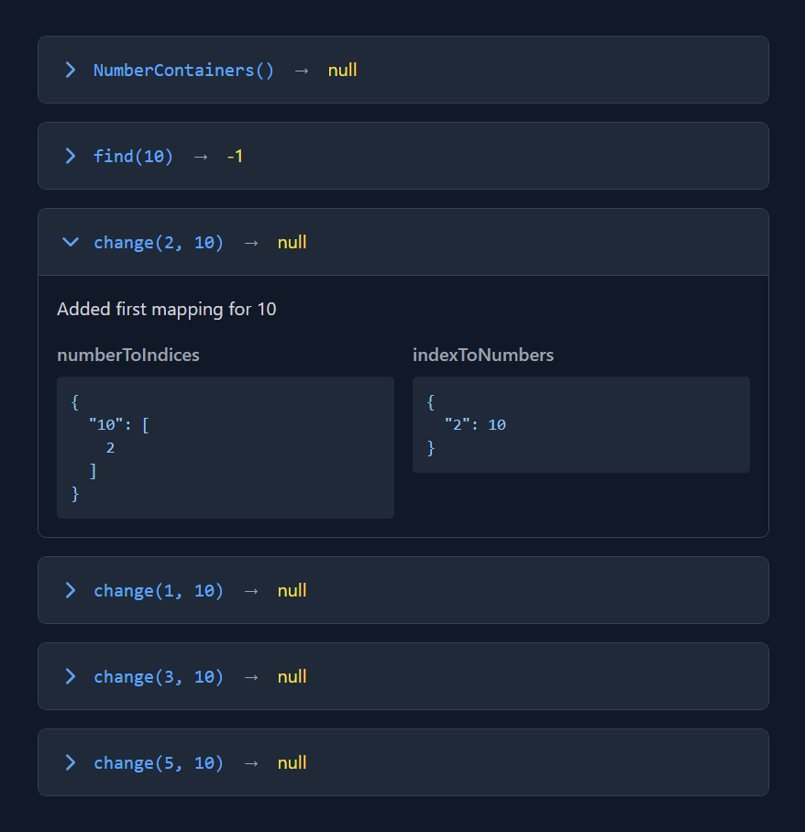

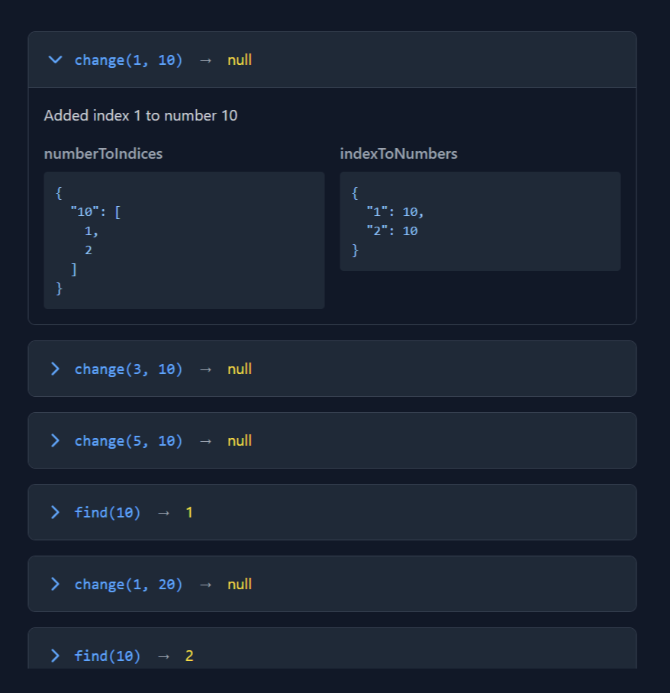

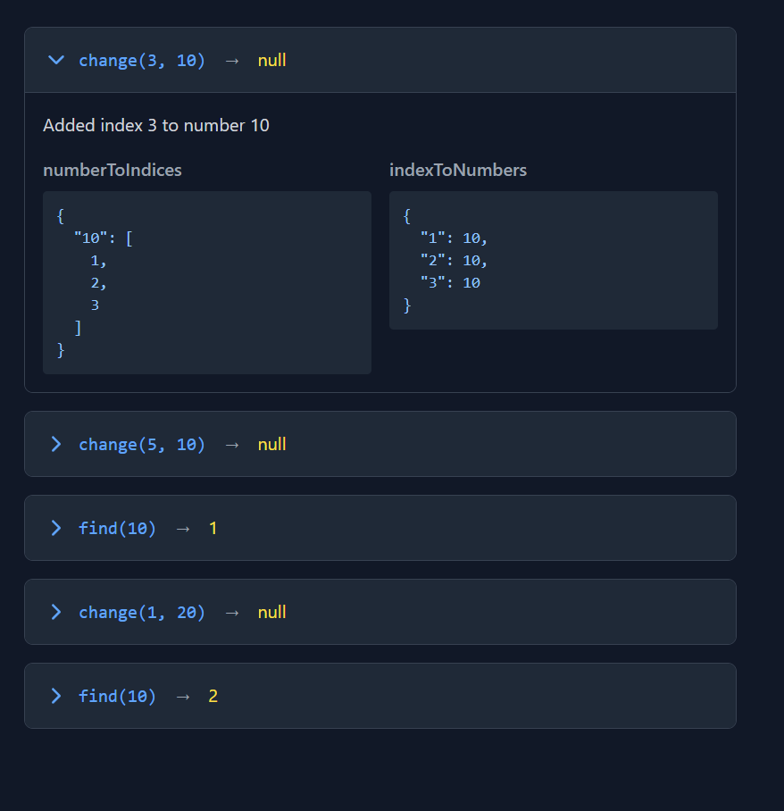

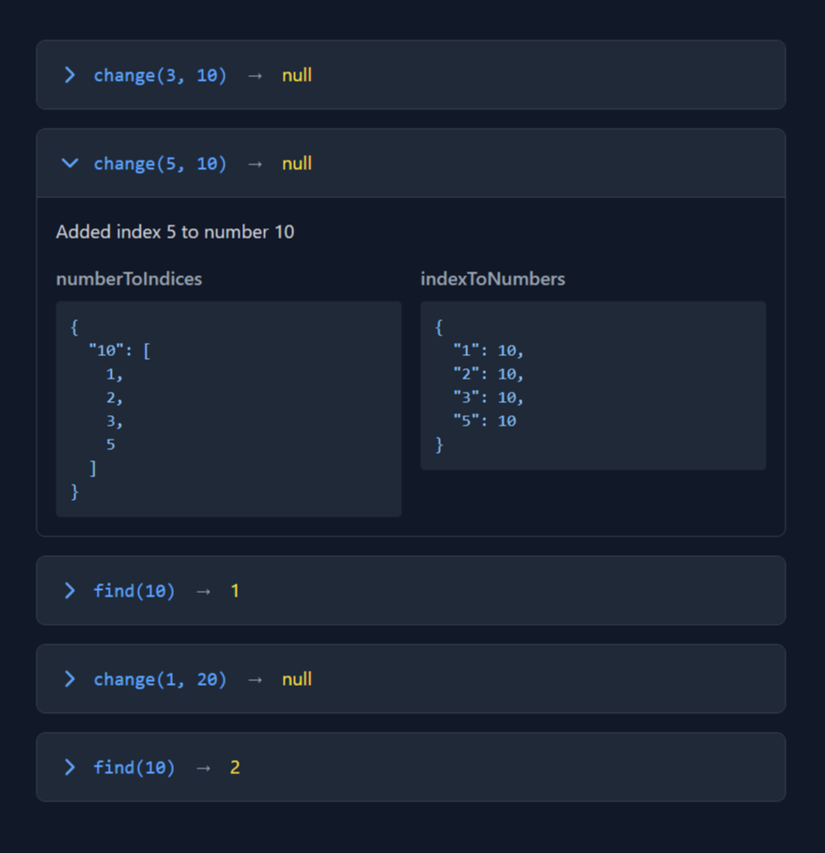

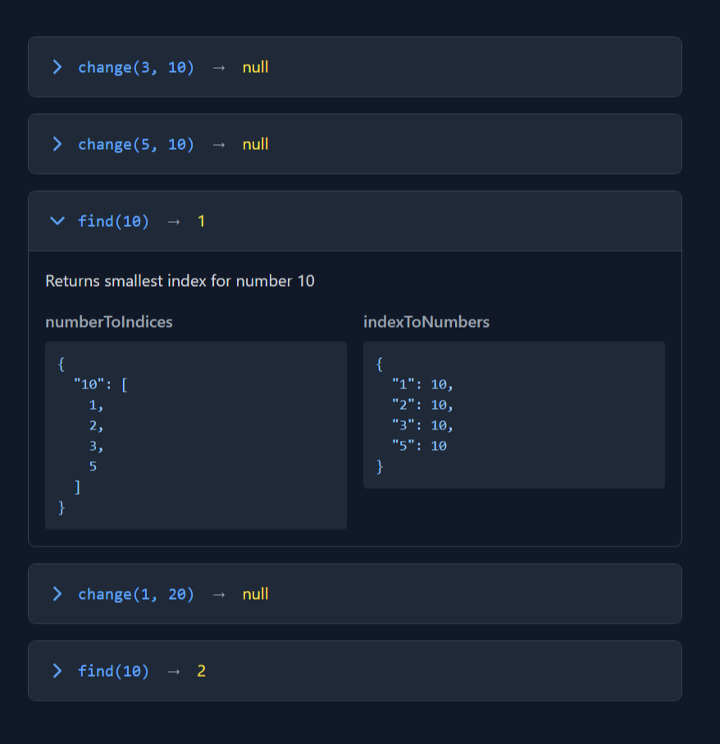

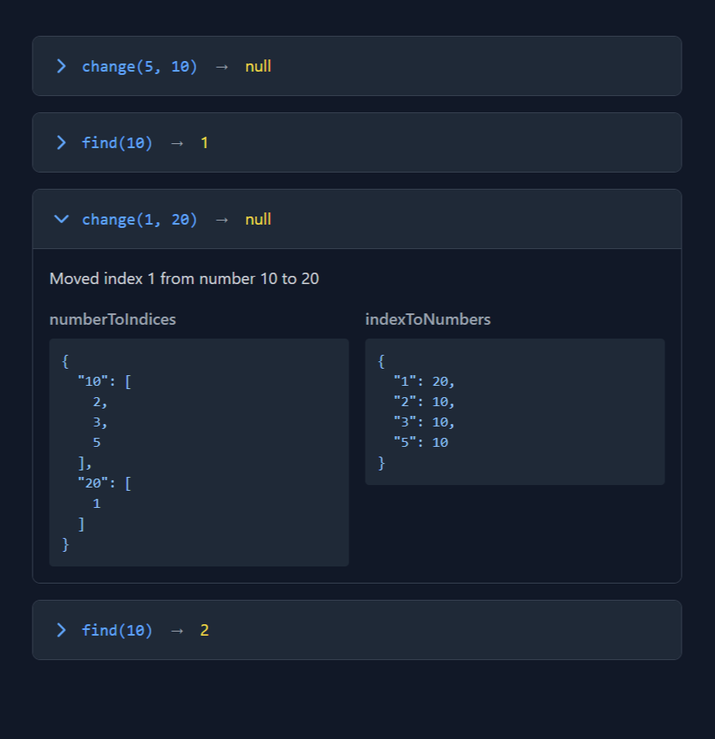

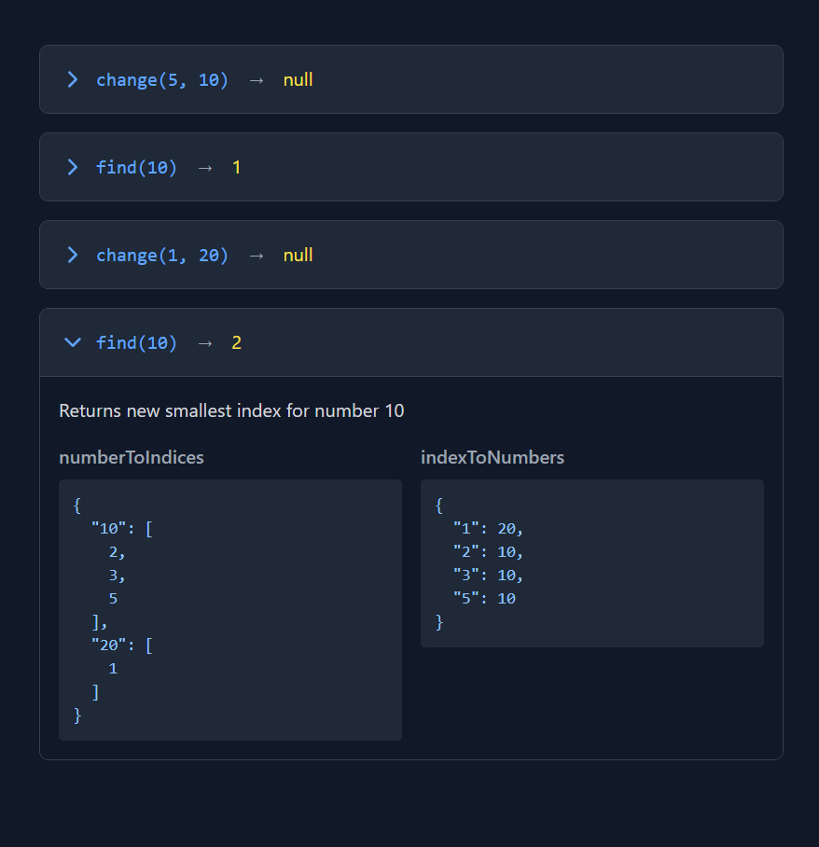

2349. Design a Number Container System
/*
Hash maps+ordered set
Time complexity:
***change(int,int): O(logn)
***find(int): O(1)
***overall: O(q.logn), q:#queries
Overall space complexity: O(n)
*/
class NumberContainers {
private:
std::unordered_map<int,std::set<int>> number_indexes;
std::unordered_map<int,int> index_number;

public:
NumberContainers() {

}
// O(logn)
void change(int index, int number) {
if(index_number.find(index)!=index_number.end()){
int old_number=index_number[index];
auto it=number_indexes[old_number].find(index);
if(it!=number_indexes[old_number].end()) number_indexes[old_number].erase(it);
}
index_number[index]=number;
number_indexes[number].insert(index);
}

// O(1)
int find(int number) {
return !number_indexes[number].empty()?*number_indexes[number].begin():-1;
}
};

