2698. Find the Punishment Number of an Integer
Given a positive integer n, return the punishment number of n.
The punishment number of n is defined as the sum of the squares of all integers i such that:
- 1 <= i <= n
- The decimal representation of i * i can be partitioned into contiguous substrings such that the sum of the integer values of these substrings equals i.

Example 1:
Input: n = 10
Output: 182
Explanation: There are exactly 3 integers i in the range [1, 10] that satisfy the conditions in the statement:
- 1 since 1 * 1 = 1
- 9 since 9 * 9 = 81 and 81 can be partitioned into 8 and 1 with a sum equal to 8 + 1 == 9.
- 10 since 10 * 10 = 100 and 100 can be partitioned into 10 and 0 with a sum equal to 10 + 0 == 10.
Hence, the punishment number of 10 is 1 + 81 + 100 = 182
Example 2:
Input: n = 37
Output: 1478
Explanation: There are exactly 4 integers i in the range [1, 37] that satisfy the conditions in the statement:
- 1 since 1 * 1 = 1.
- 9 since 9 * 9 = 81 and 81 can be partitioned into 8 + 1.
- 10 since 10 * 10 = 100 and 100 can be partitioned into 10 + 0.
- 36 since 36 * 36 = 1296 and 1296 can be partitioned into 1 + 29 + 6.
Hence, the punishment number of 37 is 1 + 81 + 100 + 1296 = 1478

Constraints:
- 1 <= n <= 1000

2698. Find the Punishment Number of an Integer

Overview
We are given a positive integer n, and our task is to return its punishment number.
The punishment number is the sum of the squares of all integers i that satisfy two conditions:
- Range: i must be within the range 1 <= i <= n.
- Partition: The decimal representation of i * i can be partitioned into contiguous substrings such that the sum of these substrings equals i.
In other words, for each integer in the range [1, n], we check whether the digits of its squared value can be split so that the resulting sum matches the original number.
Let's look at examples where the squared integer's digits can be partitioned as described:
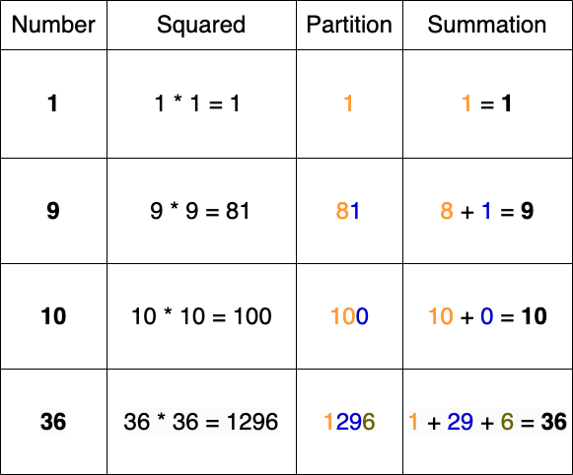

As we can see, multiple ways exist to split the digits of a squared integer, leading to different summations. Our goal is to find at least one valid partition for each integer in the given range and sum up the squares of all numbers that satisfy the condition.

2698. Find the Punishment Number of an Integer
/*
Recursion: find all combinations of non-overlapping substrings
// Time complexity:
// Space complexity:
*/
typedef std::vector<int> vi;
typedef std::vector<vi> vvi;
class Solution{
public:
int punishmentNumber(int n){
// Recursive function to get all possible partitions
// Time complexity:
// Space complexity:
auto solve=[&](std::string& s,int index,int target,auto& self)->bool{
if(index==s.size()) return target==0;
int sum=0;
for(int split=index;split<s.size();++split){
sum=sum*10+(s[split]-'0');
if(sum>target) return false;
if(self(s,split+1,target-sum,self)) return true;
}
return false;
};

int ans=0;
for(int i=1;i<=n;++i){
int sq=i*i;
std::string sq_str=std::to_string(sq);
// If a partition sum is equal to i, then and i*i to the answer
if(solve(sq_str,0,i,solve)) ans+=sq;
}
return ans;
}
};

