1752. Check if Array Is Sorted and Rotated
Given an array nums, return true if the array was originally sorted in non-decreasing order, then rotated some number of positions (including zero). Otherwise, return false.
There may be duplicates in the original array.
Note: An array A rotated by x positions results in an array B of the same length such that A[i] == B[(i+x) % A.length], where % is the modulo operation.

Example 1:
Input: nums = [3,4,5,1,2]
Output: true
Explanation: [1,2,3,4,5] is the original sorted array.
You can rotate the array by x = 3 positions to begin on the the element of value 3: [3,4,5,1,2].
Example 2:
Input: nums = [2,1,3,4]
Output: false
Explanation: There is no sorted array once rotated that can make nums.
Example 3:
Input: nums = [1,2,3]
Output: true
Explanation: [1,2,3] is the original sorted array.
You can rotate the array by x = 0 positions (i.e. no rotation) to make nums.

Constraints:
- 1 <= nums.length <= 100
- 1 <= nums[i] <= 100

Overview
We need to find whether the given integer array nums could represent a sorted array that has been rotated some number of times. A sorted array is defined as one arranged in non-decreasing order, meaning each element is less than or equal to the next. A rotation involves shifting a contiguous block of elements to the back of the array, preserving the relative order of all elements.
For example, [3, 4, 5, 1, 2] is a rotated version of the sorted array [1, 2, 3, 4, 5]. On the other hand, [3, 4, 2, 1, 5] is not a valid rotation of any sorted array because the order of elements is not preserved.

1752. Check if Array Is Sorted and Rotated
/*
Compare with sorted array
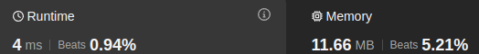
Time complexity: O(nlogn+n^2)
Space complexity: O(n+logn)
*/
class Solution {
public:
bool check(std::vector<int>& nums) {
int n=nums.size();
std::vector<int> sorted=nums;
std::sort(sorted.begin(),sorted.end());
for(int rot_index=0;rot_index<n;++rot_index){
int i=0;
while(i<n && nums[(rot_index+i)%n]==sorted[i]) i++;
if(i==n) return true;
}
return false;
}
};

1752. Check if Array Is Sorted and Rotated
/*
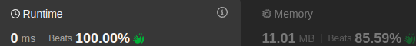
Counting bad pairs
Time complexity: O(n)
Space complexity: O(1)
*/
class Solution {
public:
bool check(std::vector<int>& nums) {
int n=nums.size();
int count=0;
for(int i=0;i<n-1;++i){
if(nums[i+1]<nums[i]) count++;
}
count+=nums[0]<nums[n-1];
return count<2;
}
};

