Conversational screening for driver hiring: process design

Conversational Screening for Driver Hiring: Process Design (short)
Grupo Sazón · Phase 1 · two-page version of phase-1-process-design.md
Defined terms: CONTEXT.md. Full detail: phase-1-detailed-spec.md.
A Screening Agent on WhatsApp replaces the first phone call. The Candidate taps a link and writes first. The agent ends ineligible Applications within two or three messages and hands Recruiters a structured, Qualified Application. People make every significant decision.

1. Conversation stages
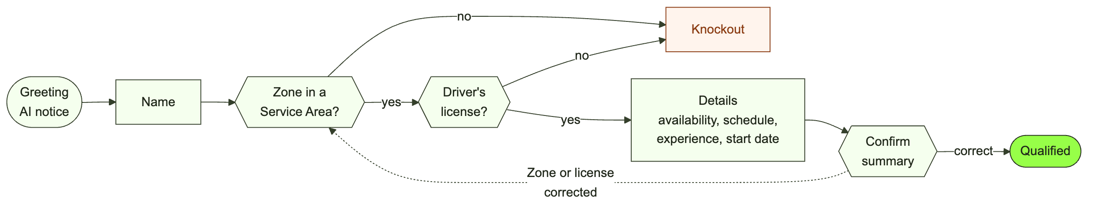
# | Stage | The agent | Branches
0 | Greeting | Says it is an AI assistant, links the privacy notice, asks for the name | A question first: answer briefly, then return
1 | Name | Collects the full name | Invalid: re-ask
2 | Zone | Matches the Zone against Service Areas | Outside all: Knockout. Ambiguous: offer options
3 | License | Asks yes/no | No: Knockout
4-7 | Details | Availability, preferred schedule, experience, start date | None
8 | Confirm | One-message summary, "¿Es correcto?" | Correction: update and re-check; a Zone or license change can Knockout
9 | Qualified | Explains next steps | A Recruiter's Approval, then the Candidate books an Interview in the chat
- One question per message. If the Candidate answers several at once, the agent captures all and skips ahead.
- Knockout checks (2, 3) run before the details, so ineligible Applications end early.
- Every answer is saved as it arrives, so the chat resumes at the last unanswered question.
- At any stage the Candidate can withdraw (Withdrawn) or ask us to stop messaging (Opted out).

2. Agent personality
Grupo Sazón's hiring assistant under a client-chosen name. Warm, quick and practical: a friendly shift manager, not an HR department. It uses tú and local vocabulary (Spain "carnet de conducir"; Mexico "licencia de manejo"), and says it is an AI whenever asked. It never promises a job, pay or start date; gives legal advice; asks about age, nationality, health, family or any protected attribute; or names Criba (every human is "the Grupo Sazón team").

3. Data fields and validation
Field | Stored as | Valid when | If invalid or ambiguous
Full name | text | 2+ words, letters, accents, hyphens | "¿Me dices tu nombre y apellido?"
Zone | zone_id; country from +34 / +52 | Inside at least one Service Area | "Centro" matches several: up to 3 buttons. Outside all: Knockout
Driver's license | yes/no | A clear yes or no | "Expired", "getting it soon" count as No, invited back
Availability | full-time, part-time, weekends | At least one | Reply buttons
Preferred schedule | morning, afternoon, evening, flexible | At least one | List message
Experience | years >= 0; platform if > 0 | "6 meses" becomes 0.5 | Informational, never a filter
Start date | ISO date | Today or later; "mañana" resolved locally | More than 60 days out: accepted, flagged
Answers are stored as canonical values in either language. Fixed choices use WhatsApp buttons (up to 3) and lists (up to 10), which cut invalid answers.

4. Edge cases
Candidate stops responding. Free-form messages are allowed for 24 hours after the Candidate's last message, then only approved templates. The Application is Stalled while nudges run, at most 3, none in quiet hours (22:00-09:00 local) or to an Opted-out Candidate:
Silent for | 1 hour | 20 hours | 48 hours | 7 days
Action | Nudge repeating the pending question | Last free-form nudge | Approved template | Abandoned, no message
A reply within 30 days reopens the Application at the pending question; later, a new Application starts.
Invalid or ambiguous answers. (1) Re-ask with an example, without blame. (2) Switch to buttons or a list. (3) Raise an Escalation so a Recruiter can take over, while the agent stays friendly. Off-topic questions get one line from client-approved FAQ content, then the pending question; with no approved answer, the agent escalates. Voice notes and images: v1 asks for text.
Spanish <-> English. The agent replies in the language of the Candidate's latest message. Switching never restarts the flow, and answers already given are kept. Any other language gets a Spanish reply with one English line offering both. Templates exist in es-ES, es-MX and en.
Exits. "No longer interested": confirm once, Withdrawn. "Stop messaging me": Opted out. "Delete my data": log an Erasure request, handled outside the chat.

5. Qualified and disqualified paths
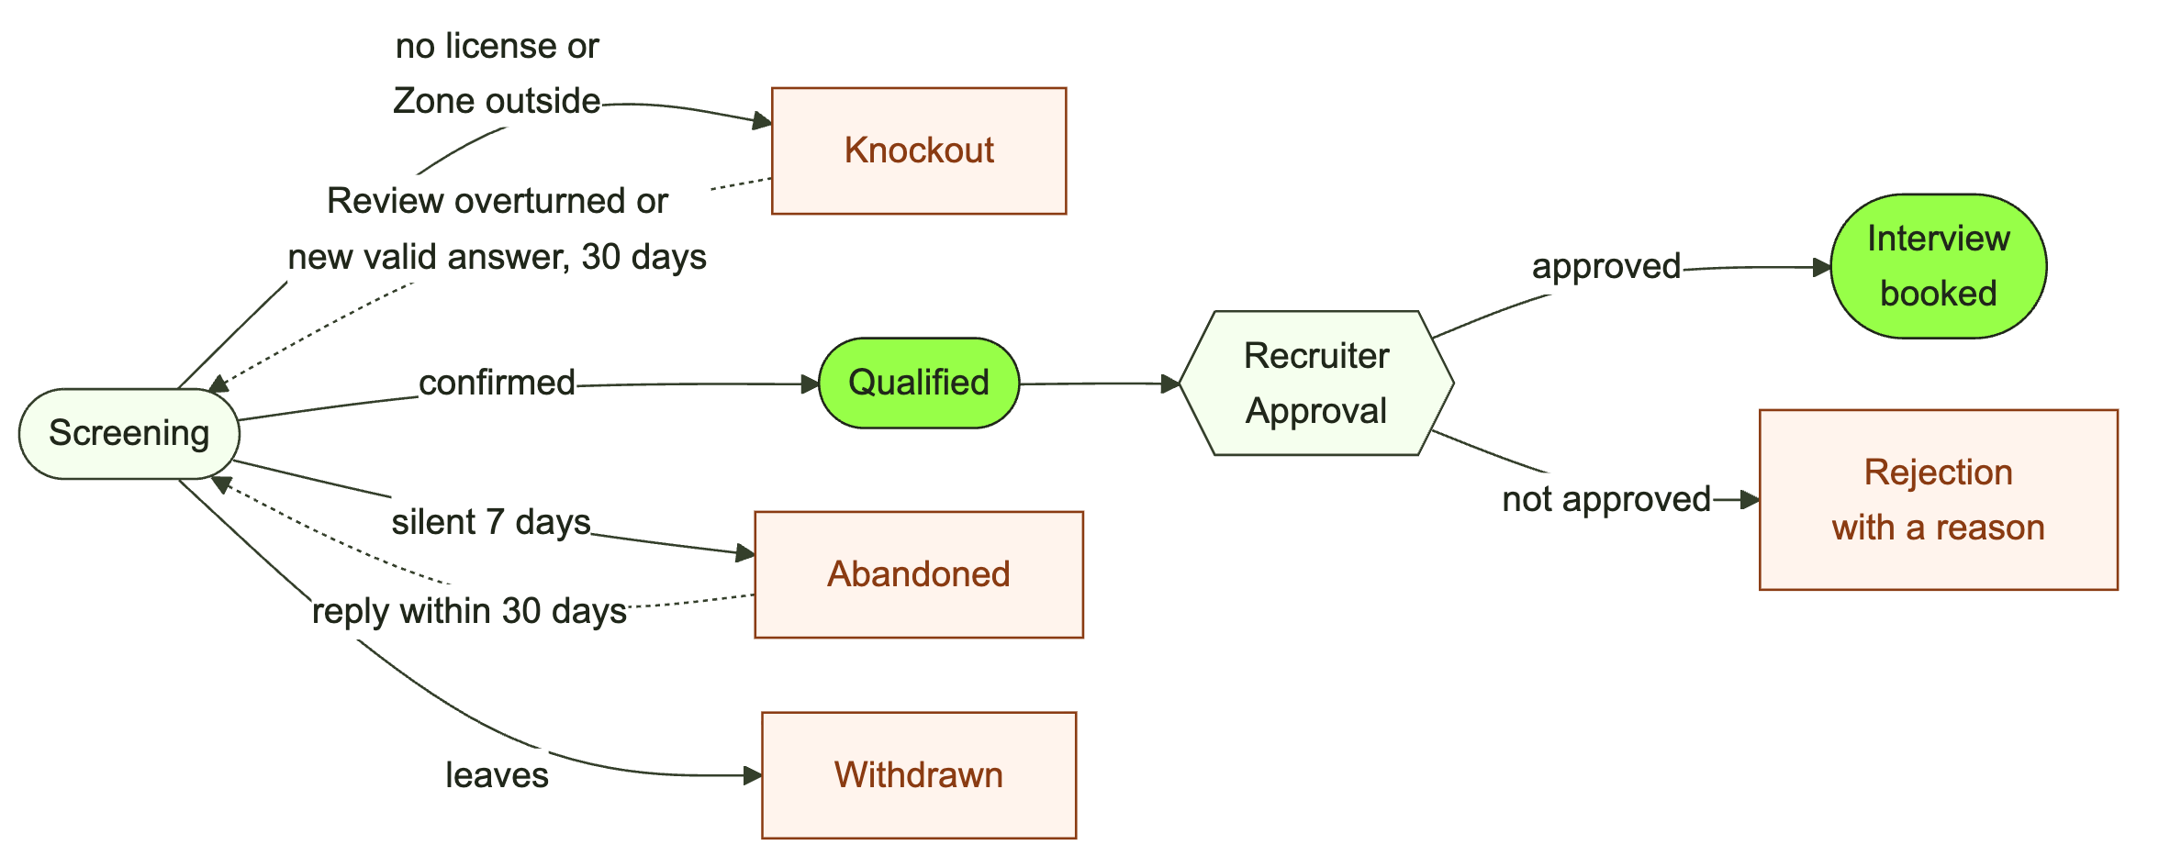
- Qualified (the Application stays open). The agent says a Recruiter will check it shortly. The first Recruiter to act Claims it.
- Approved. The agent writes at once and offers 3 Interview slots as buttons; "none work" links to a booking page. A booked slot sends an .ics invite to both sides.
- Not approved. A Rejection with a reason, sent once a Recruiter confirms.
- Knockout (no license, or Zone outside every Service Area). Sent at once from an approved template: the reason in plain words, why it is required, a link to the requirements, an invitation to come back, and how to ask for a person to Review it. A new valid answer to the failed check within 30 days reopens it.
- Abandoned and Withdrawn as in section 4. A Recruiter can make a Takeover at any stage; the agent resumes on hand-back.

6. Message tone and length
This is chat, not email.
- 1-2 sentences, under 300 characters, never more than 3 short lines. One question per message.
- Split rather than stack: never more than 2 messages in a row.
- Spoken and plain: no corporate phrasing, no bullets except the confirmation summary.
- At most one emoji, none in Knockout or Rejection messages.
- Fast replies: first within 5 seconds, later within 10.
Opening (es-ES): ¡Hola! Soy el asistente virtual de Grupo Sazón 🛵 Te ayudo a postularte como repartidor en unos minutos. ¿Cómo te llamas (nombre y apellido)?
Nudge at 1 hour (es-ES): ¿Sigues por ahí, Ana? Solo me falta saber una cosa: ¿tienes carnet de conducir?
Knockout (es-MX): Gracias, Luis. Por ahora necesitamos licencia de manejo vigente: es un requisito legal y del seguro para repartir. Cuando la tengas, escríbenos y seguimos donde lo dejamos. Si crees que hay un error, responde "revisión" y una persona lo verá.

