Enterprise-Grade Generative AI Guardrail
& Governance Framework
A Comprehensive Project Showcase for Leadership & Enterprise Architecture Interviews
Reference Implementation: Promptineering — AI Governance Platform
July 2026

1. Executive Summary & Project Context
Project purpose. This document presents the design and implementation of a scalable, enterprise-grade guardrail and governance framework that secures Generative AI and agentic workflows against adversarial attacks, data leakage, and compliance drift. The framework was realised in Promptineering, a full-stack reference platform in which every prompt traverses a policy-resolved, multi-stage security pipeline — NVIDIA NeMo Guardrails orchestration, LLMLingua token optimization, and a provider-agnostic model gateway — before any model is permitted to respond.
Business problem. Enterprises adopting Large Language Models face severe operational, security, and reputational risks. Prompt injection and jailbreak attacks can subvert system instructions; Retrieval-Augmented Generation (RAG) pipelines can exfiltrate proprietary data through over-fetching or poisoned context; hallucinated output can silently corrupt downstream business decisions; and autonomous agents with unbounded tool access can execute damaging actions at machine speed. Conventional application security controls do not address these failure modes, because the attack surface is the model's natural-language interface itself.
Core value proposition. The framework delivers a defense-in-depth architecture that intercepts both requests and responses across the entire interaction lifecycle without introducing unacceptable latency or degrading model utility. Controls are deterministic and policy-driven, every decision is explainable and auditable, and the guardrail fabric degrades gracefully: when a specialised engine is unavailable, an equivalent native control takes its place so that protection is never silently absent. Measured in the reference implementation, the full input-rail and compression pipeline executes in milliseconds while removing up to 66% of prompt tokens, demonstrating that security and cost efficiency can compound rather than compete.

2. Solution Architecture & Multi-Layer Defense Framework
Defense-in-depth paradigm. The architecture shifts security left. Rather than treating the model as a black box to be filtered after the fact, controls are compiled into the platform itself: policy suites are validated at configuration time, inputs are sanitised in real time before inference, retrieved context is governed at the access-control layer, agent actions are bounded before execution, and every output is validated after generation. The result is a layered perimeter in which no single bypass grants access to models, data, or tools.
Component topology. Controls are distributed across four planes. Client traffic — web applications, internal copilots, and autonomous agents — enters through an identity-provider-integrated API gateway that terminates authentication and applies rate limits. A guardrail proxy hosts the policy engine and input rails, masking PII and secrets before any payload crosses the trust boundary. The orchestration plane (LangChain, Semantic Kernel, or equivalent) embeds action boundaries and context-governance filters, while the model and data plane — LLM providers, per-tenant vector stores, and enterprise tool APIs — is reachable only through those governed paths. All planes emit events into an asynchronous, hash-chained audit stream.
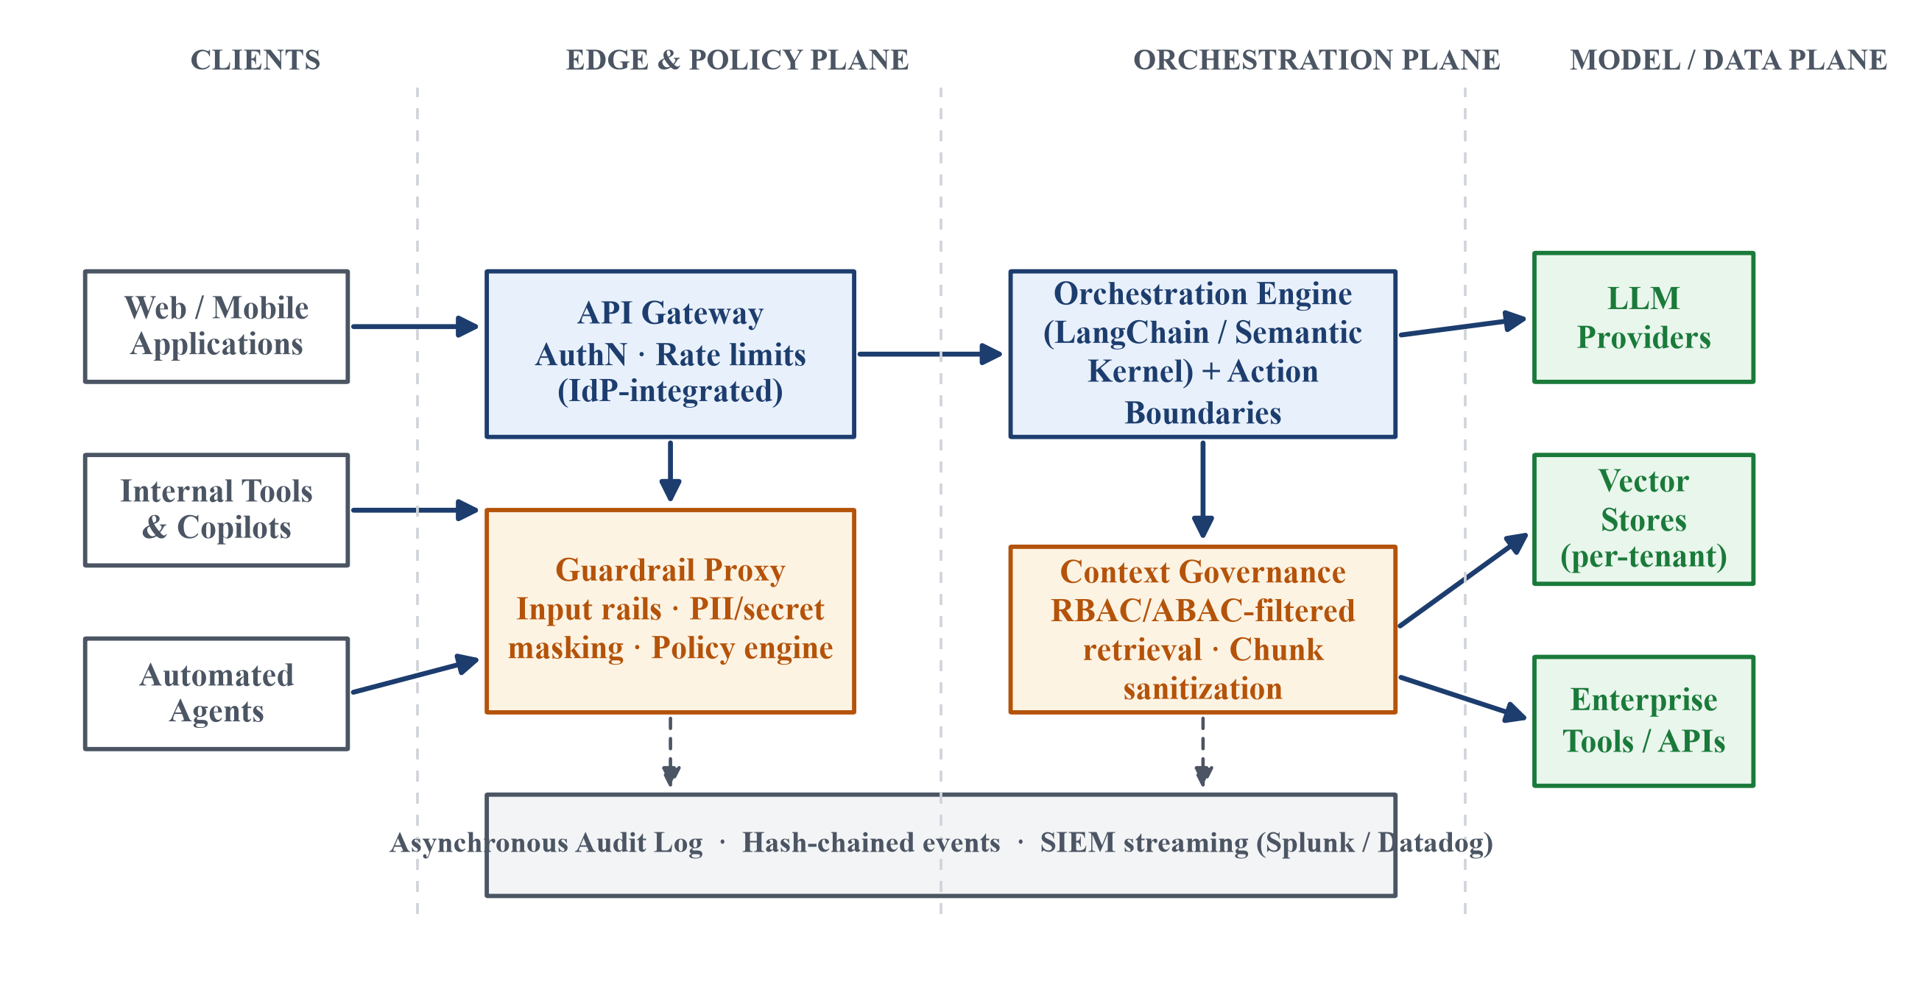
Figure 1 — Component topology: control placement across the client, edge/policy, orchestration, and model/data planes.
Design principles. Four principles govern every design decision:
- Least-privilege execution. Users, workspaces, and agents receive the narrowest policy suite, model tier, tool list, and upload allowance their role requires.
- Fail-safe defaults. Unknown file types, unmatched roles, disabled policies, and absent credentials all resolve to the most restrictive behaviour, never the most permissive.
- Deterministic policy enforcement. Access decisions derive from declarative policy configuration, not from model judgement, so identical requests always produce identical rulings.
- Asynchronous audit logging. Evidence capture is decoupled from the hot path so observability never taxes user latency.
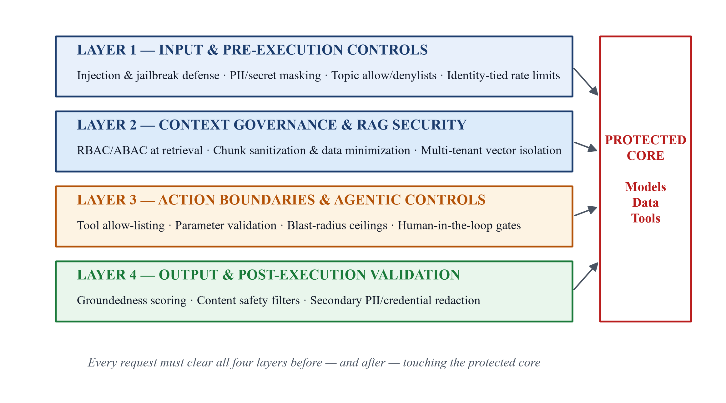
Figure 2 — The four defense layers surrounding the protected core of models, data, and tools.

3. Technical Deep Dive: The Four Defense Layers

Layer 1 — Input & Pre-Execution Controls
Adversarial defense. The first layer neutralises adversarial input before it can influence the model. Semantic classifiers and weighted heuristic signatures detect prompt injection, jailbreak framing, and persona-adoption attacks ("ignore previous instructions", "developer mode", role-play without restrictions), blocking high-confidence matches outright and flagging borderline cases for monitoring. In the reference implementation these rails are orchestrated by NVIDIA NeMo Guardrails, with an optional LLM-backed self-check rail for semantic validation of ambiguous requests.
Data privacy at ingestion. Real-time detectors identify personally identifiable information (emails, phone numbers, government identifiers, payment card numbers validated by checksum) and credentials (cloud access keys, API tokens, private keys, bearer tokens) and mask them before the payload reaches any model. Redaction is preferred over rejection wherever possible so that user productivity is preserved while data never leaves the trust boundary.
Semantic validation. Policy suites define topic allow/denylists evaluated against the sanitised input, and request rates are tied to the enterprise identity provider so that limits follow the person, not the device. Financial-sensitivity screening (IBAN, routing numbers, large monetary amounts) activates automatically under finance-domain policies.

Layer 2 — Context Governance & RAG Security
Access control integration. Retrieval is treated as a privileged data access, not a convenience. Role-Based and Attribute-Based Access Control are enforced at the vector retrieval stage itself: a query executes only against collections the caller's role, department, and clearance attributes permit, so a junior analyst's prompt can never surface an executive strategy document regardless of embedding similarity.
Data minimization. Retrieved chunks are sanitised before insertion into the context window — over-fetched spans are trimmed to the minimum relevant content, and residual PII or credentials inside retrieved documents are masked by the same detectors that guard direct input. This prevents the common failure mode in which RAG quietly becomes a data-exfiltration channel.
Knowledge partitioning. Multi-tenant deployments isolate knowledge by construction: separate vector collections per tenant with tenant identity bound into every query, ensuring that no similarity search can cross a tenant boundary even under adversarial embedding manipulation.

Layer 3 — Action Boundaries & Agentic Execution Controls
Tool guardrails. Agent tools are allow-listed per policy suite, and every tool invocation is validated against a typed parameter schema before execution — unknown tools, out-of-range parameters, and malformed payloads are rejected deterministically. The reference implementation expresses this as per-policy tool permission lists that gate what each workspace may invoke.
Blast-radius constraints. Automated workflows operate under explicit ceilings: financial limits on transaction-capable tools, volumetric limits on records touched per run, upload-size quotas per policy tier, and operational limits on chain depth and execution time. A runaway agent therefore has a bounded blast radius by design rather than by hope.
Human-in-the-loop. High-risk actions route through configurable human approval gateways. The framework snapshots state before the gated action, presents the reviewer with the full decision context, and supports rollback if an approved action later proves harmful — converting irreversible automation into a reviewable, recoverable workflow.
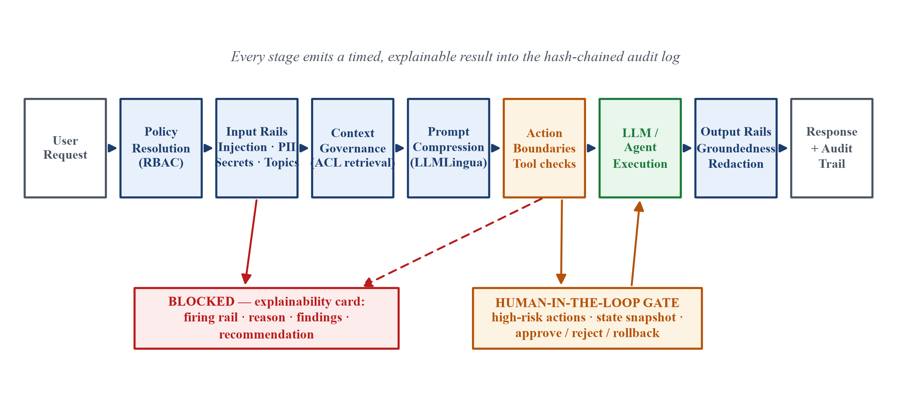
Figure 3 — End-to-end request lifecycle: policy resolution, input rails, context governance, compression, action boundaries with the human-in-the-loop gate, execution, and output validation.

Layer 4 — Output & Post-Execution Validation
Groundedness and hallucination scoring. Generated responses are scored for groundedness against the retrieved context that motivated them; claims unsupported by the context lower the fidelity score and can trigger regeneration, annotation, or escalation depending on policy strictness. This converts hallucination from an invisible risk into a measured quantity.
Content safety filtering. Multi-dimensional content filters screen for toxic, biased, abusive, or brand-inappropriate language, with per-policy response-strictness profiles (relaxed, professional, strict) governing tone and the handling of speculative content.
Output redaction. A secondary redaction pass strips PII and credentials from model output — defending against leakage that originates inside the model or the retrieved context rather than the user's prompt. The reference implementation applies the identical detector suite on egress as on ingress, so the same evidence standard applies in both directions.

4. Observability, Compliance, and Operational Resilience
Auditability and traceability. Every pipeline stage emits a structured, timed result — engine, status, confidence, findings, and recommendation — into a unified audit log whose entries are hash-chained for tamper evidence. When a request is blocked, an explainability card records precisely which rail fired, why, and what the user should change: the decision tree is traceable end to end, which is the difference between a security control and a black box.
Enterprise SIEM integration. Audit streams integrate with enterprise SIEM platforms such as Splunk and Datadog, giving the security operations centre real-time visibility into injection attempts, redaction volumes, policy violations, and anomalous usage patterns alongside the rest of the enterprise estate.
Regulatory alignment. Controls map onto emerging regulatory frameworks: the EU AI Act's transparency and human-oversight obligations (explainability cards, HITL gates), the NIST AI Risk Management Framework's govern-map-measure-manage cycle (policy suites, risk scoring, drift monitoring), GDPR data-minimisation and purpose-limitation principles (PII redaction, retrieval minimisation), and sector mandates such as HIPAA and SOX through domain-specific policy suites with dedicated compliance tags.
Incident management. Operational resilience is engineered, not assumed: an emergency kill switch can disable a policy suite or the entire gateway instantly; drift monitors compare live rail-trigger rates against baselines to detect degrading classifiers or shifting attack patterns; a false-positive tuning workflow feeds analyst dispositions back into rail thresholds; and every incident concludes with a structured root-cause analysis that traces the event through the hash-chained log.

5. Implementation Roadmap & Business Impact
Phased rollout strategy. Adoption follows a three-phase rollout that builds trust before it builds enforcement. In Shadow Mode, guardrails evaluate and log every request without blocking, establishing baseline metrics and exposing false positives at zero user cost. The Pilot phase enables inline blocking for high-confidence rails within selected business units, with human-in-the-loop gates on risky actions. Enforced Production extends full inline blocking and automated intervention platform-wide, gated by explicit criteria: false-positive rates below target, P95 latency overhead within budget, no unexplained blocks, and SOC sign-off on audit completeness.
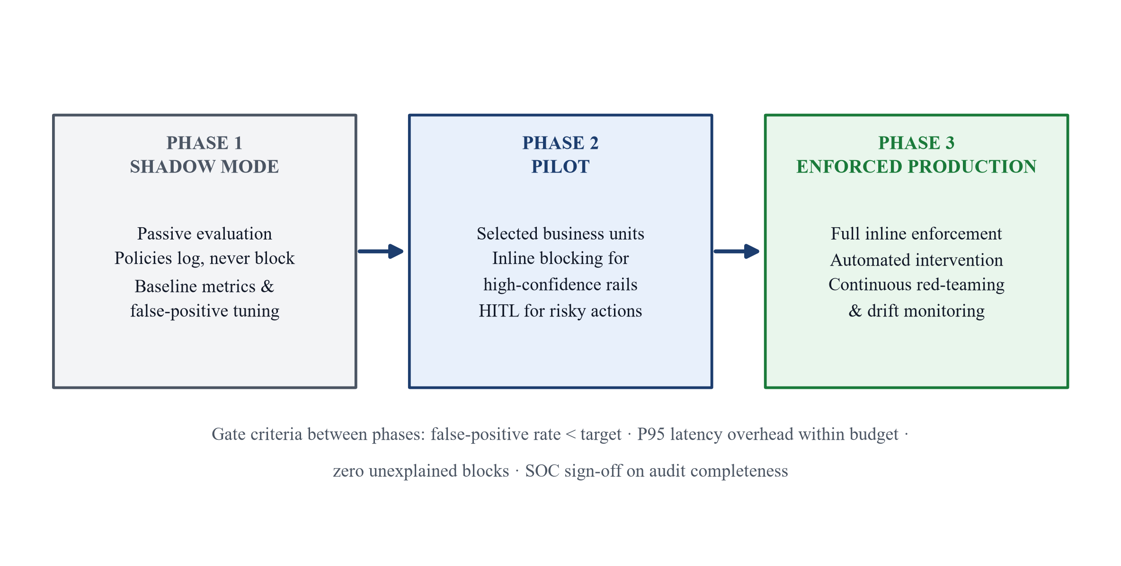
Figure 4 — Phased rollout: shadow mode, controlled pilot, and enforced production, with explicit gate criteria between phases.
Resilience and testing. An automated red-teaming pipeline continuously replays known injection corpora and newly published attack patterns against the rails, so regressions surface in CI rather than production. Load tests quantify guardrail latency overhead at each release, and a FinOps loop tracks guardrail compute cost against the token spend it avoids — in the reference implementation, semantic compression alone recovers multiples of the pipeline's own cost.
Measurable outcomes. The framework's outcomes are measurable rather than aspirational: elimination of PII and credential leakage incidents at the model boundary, reduced hallucination rates through groundedness scoring, token-cost reduction of 10–66% depending on policy compression level, complete audit coverage for every AI interaction, and — most strategically — the compliance readiness that converts Generative AI from a governance liability into an enterprise-wide capability that security, legal, and the board can all endorse.

