G53GRA Coursework Report

Joel Cox – psyjc5

# The Scene

My scene depicts a lone farmhouse, with a gently burning fire outside it, and a rather energetic pumpkin. Two robots roam, fended off by a turret in the middle of the scene. The robots walk an endless path reaching its end only to be sent back to its beginning. A dirt path shows the wear the robots have inflicted on the otherwise green grass.

# Hierarchical Modelling

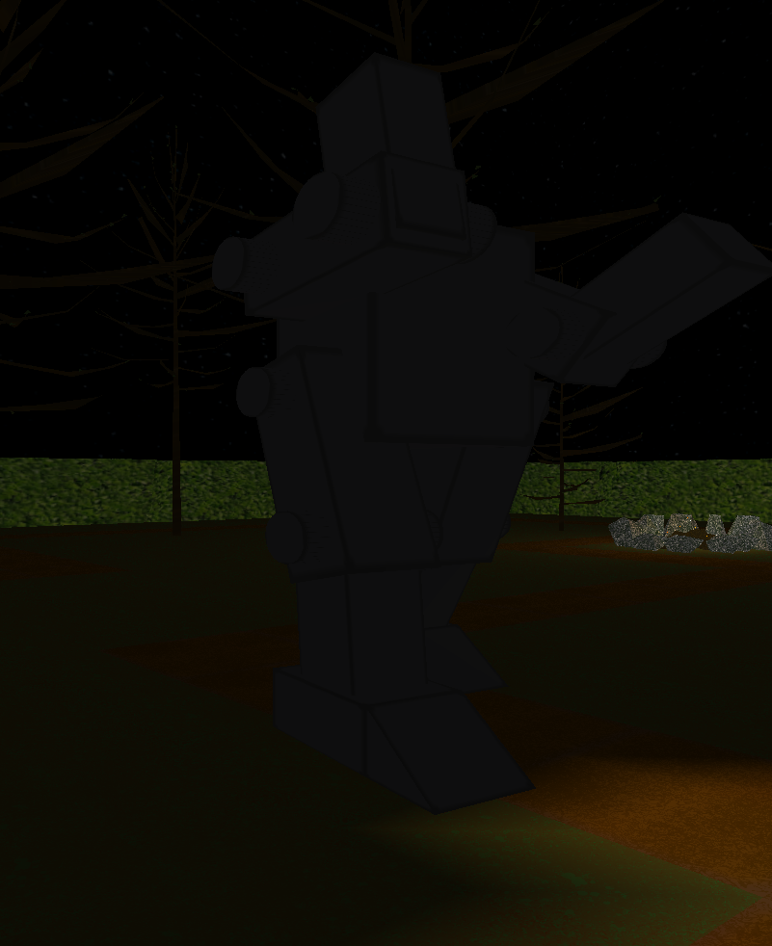In my scene there are two robots, which are comprised of several body parts: two arms, two legs, and a body. It also includes two orbital models that spin around the top of the robot. All of these parts are modelled hierarchically around the body of the robot. Each piece has an x, y, and z position, which is used to translate with before drawing. The body has the centre location, with each other part having a position equivalent to an offset; the body may have a position of 50,0,50, and the other parts positions of 5,0,0, showing their offset from the body.

Each arm and leg is made from several parts in themselves, each offset from the main body, but using values relative to each other.

The main body moves around the scene, following a path, and the rest of the robot goes with it.

# Animation

I have several animated objects in the scene.

The smallest is the campfire embers. They are simple GL_POINTS that move up and down to emulate a fire.

The turret in the middle of the scene tracks where the robot is moving, and rotates to point towards it. It then fires projectiles that move toward the robot before colliding with it.

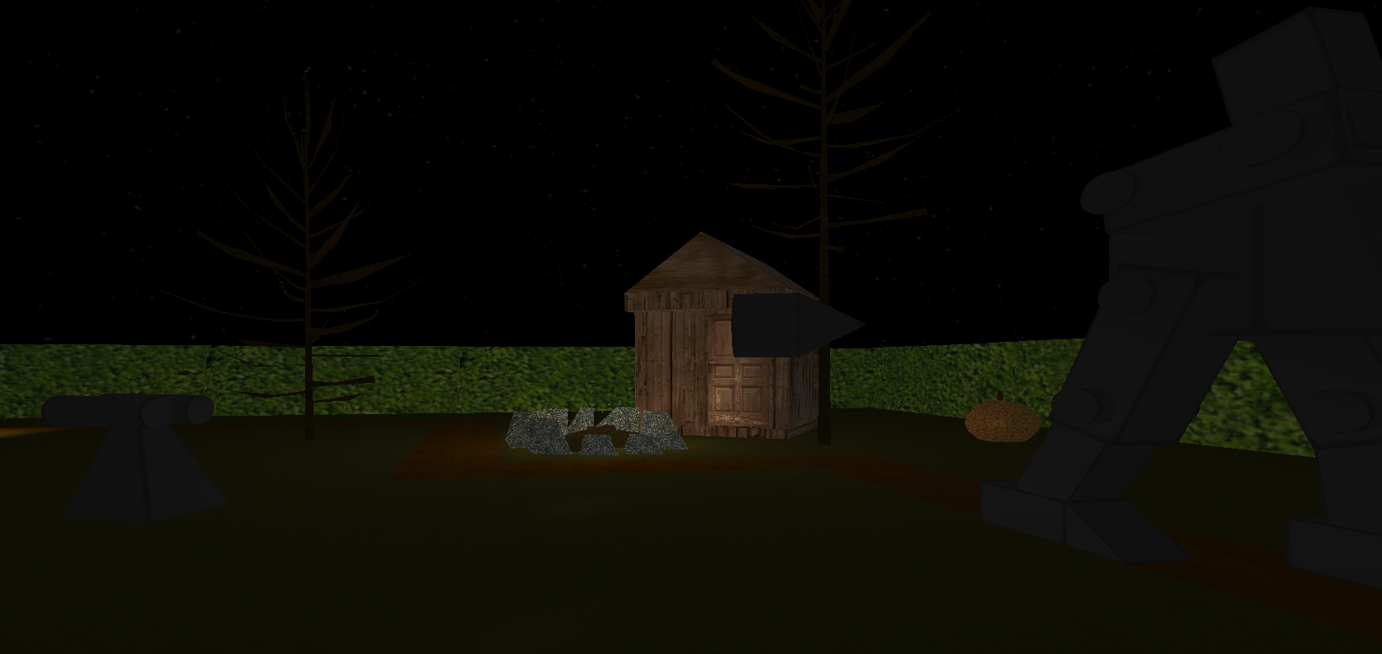The robot itself has the most animated parts. The arms and legs loop a walking animation, as well as rotating when the body rotates to turn corners in the path. There are also orbiting blocks that loop a square ring animation above the robot’s head.

The arms and legs of the robot use thresholds to alternate between moving one direction and the other. The orbital blocks use keyframes based on how much time has passed, with 1 second between each keyframe.

There is also a pumpkin which does a flip when the space bar is pressed.

# Lighting and Texturing

## Lighting

I have several lights within my scene. The first is a spotlight on the front of each robot, which illuminates the path in front of them. It uses linear attenuation to have a cut-off point, emulating a torch or similar light, shining a circle of white light.

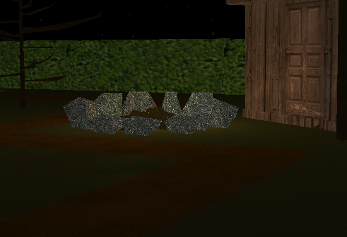The other lights are smaller, in the campfire. These lights are ambient lights that illuminate an area around them, again using linear attenuation to only light up a small area around them.

## 

## Texturing

All the models and other objects in the scene are textured. They all use a ‘.bmp’ file for a texture. The robot changes its texture colour when it is hit by a projectile from the central turret.

The texture is mapped to each vertex in a shape (QUAD/TRIANGLE) using parts of an overall texture image. Some objects use a repeating texture, whereas other objects use different parts of the texture for different parts of the object.

# Novel Features

There are a collection of novel features present in my scene, some of which have already been mentioned. The first is the inclusion of an ‘.obj’ file loader, which allowed me to include a wider variety of objects in the scene.

Another feature is the rotating turret in the centre of the scene, which tracks the movement of one of the robots, and points towards it. The projectiles also point towards their target, and slowly increase in size before they hit.

The robots themselves have a lot going on, and are independent of each other. I would consider them to be quite novel, as they animate, change textures, are modelled hierarchically, with the sub parts having their own animations, and follow a path, turning to face where they’re going.

# Self-Reflection

I feel like I learned a lot through this coursework. I started with little knowledge of how graphics were implemented, and over the course of the project I learned various techniques. Modelling objects hierarchically presented certain challenges such as managing rotations correctly. Rotations in general were quite difficult to manage, but I overcame that challenge with multiple uses of rotation, from simple animation, to tracking a moving object, and flipping a pumpkin.

I also learned how to use tools to help my scene, like Blender, a modelling software, and GIMP, a drawing tool. While my artistic prowess isn’t too impressive, I feel I created objects with a realistic feel to them. All textures apart from the house and hedges were self-made, and all models too - apart from the trees which were generated by a Blender function.