**Assignment – 2**

**Evaluation of Classifier Performance**

TEAM MEMBERS:  
 NAME: Balraj Hanmanthugari UID: U01079536 EMAIL: hanmanthugari.2@wright.edu  
 NAME: Deepika Kasula UID: U01067608 EMAIL: kasula.16@wright.edu  
 NAME: Nitish Kota UID: U01074656 EMAIL: kota.58@wright.edu

**Introduction :**

This assignment evaluates how well different classifiers perform on a dataset of text documents that have been categorised into two groups. The end goal is to see which classifier achieves the highest level of accuracy with regard to predicting the class (category) a new document would fall into based on its contents. What this exercise we seek to do is apply and compare different classification algorithms (such as Naive Bayes, K-Nearest Neighbours (k-NN) and Support Vector Machine (SVM)) to see which would deliver the most accurate predictions for the text data at hand. To make informed decisions about which classifier to choose (or tweak) we apply metrics such as accuracy, precision, recall ratio and F1-score to evaluate the effectiveness of different classifiers and expose their strengths and weaknesses. We also visualise the evaluation metrics and the confusion matrices for these classifiers to gain further insights into their performance so that we can perform an in-depth analysis.

**Comparative Analysis :**

1. **Multinomial Naive Bayes Classifier**

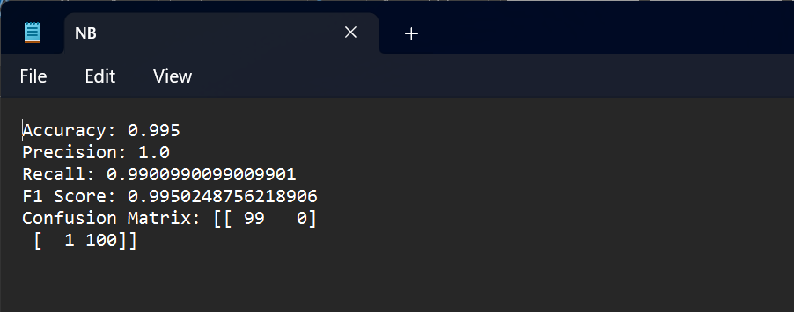

It is observed that the Multinomial Naive Bayes classifier performs well on all assessment metrics. At 99.5% accuracy, it achieves nearly perfect precision of 100%, indicating the majority of positive predictions are correct. The recall rate of 99.01% implies that the classifier effectively identifies most of the positives in the data set. Further confirmation on balance between precision and recall was found in F1 score with a result of 99.50%. Analysis using the confusion matrix reveals that only one misclassification occurs, resulting in 99 true negatives and 100 true positives; this excellent performance confirms the reliability of Multinomial Naive Bayes classifier for text classification tasks.

1. **K-Nearest Neighbors Classifier**

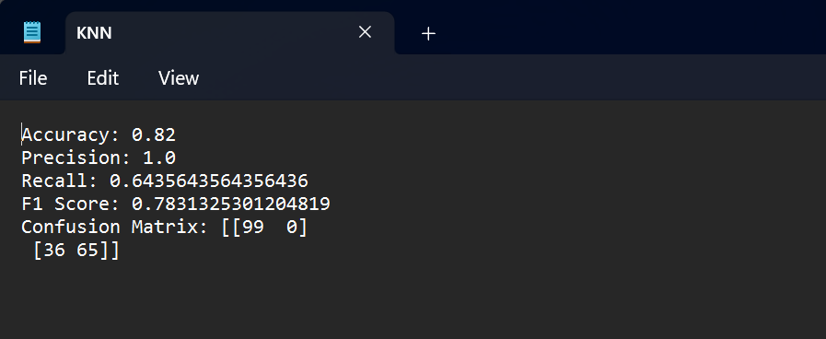

When tested on our dataset, K-Nearest Neighbors (KNN) classifier showed an accuracy rate of 82%, which means that the majority of its predictions are correct. Furthermore, the precision score of the KNN classifier is 100% revealing that all positive predictions are actually true positives. In contrast, the recall score for this algorithm is 64.36%, showing that it fails to identify a large number of positive cases in the dataset. At last, with F1 score equal to 78.31% one can claim a fairly good balance between precision and recall.

After the investigation of confusion matrix we see that there are 99 true negatives, 65 true positives, 36 false negatives and no false positives. It follows from this result that KNN classifier does well in the aspect of identifying true negatives as well as true positives but face difficulties with recognizing false negatives.

1. **Support Vector Machine Classifier**

The Support Vector Machine (SVM) classifier has a high accuracy of 98%. Its precision score of 98.99% shows that the classifier does not have many false positive predictions, meaning it has a high proportion of true positive predictions out of all the positive predictions. The recall score of 97.03% shows that the SVM classifier can pick up the majority of the positive instances in the dataset. An F1 score of 98% indicates a balance between precision and recall. Furthermore, looking at the confusion matrix, we find that the SVM classifier encounters 98 true negatives and 98 true positives, and only one false negative and one false positive. This means that the SVM classifier performs well in picking up true negative values as well as true positive values and makes very few misclassifications.

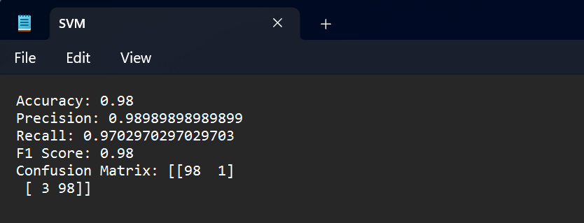

**Visualizations :**

1. **Multinomial Naive Bayes Classifier**

* **Confusion Matrices**

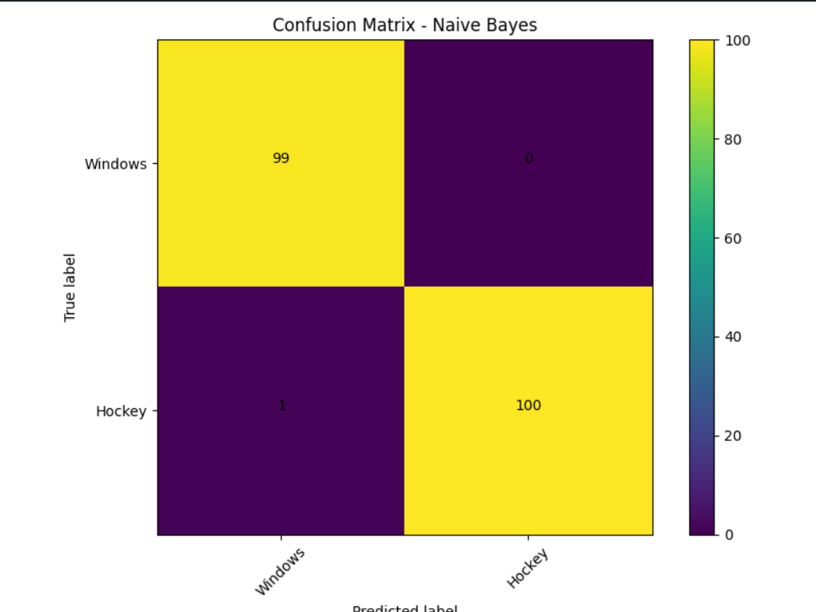

* **Evaluation Metrics Graphs**

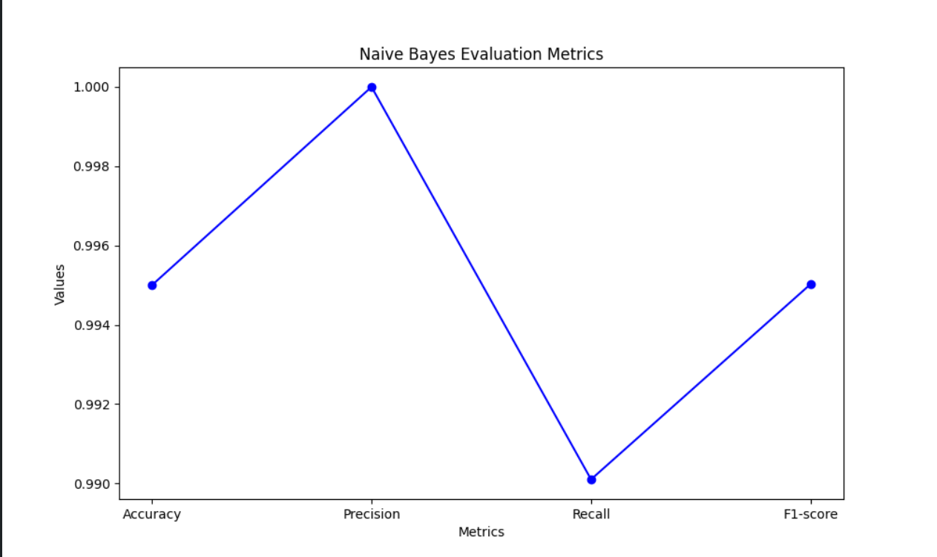

1. **K-Nearest Neighbors Classifier**

* **Confusion Matrices**

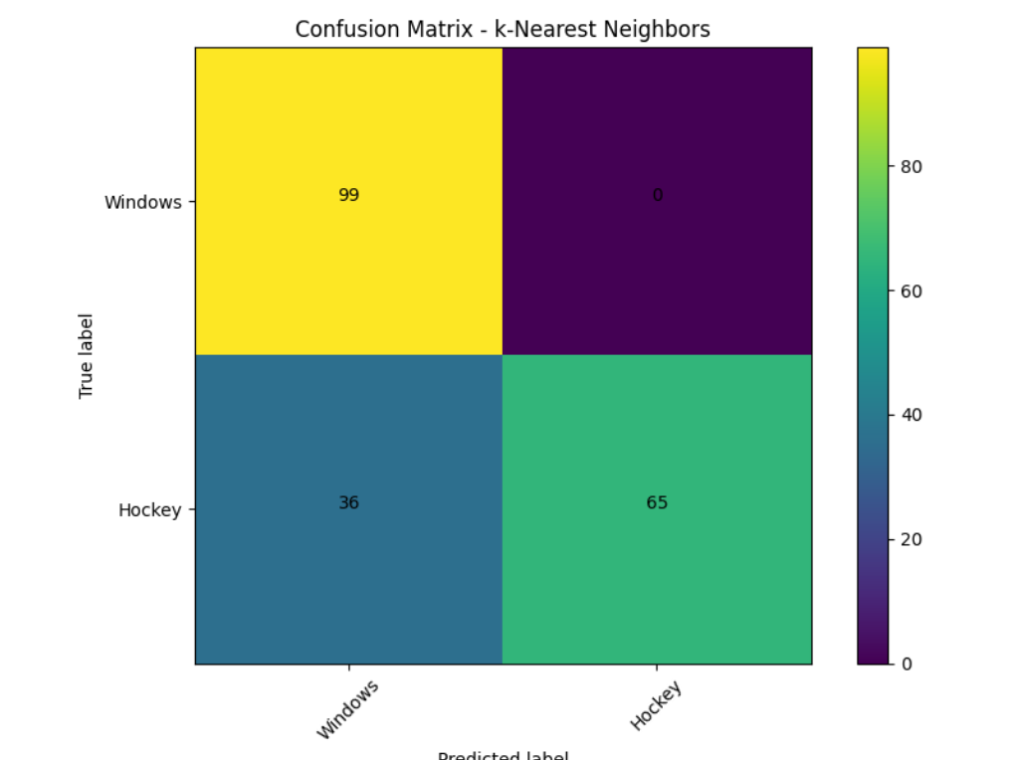

* **Evaluation Metrics Graphs**

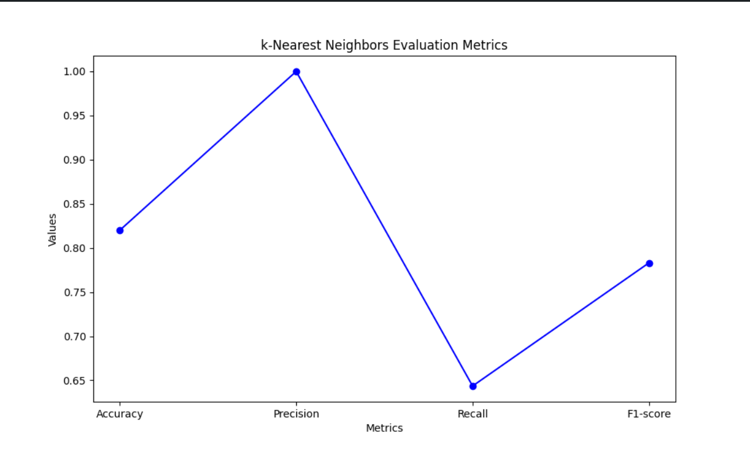

1. **Support Vector Machine Classifier**

* **Confusion Matrices**

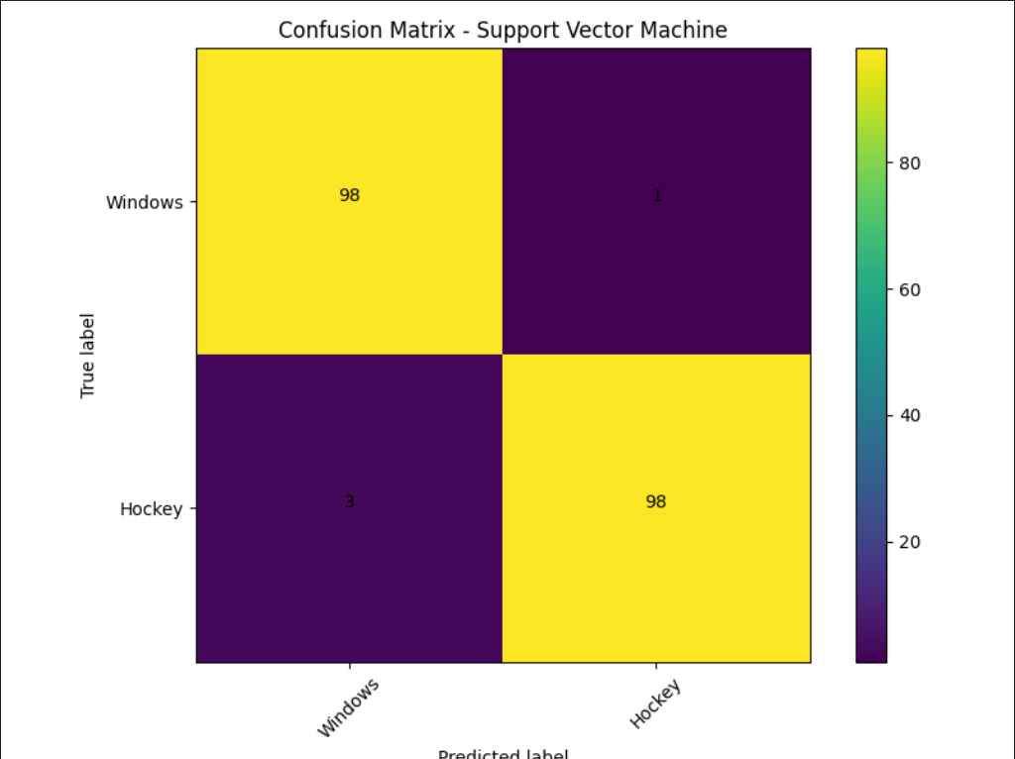

* **Evaluation Metrics Graphs**

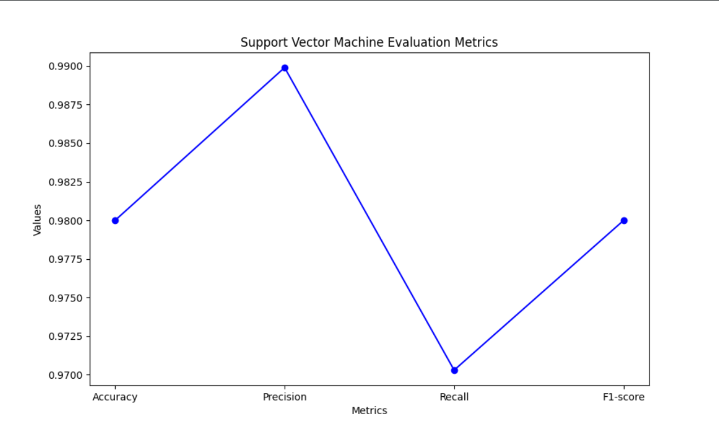

**Conclusion :**

In this exercise, we have set out to compare the performance of various classifiers with respect to their classification of text data. We evaluated the effectiveness of each classifier in successfully predicting the test data label using evaluation metrics such as accuracy, precision, recall and F1-score. The intent behind this effort was to understand what each of these classifiers is good at, and what they struggle with – like Naive Bayes or k-Nearest Neighbors, and Support Vector Machine. This discussion would give significant insights into the appropriateness of each classifier for text classification problems that will contribute to an informed selection process when it comes to building models for real-world problems.