SOFTWARE

REQUIREMENTS

SPECIFICATION

**VEHICLE PAYMENT SYSTEM**

**SOFTWARE ENGINEERING(CS223)**

**Group-7 :**

K. Raja sekhar (B16CS009)

N.Mourya Mithra (B16CS019)

**Table of Contents :**

1. Introduction

1.1 Purpose

1.2 Document Conventions

1.3 Intended Audience and Reading Suggestions

1.4 Product Scope

1.5 References

2.Overall Description

2.1 Product Perspective

2.2 Product Functions

2.3 User Classes and Characteristics

2.4 Operating Environment

2.5 General Constraints

2.6 Assumptions and Dependencies

3.External Interface Requirements

|  |  |
| --- | --- |
| 3.1 | User Interfaces |
| 3.2 | Hardware Interfaces |
| 3.3 | Software Interfaces |

4.System Features

4.1 Functional Requirements

4.2 UML diagram(s)

5.Other Non-functional Requirements

5.1 Performance Requirements

5.2 Safety Requirements

5.3 Security Requirements

5.4 Software quality and attributes

5.5 Business Rules

1. **Introduction**

1.1 Purpose

The purpose of this documentation is to provide a detailed description and working of vehicle payment. It will explain the purpose and the development of software. It will also explain system constraints, user interface, and many other factors. This document is primarily meant for the user i.e vendor.

1.2 Intended Audience and Reading Suggestions

This documentation is intended for the end-user of our software. *The rest of* *this SRS contains how the product scope,functions and its characteristics .*

1.3 Scope of the Product

The software being specified for vehicle payment and its purpose is to generate transport bills for a vendor in an institute.It makes user to differentiate between the various types of vehicles . The price is mainly calculated as per time.

1.4 References

* [www.slideshare.net](http://www.slideshare.net/)
* UML@classroom
* Ian sommerville

1.5 Overview

The following documentation provide complete overview of SRS documentation for “Vehicle payment.” The following document is completely designed in the view of user and the following subsections are arranged to complete outlook of the software, its perspectives,features and the system requirements.

1. **Overall Description**

2.1 Product Perspective

This Software is self-contained and works relatively as efficient as other packages related to the subject. It provides simple database rather than complex one for higher requirements. It provides good and easy interface to both the user new as well as experienced user.

2.2 Product Functions

* The person who wishes to rent a vehicle enters the website and books a vehicle.
* When he books a vehicle,he is assigned a unique ID,and records of him are maintained in database.
* Vendors are provided with unique ID and the interface from which they can retrieve data related to them from database.
* Once the vendor gets the orders products are delivered sequentially.

2.3 User Classes and Characteristics

There are two types of users who shall use this software, they include the vendor and the customer. However they have different characteristics. The vendor will use the software in order to perform the necessary tasks of generating bills of the vehicles that are booked on daily or monthly basis . The vendor has other characteristics which including accepting or rejecting various requests initiated by the customer for booking a vehicle. The customer will have the option to view his details and the details of the vehicle. He can also request various facilities which include requests for outstation and requests for vehicles on fixed monthly km basis.

2.4 General Constraints

The system should have windows operating system.

2.5 Design and Implementation Constraints

Customer can book a vehicle only after getting his/her unique ID and total bill is generated monthly or only when customer finishes his allotment of time.

2.6 Assumptions and Dependencies

This project works to cover needs of customer and vendor. This software is user-friendly.

1. **External Interface Requirements**

3.1 User Interfaces and Priorities

This software provides good interface for the front end of the database so that new users can easily use the system.

* Should be easily accessible from Web browsers.
* Contextual error-correction.
* Available in English language.

1. **System Features**

4.1 Functional Requirements :

4.1.1 Customer :

* Easy interface to find transport vehicles and its availability.
* End to End functions of vehicle booking including change route and cancellation.
* Interface to register and track vehicles.
* To track vehicles and send confirmation
* . To generate bills and optimize the route.
* To save the bills in database.

4.1.3 Vendor or service provider :

* Track and address complaints.
* To process requests of customer and maintenance of schedule.

4.2 UML Diagram(s)

4.2.1 Use_case diagram :

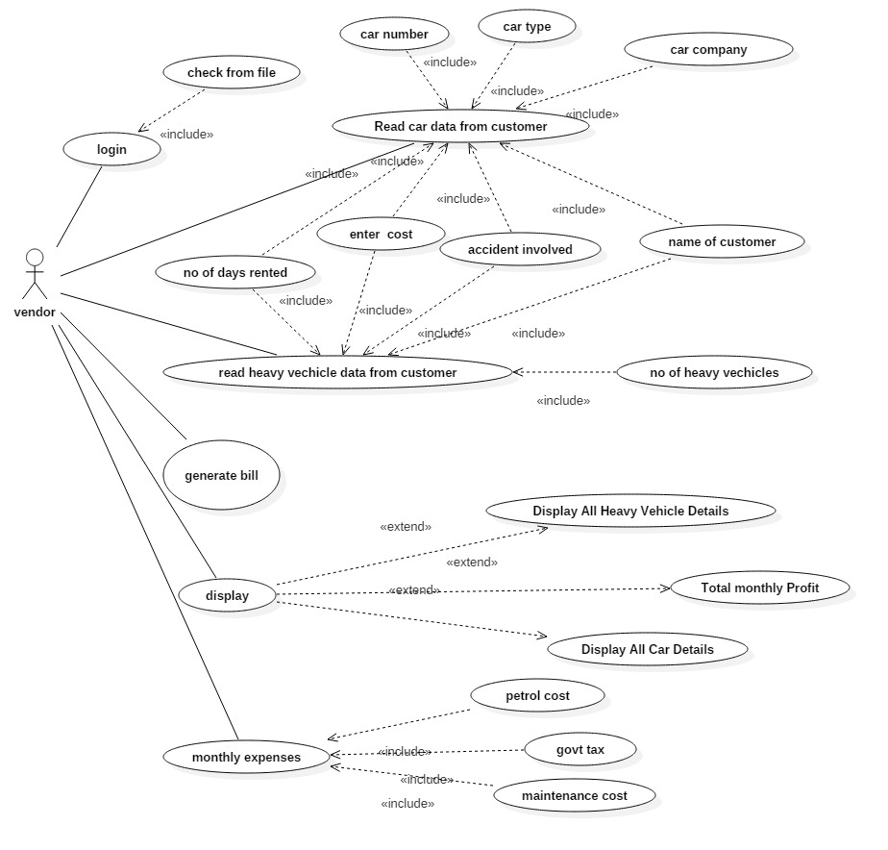

4.2.2 Class diagram :

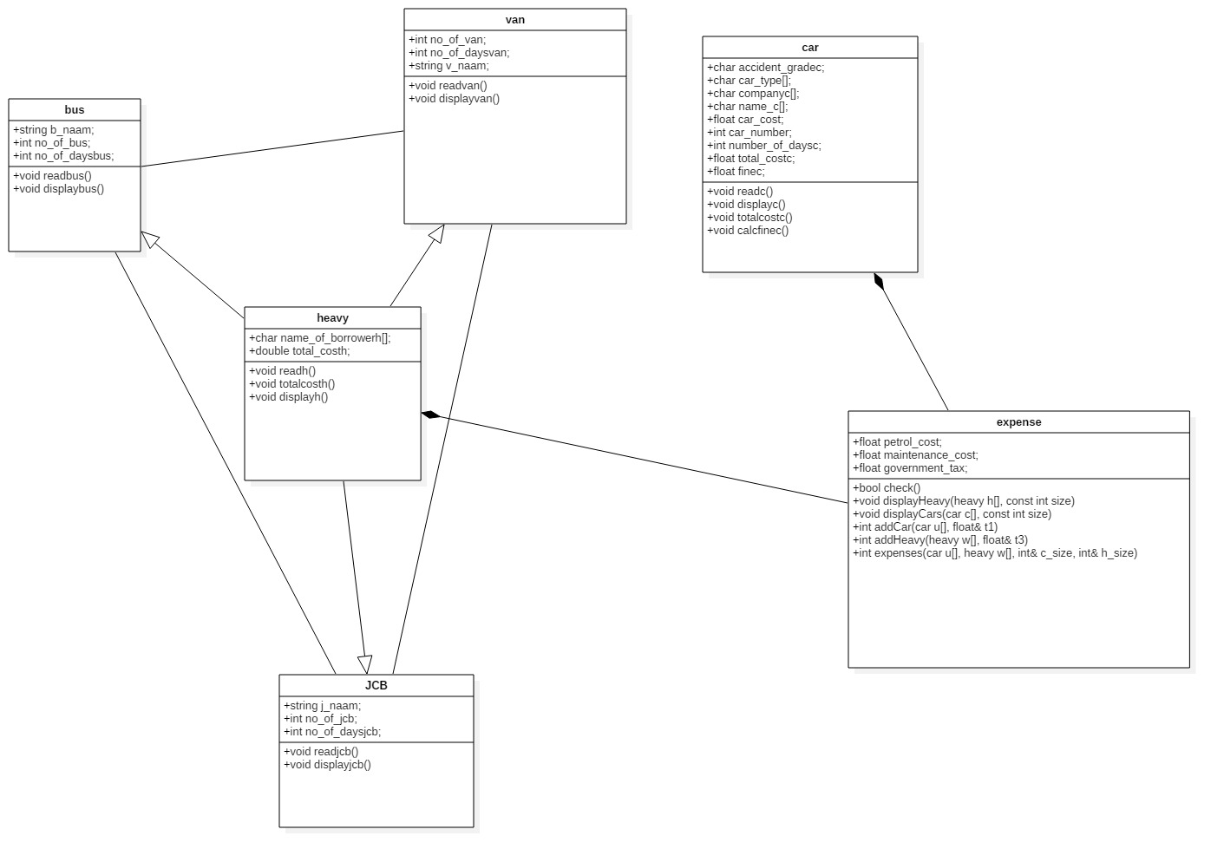

4.2.3 Sequential diagram(s) :

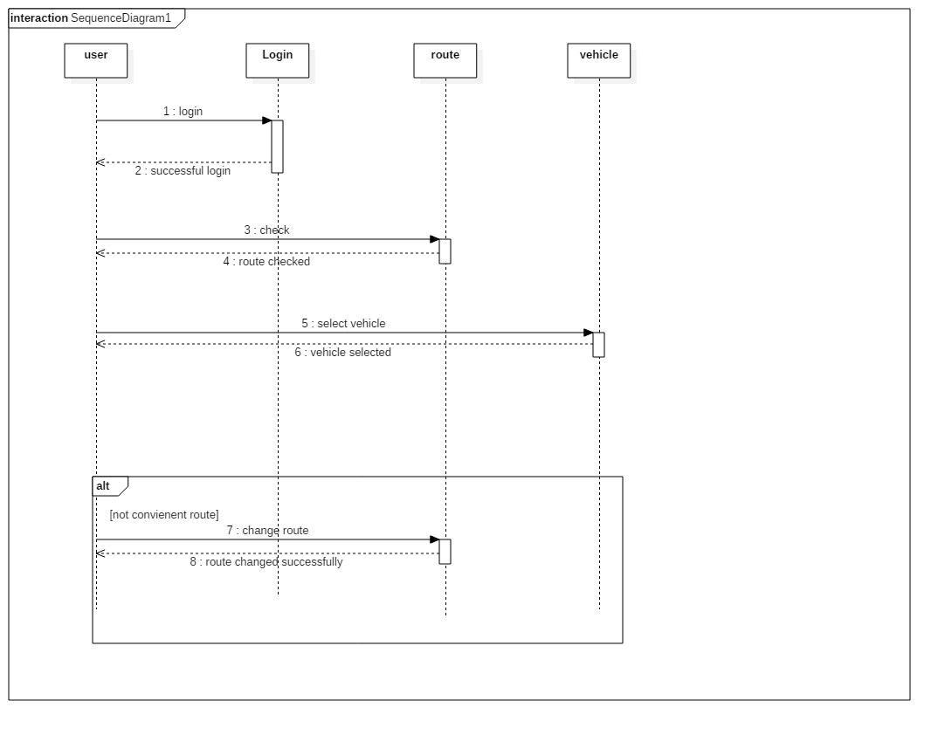

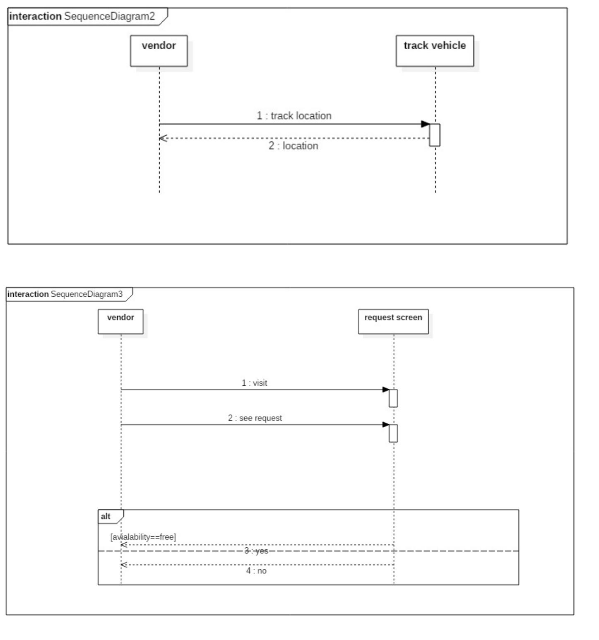

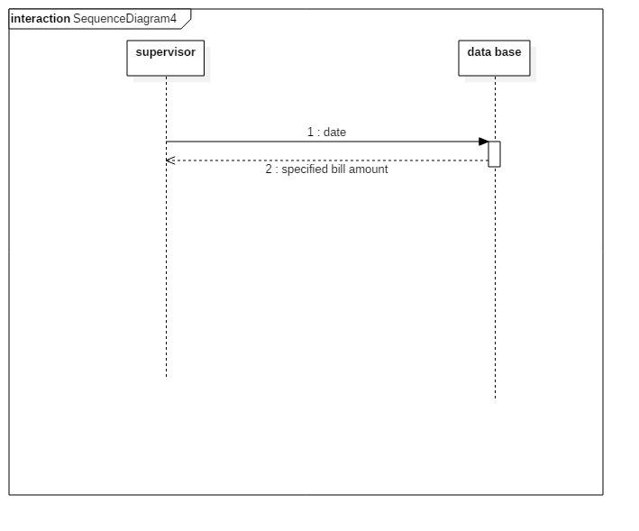

4.2.4 Activity diagram :

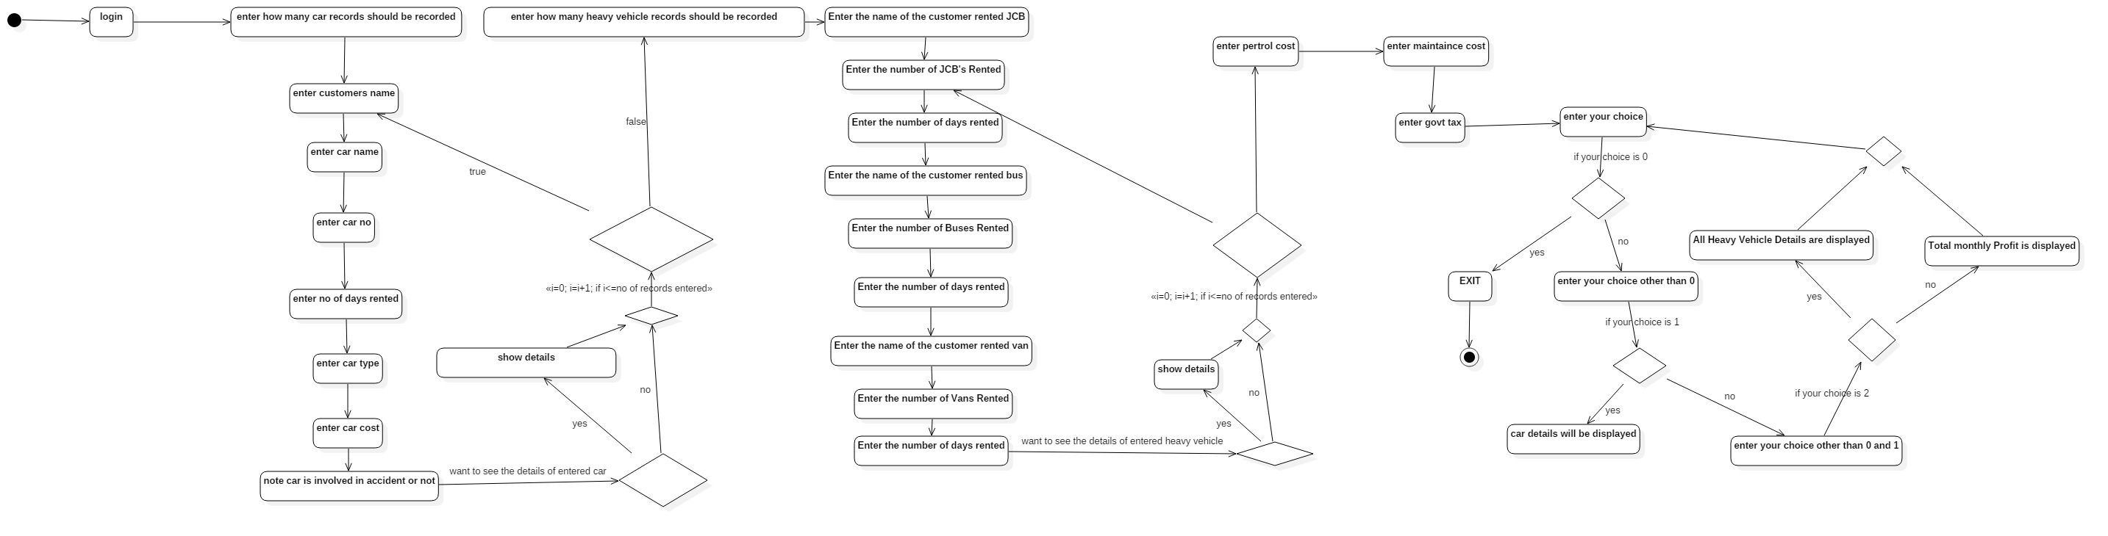

1. **Other Non-functional Requirements**

5.1 Performance Requirements

* Good working PC with all requirements mentioned above.
* System should not be overloaded.

5.2 Safety Requirements

The database may get crashed or damaged due to some viruses or some Operating System requirements. Therefore it is mandatory to have a backup for your data.

5.3 Security Requirements

* The System uses secure database.
* Customer can just see the vehicles and book them.They cannot edit or modify the details of vehicles.
* Proper user authentication will be provided.
* There should be separate account for admin and the user.So,that no one can access the database except admin.

5.4 Software Quality and attributes

* 1. 24 X 7 availability.
* 2. Secure Access control.
* 3. Error corrections: Ensure customer can correct errors with minimal problems. For example, if source or destinations have been slightly mis-stated, then correction should be easy.
* 4. Double confirmation from customer before booking/altering or cancelling vehicle.

5.5 Business Rules

* More than three attempts at login and failure will intimate to system administrator.
* Response time should be minimum.
* System should automatically update after every transaction.