**001-CPD-S (شكوى)**

* We will use Roles for the given actors and there is no need for grouping the roles? (مكتب تلقي الشكاوي, مدير حماية المستهلك, القلم, المدير العام)
* We have the forms actions buttons for (workflow forms) in order to forward/reject the transaction, but for regular steps (not tasks) do we have a dynamic actions or just 2 static ones => next/reject?
* Will we use draft feature which we implemented in GROHE?
* Most of the times we have custom text in notifications, could we have 2 workflow steps for notifications 1 for custom ones (per transaction user change notification text which given from workflow step) and the other one is automatically triggered by passing the step?
* In page 26 in (شكوى) table description we have a logical condition which has to be applied, (لا يمكن تقديم نفس نوع الشكوى على نفس التاجر في نفس الشهر) so do we need to add a general condition for process?
* Waiting workflow steps should have a custom text in order to show it to user when he opens transition, right?? (انتظار رد قوى الأمن, انتظار الحكم, انتظار رد الجهات المعنية)
* Should we implement workflow admins feature, which is simply a table has (workflowId, RoleId) to define users whom can always take actions on a workflow whenever they want, or we add a regular **Admin** role and give it to the real admins? Or also we could use WorkflowAdmins Table with another approach, we can use it for user as a final approver for each workflow. **Example** (المدير العام) should be the final approver of (شكوى) regardless the workflow ending.

**002-CPD-S (إعادة نظر بمحضر ضبط)**

* (رقم و تاريخ تسجيل الطلب) will be a custom notes?
* (الحكم في ملف الشكوى) will be a custom notes?
* (التوجيهات) will be a custom notes?
* According to diagram in page (49) Task Transfer should have multi ways in output ,, is it right ?

**003-CPD-S (إعادة فحص عينات)**

* (طلب تحليل إضافي) is a Workflow Form Action or new step or returning the process to the requester to re-include new documents? (Page 53)

Or just a regular Custom Media File?

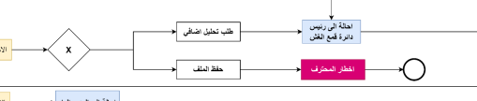

* We have to find a way to link conditions with actions/assigning to resolve this issue (Page 53)

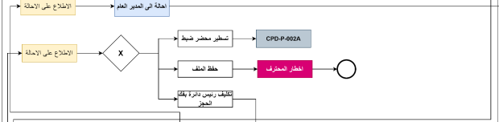

* What is the meaning of (تسديد النتيجة) (أخذ العينة) (الحالة العينة الى المختبر) (تسطير محضر ضبط)
* We should add new Work (reassign) which is different than task transfer I think, because this will be automatically change assign by passing this step with no needed actions. Is this right? (Page 53)

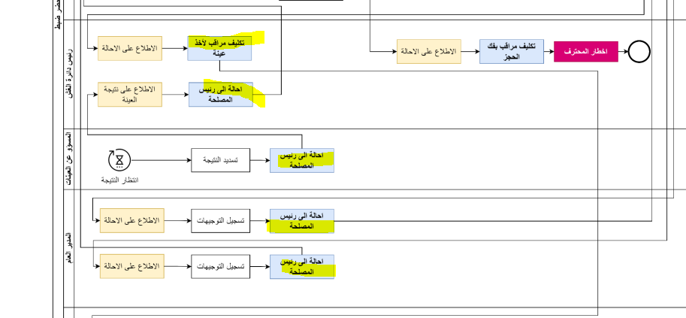

**004-CPD-S (طلب تركيب أو تصليح مضخات)**

* (اصدار اذن تركيب او تصليح) is a custom note?
* Notifications must be changeable within transactions in order to accomplish this:

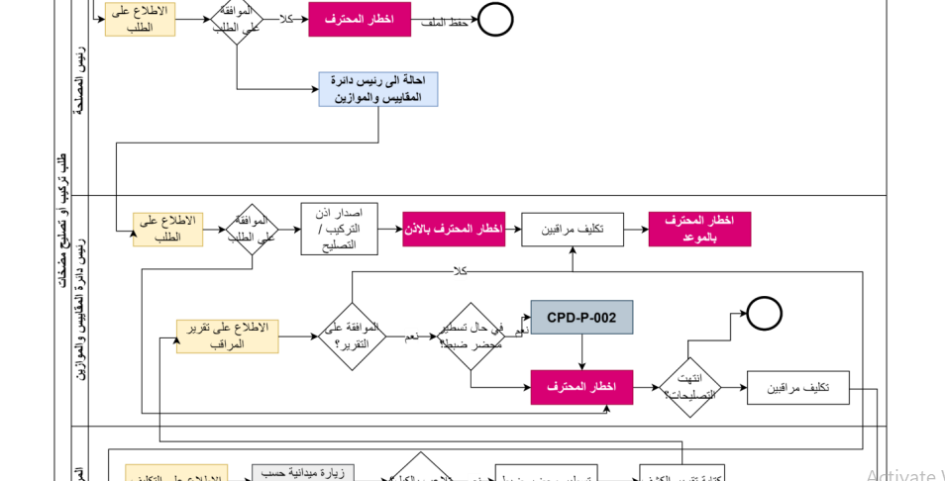

(اخطار المحترف بالإذن, اخطار المحترف بالموعد)

Or we can create a new workflow step for custom notifications (custom text / custom role / custom user)

* How we can define (تلاعب بالكيل)

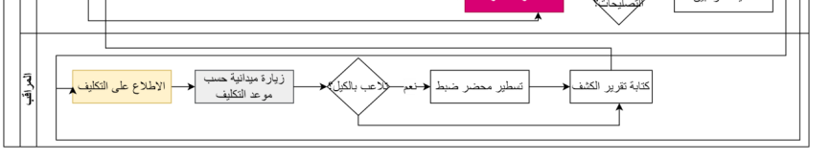

Could it be an uploaded media file? (and if yes could we have an actions on uploaded custom media file)

* What is the meaning of (تسطير ملف ضبط) and when it used as a condition , what does logic stand for , in order to proceed ?

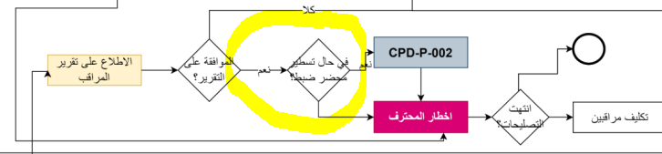

**005-CPD-S (طلب تعيير قبابين)**

* Do we have a certificate image … and If yes does it will be static with certificate Id, or custom with each certificate requester? and how requester will receive it? (by Media files in the process space or by email)

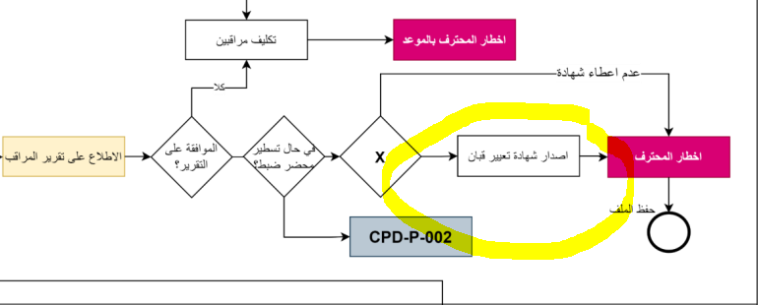

* Who will be responsible to process after waiting workflow steps? Is it current responsible role or admin or we need to add role with these steps?

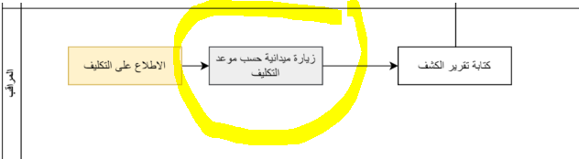

**006-CPD-S (طلب كيل صهريج لتجديد الشهادة السنوية)**

* How we can define (تلاعب بكيل الصهريج)

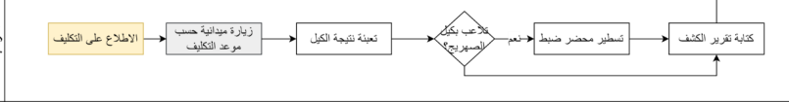

Could it be an uploaded media file? (and if yes could we have an actions on uploaded custom media file)

* Is (نتيجة الكيل) a custom notes?
* Is (زيارة ميدانية حسب موعد التكليف) a workflow step **waiting for sample results**?