Time Series Analysis using Python
Internship Task 3 – Data Science
Name: Mousam Kumari
Registration No: 23105113053
Course: B.Tech CSE
College: Motihari College of Engineering
Internship: Data Science using Python
🟦 1. Objective
The objective of this project is to perform time series analysis on airline passenger data to identify trends, seasonality, and forecast future values using statistical models like ARIMA.
🟦 2. Introduction
Time series analysis is a technique used to analyze data points collected or recorded at specific time intervals. It helps in understanding patterns such as trend, seasonality, and cyclic behavior in the data. This project focuses on analyzing airline passenger data and predicting future values.
🟦 3. Dataset Description
The dataset used in this project is the Air Passengers Dataset, which contains monthly data of airline passengers from 1949 to 1960.
Features:
- Month: Time period (monthly data)
- Passengers: Number of airline passengers
🟦 4. Tools and Technologies Used
- Python
- Pandas
- NumPy
- Matplotlib
- Statsmodels
- Scikit-learn

🟦 5. Methodology

🔹 Step 1: Data Loading
- The dataset is loaded using Pandas and the date column is set as the index.
https://raw.githubusercontent.com/jbrownlee/Datasets/master/airline-passengers.csv

🔹 Step 2: Data Visualization
- A line plot is created to visualize the number of passengers over time.

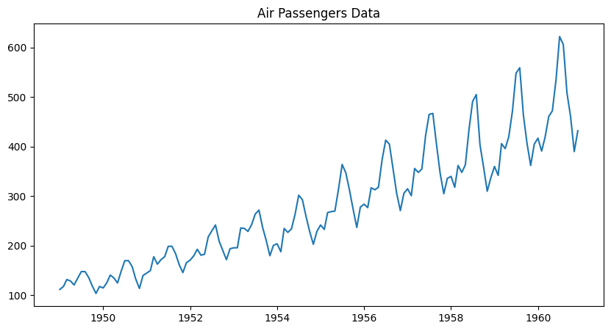
🔹 Step 3: Decomposition
The time series is decomposed into:
- Trend
- Seasonality
- Residual
- 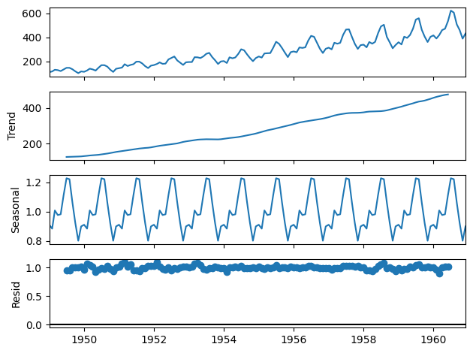

🔹 Step 4: Moving Average
- Moving averages (6-month and 12-month) are calculated to smooth the data.
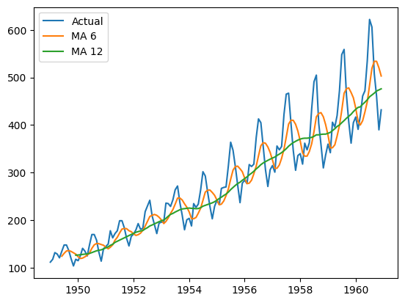

🔹 Step 5: Model Building (ARIMA)
- An ARIMA model is applied to the dataset to forecast future passenger values. 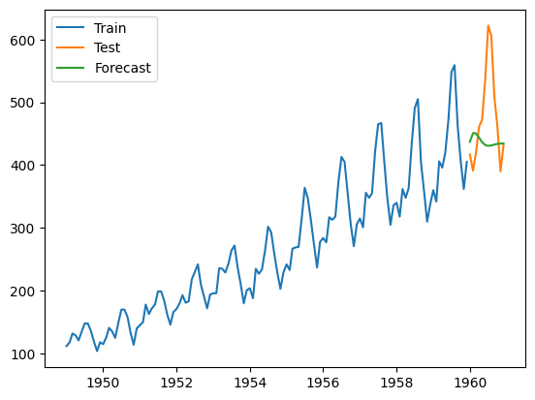
🔹 Step 6: Forecasting
- Future values are predicted using the trained model.
🔹 Step 7: Model Evaluation
- The model performance is evaluated using RMSE (Root Mean Squared Error).
🟦 6. Results and Analysis
- The dataset shows a clear upward trend in passenger numbers.
- Strong seasonality is observed, with peaks occurring every year.
- The ARIMA model successfully captures the trend but may slightly miss seasonal peaks.
- RMSE value indicates that the model provides reasonable accuracy.

🟦 7. Conclusion
- Time series analysis is an effective method to analyze and forecast data over time. In this project, the airline passenger dataset was analyzed successfully, and future predictions were made using the ARIMA model. The results demonstrate the usefulness of statistical models in forecasting real-world data

🟦 8. Future Scope
- Use advanced models like SARIMA for better seasonal forecasting
- Apply machine learning models for improved accuracy
- Use larger datasets for more reliable predictions

🟦 9. References
- Python Documentation
- Pandas Library
- Statsmodels Library
- Online resources and tutorials

