**# FutureDemandCodingChallenge_Mousami**

This repository contains a Python script to crawl events data from the Lucerne Festival website and store it in a PostgreSQL database with a custom schema. the result table from database is saved in comma seperated value file names "**Postgres_ResultTableof_ScrappedData**". Additionally, there's a Dockerfile included to containerize the solution for easy deployment using Docker Compose.

**Task Description:-**

Use Python to write a script to crawl events (date, time, location, title, artists, works and image link) from the following link: https://www.lucernefestival.ch/en/program/summer-festival-24

Insert data into a database (PostgreSQL), with a self-defined schema

BONUS TASK: dockerize your solution so we can run it with docker compose

**Instructions**

To deploy and run the solution, follow these steps:

**1. Build Docker Image:**

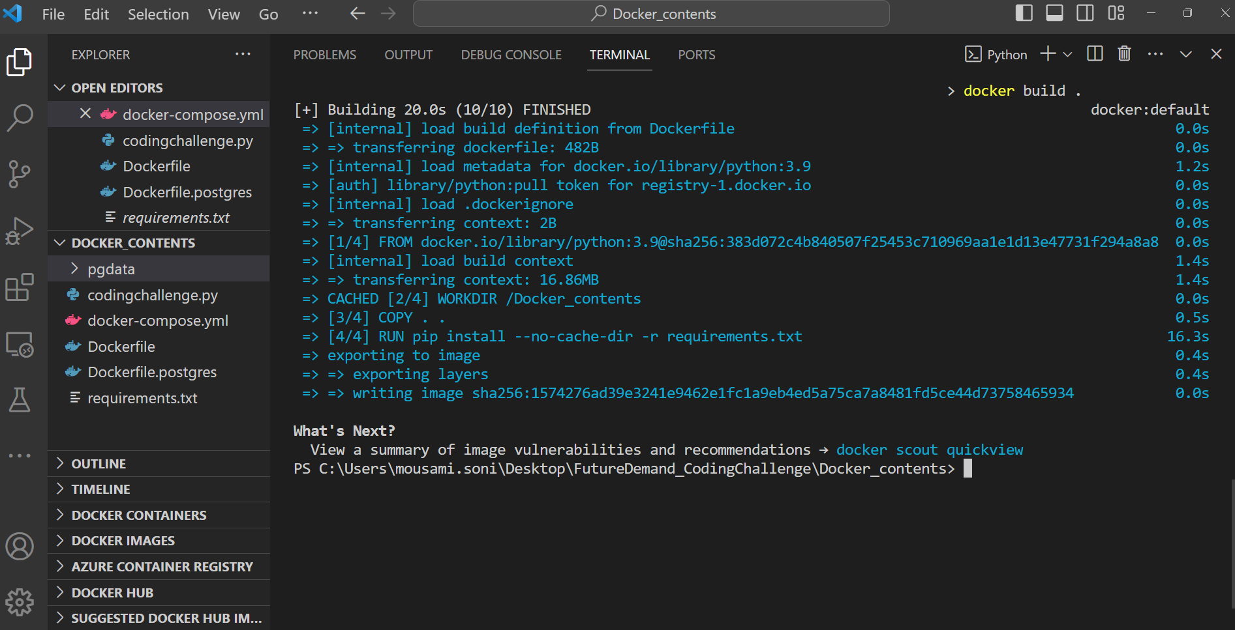**“docker build .”** to build a Docker image from the Dockerfile located in the current directory:

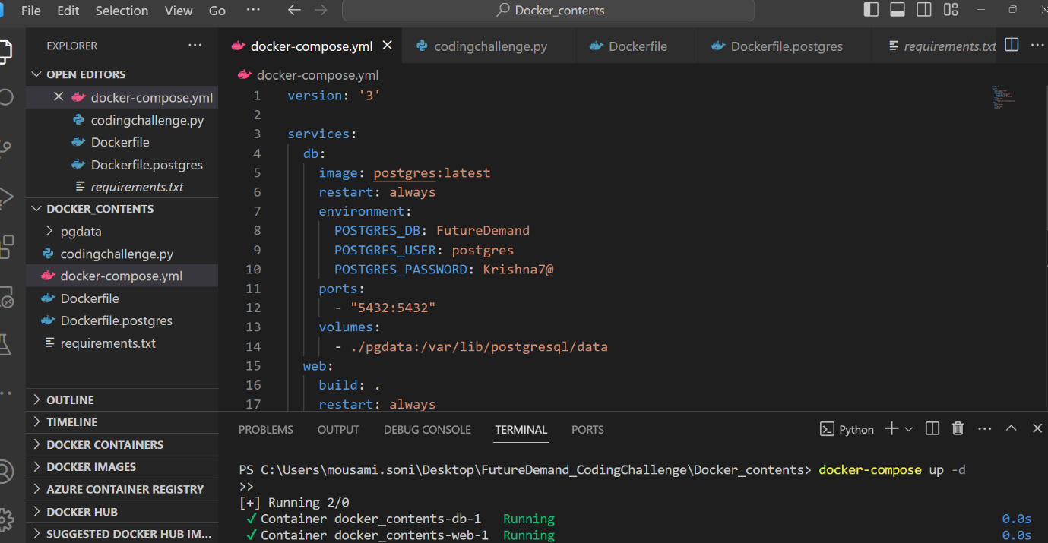2. After building the image, use "**docker-compose up -d**" to start the Docker containers defined in the docker-compose.yml file in detached mode.

**docker compose up** launches docker container defined in a “docker-compose.yml”

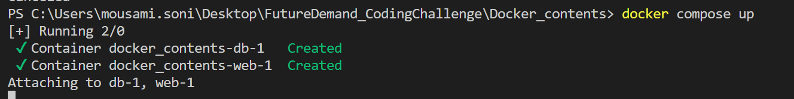

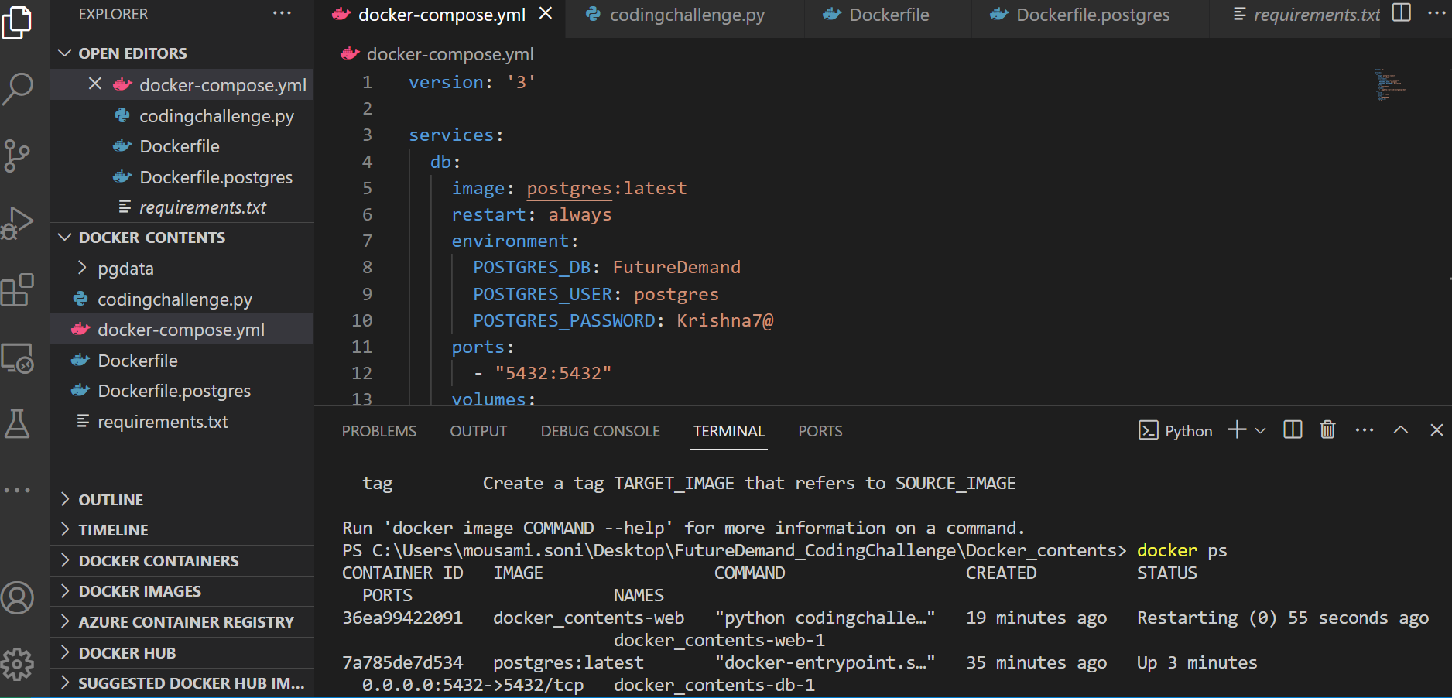3. Finally, use "**docker ps**" to list all running Docker containers and verify that the containers started successfully.