

CMPE/SE 133
Computer Engineering/Software Engineer, II
Team 4 – Qurious Designs
Requirement Analysis Document (RAD) Version 1.0
San Jose State University
March 5th, 2015

Chi, S.
Doan, Q. V.
Gaggutur, M.
Heflin, T.
Nguyen, D. D.
Nguyen, D.
Nguyen, K.
Tran, H.
Win, K.
(007624253)
(007772856)
(008579142)
(008770437)
(007978256)
(009523423)
(008756670)
(008912904)
(008715252)

Revision History
Revision | Date | Originator | Comments
1 | 3/1/2015 | Doan, Q. | Initial Revision.
2 |  | .
3
4
5
6
7

1. Introduction

Social Networking is leading the way for 21st century communications. Social networking is the grouping of individuals into specific groups. Although social networking is possible in person, primarily in schools, workplace, or the general public; a lot of people tend to favor online networking. This is because the internet is filled with millions of individuals who are looking to create promising connections based through personal interest.

The primary application of social networking is websites. The development of these applications is rigorous and difficult, but it is worthwhile. These web applications will map and measure relationships between people, groups, organizations, computers, and other interest. Online networking is a way to provide visual and analytical methods of approaching the human relationships.

  - Problem Statement

Social network sites are defined as web-based services that allow individuals to construct a public profile, define a list of other users with whom they share a connection with, and view their list of connections and those made by others. The evolution of social networking allows user to connect for professional purposes now. This project will define the requirements for a web page that full fills this purpose. The product that will be developed from these requirements will be known as ProConnect.

Users will user this service to further their careers and recruiters can subscribe and use it to find candidates for employment. There is a similar product in the market today known as LinkedIn. The purpose of the purposed product, also called ProConnect is to provide users a lightweight version of LinkedIn.

  - Purpose of the System

ProConnect is a professional networking service for work related material. The application will provide users the basic functionalities and features of online networking. The user will create a profile and begin to connect with other people through recommended interests and personal searches. With an account, ProConnect members can increase their professional appeal, seek professional opportunities, and reinforce their connections through networking. Users will primarily approach the system for the professional aspects of it, but users can still use the product for traditional networking through ProConnect social features. Users will have the features to message their friends or colleagues, they can post activities onto their feed page, and update their user information at any time. ProConnect will represent a lightweight version of the LinkedIn portal.
  - Scope of the System

The following points will describe the specific goals that ProConnect will deliver to the users:

- It is a web-based application.
- Users can create a profile.
- Users can send messages.
- Users can maintain connections.
- Users can invite other people.
- Users can interacts with others
- Discussion forum is provided
- Registration/Login facility.
- Open community.
- User can find job listings.
- User can find job seekers.

  - Objectives and Success Criteria of the Project

The objective of this project is to connect user for the purpose of professional networking. ProConnect is aiming to develop and maintain the human relationship by providing its user with an active social life. This project is a web based application that can be accessed throughout the world. The relationships that ProConnect members develop and maintain is made possible through its features and functions, specifically through messaging, pictures, and many more.

The success of the system depends on meeting the following core set of objectives:

- Creating an attractive user interface for users.
- Making sure the system is secure against threats.
- Making sure that all functions and features are operable.
- Creating a reliable application for users.

ProConnect will allow the user to connect to their professional lives and will help them in the establishment of new business contacts. To join this site, the user needs to register and then sign in to start connecting and experiencing professional social networking.

  - Definitions, Acronyms, and Abbreviations

The following is a list of definitions, acronyms, and abbreviations that are conventional in the development of web pages, and they will be used frequently throughout the Requirement Specification.

- AJAX: Asynchronous JavaScript And XML
- CSS: Cascading Style Sheet.
- DNS: Domain Name Service.
- DOM: Document Object Model.
- FAQ: Frequently Ask Questions.
- FTP: File Transfer Protocol.
- HTML: Hypertext Markup Language.
- JS: JavaScript.
- JSON: JavaScript Object Notation.
- MySQL: Open Source web database software designed for used with PHP.
- OOP: Object Oriented Programming.
- PHP: Personal Home Page Hypertext Preprocessor.
- PNG: Portable Network Graphics.
- SQL: Structured Query Language.
- UML: Unified Modeling Language.
- URL: Uniform Resource Locator.
- XML: Extensible Modeling Language.
- WWW / W3: World Wide Web.

  - Overview

The product hopes to connect users via the internet. From this connection users can expect an application specific web page for professional relationships. The user can expect the product to be operable in all its features and functionalities.

2. Current System

Social Networking has been an increasingly popular means of communicating and connecting. The user base has e ranges from teenagers to elderlies. Over 47% of Americans use social networks such as Facebook, LinkedIn, Twitter, and Instagram in 2011. This is a large jump from 2008, when the estimated social networkers was around 22%. One of the many beginning social networking sites that was introduced in the 20th century was SixDegrees.com. The site allowed users to create profiles, list their friends, and create a personal image for them. Each of these features in some form or another was adapted into every social networking application that came after it. Overtime, this phenomenon has evolved from personal to professional usage.

Many companies will do a background check on their applicants before hiring them. In most cases, employers will discover their applicants’ social pages and do a study on their abilities and characteristics from it. LinkedIn is an example of professional networking. Users will create their own professional image, completely separate from their personal pages.

The basic functionalities of a professional networking site are creating profiles, maintaining connections, and finding opportunities. Users can invite anyone to become a member of the site. This will expand the user base, and increase the many possible connections user can have. Profiles are the first thing a user will look at, and if you have not met in person before, this is going to form their first opinion of the user. This will result in a connection being built if the user has been impressed by a profile. Connecting is the core idea of any social networking application.

Professional networking sites promote job opportunities. Users can find jobs, people, and businesses that are either recommended from others, or that they find themselves. One of the most beneficial features of some of these networking pages is that certain users (employers) have the ability to list jobs and search for potential candidates. This will result in some jobs being exclusive to networking sites. On the other hand, job seekers can review the profiles of their hiring managers and discover whether or not they want to work for them. This is the main premise of professional networking.

Social Networking is a largely expanding area of communication. Many people use these applications in their everyday lives to expand their networks with other people that share the same interest that they have. From personal to professional, online networking

3. Proposed System

ProConnect will represent a system when user can develop personal and professional relationships through online networking. These are a few of the many features that ProConnect will provide.

- Proposed site is application specific to professional networking.
- Privacy of the user is given the highest priority.
- Allow users to select what to display on their personal page.
- Easy searching module.
3.1 Overview

ProConnect allows us to see our relationships through an easy-to-use interface. The purpose of the product is application specific. The product represents a center to interact with others, building a professional identity, and to discover new professional opportunities. The user interface is presented through a web browser. ProConnect will implement two main ideologies of constraints: paths and barriers.

Paths restrict user action to linear motion. This is accomplished through channels or grooves. Paths are particularly useful in controls where the control variable range is relatively small. A familiar example would be the “slide-to-unlock” function on mobile phones. The user swipes a path from left to right once to unlock the phone. There is no way to misuse this function.

Barriers absorb or redirect user actions. By doing this, barriers are able to slow, deflect, or stop user actions that may cause them to have a bad experience with the software. A common barrier is a pop-up dialogue box that can be found on many interfaces. The dialogue box could display a message such as, “Are you sure you want to send this message?” to insure that the user is prepared to send the message or not. Barriers are placed to protect the user.

3.2 Functional Requirements

In functional requirements, we identified the necessary task and activities that must be done. If an object is interactive, then it has to be able to listen to the user’s action and perform a task based on that action. Functional requirements display the necessities of event handling mechanism in every page.

    - Account

Every user must create an account in order to use ProConnect. When a user accesses the site for the first time, they must create an account before using any features. The account creation process is divided into two seconds. The first section requires the user to input their login information. This includes the first and last name of the user, email address, password, and password confirmation. The purpose of the password confirmation is to ensure that the user did not accidentally mistype when creating a password. The second section deals with information about the user’s location and employment status. The location ID will allow the user to see activities around their area. The employment status will determine the type of activities the user will see.

The account is the head class that all other objects will use to determine what a user does and when the user did it. The account information has four purposes: contain login information, contain profile information, and contain privacy information. In the account, the user has the ability to change any personal information. This includes email addresses, passwords, and privacy settings. The changes are recorded into the ProConnect database to dynamically change the user’s experience as well as their profile.

    - Activities

Activities are used commonly on to Internet to provide users with updates from the website and other subscribers the user collaborate with. This content will dynamically update within a certain time frame. In ProConnect, the activities will not only contain the updated information of users, but it will also recommend local events and job listings that match your user preference.

    - Dashboard

The dashboard will be a module the user will see after signing into ProConnect. The dashboard will be used as a fixed navigation tool for the user. The dashboard will allow the user to consistently see interactive icons that can range from simply redirecting the user back to their own activities page to allowing this to edit there personal profiles.

Req ID | Req Name | Priority | Description
dash-01 | Modules Overview | HIGH | UI display statuses and activities from each modules: Activities, Recommendations, Notifications, Messages, Network, Profile
dash-01-01 | Modules Overview - Activities | HIGH | Activities preview at dashboard take majority of the real estate to display most current activities from User's network and user should be able to load more activities as they scroll down or click "more"
dash-01-01-01 | Updates | HIGH | User can share their own activities with other ProConnect members
dahs-01-01-02 | Submit | HIGH | User clicks to send his update information into `Activities`
dash-01-02 | Modules Overview - Recommendations | LOW | The recommendations on the dashboard does not need to take a lot of real estate but focus on display the most relevant recommendations
dash-01-02-01 | People You May Know | MED | Displays a list of 3 people that the user may know according to the users work history/education
dash-01-02-02 | People Who Have Viewed | MED | Displays a list of 3 people that has viewed the primary user's profile
dash-01-03 | Modules Overview - Notifications | HIGH | Notifications preview in the dashboard can be as simple as an icon or glyphicon showing number of unread notifications. On click can either display a preview of these notifications or take the user to Notifications Center module.
dash-01-04 | Modules Overview - Messages | MED | Messages Center preview in the dashboard can be display as simple as an icon or glyphicon showing number of unread message and on click should take user to the Message center module
dash-01-05 | Modules Overview - Network | LOW | Preview simply display number of connections user currently have. The preview can also display a list of connections (top 10) order by the most frequent contact or most recent contact the user interact with
dash-01-06 | Modules Overview - Profile | HIGH | On the dashboard, the preview of the profile module would be the user's name and profile image. On click, the user will be taken to the main profile page where they can edit, update
dash-02 | Prioritized Navigation | HIGH | Provide quick access to each module in the system. UI displays should take into consideration of which module should be more visible than others in terms of frequent access and intuitiveness.
Table 1: Dashboard Functional Requirements.

    - Home

The ProConnect Home page will have three main functionalities: signing up, signing in, and requesting a password (if user forgot their own). When a user selects any of these functions they can expect to be sent to a new page depending on their choice.

Req ID | Req Name | Priority | Description
Home-01 | Navigation | HIGH | Display links to general information: about us, contact, FAQ, Sign In, Sign Up
Home-02 | Quick Sign In section | HIGH | Inputs of username and password to allow user to login. Upon invalid login, take user to main Login module to proceed with retrying or forgot passwords, forgot username...
Home-03 | Sign up link | HIGH | Highly visible link to the signup module
Home-04 | Information Navigation | MED | The navigation bar or links can locate the bottom of the home page to provide more information about our services, FAQ, about us, and contact information
Home-05 | About Us | LOW | About us page, quick overview about who we are what services we offer
Home-06 | Contact Us | LOW | A simple form to contact us for help or questions regarding our services
Home-07 | FAQ | LOW | Questions and answers about our services, what information we collect and what how our services can benefit our users
Table 2: Home Functional Requirements.

3.2.5 Message

Unlike with chatting, users can send a message to any other user. In order for user A to send a message to user B, they will navigate to the message module located on the dashboard. He/she then fills out the form with the appropriate user information, message title, and the message content. The new message will be sent to User B’s inbox in the message center. Messaging is implemented by storing a record of the message in the server. First a message object is constructed that takes in ID’s from user A and B, the message content, and the date it was sent.

Req ID | Req Name | Priority | Description
messageCenter-01 | Create New Message | HIGH | create message
messageCenter-01-01 | Recipient | HIGH | add the recipient of the message
messageCenter-01-02 | Subject | MED | add subject line of the message
messageCenter-01-03 | Message | HIGH | write message to the message field
messageCenter-01-04 | Send Button | HIGH | send message
messageCenter-01-05 | Cancel Button | HIGH | cancel message and go back to inbox
messageCenter-02 | Inbox | HIGH | shows the list of received messages
messageCenter-02-01 | Search Inbox | LOW | search messages in the inbox
messageCenter-03 | Message | HIGH | display received message
messageCenter-03-01 | Reply | HIGH | reply to the message
messageCenter-03-02 | Back Button | HIGH | go back to Inbox
messageCenter-04 | ProConnect Logo | HIGH | Interactive Image
Table 3: Message Functional Requirements.

    - Network Management

The most important feature is being able add, remove, and find new connections with other ProConnect members. Users can type in the name, or email address of a colleague in the search bar in the dashboard module. After clicking search, the will be sent to a new page containing a list of possible people that match the user’s input.

Aside from finding new connections, the user has the feature to accept and decline networking request from other ProConnect members. This is visible through the Network Management Module located on the dashboard. When the user enters the module, they will see a list of people trying to connect with them. If the user accepts the connection then both user will be linked. In the second case that the user denies the request, then the module will remove the user from the list.

Req ID | Req Name | Priority | Description
Network-01 | Add connections | HIGH | Allow user to enter a username or email directly add a new connection. Also allow user to be able import from a contact list or an external account with available APIs
Network-01-01 | Username / Email | HIGH | User inputs the name of the colleague they are looking for
Network-01-02 | Submit | HIGH | User clicks to submit information to database to search for colleague
Network-02 | Remove connections | HIGH | allow user to remove a user from their network quick suggestion through email or user id or search by name
Netword-02-01 | Username / Email | HIGH | User inputs the name of the colleague they are looking for
Network-01-02 | Submit | HIGH | User clicks to submit information to database to search for colleague
Network-03 | Connections Suggestion | MED | A module part of the Network management page to suggest a connection that has common connections with user or in similar industry, or associations with common organizations or interests
Network-04 | Connections browsing | MED | Part of the landing page of network management, the user should be able to see a list of current connections. The user can see which company and status their connections as they browse. The list can be sorted by either most recent in contact with or by Name, Companies.
Network-05 | Search | MED | the ability to search the network quickly by any keywords regarding industry, names, companies, or skills
Network-05.1 | Search Advanced features | HIGH | This feature will be for user with "recruiter" status in their account and are allowed to access important information about user. Allow search by skills set, experience or companies was or currently work for.
Table 4: Networking Functional Requirements.

    - Notification Center

The notification center will serve as a module to alert the user of news involving the user. The center will have many notification types: new message notification, new invitation notification, job alert notification, event alert notification, and many more. The module will alert the user if another member is attempting to contact them, or it can alert the user of a job opening within the user’s area that match his/her job skills.

Req ID | Req Name | Priority | Description
notificationCenter-01 | new message notification | HIGH | notification when user receives a new message
notificationCenter-02 | invitation notification | HIGH | notification when user receives a new invitation to connect
notificationCenter-02-01 | invitation accept notification | MED | notification when someone accepts your invitation
notificationCenter-03 | service update notification | LOW | notification when service update is available
notificationCenter-03-01 | job alert | HIGH | notification for job search alert
notificationCenter-03-02 | event alert | MED | notification when there is an event
notificationCenter-03-03 | comment on update notification | MED | notification when someone comments on your update
notificationCenter-03-04 | like on update notification | MED | notification when someone likes your update
notificationCenter-03-05 | comment on group discussion notification | LOW | notification when someone comment on your group discussion
notificationCenter-03-06 | likes on group discussion notification | LOW | notification when someone likes on your group discussion
notificationCenter-03-07 | new viewer notification | LOW | notification when someone views your profile
Table 5: Notification Functional Requirements.

    - Profile

On the Profile page, the user can view his/her profile details. The profile will contain three main sections: the user’s personal information, work information, and a file manager. The first section will include a profile image that the user can update freely. It will also display their name, email, and other networking applications that are being used, which the user can edit. The second section will contain the user’s work history; this is including their educational background. The final section is a file manager that allows the user to upload and share any of his/her personal file, such as: resumes, photos, videos, websites, or presentations. This information is also visible to other ProConnect members, but they cannot edit the information.

Req ID | Req Name | Priority | Description
Profile-01 | Profile Image | LOW | Allows user to click on their image to upload an image of their own. On signup, there should be a default image to be placeholder
Profile-02 | Personal Information | HIGH | Requires user to enter name, mailing address, phone number, email, alternate email
Profile-02-1 | Name | HIGH | First Name and Last Name are required with optional middle initial
Profile-02-2 | Email | HIGH | The email should be unique to the user and no other users can have the same email address as the user will be allowed to use their email to log into their account
Profile-02-3 | Online Social Media | LOW | User ID and accounts of other social media to connect through
Profile-02-4 | Email Address | LOW | Personal mailing address as optional
Profile-03 | Skills | MED | allow user to quickly add new skills and rank how proficient they are with each skills, also allow endorsement from other users for each skill the user claims to have
Profile-04 | Experience | HIGH | allows user to add work experience with other company or organizations and how long the experience was for
Profile-05 | Projects | HIGH | allows user to add projects that they ahve work on including the name of the project, the project website, the description of the project and other ProConnect Users who work on the same project
Profile-06 | Education | HIGH | allows user to add schools that they have attend to. Should suggest school names if the school is popular. Allow adding certifications for each education listed also expectation of graduation or graduation date. Also add activities and societies they have particiated at each school
Profile-07 | Login | HIGH | let user manage their passwords and login id, change account type of subscribe as a recruiter
Profile-08 | File Manager | HIGH | User manages the files they upload
Profile-08-01 | Document | HIGH | Document specific upload - on click, explorer pop up
Profile-08-02 | Photo | HIGH | Photo specific upload - on click, explorer pop up
Profile-08-03 | Link | LOW | Link specific upload - on click, explorer pop up
Profile-08-04 | Video | LOW | Video specific upload - on click, explorer pop up
Profile-08-05 | Presentation | LOW | Presentation specific upload - on click, explorer pop up
Table 6: Profile Functional Requirements.

  - Nonfunctional Requirements

3.3.1 Usability

ProConnect will promote high usability prospects. The user can expect to use the site as freely as they want. The only restriction that the use will have is that they need to register with ProConnect in order to use all features and functionalities. There will be an online help desk that will inform and aid the user through any troubles they might have with the system.

ProConnect will promote basics of availability and accessibility. We will ensure server uptime, it is important to ensure that our members will be able to load our site. ProConnect will assure that there will not be any dead links. Finally, we will assure ProConnect can handle all sorts of connections. All of this is to ensure that the user will be able to use the website smoothly.
3.3.2 Reliability

ProConnect must perform all required functions to establish a highly robust environment. We will assure all our members that their confidential information will remind confidential, this involves login information, access to their own personal file (Documents, Media, Video), and we will assure that the system will be operable at all times. In the event that the system fails, we will have several backup-servers to reestablish the system while we work to fix the problem. Not only will we ensure the integrity of our system, but we will also protect the privacy and wellbeing of our users. This is done with the use of the user password. It will have a 2^16 bit encryption that is not readable by anyone. ProConnect will assure all users functionality and dependability at all times.

3.3.3 Performance

ProConnect will address the following to assess the site’s performance: Response Time, Workload, and Scalability. The general advice on response time is that 0.1 seconds is about the time for having the user feel that the system is reacting instantaneously. 1.0 second is the time limit for the user’s flow of thought to stay uninterrupted. ProConnect will take in this advice to assure that pages will not load longer than 1.0 seconds, unless it is strongly affected by the user’s connection. The workload is often described as the scenarios that the users are likely to execute. Scalability is the specified as the increase in the system’s workload that the system should be able to process. One example of a quality requirement for ProConnect is that the activities page should automatically update every 5 minutes.

    - Supportability

The website will have the ability to be easily modified and maintained to accommodate typical usage or change scenarios. ProConnect will concern adaptability, maintainability, and internationalization. The current system will be easy to adjust to deal with additional applications, and it will be built to deal with new technology or to fix defects. The only constraint on the system is that ProConnect is only supported by a limited amount of web browsers. The system will support major web browsers, such as Google Chrome, Mozilla Firefox, and Internet Explorer.

    - Implementation

Implementation involves gathering all the contents necessary to populate the pages of the site. ProConnect is constrained within traditional web page languages. All front-end related software associated with ProConnect, will be written in HTML, CSS, and JS. The back-end related software be implemented through the MySQL workbench. The scripting language PHP will be used to bridge the gap between the front and back end of the website. These languages will constrain the limit of actions that can be performed by the user, thus increasing the usability of the design and reducing the likelihood of operator error.

    - Interface

ProConnect will be constrained to a handful of web browsers. If it is accessed from another application such as Opera, then there could prove to have some faultiness, missing images, or rigid performance. Also, the product cannot be displayed on mobile applications because full HTML script on a mobile device would cause the product to perform poorly.

3.3.7 Packaging

Packages are hidden batches of files that download onto the user’s computer when it is accessed. In order for a user to download the packages from ProConnect, they will need a web browser such as Internet Explorer, Mozilla Firefox, or Google Chrome. Currently ProConnect has not been optimized for mobile viewing. If a user accesses the web page through a mobile application, then it will be rigid and difficult to display. For now, ProConnect will only be displayed on desktop browsers. ProConnect has not confirmed quality uses on other browsers such as Safari or Opera. When a user accesses the ProConnect site, packages containing HTML, CSS, and JS scripts will download onto the browser to display the web page.

3.3.8 Legal

ProConnect will abide by all legal requirements. On every page (excluding the user’s homepage), we will display links that will lead the user to our company information, privacy policy, cookie policy, and user agreements. Our company information will display all of our business information, including name, addresses, and place of registration.

ProConnect is a web site that will meticulously collect user information. In order to protect the user, the privacy policy is there to inform the user what ProConnect will do with the data, and that all usage will comply with The Data Protection Act. Also, the user is allowed to change their ProConnect information at any time by editing their profile, deleting content, or by closing their account.

The User Agreement section will inform the reader that they are entering a legally binding contract with ProConnect. The user will agree to use our product, and we will have the freedom to collect, use, and display any information the user provides as long as it abides by all legal requirements.
At ProConnect, we believe in being clear and open about how we user the information provided by users. The Cookie Policy will explain to the user about how and when we use cookies. A cookie is a small file placed onto your device that enables ProConnect features and functionality. For example, cookies allow us to properly identify your device, secure your access to ProConnect, and even know if someone is attempting to access your account.

Usage | Description
Authentication | If you’re signed in to ProConnect, cookies will help us show you the right information and personalize your experience.
Security | We use cookies to enable and support our security features, and to help us detect malicious activity and violations of our User Agreements.
Preferences, Features and Service | Cookies can tell us which language you prefer to use. They can help you fill out forms on ProConnect more easily.
Performance, Analytics and Research | Cookies help us learn how well our site and plugins perform in different location. We may also use cookies to understand, improve, and research products, features, and services.
Table 7: Legal assurances of ProConnect.

  - System Models

There will be many tables, diagrams, and scenarios in the following section. All of these UML diagrams will simplify the implementation of ProConnect.

3.4.1 Scenarios

Scenario Name | signUp
Participating Actor | User
Flow of Events | - The user will access ProConnect through a web browser.  - Packages will be downloaded onto the web browser and the home page will display.  - The user will navigate to find that the Sign Up div is in the center of the home page.  - The User will input the necessary information to create an account.  - Once the user has successfully inputted the correct information, an email confirmation will be delivered to the user.  - The user will go to his/her email and activate the link that is attached to the ProConnect Account Confirmation email.  - The link will redirect the User to their new profile.
Table8: Sign Up Scenario.

Scenario Name | messaging
Participating Actor | User A  User B
Flow of Events | - User A wants to message User B.  - User A access the Message Module located on the Dashboard.  - User A will be directed to the Messaging page.  - User A will write in the recipient’s name.  - User A will write the message body.  - User A will submit the form, and a message is created.  - User B receives the message in their inbox.
Table9: Messaging Scenario.

Scenario Name | removeMessage
Participating Actor | User
Flow of Events | - User will navigate their Message Center page.  - User will find the message thread he/she wished to remove.  - User will click on trash message.  - Message will be removed from the user’s inbox and in ProConnect’s database
Table10: Remove Message Scenario.
Scenario Name | colleagueSearching
Participating Actor | User A  User B
Flow of Events | - User A searches for a User B by inputting their name into a textfield.  - The database will receive the information in the textfield and culminate a unordered list of possible User B’s.  - User A is directed to a new page that list ProConnect members that match the information User A inputted.  - For every possible User B, that User A views, then User B will be notified of it.
Table11: Colleague Searching Scenario.

Scenario Name | deleteProfile
Participating Actor | User A
Flow of Events | - User A will access the Account Settings module.  - User A will be redirected to a page where he/she has to re-enter their user information to access their account settings.  - User navigates to Close Your Account hyperlink.  - User is redirected to a new page that asks for the reason behind their decision.  - User clicks continue, and the account is closed temporarily.  - After a number of day, the account is permanently closed.
Table12: Deleting Profile Scenario.

Scenario Name | signIn
Participating Actor | User
Flow of Events | - The user will access ProConnect through a web browser.  - Packages will be downloaded onto the web browser and the home page will display.  - The user will navigate to find that the Sing In section is located at the top of the home page.  - The user will enter in email and password.  - The user will be directed to their ProConnect profile.
Table13: Sign In Scenario.

Scenario Name | editProfile
Participating Actor | User
Flow of Events | - User will edit their profile by locating the profile tab on their dashboard.  - The tab will contain a hyperlink to send the user to a page that will allow the user to edit their profile.
Table18: Editing Profile Scenario.

Scenario Name | accessPrivacy
Participating Actor | User
Flow of Events | - User will find the Account and Setting module on their dashboard.  - User will click on the module and be sent to a page where they have to enter their login information for security purposes.  - User will be sent to their Account and Settings page.  - User will navigate to find their privacy settings.
Table14: Accessing Settings Scenario.

Scenario Name | gotoConnections
Participating Actor | User
Flow of Events | - User will navigate from their landing page to their connections.  - User will be directed to a new page called Connections
Table15: Go to Connections Scenario.

Scenario Name | removeConnections
Participating Actor | User A  User B
Flow of Events | - User will find the User B they are removing a connection with by inputting their name or email into a searchfield.  - User A will confirm that they will remove User B.
Table16: Remove Connections Scenario.

Scenario Name | addImage
Participating Actor | User
Flow of Events | - User will edit their picture by clicking on their profile image on their profile page.  - A file manager will pop up asking if the user want to upload a new image.  - The user agrees to upload a new image.  - The image is stored on to the ProConnect database.  - The image is displayed on the user’s profile.
Table17: Adding Image Scenario.

Scenario Name | updateActivities
Participating Actor | User
Flow of Events | - User navigates to their home page.  - User finds the activities section located in the middle of the screen.  - Above the activities section and below the dash board is a location for users to enter into a textfield an activity that they are doing, or have done already.
Table19: Updating Activities Scenario.

3.4.2 Use Case Models

The following section will provide a list of use case models that will represent the many features and functionalities that users can expect.
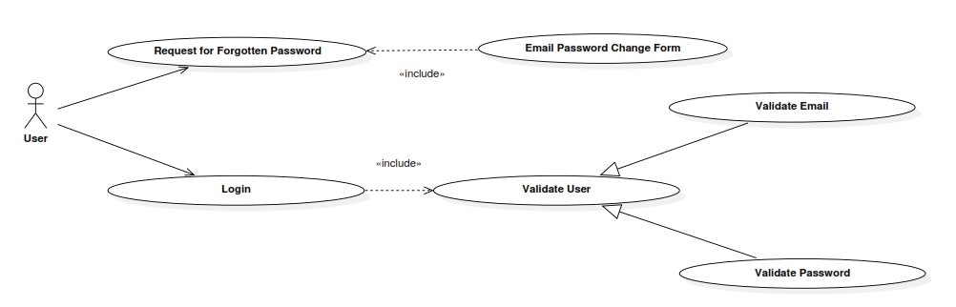
Figure 1: Use Case of Signing In / Up

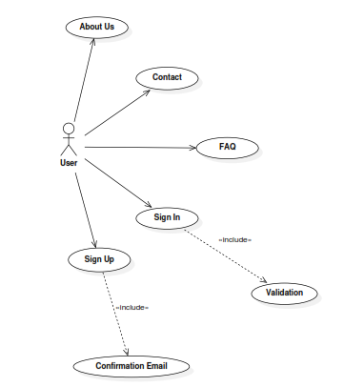
Figure 2: Use Case of Home Features

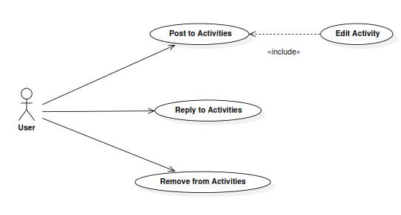
Figure 3: Use Case of Activities Features

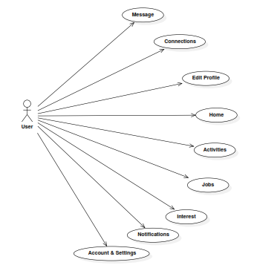
Figure 4: Use Case of Dashboard Features

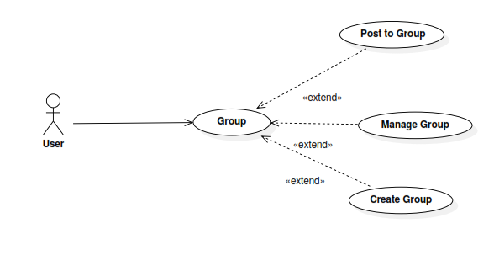
Figure 5: Use Case of Groups Features

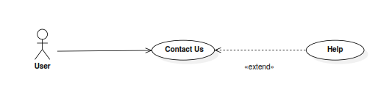
Figure 6: Use Case of Help Features

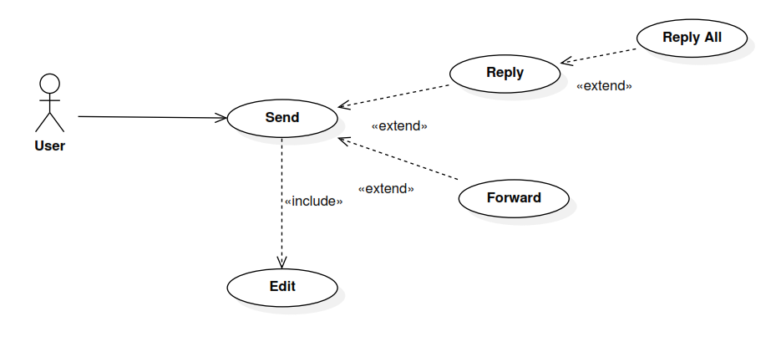
Figure 7: Use Case of Messaging Features

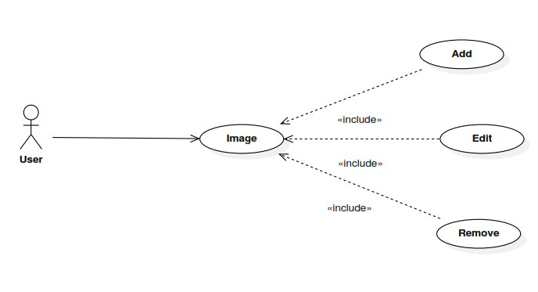
Figure 8: Use Case of Image Features

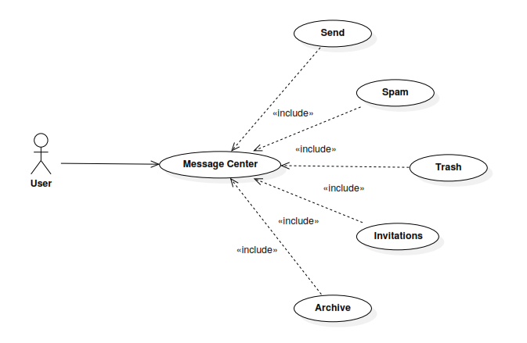 Figure 9: Use Case of Message Center

3.4.3 Analysis Object Model

The following is a database class diagram of the product.

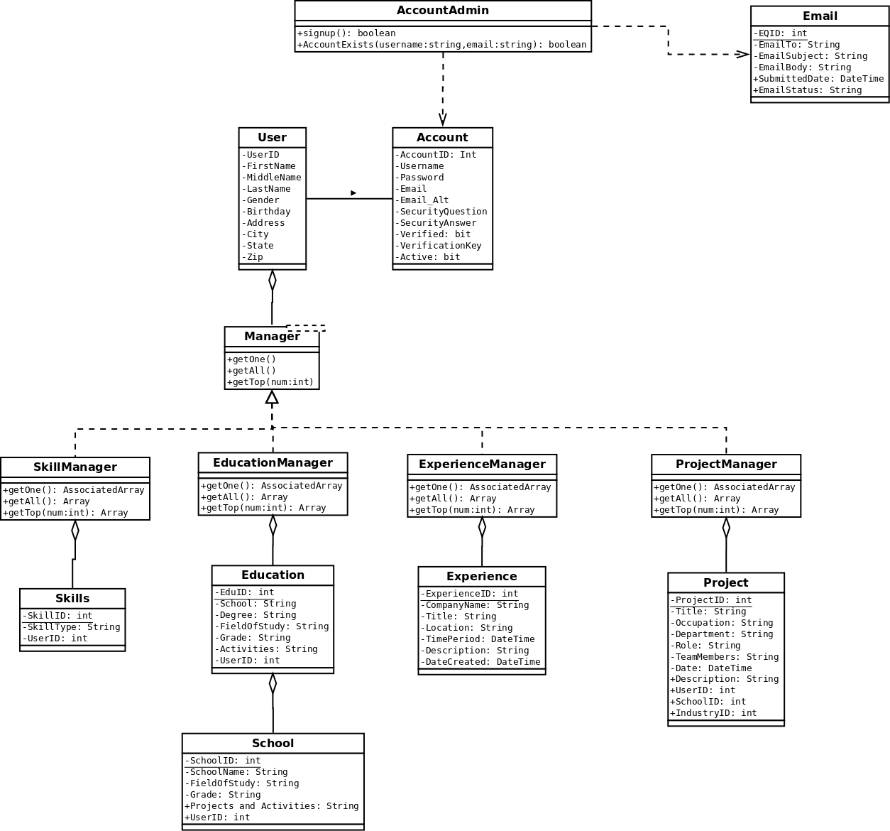

Figure 10: Class Diagram of ProConnect Backend Development.

    - Dynamic Model

The following section will present the dynamic models of the system.
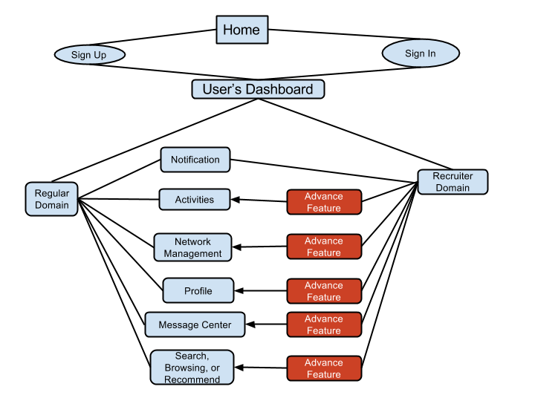
Figure 11: Event Flow of User Signing In / Up
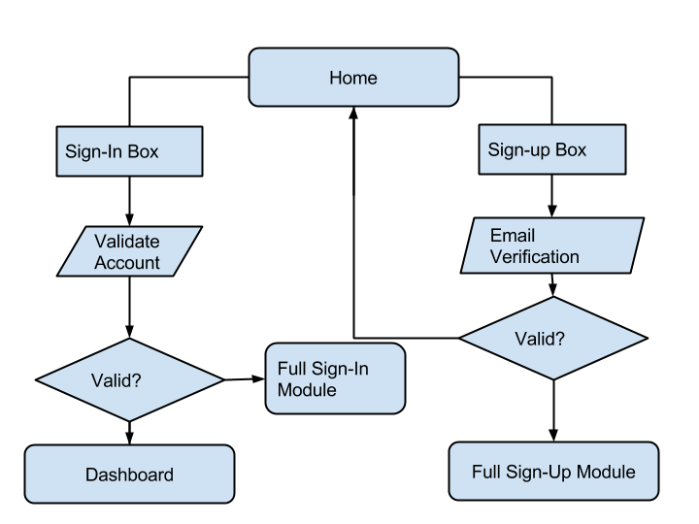
Figure 12: State of User Signing In / Up
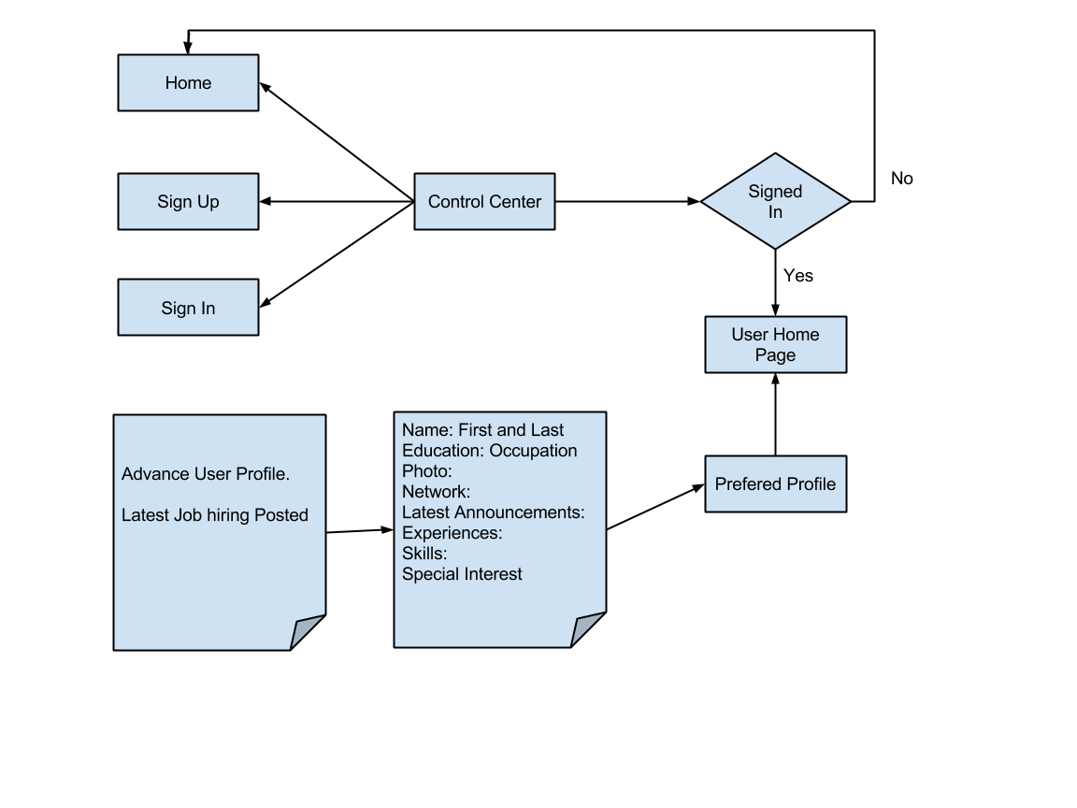Figure 13: State Diagram for Control Center.

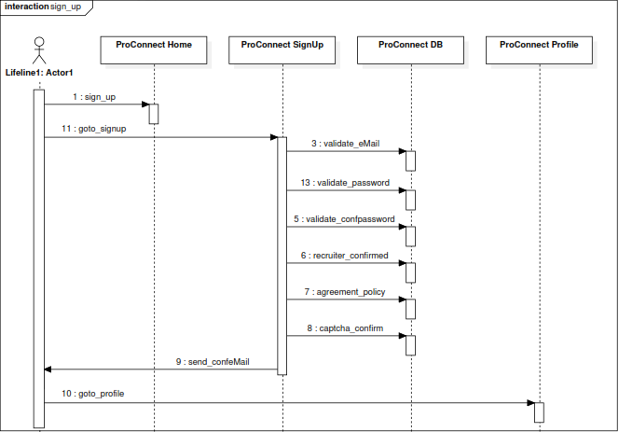
Figure 14: Sequence Diagram of Signing Up.
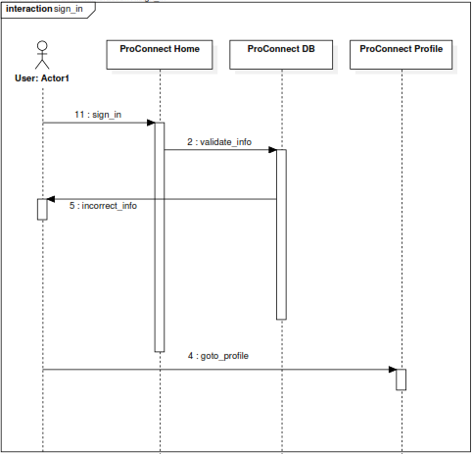
Figure 15: Sequence Diagram of Signing In.

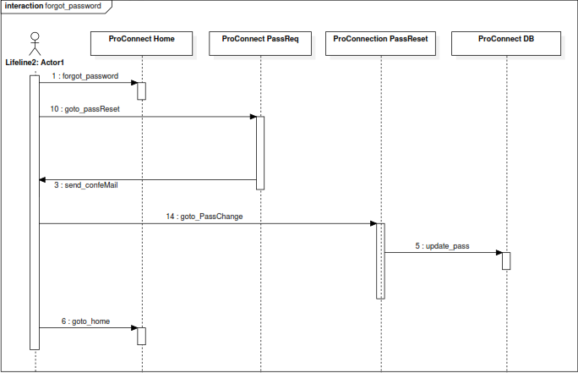
Figure 16: Sequence Diagram of Requesting a Password Reset.
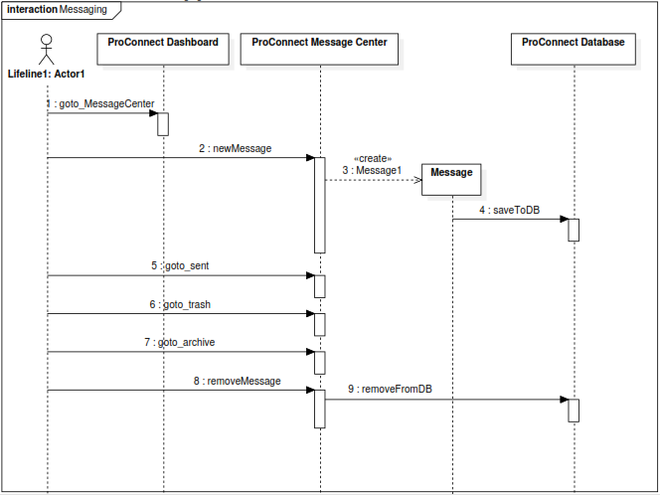 Figure 17: Sequence Diagram of Message Center.

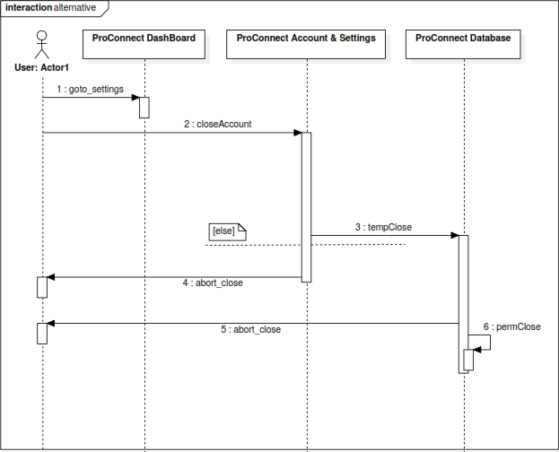
Figure 18: Sequence Diagram of Closing an Account.

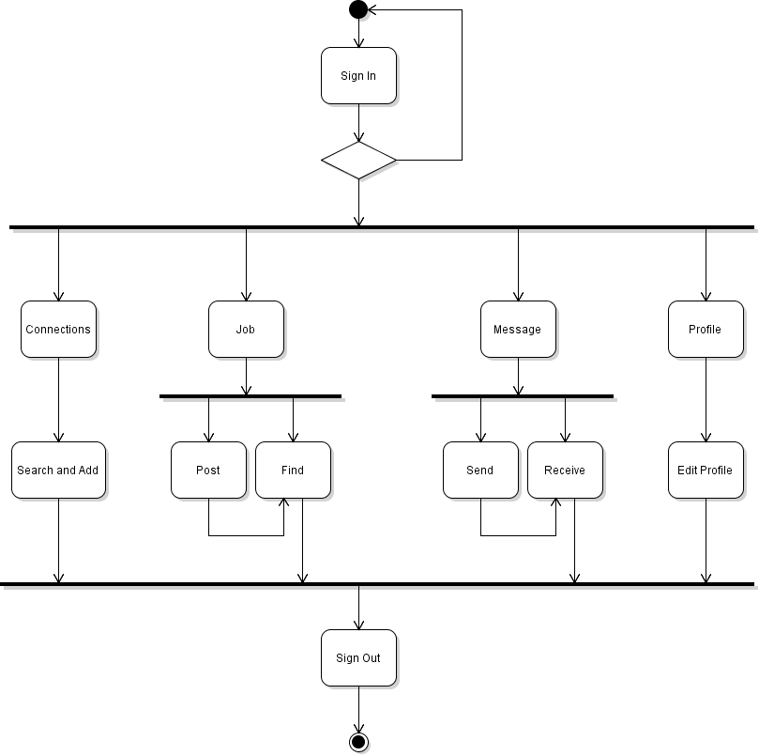
Figure 19: Activity Diagram of ProConnect main features.

3.4.5 User Interface

In the following section, there will be a list of images that represents the ProConnect. There will also be an extensive list of page mock ups that will represent the overall display of ProConnect.

Figure 20: ProConnect Logo.

Figure 21: ProConnect Background.

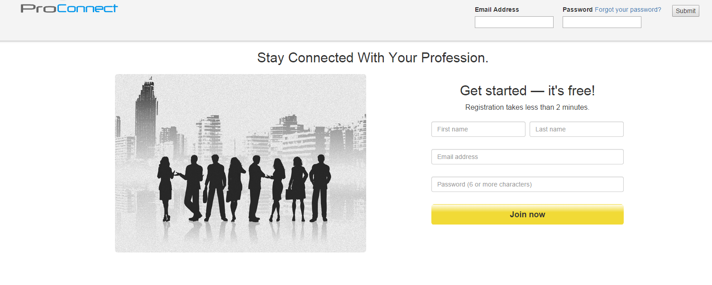
Figure 22: ProConnect Home Page.
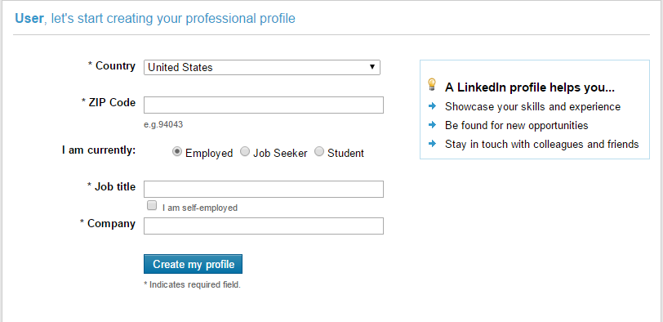
Figure 23: ProConnect Second Sign Up Page.

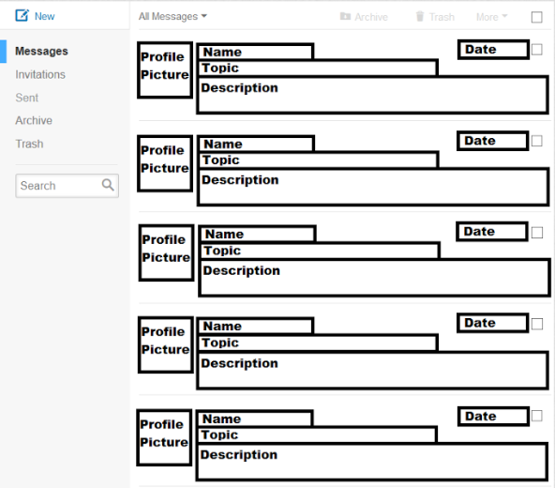
Figure 24: ProConnect Message Center Page.
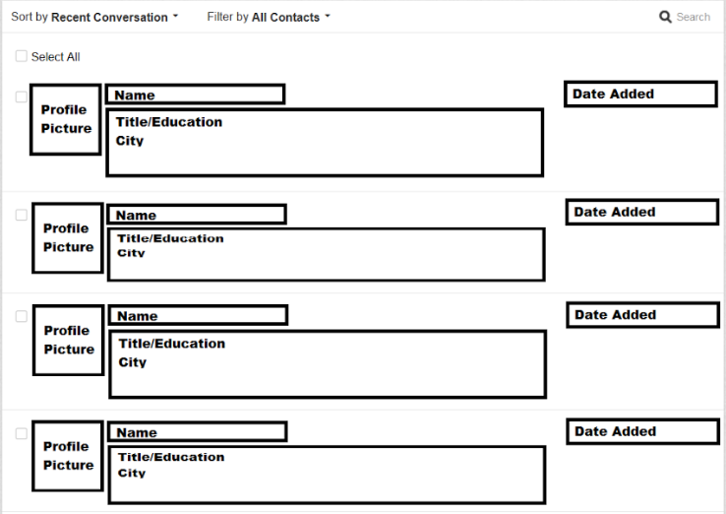
Figure 25: ProConnect Connections Page.

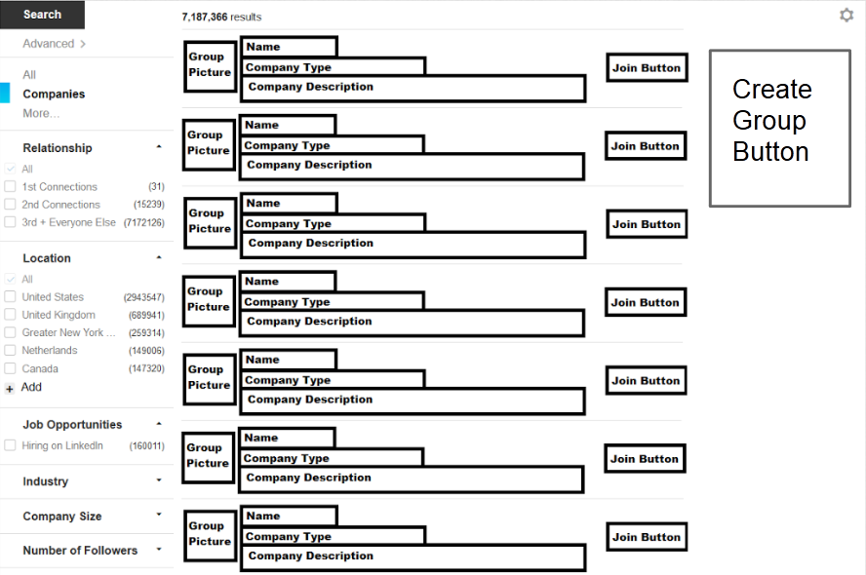
Figure 26: ProConnect Group Searching Page.
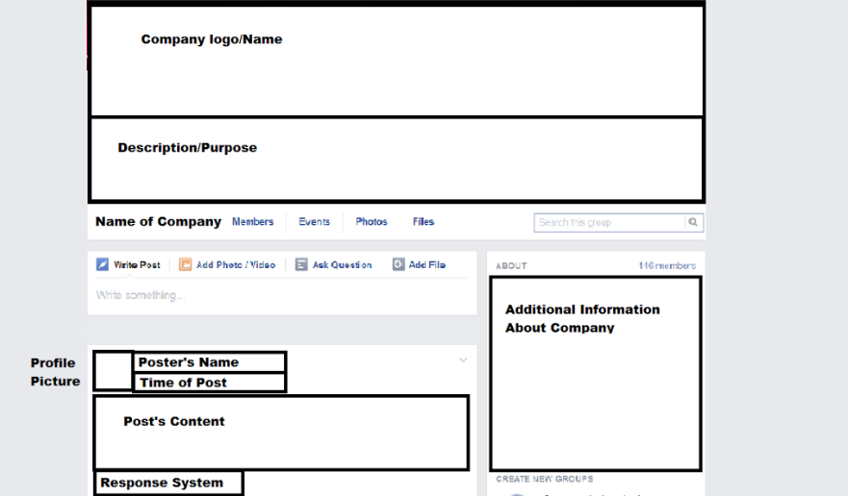
Figure 27: ProConnect Background.

4. Glossary

Animation – The process by which a set of images simulate movement when they are shown in a specific order

Apache – A web server developed by the Apache Software Foundation. It works with a range of operation systems including Linux, Unix, Solaris, and Windows.

ASCII – Stand for American Standard Code for Information Interchange. ASCII is a set of codes used to represent various character including letters, numbers, and special control characters.

Bandwidth – The amount of data that can be transmitted over an internet connection in a specific period of time.

Bit – Abbreviation for binary digit. A bit is a unit of data that can have a value of 0 or 1. It is the smallest unit of data that can be stored in a computer.

Browser – Same as a web browser.

Cache – Pronounced as cash. In web terms, a cache is a storage space where the copies of web pages and other web resources such as images are stored.

Compress – In web terms, compression is reducing the size of web resources such as webpages and images so that they are received and viewed quicker by the user.

Cookie – A small text file that a web server may store on a user’s computer for the purpose of uniquely identifying the user during future visits to a website.

CSS – Stands for Cascading Style Sheet. CSS is a language used for declaring style sheets that describe how the contents on webpages will appear.

Database – A collection of data stored in a computer in such a way that a program or a webpage can easily find, select, and/or manipulate the desired data.

DNS – Stand for Domain Name System. DNS is a system used to translate domain names into IP addresses.
Download – The process by which data is transferred from a remote location to a computer.

E-Mail – A unique name that is used to identify and send e-mail messages to a person or organization on the internet.

Encryption – The process by which data is converted into a secret code from its original form via some algorithm. The data in its original form can then only be read by those who can reverse the encryption.

Firewall – A system used to prevent access to a network or certain devices on a network.

Forum – An online discussion group devoted to various subjects.

Host – A computer that is accessed by a user from a remote location, also any computer on a network.

HTML – Stands for Hyper Text Markup Language. HTML is a language that is the core of the World Wide Web. HTML defines the structure of a web document as well as the layout of text and various elements on it such as buttons and images.

HTTP – Stands for Hyper Text Transfer Protocol. HTTP is a protocol that typically runs on port 80 and is used to send web resources such as images and HTML documents across the World Wide Web.

Hypertext – Text that is linked to other documents in a way that makes it possible for readers to read related documents by clicking on a highlighted word or symbol.

JavaScript – An object-oriented high level language used for web development. JavaScript was originally created by Netscape.

Linux – A free open source operating system based on UNIX. Linux gets its name from the man responsible for developing most of the operating system’s kernel.

MySQL – A free open source database system commonly used for interaction with web applications.

OS – Stands for Operating System. An OS is the central program on a computer. An OS is responsible for running other programs, getting inputs from the user, sending output to the screen, and communicating with the hardware.

PHP – Stands for Hypertext Preprocessor. PHP is an open source, server-side, high level, object-oriented web language used to develop dynamic web pages.
PNG – Stands for Portable Network Graphics. PNG is a graphics format that uses lossless data compression.

Scripting – A language used to write scripts that are usually executed in a web browser or a web server. Scripting languages are often used to add functionality to web pages such as interaction with the user, animation, and different menus.

URL – Stands for Uniform Resource Locator. A URL is an address containing three parts that points to resources on the internet. The first part of a URL specifies the protocol to use. The second part of a URL specifies the domain or IP address where the resource is located. The third part of a URL specifies the location of the file.

Virus – A malicious program whose purpose is to harm a computer by deleting files, preventing log ins, and other malicious activities.

ZIP – A popular file compression format. Files that are compressed with the ZIP format have a .zip extension and are called ZIP files.

5. Appendices

A. Hardware Requirements

  - Process : Intel Pentium IV 2.0 GHz or higher
  - RAM : 512 MB and higher
  - Disk Space : 80GB and higher
  - Monitor : CRT/LCD/LEF monitor
  - Keyboard : Normal/Electrical/Mechanical
  - Mouse : Compatible Mouse

B. Team Staffing and Responsibilities

Back-End Team

- Hung Tran (Team Lead/ Team Manager)
  - Hung Tran is the leader of the back-end developers. He is responsible for overseeing the development and implementation of the MySQL database. As team manager, he is also responsible for overseeing the developments and progress of the entire team.
- Kyaw Win
  - Kyaw Win is a back-end developer, and is responsible of writing the script that will bridge the interface and the database.

Front-End Team

- Duy Nguyen (Team Lead)
  - Duy Nguyen is the leader of the front-end developers. He is responsible for overseeing the development and implementation of the user interface.
- Sung Chi
  - Sung Chi is a front-end developer, and she is responsible for writing the HTML, CSS, and JS that will create the user interface of ProConnect.

Requirement Engineering Team

- Quoc Doan (Team Lead)
  - Quoc Doan is the leader of the requirement engineering team. He is responsible for determining user expectations for ProConnect.
- Khanh Nguyen
  - Khanh Nguyen is a requirement engineer, and he is responsible for determining the needed features and functionalities of the product.
- Duy Nguyen
  - Duy Nguyen is a requirement engineer, and he is responsible for validating the relevance and detail on the features and functionalities of the product.

UI Design

- Timmy Heflin (Team Lead)
  - Timmy Heflin is the leader of the UI design team, and he is responsible for overseeing the designs of ProConnect.
- Mohammed Gaggutur
  - Mohammed Gaggutur is a member of the UI design team, and he is responsible for creating the designs of ProConnect.

C. Notebook Log

The follow section will list the partial agendas and conversations of the Qurious Designs meetings.

Meeting – 02.05.2015

Agenda:
- Meeting Process:6
  - Time: Thursday @ 4 P.M. Weekly
  - Location: SCE [ENGR 294] or Library (Reserve Room, or Mezzanine)
  - Minutes Taker: → Duy Nguyen → Duy D Nguyen → Hung Tran → Khanh Nguyen → Kyaw Win → Timmy Heflin → Mohammed Gaggutur → Quoc Doan
- Discuss Language and Tools:
  - Client-side: HTML, CSS, JavaScript
  - Server-side: PHP and MySQL (Alternative: C#/VB .NET and MS SQL, or Node.js and MongoDB)
  - IDE: Free For All
  - Version Control: Git: Bitbucket, Github, Google Drive, or Dropbox.
  - COTS: Bootstrap, JQuery, Foundation, Web Templates
- Software development model: Agile Programming (Goal 3 versions)
  - Plan & Design
  - Implement
  - Test
  - Release, get Feedback and Repeat
- First Step: Plan and Design
  - Requirements Elicitation and Analysis
  - Target: Job seekers, recruiters
  - Functional Requirements: Core functionalities and features
  - Non-functional requirements
  - Views: UI Design: for Job Seekers, and for Recruiters
  - Controllers: JavaScript classes and objects
  - Models: SQL structures and PHP Delivery
- Tasks delegation:
  - Requirements Engineering (2)
  - UI Design (2)
  - Classes Design: UML (2)
  - Database Design: UML (2)
- GOAL: Plan and Design for Version 1.0 done by Thursday 02/12/2015
- Confirm Next Meeting 02/12/2015 @ 4 P.M.

Meeting – 02.12.2015

- Recap Last Week:
  - UI Team: Outline of UI pages, summary of number pages needed. UI Flow/Links Map
  - DB Team: Database design. Tables Mapping. Analysis of information required for ProConnect
  - Requirements Team: System Overview. Summary of system modules and requirements of each. Function and Non-Functional.
- Meeting Objectives:
  - Progress report from teams
  - BiWeekly Meeting: (Wed 02/18/2015 @ 5:00pm): Who’s available? What are we reporting? Scribe? What should we bring? Goals for next Bi-Weekly Meeting?
  - Team restructuring options:
    - Keep team as is
    - New Structure 1: 2 front end developers, 2 back end developers, and 5 continue on Requirements Engineering, Research and Design
      - Goal: Achieve first version of product sooner
    - New Structure 2: Quoc ⇒ Requirements Engineering, Hung => Database Design, and Amy => UI, Mohammed ⇒ Requirements
      - Invest more in planning and design
    - Any more ideas?
- Next 2 week Objectives:
  - Goal: Finish Version 1.0 Home SignUp and SignIn - Stop Point: User Dashboard
  - Requirements Engineering: Activities Module Requirements, Profile Requirements Continue ⇒ More details (High priority), Network/Connections Management Continue ⇒ More details (High priority)
Meeting – 02.18.2015

Time start: 5:01 10/18/2014

Missing: Duy (last minute work excuse)
Mohamed (Class)

Review: hung manage
Duy Amy front end dev
Hung and Kyaw back end dev

Req engineering Quoc-lead, Duy khanh

UI design:

Milestone: March 1

Start coding right away with version 1.

Req engineering,

User, Class diagram, next week first draft, second draft next week after

Prof: since doing agile, focus on high priority, can shuffle priority later, only focus on priority item.
Hung: Most modules we going to dev., first main feature, home page, login, signup, recruiter page layered on top of reg user

Hung: Progress report on back end, [handover database design chart], there might be extension as we go on. Use MYSQL and PHP for back end. Expect to have code by the end
Prof: I need to see the class diagram and see relationship with data

UI: design the ICON and MENU BAR AND BACKGROUND by end of the. Relationship diagram needs to be developed
Hung: Front end is already been working on, this is how it looks like,

Prof: Is this the real LinkedIn,

Hung: no this is just the mockup

Hung: in terms of team communication meet on every Tuesday and Thursday. Also 5 minutes after class, and email. For development, we use Git as version control

Prof: Nice sort of like agile stand up meeting
Prof: So Quoc you’re the requirement engineer? You want to talk to User experience side and which color is more attractive to profession. Blue most social networking site is blue. Maybe u want to use any other different color. What kind of color scheme you want to use? Once you have figure it out put it through the requirement.

Hung: I want to go over the first version 0.1.0 March 1. Mainly have user profile, login
Prof: start with 0.1 for unreleased

Hung: that would be 5 pages total, home, login, logout, register, and profile both back end and front end.

Prof: For requirement is not really agile, get spreadsheet on with priority on them and shuffle around easily. So call back long list.

Hung: [show prof spreadsheet chart of requirement] For functional requirement, class diagram and used case done, nonfunctional requirement, if possible we want requirement for feed page but not necessary. For design team, layout where links go to, prototype of navigation. If time is short we going to use off the shelf template.

Hung: After March 5th, were going to test, identify the bug and reevaluate. Some team restructuring after march5th.

Prof: So have we up with any questions?

Timmy: what do you mean by forum?

Prof: Groups and posting comments, view groups etc.
Meeting end: 5:20 pm

Meeting – 02.26.2015

UI Report
- Clickable presentation
  - Recruiter label next to icon
  - Menu is clickable.
  - Search button take to Search landing page
  - Groups: group landing page.
  - Need a background for Frontend
  - Put a red box on clickable area/elements

Front End
- Done: JavaScript to handle events of layout changes,
- Not Done: JavaScript/Ajax to get data
- Sunday: Frontend & Backend merge

Back End Progress Report.
- Tables are created. Schema are in backend branch /lib/sql/
- Classes associated with each schema are created to quickly access data
- Controller is created to manage sessions and relaying traffic
- returned json is key-dynamic to adapt to changes in front-end

QA & QC
- March 5th: to do first testing and create a list of bugs

ProConnect 0.2 NEXT move to next meeting

Weaknesses:
- Communication:
  - From every unit and from the top
  - Requirements: redundancy
  - Overdue communications
- What to do to fix this
  - Feedback
  - Sub-leads meeting
  - UI and Requirements will be ahead of the team
  - Google Hangouts with subleads
- Quoc: find out about hosting

D. Project Plan

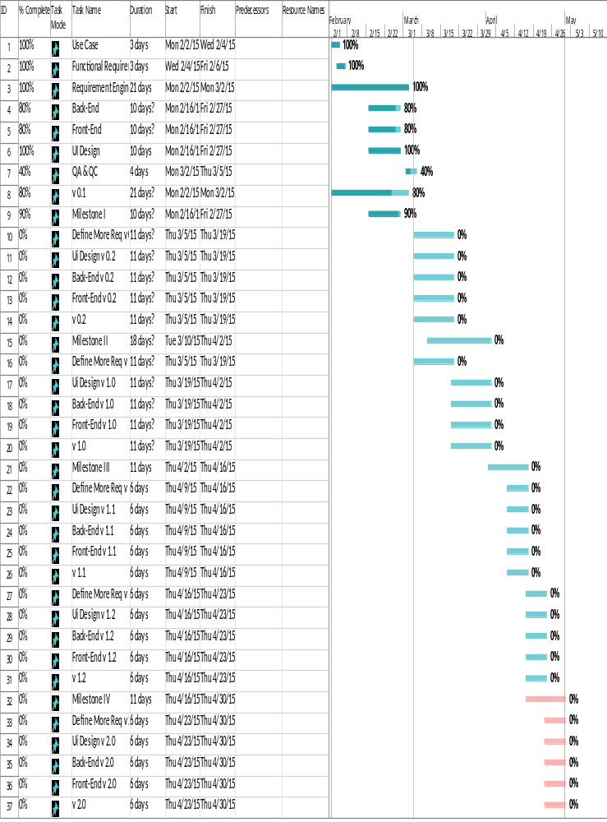
Figure 28: Project Plan Portrait View
Figure 29: Project Plan Landscape View
6. References

Boase, J., Horrigan, J. B., Wellman, B., & Rainie, L. (2006). The strength of Internet ties. Pew
Internet and American Life Project. Retrieved May 20, 2006 from http://
www.pewinternet.org/pdfs/PIP_Internet_ties.pdf
Boase, J., Horrigan, J. B., Wellman, B., & Rainie, L. (2006). The strength of Internet ties. Pew
Internet and American Life Project. Retrieved May 20, 2006 from http://
www.pewinternet.org/pdfs/PIP_Internet_ties.pdf

Ellison, N., Steinfield, C., & Lampe, C. (2007). The Benefits of Facebook ‘‘Friends:’’
SocialCapital and College Students’ Use ofOnline Social Network Sites. Journal of
Computer-Mediated Communication, 12(4), 1143-1168.

Facebook. (n.d.). Retrieved March 1, 2015, from https://www.facebook.com/

Singh, U. (n.d.). Popularity of Online Job Portals among Indian Non-IT Students. Retrieved
March 1, 2015, from http://ijeit.com/vol 2/Issue 7/IJEIT1412201301_32.pdf

Tarng, C. (February 5, 2014). Project ProConnect. Retrieved March 3, 2015, from
https://sjsu.instructure.com/courses/1139756/files/folder/Project?preview=37017739

The Times of India: Latest News India, World & Business News, Cricket & Sports, Bollywood.
(n.d.). Retrieved March 1, 2015, from http://articles.timesofindia.indiatimes.com/2013-
06-23/india/40146190_1.html

World's Largest Professional Network | LinkedIn. (n.d.). Retrieved March 1, 2015, from
https://www.linkedin.com/

