HHMI-JFRC

Daniel Flickinger

flickingerd@janelia.hhmi.org

12 April 2019

Mouse Brain Microscope Assembly and Alignment Guidelines

Contents

1) Overview 1

2) Document notes 2

a) Parts list 2

b) 3D model 2

c) Part fabrication drawings 2

3) Guidelines for features not in 3D model 2

a) Optics mounting (glue based) 2

b) Connection of microscope head to pneumatic cylinder 6

c) Cage construction 6

d) Gluing balls and rods for microscope head kinematic attachment to table 7

e) Optical trigger optics 7

f) Table optics and periscope 7

4) Adjustment of microscope optics 8

a) Excitation optics 8

b) Detection optics 9

c) Resonant mirror edge blocks 9

5) Regular alignment procedure 9

# Overview

This document is intended to provide guidelines for assembling and aligning the custom two-photon microscope designed for long-term whole mouse brain imaging at the Janelia Farm Research Campus by Nathan Clack, Karel Svoboda, and members of the JFRC Instrument Design and Fabrication department. It only covers the microscope itself, the table optics, and cage. The sample bath and stages, vibratome, and custom electronic assemblies will be covered in other documents. It is intended to provide useful information for someone who already has experience with building custom laser scanning microscopes, and will probably not allow others who lack this or similar experience to successfully build this microscope, unless they possess extensive optical and physical knowledge (and/or extensive free time). The following additional documents will be used for microscope construction:

Parts list: MouseLight_Microscope_PartsList.xlsx

3D model: 3D Models/MouseLight_Microscope_Version_2.dwfx

Part fabrication drawings: Fabrication Plans/

Pictures:

MouseBrainMicroscope_OpticalTriggerPic.JPG

MouseBrainMicroscope_TableOpticsPic.JPG

MouseBrainMicroscope_TableOpticsPic2.JPG

# Document notes

## Parts list

This is a nearly full parts list for the whole microscope, table optics, and cage. Some spare parts are suggested to be bought. Notes are included with some items where there may be difficulty in ordering the exact correct thing, or when some thought will be necessary to determine what should be purchased. The “Table Optics” section is only approximately sufficient, as the required table optics are somewhat variable from one table to the next.

## 3D model

The 3d model DWFX file can be opened by the [Autodesk Design Review](http://usa.autodesk.com/design-review/) software, which is free to download and install. This file contains a full 3D model. It contains metadata about each part, allows the visibility of each part to be controlled, and allows taking measurements between any model features.

## Part fabrication drawings

There is one drawing for each custom, mechanical part, which should be all that is necessary for manufacturing. Not all machine shops will be able to fabricate all of the parts, as some are a bit complicated. We have used Zera Development Company (Santa Clara, CA) extensively for nearly all of these parts, and have found them to provide a great value and relatively quick turnaround. Any included STL files are for parts that we have always had 3d printed. We have used Objet Connex 3d printers for these parts. Any rapid plastic prototying company using a similar (multi-jet/poly-jet) technology should be able to create functional parts using the STL files.

# Guidelines for features not in 3D model

## Optics mounting (glue based)

All optics should be in the 3D model. The optics that don’t have an obvious retaining ring or set screw are mounted using glue. The only glue that has been used for this at Janelia is Hardman “Double Bubble Red” quick-setting epoxy, available from McMaster-Carr 7538A11. The following pictures show recommended locations for gluing (generally, small amounts like ~1x4mm beads along optics edges, or larger amounts for the larger optics). Certainly, other gluing methods could work, but mounts were designed for glues of a similar, thick viscosity. Less viscous glues would creep over clear apertures for many of these optics.

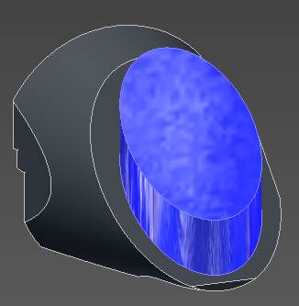

Figure . Large, elliptical mirror

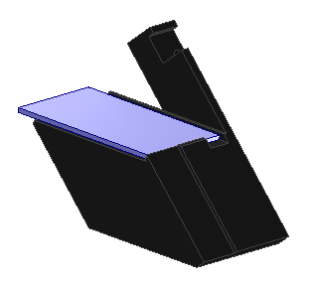

Figure . Primary dichroic

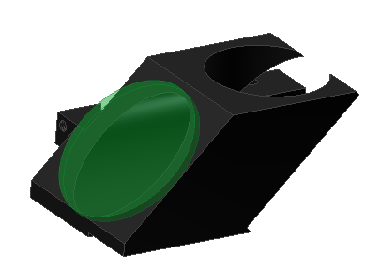

Figure . Light trap

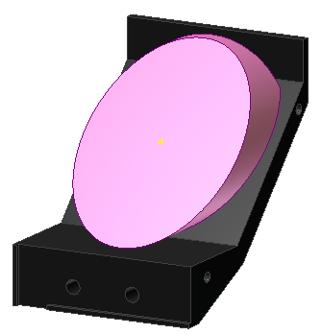

Figure . Large elliptical mirror in detection arm

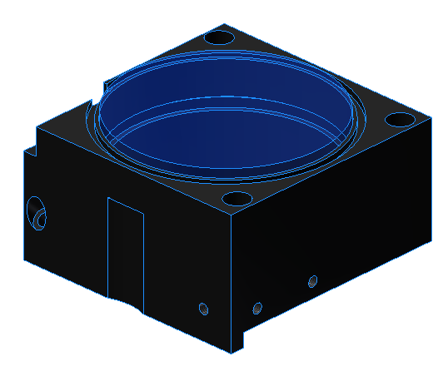

Figure . Large achromat

The secondary dichroic is not glued in place. It is held by three 002 buna-n o-rings, which are placed sideways in the three shallow slots in the top half of the dichroic cube.

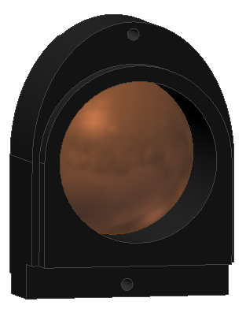

Figure 6. Aspheric lenses (Glue is carefully placed between walls and steeply inclined portion of lens, such that it doesn’t enter the used aperture of the convex lens surface)

## Connection of microscope head to pneumatic cylinder

The large pneumatic cylinder provides damping, such that if the microscope head is released at the top of its movement, it will settle slowly to the bottom, without doing damage to the optics. It was intended to be possible as well to attach controlled air to the cylinder, such that the head up and down movement could be automated (in which case it would also be necessary to design a new, automated head latch). To allow for the least amount of mechanical constraint, the microscope head is attached to the pneumatic cylinder with a wire rope that is threaded through the two socket head cap screws with drilled heads that are present in the model. The wire rope, compression sleeves, and crimping tool for this are included in the parts list.

## Cage construction

Nearly all materials for constructing a cage are included in the parts list. The cage size that we use is 38”w x 50”d x 32”h. The construction should be mostly self-explanatory. The construction angle brackets are used to strengthen the front of the cage against skew, as it doesn’t have a wall to provide this strength. The top, back, and sides are covered with black, anodized aluminum sheets that we custom cut from 4’x8’ sheets. We attach the walls with magnetic tape. Care must be taken when applying the magnetic tape. All surfaces should be cleaned first. Then, tape should be adhered to the frame, and a second set of tape should be magnetically attached to this tape. The adhesive should be removed from this tape, and each wall should be attached one at a time, adhering all of the second set of tape to each wall all at once. This is necessary because the magnetic tape has alternating N and S domains, and this method ensures that the all of the tape on each wall will align properly with all of the tape on the frame. (If the tape doesn’t align properly it will repel instead of attract!) The tape should further be burnished well on the frame and walls to ensure proper adhesion. The thinner tape in the parts list is for attaching to the front curtain.

## Gluing balls and rods for microscope head kinematic attachment to table

All 3 balls and 6 rods should have epoxy applied to where they touch the metal. We have used the Hardman Red quick-set epoxy for this (see gluing optics section), but it would be better to use a longer setting epoxy. After the epoxy is applied and all balls and rods have been placed, but well before the epoxy sets, the head should be attached to the base and the latch secured. In this way, the force from the latch will force each ball and rod into its pocket, reducing the glue thickness between each of these elements and the pocket walls.

## Optical trigger optics

The optical trigger optics are pictured in MouseBrainMicroscope_OpticalTriggerPic.JPG, with an approximate beam path. These are located on the raised optical table. The resonant mirror is the source of the alignment beam (ultimately coming from the fiber coupled 635nm laser source), at the lower right of the image. Not pictured is the photodiode detector, located just outside the lower left side of the image. The optics need to be aligned such that the alignment beam hits the photodiode at the end (turnaround) of the scan line, at the intended imaging resonant scan amplitude (usually full amplitude). The length of the propagation line is set roughly by the Rayleigh range of the beam after the fiber collimator. This is because the precision of the triggering can be increased by lengthening the propagation line, up until the propagation length roughly exceeds the Rayleigh range. At that length, any further increase in the propagation length comes along with a proportional increase in the beam size, resulting in no further triggering precision. Sufficient triggering precision is probably achievable with a shorter propagation line, but this has not been experimentally confirmed.

## Table optics and periscope

The table optics and periscope are pictured in MouseBrainMicroscope_TableOpticsPic.JPG and MouseBrainMicroscope_TableOpticsPic2.JPG . Note that the system pictured uses two lasers. The beamline for the main imaging laser (Coherent Chameleon) has been approximately drawn. The parts list only contains parts for this main imaging line, although it assumes that one laser will be split between two rigs, as illustrated in the picture. The order of optics as pictured is:

Dielectric mirror (see note in parts list),

Half-wave plate

Polarizing beamsplitter cube

Silver mirror

Electro-optic modulator (Pockels cell) in crossed orientation

(Switch to second picture) Silver Mirror

Polarizing beamsplitter (for second beam line—not in parts list)

Silver mirror (placed within reach of user for ease of aligning beam into microscope). This is the “main table optics alignment mirror” referred to in section 4)a)7.

Silver mirror

Periscope (two silver mirrors)

1/2” silver mirror for direction to resonant mirror (this part is contained in the 3D model).

The upper and lower mirror assemblies in the periscope are made using the same parts (these are hard to see in the picture). They each consist of a XT95P11 rail carriage, and a kinematic mirror mount with a H45 45deg mirror mount inserted. Note that all pictured mirror mounts are Thorlabs KM100 mounts, while it is recommended in the parts list to use Thorlabs Polaris-K1 mounts. These should hopefully reduce long-term beam wander, which is often observed.

It’s assumed that the user is familiar with setting up these optics and aligning the beam through them.

# Adjustment of microscope optics

## Excitation optics

The following is intended to be a general outline of the procedure for adjusting/aligning the excitation optics of the microscope, and will lack step-by-step details. The general procedure is as follows (all accessory parts mentioned are contained in parts list):

Set up all optics as in 3D model. Precise distances between all adjustable optics need not be met at this stage.

Use periscope optics and adjustable mirror on resonant mirror assembly to center input beam on resonant mirror.

Adjust resonant mirror angle (while mirror is off) to center beam on cage attached to res mirror assembly exit (use, e.g., Thorlabs LCPA1 for this).

Adjust 2”, right-angle kinematic mount after res mirror assembly such that beam afterwards is aligned with cage

Adjust separation of three lens set after res mirror from 3 lens set after 2” mirror such that beam is collimated at galvo mirror (Thorlabs SI100 is useful for this—laser must be set to “alignment mode” or otherwise set to CW operation for this to work). The distances between the three lenses in the first or second lens set are not critical.

Adjust separation of res mirror assembly from first three lens set such that beam is stationary at position of galvo mirror when res mirror is oscillating.

Beam should be centered on galvo mirror. If it is slightly off, then it should be centered with a slight tweak of the “main table optics alignment mirror”, which should have been set up as a faraway (beam-wise), yet accessible mirror on the main optical table (first mirror before periscope, if the table optics are set up as shown in the pictures). Using this mirror ensures minimal angular beam errors as the beam position is tweaked downstream. It will be used often for alignment.

Use the “main table optics alignment mirror” (see step 7) and galvo mirror angle (while galvo mirror driver is on and centered at zero control volts) to align the beam with the cage after the galvo mirror. The Special Optics scan lens will need to be removed for this step.

Replace Special Optics scan lens and adjust separation of this lens and Zeiss tube lens such that beam is collimated at objective (again, SI100 can be used for this).

Adjust distance from galvo mirror to Special Optics scan lens until beam is stationary at objective back aperture when either res mirror or galvo mirror is scanned. Note that the entire assembly from the res mirror to the galvo mirror will need to be moved for this.

Perform “Regular alignment procedure” outlined in section 5).

## Detection optics

First, take care to set the stop of the primary dichroic carriage properly, at the distance indicated in the 3d model. This stop is a long M3 set screw, which should be secured with a nut. After this, the only remaining adjustment in the detection optics is the PMT positions. The PMT z-positions is set by adding/removing shims, and the number of shims shown in the 3D model should be correct (as measured with an existing microscope). The PMT x,y-positions are best set while imaging. A bright, uniform fluorescence field should be imaged, such as a pool of fluorescein, or a plastic, fluorescent slide. The beam power should be increased and the PMT gain should be decreased until the cage curtain can be opened slightly without a noticeable change in signal (room lights should be out, of course). Then, while imaging, the PMT positions can be changed by hand while observing the signal. The signal should be seen to have a maximum within reach of both x and y adjustments. It should be possible to adjust x and y separately, and set the screw tension on the adjustment plates such that a position will be held when one’s hand is removed. Then the screws can be tightened to lock down the position.

## Resonant mirror edge blocks

The two independent beam blocks right after the Special Optics scan lens are for blocking the edges of the resonant mirror scan pattern, so that unnecessary light is not applied to the sample as the resonant mirror turns around. These are adjusted manually.

# Regular alignment procedure

This alignment procedure should be performed regularly (e.g. daily) to ensure that there has not been beam wander, unless it has been observed that regular adjustment is not necessary.

Remove objective and attach alignment jig in its place. In the 3d model, both objective and alignment jig are shown attached at the same time, overlapping one another.

Open the upper iris in the alignment jig wide. Observe the beam passing through this iris with a beam viewing screen (paper or Thorlabs VRC4). Adjust the “main table optics alignment mirror” (see section 4)a)7 ) to center the beam in the iris. This adjusts the beam centration at the objective.

Adjust the lower iris in the alignment jig to a diameter of approx. 2-3mm. Adjust the upper iris until it is slightly larger than this, such that a shadow of the upper iris in the beam forms a thin ring around the lower iris. If this shadow is not centered with the lower iris, then it can be adjusted either by adjusting the galvo mirror angle, res mirror angle, or the mirror right before the resonant mirror. This adjusts the beam angle at the objective (centering the scan field on the objective field).

Repeat steps 2 and 3 iteratively, adjusting as necessary, until beam position and angle at objective are both satisfactory. In the future, it will usually be sufficient to only perform step 2.