Moushreeta Debroy

22122132

MongoDB Date: 09/12/22

____________________________________________________

Q1. Create collection “books” and insert minimum of 4 similar documents.

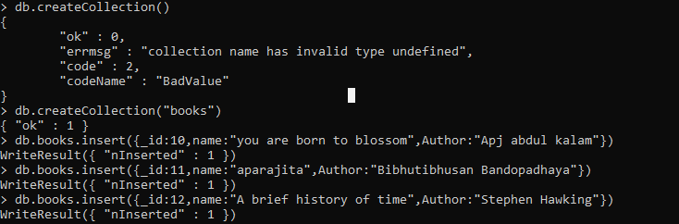

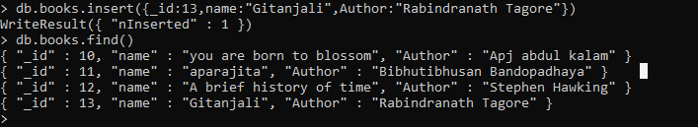

Q2. Give no _id value to the insert.



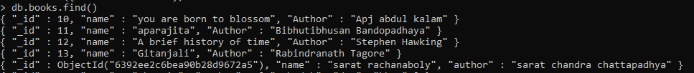

Q3. Add multiple authors



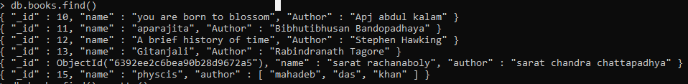

Q4. Use find() and pretty()



