# (6) Details of the algorithm(s)/approach(es) that will be used

# Genetic Algorithm

**6.1 Introduction**

Genetic Algorithm (GA) is one of the first population-based stochastic algorithm proposed in the history . Similar to other EAs, the main operators of GA are selection, crossover, and mutation. This chapter briefly presents this algorithm and applies it to several case studies to observe its performance

**6.2 Inspiration and Selection**

GA is a population-based algorithm . Every solution corresponds to a chromosome and each parameter represents a gene. For improving poor solutions, the best solutions are chosen randomly with a selection (e.g. roulette wheel) mechanism .What increases local optima avoidance is the probability of choosing poor solutions as well. This means that if good solutions be trapped in a local solution, they can be pulled out with other solutions.

The GA algorithm is stochastic , given problem is the process of maintaining the best solutions in each generation and using them to improve other solutions .The crossover between individuals results in exploiting the ‘area’ between the given two parent solutions .behavior of GA. Similar to the nature and lead other solutions towards the global optimum.

Natural selection is the main inspiration of this component for the GA algorithm .the GA algorithm employs a roulette wheel to assign probabilities to individuals and select them for creating the next generation proportional to their fitness (objective) values .This mechanism simulates the natural selection of the fittest individual in nature. Since a roulette wheel is a stochastic operator, poor individuals have a small probability of participating in the creation of the next generation. If a poor solution is ‘lucky’, its genes move to the next generation. Discarding such solutions will reduce the diversity of the population and should be avoided.

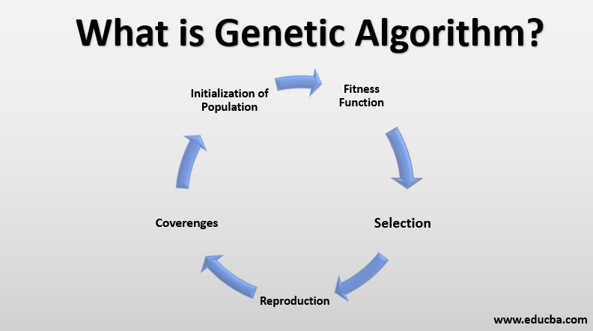

**6.3 Main types**

* Uniform crossover : Each gene (bit) is selected randomly from one of the corresponding genes of the parent chromosomes.  
  Use tossing of a coin as an example
* 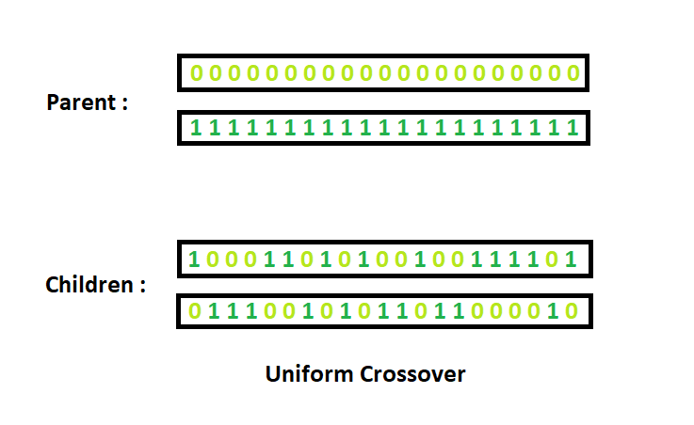 technique
* Half uniform crossover : In the half uniform crossover scheme (HUX), exactly half of the nonmatching bits are swapped. Thus first the Hamming distance (the number of differing bits) is calculated. This number is divided by two. The resulting number is how many of the bits that do not match between the two parents will be swapped.

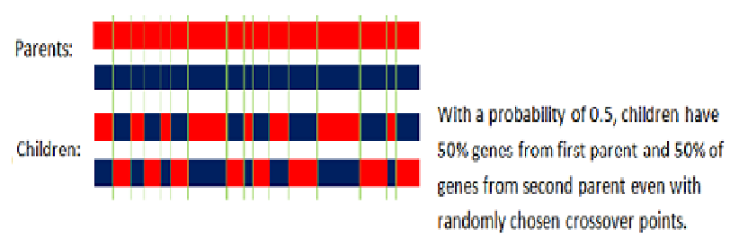

**6.4 Conclusion**

This section presented GA as one of the most popular evolutionary algorithm in the literature. After discussing the main evolutionary operators, several experiments were conducted to see the impact of changing controlling parameters on the performance of this algorithm. It was observed that the mutation rate should be tuned carefully since it can degrade the performance significantly when its value is high. It was also observed that the crossover rate is important in getting better results, but it can be set to high values without negative consequences as opposed to the mutation rate. For training NNs, a continuous version of GA should be employed as discussed in the preceding chapter (ACO). Due to the difficulty of training NN, both crossover and mutation rates will tuned.

**6.5: advantages and disadvantages genetic algorithm**

The advantages

1. The concept is easy to understand.

2. GA search from a population of points, not a single point.

3. GA use payoff (objective function) information, not derivatives.

4. GA supports multi-objective optimization.

5. GA use probabilistic transition rules, not deterministic rules.

6. GA is good for "noisy" environments.

7. GA is robust w.r.t. to local minima/maxima.

8. GA is easily parallelized.

9. GA can operate on various representation.

The disadvantages

1. GA implementation is still an art.

2. GA requires less information about the problem but designing an objective function and getting the representation and operators right| can be difficult. 3. GA is computationally expensive i.e. time-consuming.