How “**Super**” Function handles multiple classes ?

Super function in multiple classes follows the MRO (method resolution order) which is a specific order that python decides to see which classes was inherited from in the right order as shown in the example here :

* The teacher class was inherited from the employee class which is inherited from the person class in order

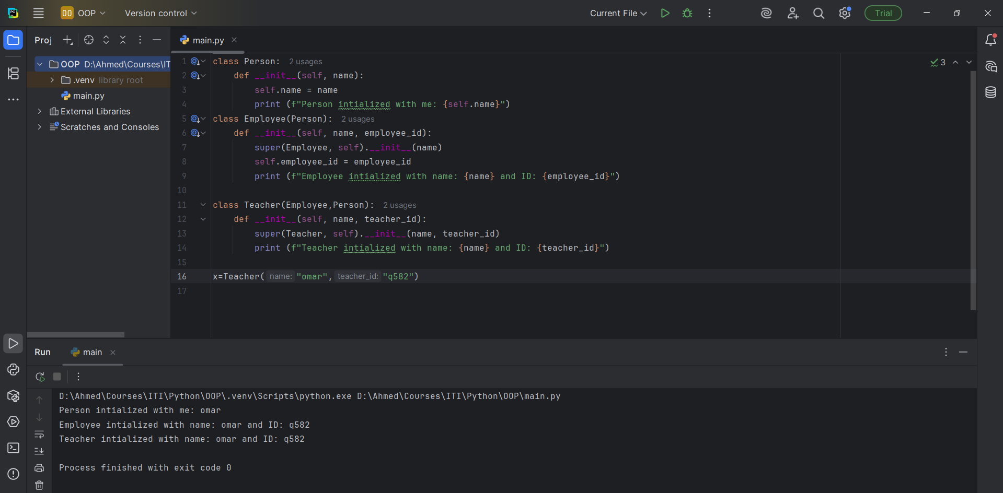

If Human and Mammal Have the same method like eat but with different Implementation. When

Child[Employee] calls eat method how python handle this case.

In this case over here as well python follows the MRO so the child class Employee when it calls the method eat() it will see the methods eats in order and call the first one it reads as shown it printed “Human Eats”

