* Pour ne pas utiliser la console de GCP on peut installer le sdk cloud ( client ) sur notre pc et lancer la commande suivante : gcloud

1– GCP

POUR CREER UN UNE VM SUR GCP (un site web)

– Compute engine

* creer un projet
* machine virtuelles
* creer une instance et suivre choisir les options de VM disponiblent

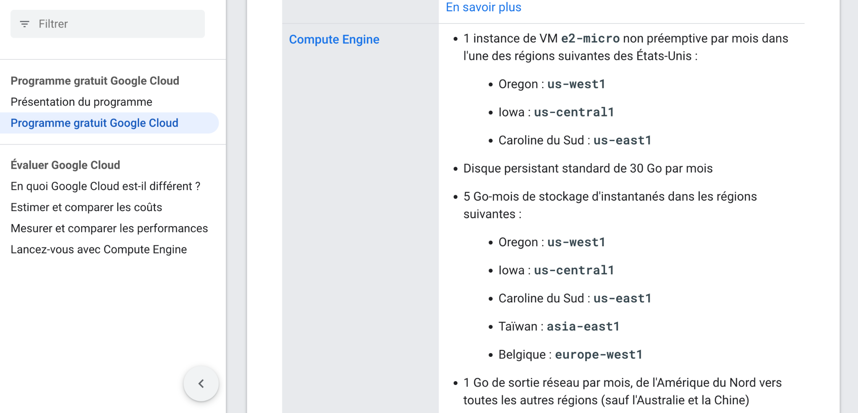

* Après les réglages , on crée l’instance
* Ensuite on se connecte en SSH

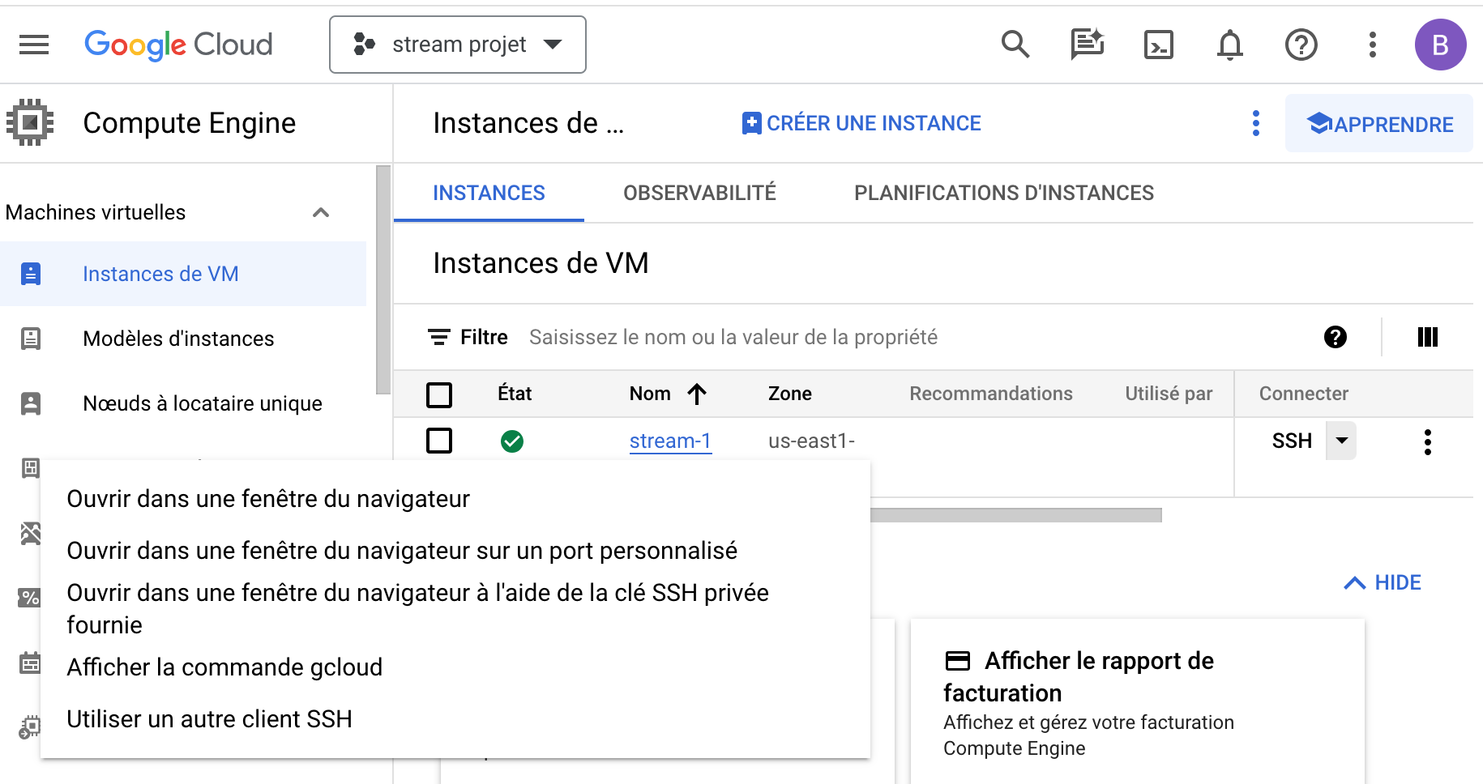

* Dans la fenetre affichée faire Ouvrir dans une fenêtre du navigateur
* Attention : comme on peut le constater, lorsqu’on exécute la commande gcloud compute ssh --zone "us-east1-b" "stream-1" --project "stream-projet" dans la console ci-dessous , il se produit l’erreur suivante (voir image)
* 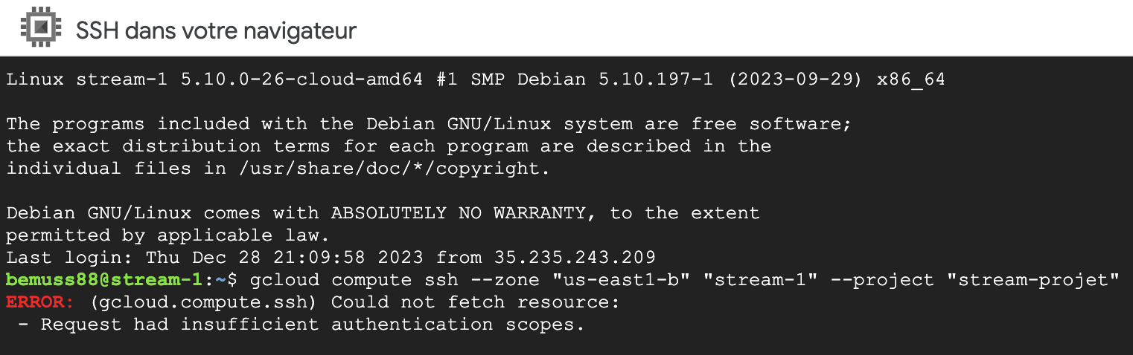
* Pour resoudre le probleme il faut lancer la commande dans un shell en local comme dit dans ce lien : <https://www.googlecloudcommunity.com/gc/Infrastructure-Compute-Storage/Any-gcloud-compute-command-results-in-Error-quot-Request-had/m-p/496808#M1930>
* Notre problème se résout comme avec la solution proposé par le lien ci-dessus

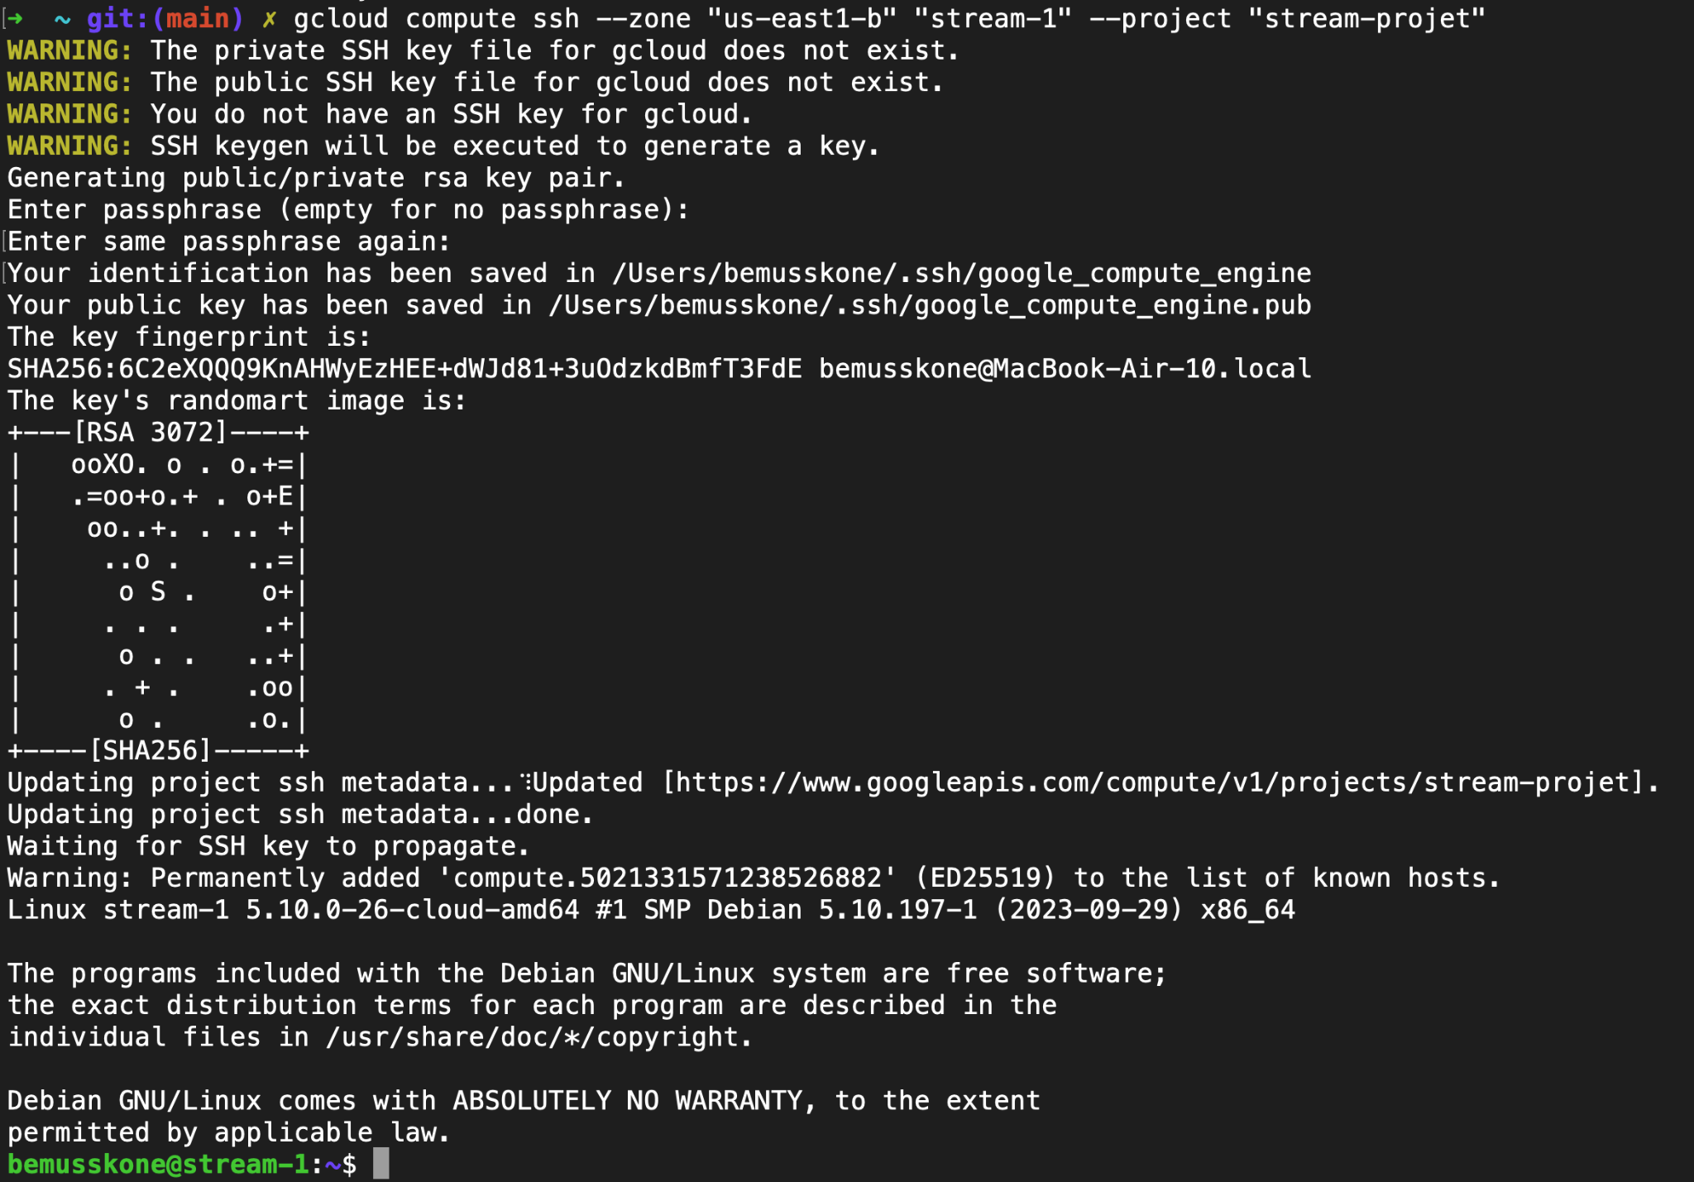

COMMANDE TERMINAL POUR LA PREMIERE VM (site web)

Last login: Sat Dec 23 17:05:03 on ttys000

You have mail.

[oh-my-zsh] plugin 'git,osx,sublime' not found

Running `brew update --auto-update`...

==> **Auto-updated Homebrew!**

Updated 2 taps (homebrew/core and homebrew/cask).

==> **New Formulae**

texi2mdoc

==> **New Casks**

geekbench-ml ollama opencat streammusic

You have **46** outdated formulae and **1** outdated cask installed.

Warning: archey 1.6.0_1 is already installed and up-to-date.

To reinstall 1.6.0_1, run:

brew reinstall archey

**➜ ~** **git:(main) ✗** gcloud compute ssh --zone "us-east1-b" "stream-1" --project "stream-projet"

**WARNING:** The private SSH key file for gcloud does not exist.

**WARNING:** The public SSH key file for gcloud does not exist.

**WARNING:** You do not have an SSH key for gcloud.

**WARNING:** SSH keygen will be executed to generate a key.

Generating public/private rsa key pair.

Enter passphrase (empty for no passphrase):

Enter same passphrase again:

Your identification has been saved in /Users/bemusskone/.ssh/google_compute_engine

Your public key has been saved in /Users/bemusskone/.ssh/google_compute_engine.pub

The key fingerprint is:

SHA256:6C2eXQQQ9KnAHWyEzHEE+dWJd81+3uOdzkdBmfT3FdE bemusskone@MacBook-Air-10.local

The key's randomart image is:

+---[RSA 3072]----+

| ooXO. o . o.+=|

| .=oo+o.+ . o+E|

| oo..+. . .. +|

| ..o . ..=|

| o S . o+|

| . . . .+|

| o . . ..+|

| . + . .oo|

| o . .o.|

+----[SHA256]-----+

Updating project ssh metadata...⠹Updated [https://www.googleapis.com/compute/v1/projects/stream-projet].

Updating project ssh metadata...done.

Waiting for SSH key to propagate.

Warning: Permanently added 'compute.5021331571238526882' (ED25519) to the list of known hosts.

Linux stream-1 5.10.0-26-cloud-amd64 #1 SMP Debian 5.10.197-1 (2023-09-29) x86_64

The programs included with the Debian GNU/Linux system are free software;

the exact distribution terms for each program are described in the

individual files in /usr/share/doc/*/copyright.

Debian GNU/Linux comes with ABSOLUTELY NO WARRANTY, to the extent

permitted by applicable law.

**bemusskone@stream-1**:**~**$ curl -k https://ottertelcom

curl: (6) Could not resolve host: ottertelcom

**bemusskone@stream-1**:**~**$ curl -k https://ottertelecom.com/ip

35.237.26.146

**bemusskone@stream-1**:**~**$ sudo apt update

Get:1 https://packages.cloud.google.com/apt google-compute-engine-bullseye-stable InRelease [5146 B]

Get:2 https://packages.cloud.google.com/apt cloud-sdk-bullseye InRelease [6406 B]

Reading package lists... Done

Building dependency tree... Done

Reading state information... Done

8 packages can be upgraded. Run 'apt list --upgradable' to see them.

**bemusskone@stream-1**:**~**$ cat /etc/debian_version

11.8

**bemusskone@stream-1**:**~**$ apt list --upgradable

Listing... Done

curl/oldstable-security 7.74.0-1.3+deb11u11 amd64 [upgradable from: 7.74.0-1.3+deb11u10]

google-cloud-cli/cloud-sdk-bullseye 458.0.1-0 amd64 [upgradable from: 456.0.0-0]

google-cloud-packages-archive-keyring/google-compute-engine-bullseye-stable 1.2-593626690 all [upgradable from: 1.2-589865220]

libcurl3-gnutls/oldstable-security 7.74.0-1.3+deb11u11 amd64 [upgradable from: 7.74.0-1.3+deb11u10]

libcurl4/oldstable-security 7.74.0-1.3+deb11u11 amd64 [upgradable from: 7.74.0-1.3+deb11u10]

openssh-client/oldstable-security 1:8.4p1-5+deb11u3 amd64 [upgradable from: 1:8.4p1-5+deb11u2]

openssh-server/oldstable-security 1:8.4p1-5+deb11u3 amd64 [upgradable from: 1:8.4p1-5+deb11u2]

openssh-sftp-server/oldstable-security 1:8.4p1-5+deb11u3 amd64 [upgradable from: 1:8.4p1-5+deb11u2]

**bemusskone@stream-1**:**~**$ uname -a

Linux stream-1 5.10.0-26-cloud-amd64 #1 SMP Debian 5.10.197-1 (2023-09-29) x86_64 GNU/Linux

**bemusskone@stream-1**:**~**$ sudo apt install nginx

Reading package lists... Done

Building dependency tree... Done

Reading state information... Done

Get:26 https://deb.debian.org/debian bullseye/main amd64 nginx-core warning: Falling back to a fallback locale ("C.UTF-8").

Setting up nginx-core (1.18.0-6.1+deb11u3) ...

Upgrading binary: nginx.

Setting up nginx (1.18.0-6.1+deb11u3) ...

Processing triggers for man-db (2.9.4-2) ...

Processing triggers for libc-bin (2.31-13+deb11u7) ...

**bemusskone@stream-1**:**~**$ curl -k https://ottertelecom.com/ip

35.237.26.146

**bemusskone@stream-1**:**~**$ ls -hl /var/log/ngnix

ls: cannot access '/var/log/ngnix': No such file or directory

**bemusskone@stream-1**:**~**$ ls -hl /var/log/nginx

total 8.0K

-rw-r----- 1 www-data adm 541 Dec 28 22:46 access.log

-rw-r----- 1 www-data adm 76 Dec 28 22:22 error.log

**bemusskone@stream-1**:**~**$ cd /etc/nginx/

**bemusskone@stream-1**:**/etc/nginx**$ cd sites-enabled/

**bemusskone@stream-1**:**/etc/nginx/sites-enabled**$ ls

**default**

**bemusskone@stream-1**:**/etc/nginx/sites-enabled**$ cd default

-bash: cd: default: Not a directory

**bemusskone@stream-1**:**/etc/nginx/sites-enabled**$ ls -hl

total 0

lrwxrwxrwx 1 root root 34 Dec 28 22:22 **default** -> /etc/nginx/sites-available/default

**bemusskone@stream-1**:**/etc/nginx/sites-enabled**$ cat default

##

# You should look at the following URL's in order to grasp a solid understanding

# of Nginx configuration files in order to fully unleash the power of Nginx.

# https://www.nginx.com/resources/wiki/start/

# https://www.nginx.com/resources/wiki/start/topics/tutorials/config_pitfalls/

# https://wiki.debian.org/Nginx/DirectoryStructure

#

# In most cases, administrators will remove this file from sites-enabled/ and

# leave it as reference inside of sites-available where it will continue to be

# updated by the nginx packaging team.

#

# This file will automatically load configuration files provided by other

# applications, such as Drupal or Wordpress. These applications will be made

# available underneath a path with that package name, such as /drupal8.

#

# Please see /usr/share/doc/nginx-doc/examples/ for more detailed examples.

##

# Default server configuration

#

server {

listen 80 default_server;

listen [::]:80 default_server;

# SSL configuration

#

# listen 443 ssl default_server;

# listen [::]:443 ssl default_server;

#

# Note: You should disable gzip for SSL traffic.

# See: https://bugs.debian.org/773332

#

# Read up on ssl_ciphers to ensure a secure configuration.

# See: https://bugs.debian.org/765782

#

# Self signed certs generated by the ssl-cert package

# Don't use them in a production server!

#

# include snippets/snakeoil.conf;

root /var/www/html;

# Add index.php to the list if you are using PHP

index index.html index.htm index.nginx-debian.html;

server_name _;

location / {

# First attempt to serve request as file, then

# as directory, then fall back to displaying a 404.

try_files $uri $uri/ =404;

}

# pass PHP scripts to FastCGI server

#

#location ~ \.php$ {

# include snippets/fastcgi-php.conf;

#

# # With php-fpm (or other unix sockets):

# fastcgi_pass unix:/run/php/php7.4-fpm.sock;

# # With php-cgi (or other tcp sockets):

# fastcgi_pass 127.0.0.1:9000;

#}

# deny access to .htaccess files, if Apache's document root

# concurs with nginx's one

#

#location ~ /\.ht {

# deny all;

#}

}

# Virtual Host configuration for example.com

#

# You can move that to a different file under sites-available/ and symlink that

# to sites-enabled/ to enable it.

#

#server {

# listen 80;

# listen [::]:80;

#

# server_name example.com;

#

# root /var/www/example.com;

# index index.html;

#

# location / {

# try_files $uri $uri/ =404;

# }

#}

**bemusskone@stream-1**:**/etc/nginx/sites-enabled**$ cd /var/www/html

**bemusskone@stream-1**:**/var/www/html**$ ld -hl

-bash: ld: command not found

**bemusskone@stream-1**:**/var/www/html**$ cd -hl

-bash: cd: -h: invalid option

cd: usage: cd [-L|[-P [-e]] [-@]] [dir]

**bemusskone@stream-1**:**/var/www/html**$ ls -hl

total 4.0K

-rw-r--r-- 1 root root 612 Dec 28 22:22 index.nginx-debian.html

**bemusskone@stream-1**:**/var/www/html**$ sudo yolo.html

sudo: yolo.html: command not found

**bemusskone@stream-1**:**/var/www/html**$ sudo vim yolo.html

**bemusskone@stream-1**:**/var/www/html**$ sudo vim yolo.html

**bemusskone@stream-1**:**/var/www/html**$ sudo vim yolo.html

**bemusskone@stream-1**:**/var/www/html**$ sudo vim yolo.html

**bemusskone@stream-1**:**/var/www/html**$ sudo apt -y install htop

Reading package lists... Done

Building dependency tree... Done

Reading state information... Done

The following additional packages will be installed:

libnl-3-200 libnl-genl-3-200

Suggested packages:

lm-sensors lsof strace

The following NEW packages will be installed:

htop libnl-3-200 libnl-genl-3-200

0 upgraded, 3 newly installed, 0 to remove and 8 not upgraded.

Need to get 211 kB of archives.

After this operation, 573 kB of additional disk space will be used.

Get:1 https://deb.debian.org/debian bullseye/main amd64 libnl-3-200 amd64 3.4.0-1+b1 [63.6 kB]

Get:2 https://deb.debian.org/debian bullseye/main amd64 libnl-genl-3-200 amd64 3.4.0-1+b1 [21.2 kB]

Get:3 https://deb.debian.org/debian bullseye/main amd64 htop amd64 3.0.5-7 [127 kB]

Fetched 211 kB in 0s (1572 kB/s)

perl: warning: Setting locale failed.

perl: warning: Please check that your locale settings:

LANGUAGE = (unset),

LC_ALL = (unset),

LC_CTYPE = "UTF-8",

LANG = "C.UTF-8"

are supported and installed on your system.

perl: warning: Falling back to a fallback locale ("C.UTF-8").

Selecting previously unselected package libnl-3-200:amd64.

(Reading database ... 60219 files and directories currently installed.)

Preparing to unpack .../libnl-3-200_3.4.0-1+b1_amd64.deb ...

Unpacking libnl-3-200:amd64 (3.4.0-1+b1) ...

Selecting previously unselected package libnl-genl-3-200:amd64.

Preparing to unpack .../libnl-genl-3-200_3.4.0-1+b1_amd64.deb ...

Unpacking libnl-genl-3-200:amd64 (3.4.0-1+b1) ...

Selecting previously unselected package htop.

Preparing to unpack .../htop_3.0.5-7_amd64.deb ...

Unpacking htop (3.0.5-7) ...

Setting up libnl-3-200:amd64 (3.4.0-1+b1) ...

Setting up libnl-genl-3-200:amd64 (3.4.0-1+b1) ...

Setting up htop (3.0.5-7) ...

Processing triggers for man-db (2.9.4-2) ...

Processing triggers for libc-bin (2.31-13+deb11u7) ...

**bemusskone@stream-1**:**/var/www/html**$ df -hl

Filesystem Size Used Avail Use% Mounted on

udev 2.0G 0 2.0G 0% /dev

tmpfs 394M 384K 393M 1% /run

/dev/sda1 9.7G 1.9G 7.3G 21% /

tmpfs 2.0G 0 2.0G 0% /dev/shm

tmpfs 5.0M 0 5.0M 0% /run/lock

/dev/sda15 124M 11M 114M 9% /boot/efi

tmpfs 394M 0 394M 0% /run/user/1001

**bemusskone@stream-1**:**/var/www/html**$ sudo fdisk -l

sudo: fdisk: command not found

**bemusskone@stream-1**:**/var/www/html**$ htop

**bemusskone@stream-1**:**/var/www/html**$ exit

logout

Connection to 35.237.26.146 closed.

Updates are available for some Google Cloud CLI components. To install them,

please run:

$ gcloud components update

To take a quick anonymous survey, run:

$ gcloud survey

**➜ ~** **git:(main) ✗**

2– TERRAFORM & GCP

* TUTO1 : VPC

On va créer une infrastructure

On reprendra les même manipulation avec GCP en écrivant nos propres fichiers terraform

Pour ce faire, la documentation terraform nous montre le chemin à suivre. Le lien de la documentation ci-dessous <https://developer.hashicorp.com/terraform/tutorials/gcp-get-started/google-cloud-platform-build>

* TUTO2 : VM

Apres avoir crée un reseau VPC, nous allons créer une VM et modifier les configurations de cette VM

Suivre les étapes de ce lien : <https://developer.hashicorp.com/terraform/tutorials/gcp-get-started/google-cloud-platform-change>

ATTENTION : erreurs rencontrées lors de l’execution des commandes des etapes.

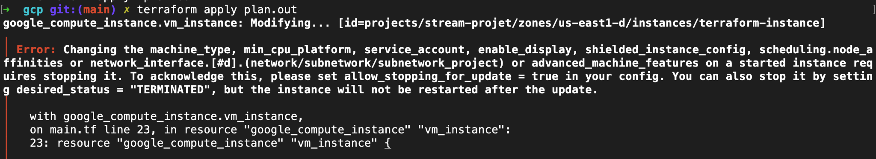

Pour resourdre ce probleme, il faut rajouter la ligne suivante dans la configuration de la ressource : allow_stopping_for_update = true

Voir le lien suivant pour plus d’information : [**https://github-com.translate.goog/hashicorp/terraform-provider-google/issues/6351?_x_tr_sl=en&_x_tr_tl=fr&_x_tr_hl=fr&_x_tr_pto=sc**](https://github-com.translate.goog/hashicorp/terraform-provider-google/issues/6351?_x_tr_sl=en&_x_tr_tl=fr&_x_tr_hl=fr&_x_tr_pto=sc)