1. Introduction

Mobile Applications have a unique way of interaction with Users knowing that more than 5 billion people own a smartphone, the market is overflooded with Apps and having an App to run your business became essential. Big tech companies understand that in order to get the user to like your product, it has to be critical which means simple and forward. Most of the market is dominated by Social Media companies like Facebook (1 Billion downloads), Viber (500 Million downloads), Snapchat (1 Billion downloads) …etc.

We tend to choose this subject to be our Graduation project because we believe that it is the most reliable choice based on our previous experience with Mobile Applications and the limitless possibilities to integrate our own ideas to create a final app that not only satisfies the assigned tasks but can also react to unexpected user interference and abnormal situations, in order to do that, the application needs to have some criteria which we believe are very important such as Coherency, Flexibility, Robustness …etc.

* The tools used to make this project
  + 1. Dart for Flutter in layouts and interfaces (Front-End Development)
    2. Firebase for database administration and management (Back-End Development)
    3. Adobe Illustrator CC for Conception and Graphic Design
* Objectives

We want to build a Multi-Platform (Android/IOS) Mobile Application for instant messaging and chat.

* Project Development
  + 1. Chapter 1: Objectives and Functionalities
    2. Chapter 2: Conceptions and Diagrams (Use-Case, Sequence, Class)
    3. Project Making & Testing
* Specifications

1. **Chat Interface**

This is the most important interface it allows you to send and receive messages. The interface is referred to as a ‘Conversation’.

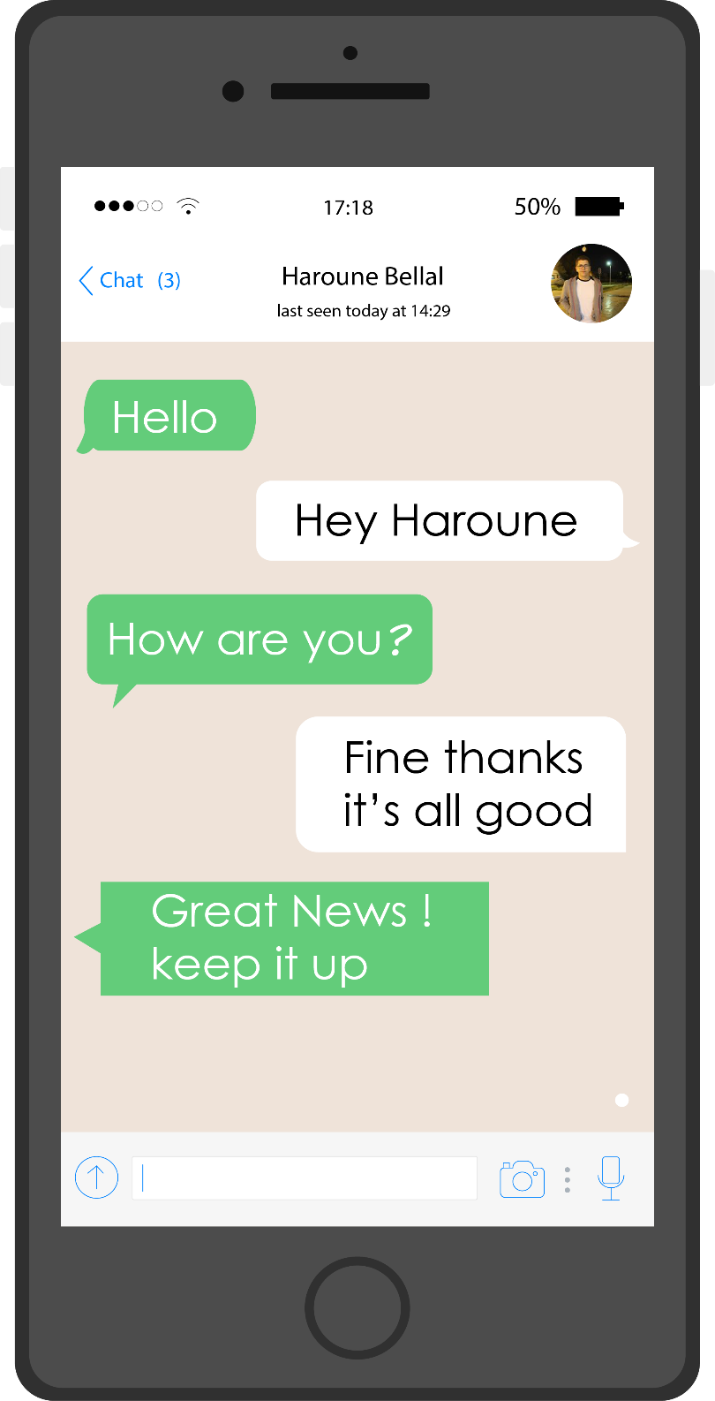

Figure - Conversation

1. **Database Auto-Save**

The app will send a ‘write’ request to the database whenever sending a message, it saves you the text and the timestamp of each message.

1. **Read Past Messages**

The users are allowed to read previous messages loaded directly from the database after executing a ‘read’ request and showing the timestamp of every specific message sent.

1. **Message Suppression**

Users are given a feature to delete either a specific message sent at a specific time or suppress the whole conversation and deleting it directly from the database.

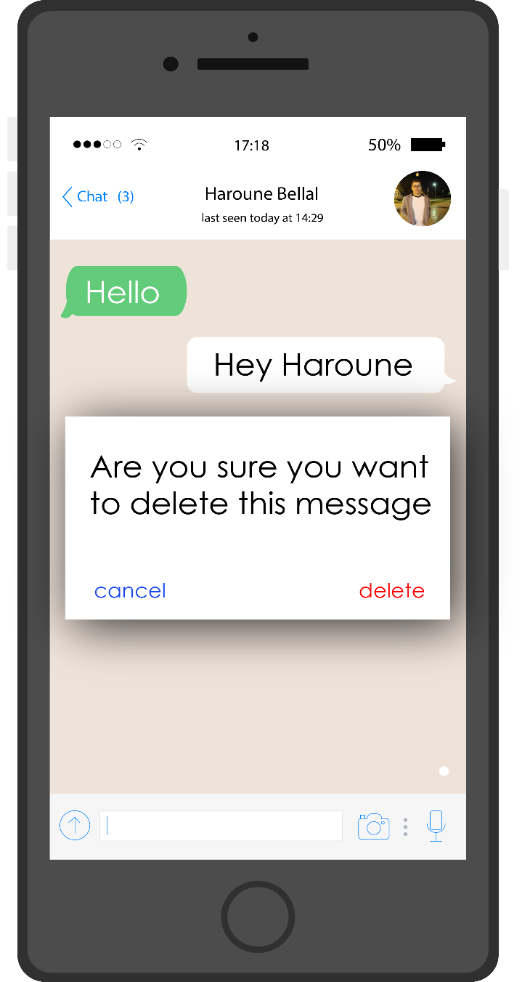

Figure - Message Suppression

1. **Multi-Users**

This app supports multiple accounts and everyone is allowed to create an account as long as it respects the restrictions and verifications, users are unique and have a unique ID generated after performing a successful Sign-Up.

1. **Password Authentication**

Every account is secured by a strong password more than six characters long and it is needed when the user wants to Log-In.

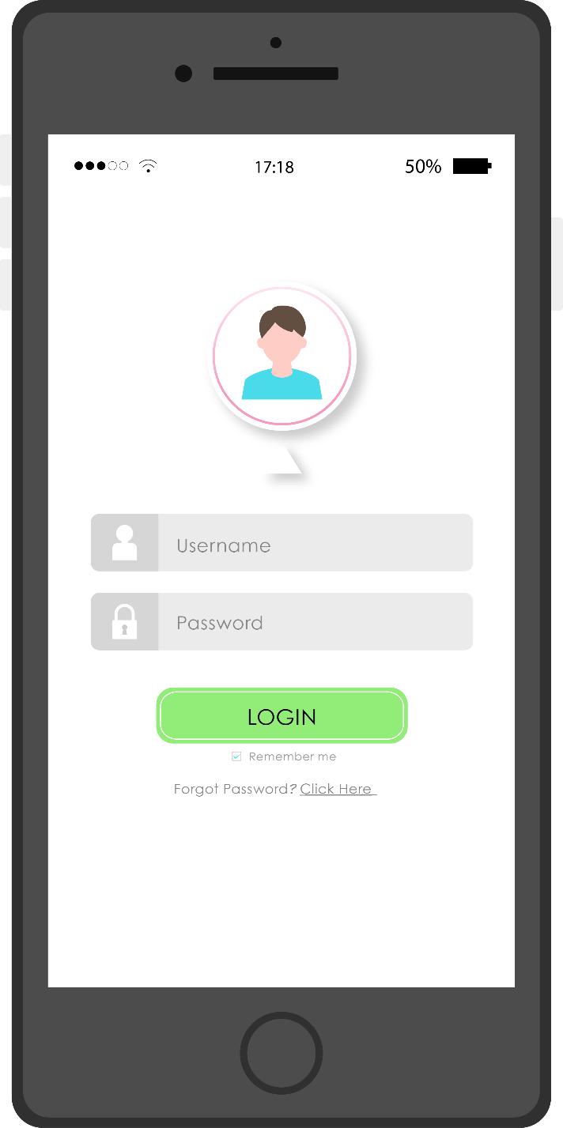

Figure - Password Authentication

1. **Account Deletion**

A user can delete his account manually by going to the account settings and confirm to delete his account form the database which will suppress all the conversations and contacts.

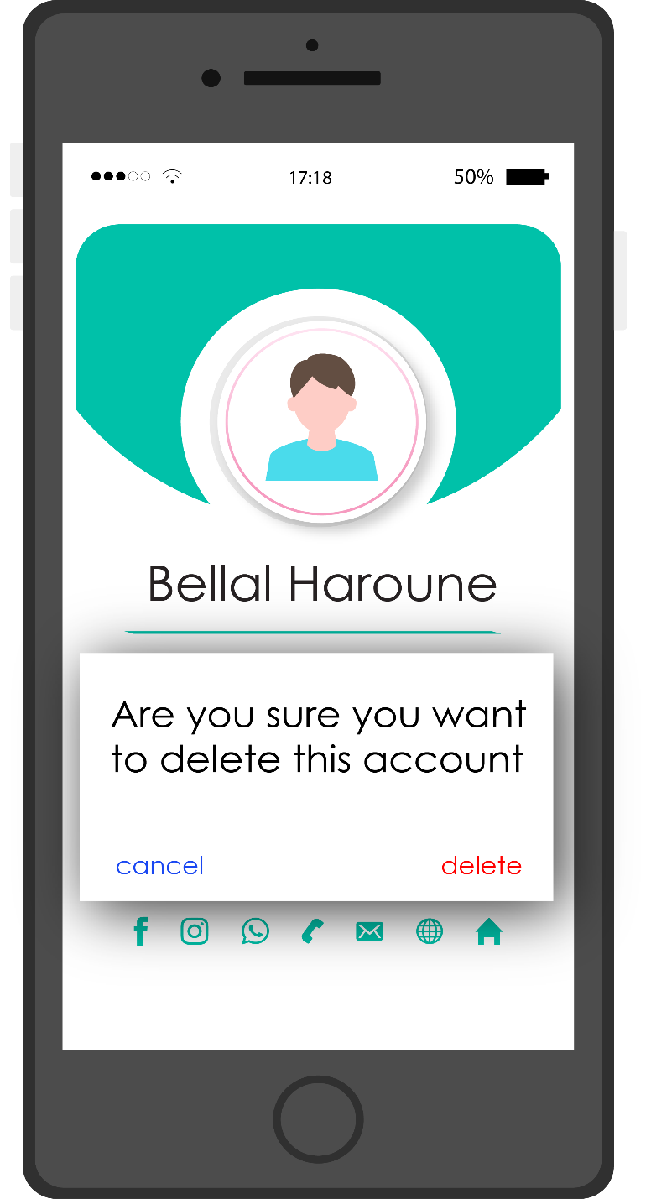

Figure - Account Deletion

1. **Password Change**

Every user has the right to change the password directly if the user is already Logged In. In case where the user forgets his password, he can request a password reset by giving the email which will be sent with a confirmation link to change the password.

1. **Message Forwarding**

Every user can create a conversation with another targeted user and the conversation will be private for the rest of the users so the conversations interface is unique at each user.

1. **Message Defuse**

The app allows its users to defuse a message with two steps, creating a conversation between all the users if it does not exist and sending the message thought the database. The conversation becomes accessible by all users.

1. **Customize Profile**

Every user has a customisable profile (Profile Picture, Bio, Username, Email) where the user can change the profile picture and the bio.