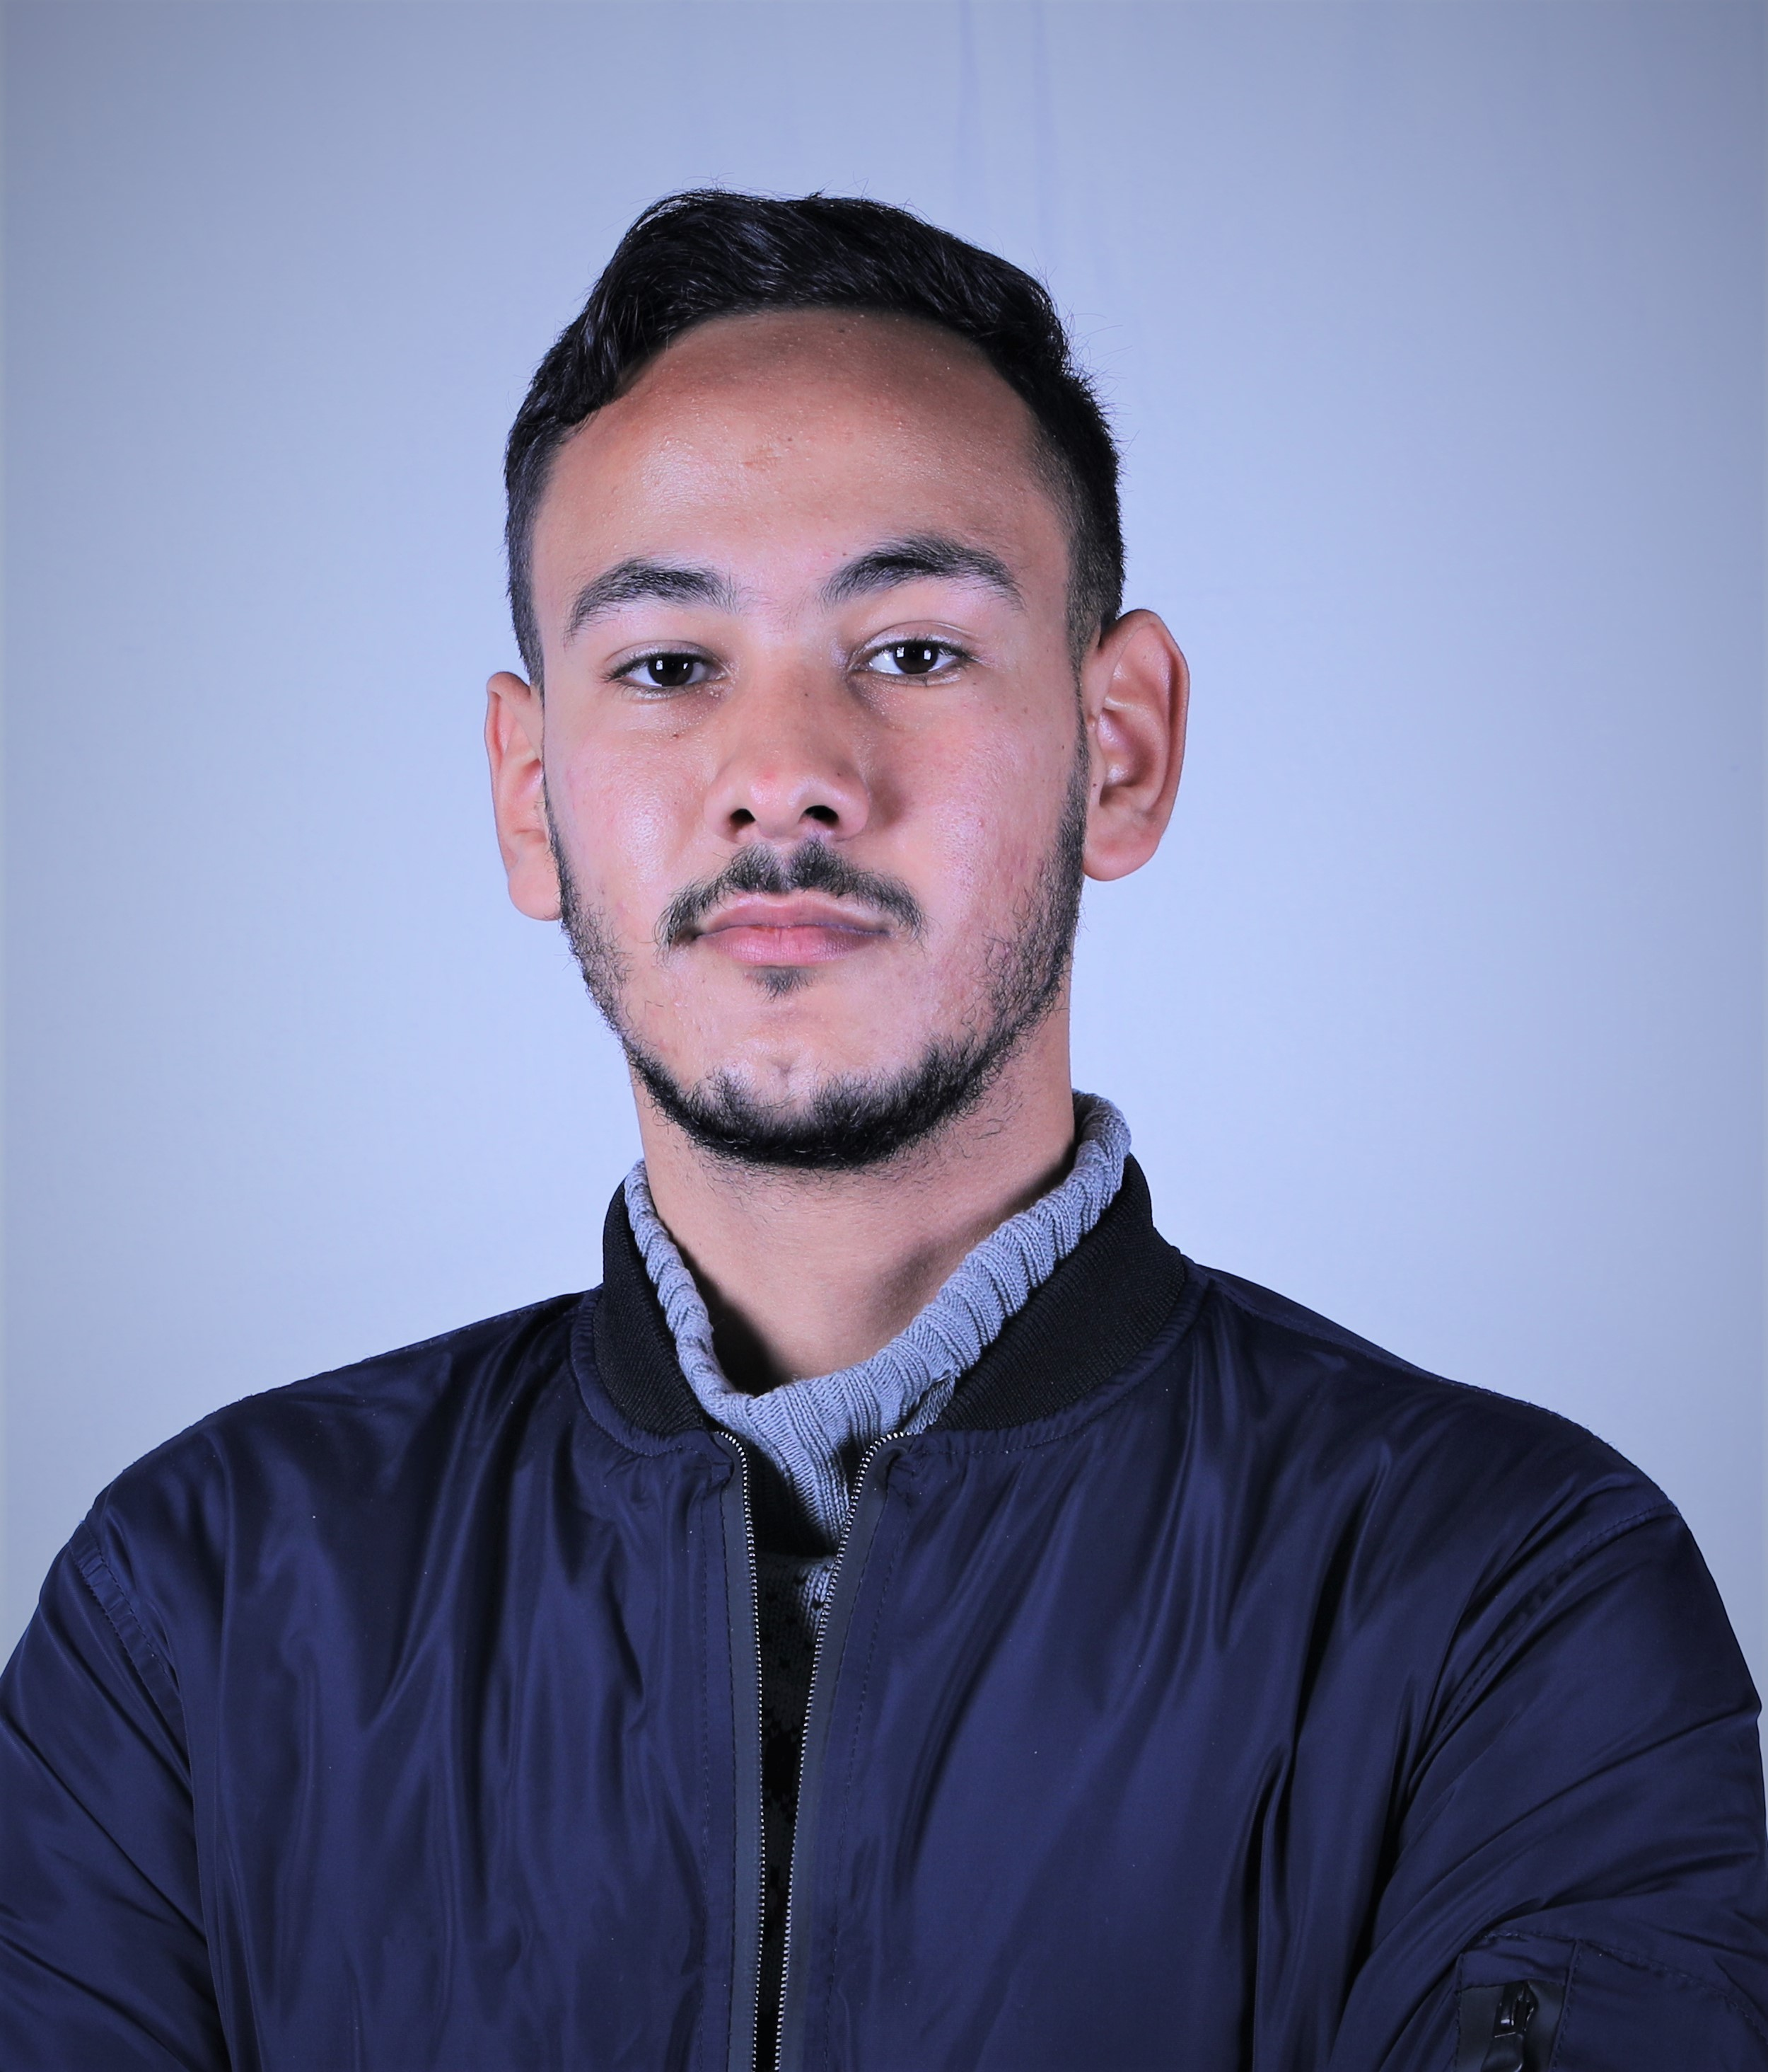

# Personal Information

OTMAN OTMAN

Adrress : 135 bloc 10 qu Riyad Safi

Age : 23

Gender : male

# Contact Information

Email : otman.mousetaf@gmail.com  
Phone : 0637274172

# EXPERIENCES

Ocp

2016 - 2018

Softwer developer cs