### **🧾 Expenses Table**

This table tracks individual expense records for the organization. Each record represents a single expenditure and includes key details such as:

* **Amount**: The monetary value of the expense.
* **Category**: The type of expense (e.g., travel, office supplies, utilities).
* **Date**: The date the expense was incurred.
* **Description**: A brief summary of what the expense was for.
* **Submitted By**: The person who submitted the expense.
* **Department**: The department responsible for the expense.  
  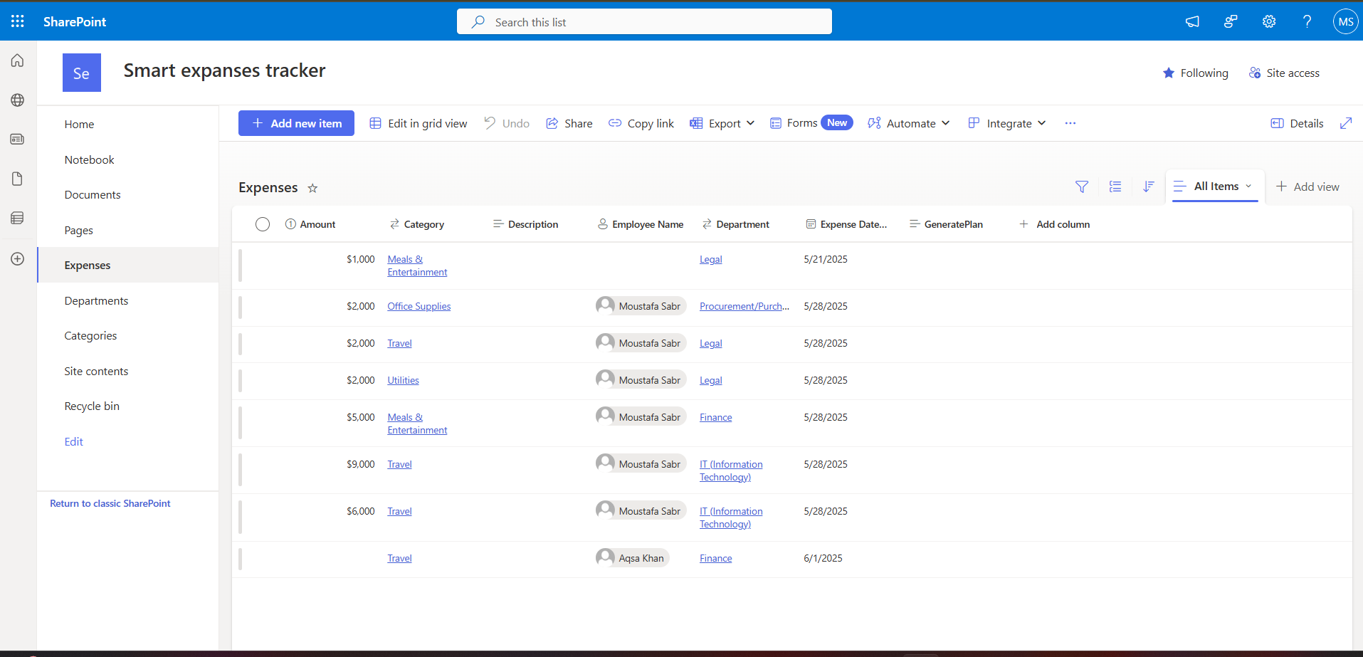

### **💼 Budget Table**

This table serves as a **financial blueprint** for the organization, defining budget allocations for each department or category. Each record represents a **planned budget allocation** and contains the following fields:

* **BudgetAmount**: The monetary amount allocated for the category or department.
* **Category**: The purpose of the budget (e.g., marketing, operations, R&D).
* **Department**: The department responsible for managing the allocated budget.
* **Start Date**: The date when the budget period begins.
* **End Date**: The date when the budget period ends (if applicable).
* **Description**: A short explanation or note about the budget allocation.

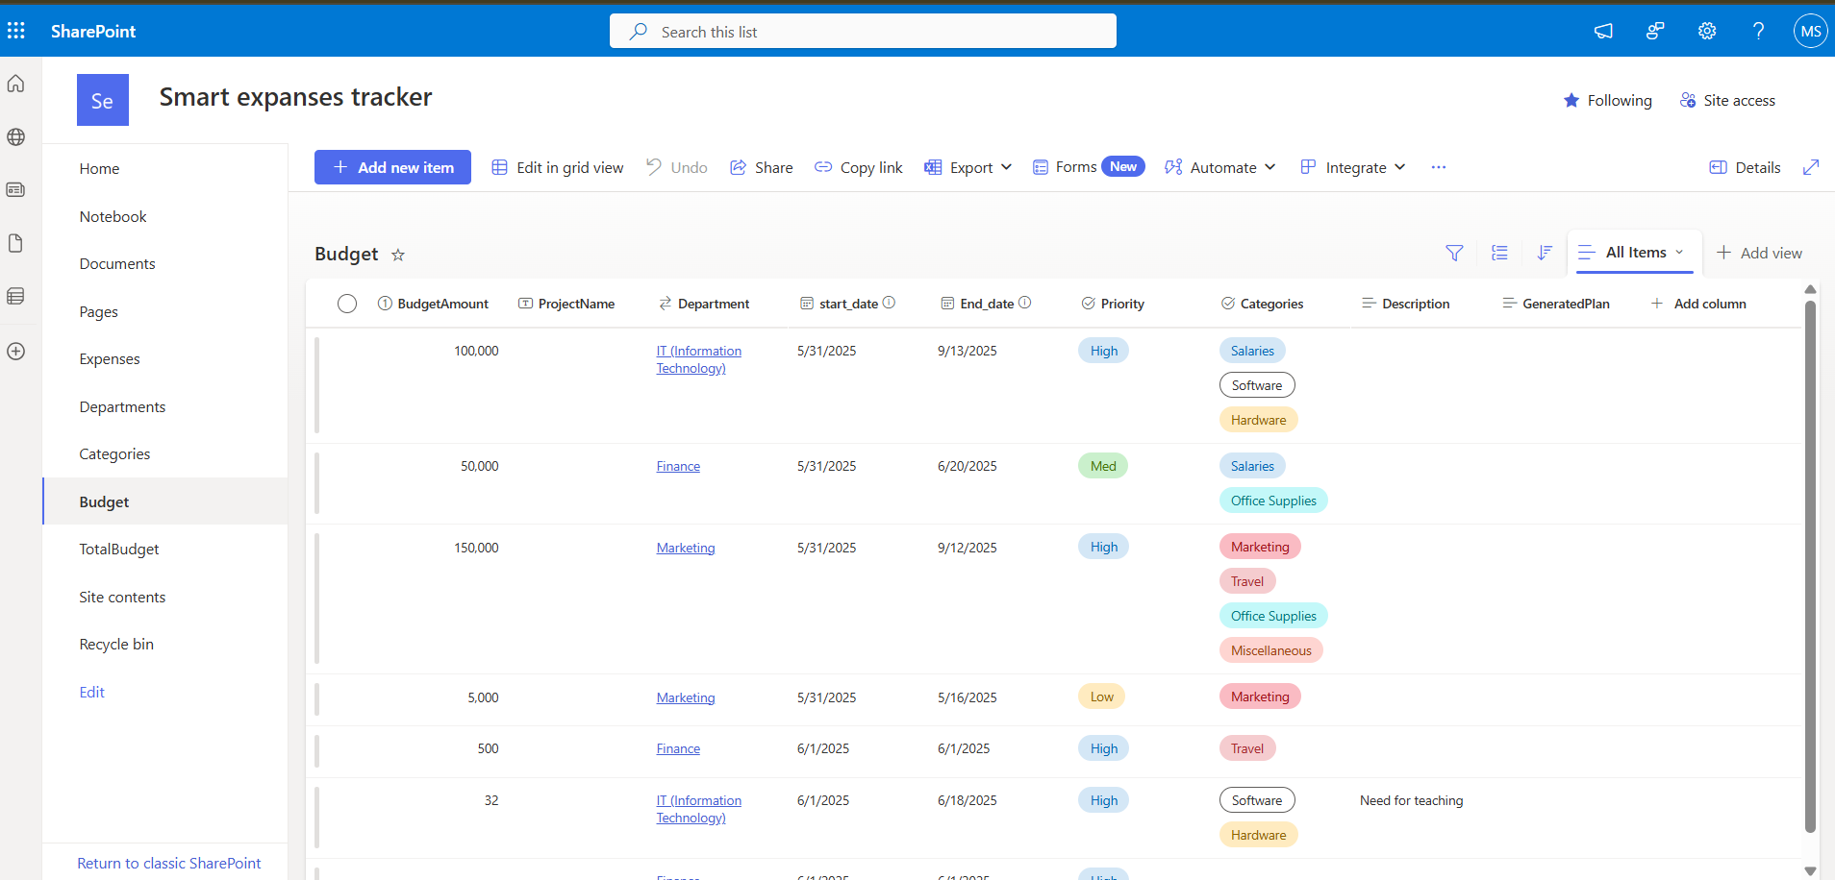

### **🏢 Departments Table**

This table acts as the **backbone of the organizational structure**, defining the various departments within the company. Each record represents a **single department**.

**Fields include**:

* **DepartmentName**: The official name of the department (e.g., Sales, Marketing, IT, HR).

This table enables the system to **associate budgets, expenses, and activities** with the correct department, ensuring **accountability and clarity** across the organization.

### **🗂️ Categories Table**

This table defines the **types of expenses or budget allocations** across the organization. It helps **classify and group financial data** for better reporting and analysis.

**Fields include**:

* **CategoryName**: The name of the category (e.g., Travel, Office Supplies, Advertising, Utilities).
* **Description** (optional): A brief explanation of what the category covers.

By using this table, the app can **filter and analyze expenses** by category, making it easier to **track spending trends** and support **data-driven decision-making**

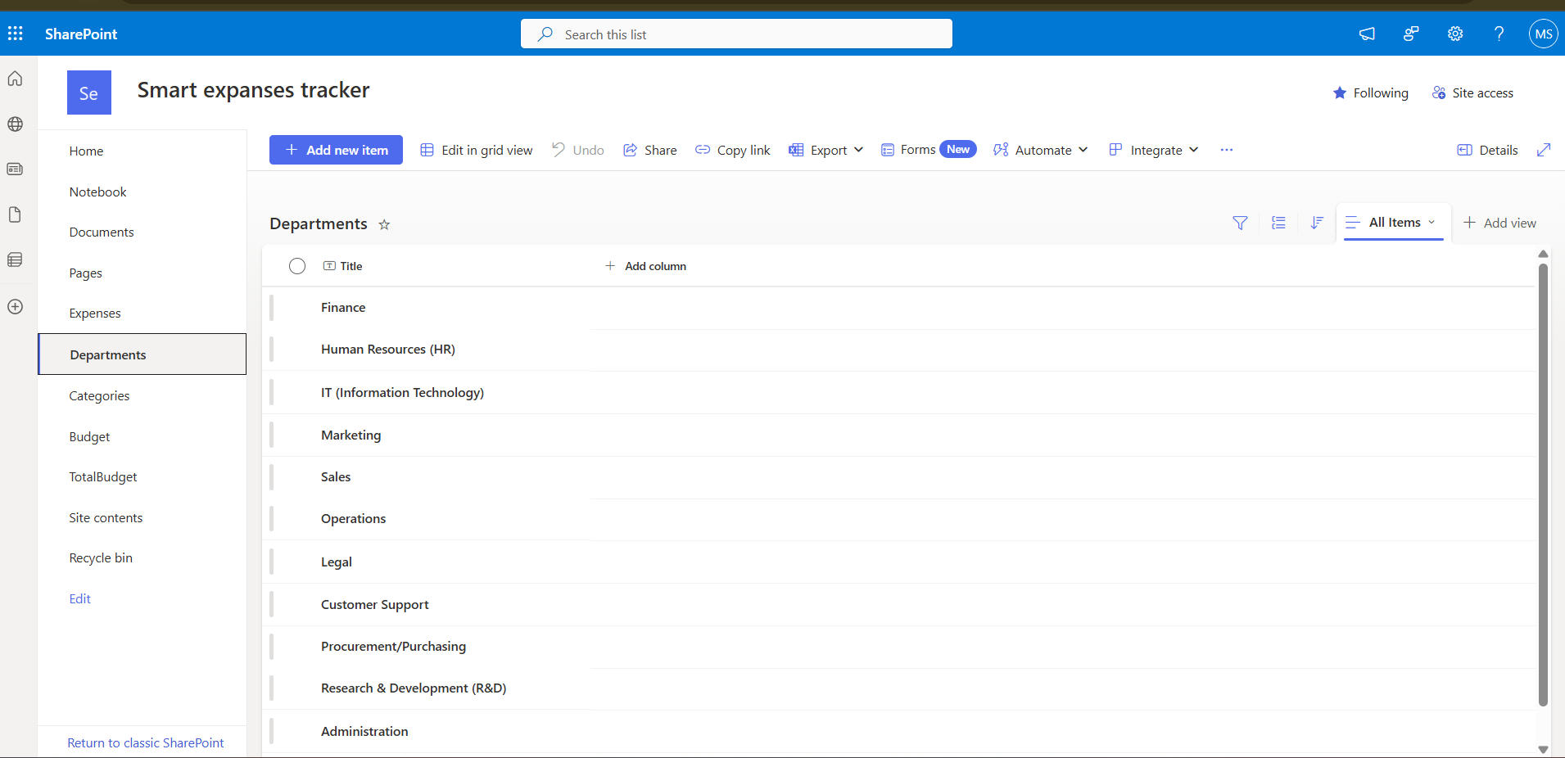

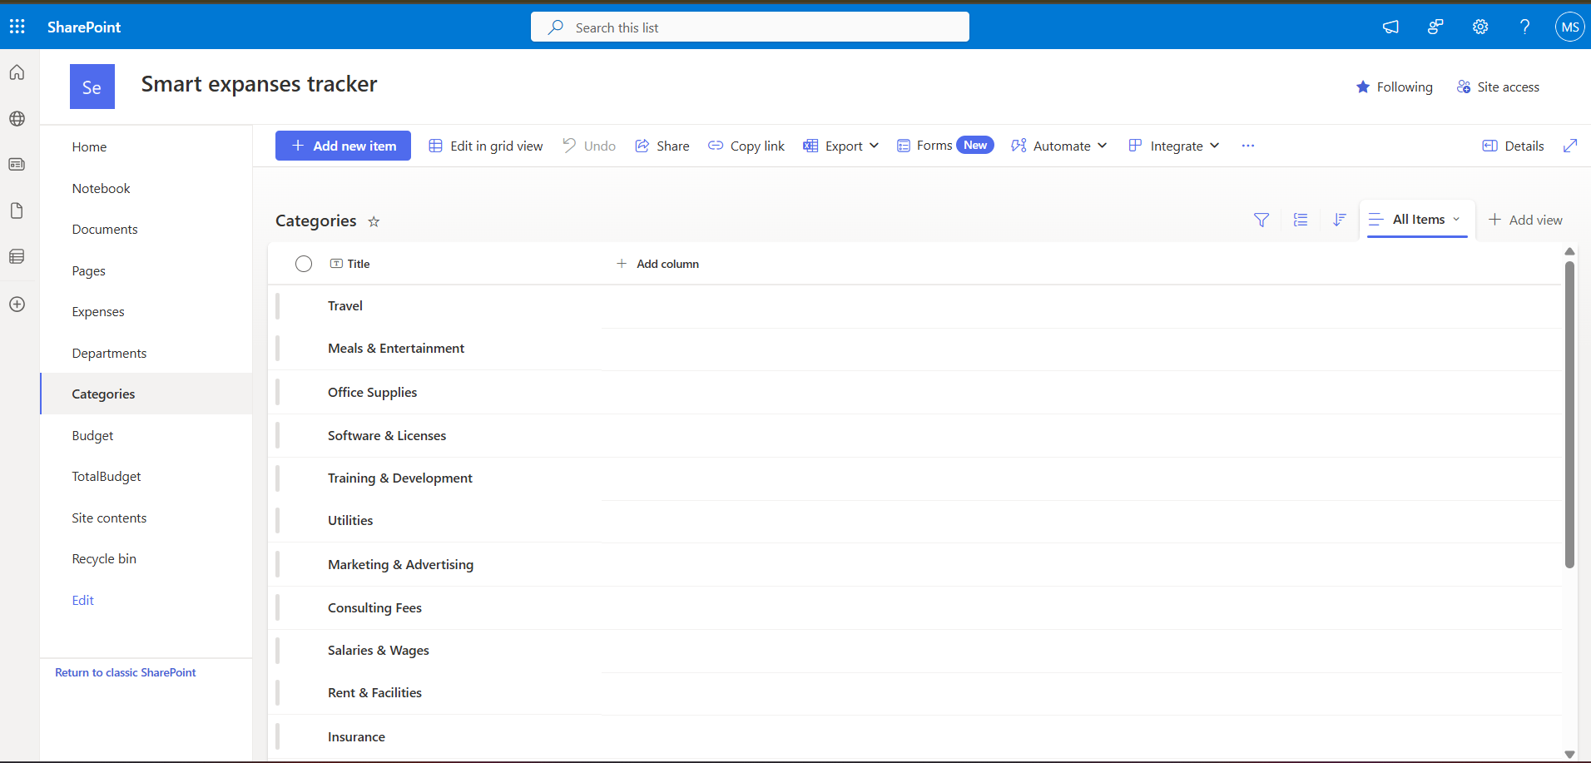

### **🌊 Splash Screen**

The **Splash Screen** is the **first impression** of the app, acting as a **loading page** while data initializes. It typically shows a **logo**, **branding elements**, and a **loading indicator** to reassure users that the app is starting up properly.

It’s designed to create a **smooth, professional entry point** into the application, ensuring the user feels confident and engaged from the moment they launch the app.



### **🏠 Home Screen**

The **Home Screen** serves as the **central hub** and **navigation point** for the entire application. It's designed to be **intuitive** and **user-friendly**, providing easy access to the core features that help manage and monitor the company’s financial data.

**Key Features:**

* **Add Expense:** Quickly log new expenses with all necessary details.
* **Add Financial Plan (Budgets):** Create or update the company’s financial plans and allocate budgets effectively.
* **View Reports:** Access detailed financial reports, including expenses, budget allocation, and trends over time.
* **Financial Health Indicator:** A visual and textual indicator showing the **current financial status**, helping users make informed decisions at a glance.

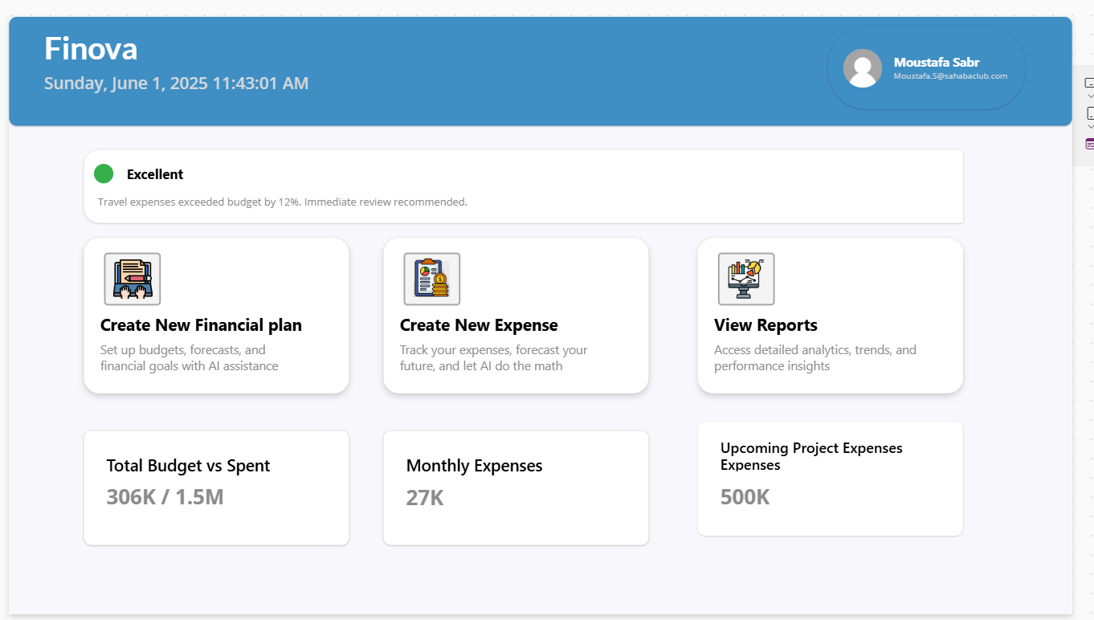

### **💸 Add Expense Screen**

This screen is where users **record new expenses** incurred by the company. It’s designed to capture all relevant details to keep your financial records precise and up-to-date.

**Core Elements:**

* **Expense Amount:** Enter the exact amount spent, with proper currency formatting.
* **Expense Date:** Specify when the expense occurred to maintain chronological accuracy.
* **Department:** Select the department responsible for the expense to keep budgeting organized.
* **Category:** Categorize the expense (e.g., travel, supplies) to facilitate detailed reporting and analysis.
* **Description:** Add optional notes or details to provide context for each expense.

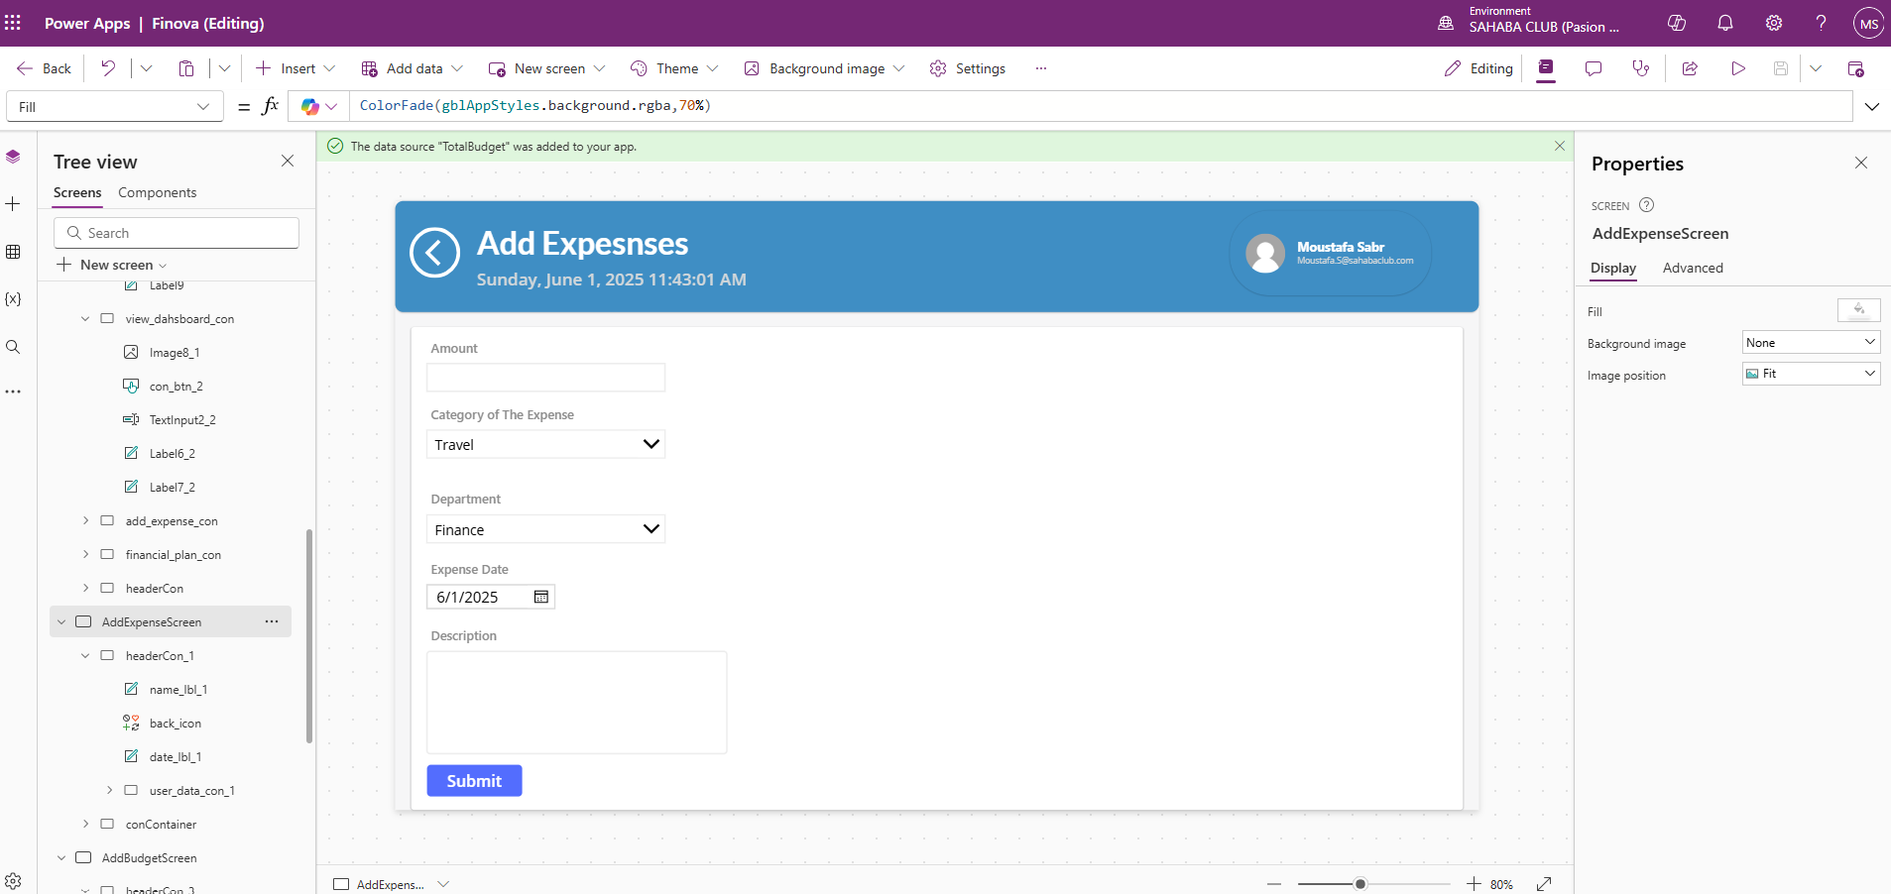

### **💰 Add Budget Screen**

This screen lets users **create new financial plans** by setting budget limits for departments or projects. It’s the command center for controlling where and how money gets allocated.

**Key Components:**

* **Budget Amount:** Define the maximum amount allocated—formatted smartly to show K or M for clarity.
* **Department:** Assign the budget to a specific department, enabling targeted financial management.
* **Category:** Choose relevant budget categories to keep spending organized and easy to track.
* **Start and End Dates:** Set the time frame for the budget, ensuring financial plans are time-bound and measurable.
* **Notes/Description:** Optionally add context to explain the budget’s purpose or constraints.

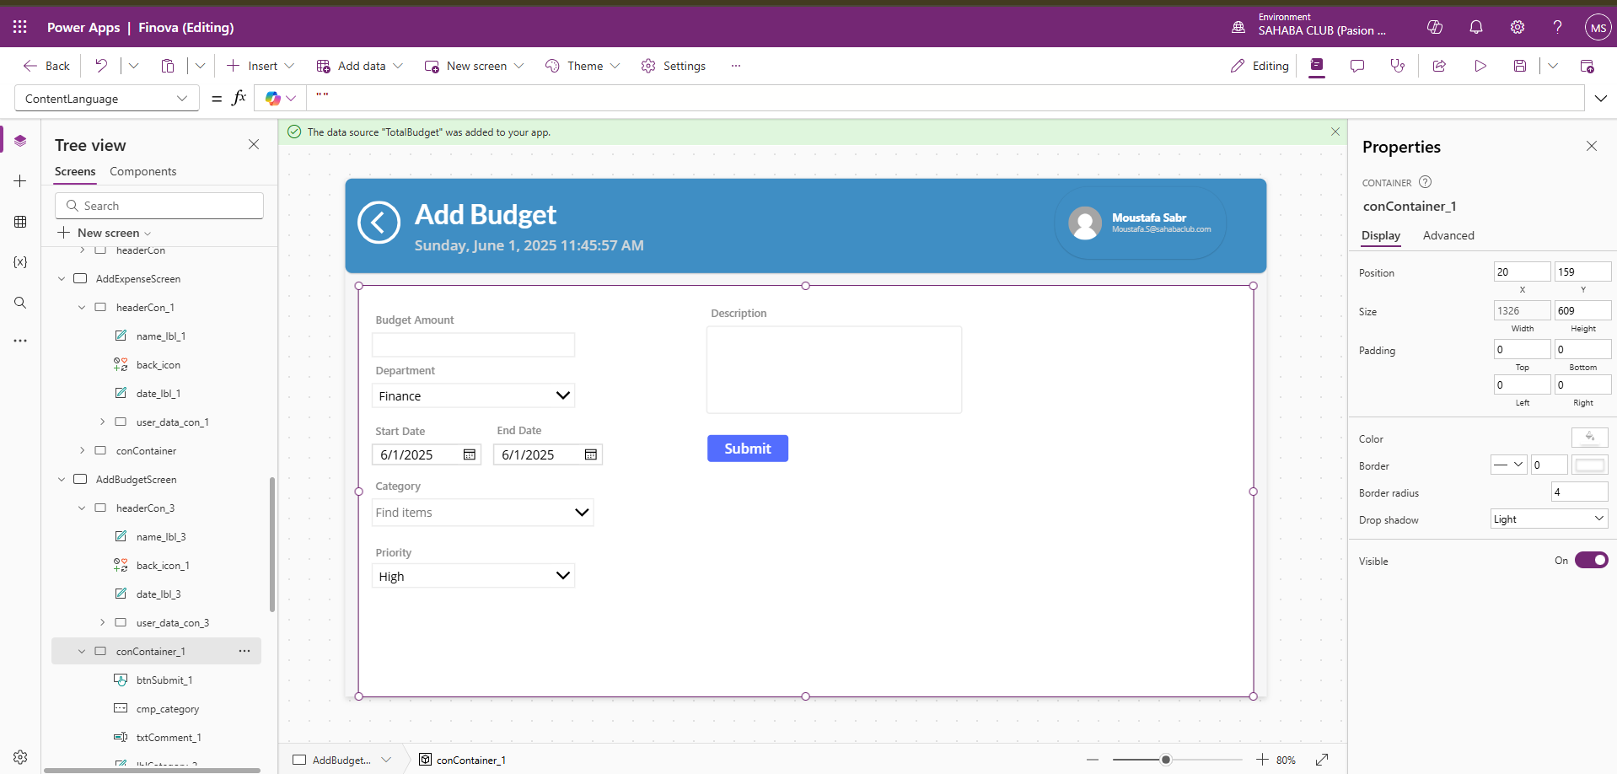

### **📊 Dashboard Screen**

### The command center for your financial pulse, presenting **detailed budget insights sliced by category and department**—no fluff, just facts.

### **Core Elements:**

### **Total Expenses by Category:** See exactly how much each spending category is consuming from the overall budget—spot the biggest money pits at a glance.

### **Total Expenses by Department:** Break down expenses department-wise to quickly identify who’s burning through their allocation and who’s playing it cool.

### **Total Budget Overview:** Clear display of the total allocated budget alongside the sum of all expenses for context.

### **Budget Consumption Analysis:** Highlight which departments or categories have exceeded or are close to exceeding their budget, empowering precise corrective actions.

### 

