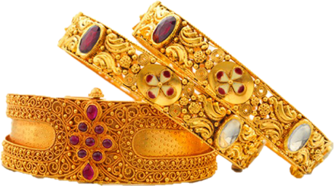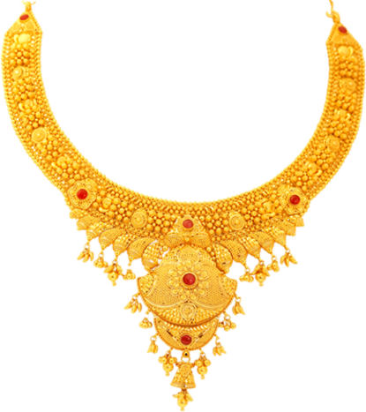

**SNEHA JEWELLERY**

**NEW DESIGN**

**NEW COLLECTION**

**Gariahat, Kolkata – 7000001, Ph - 5487114684**