1.

Cloned the git repo and checked all the docker images and containers before proceeding.

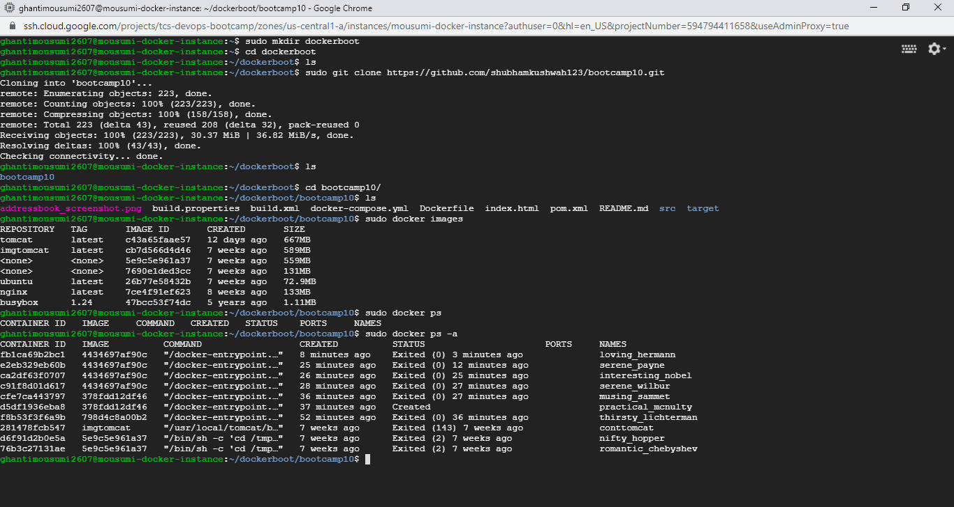

2.

Updated the Dockerfile and built. After building checked if the image is showing in images list or not.

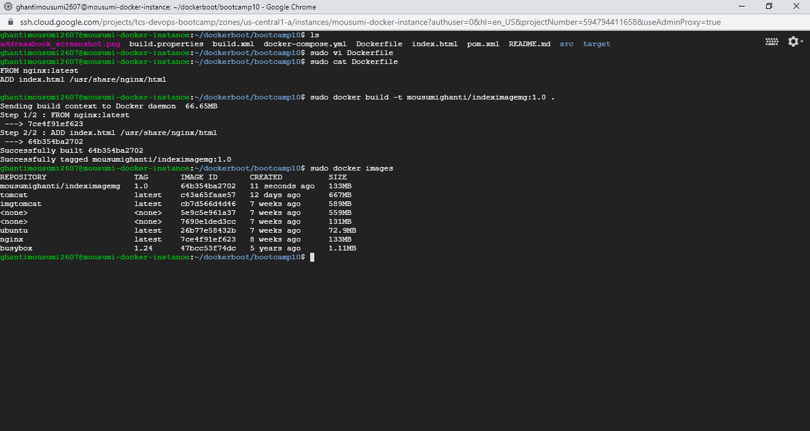

3.

Logged in using Docker login and pushed the recently built image in DockerHub.

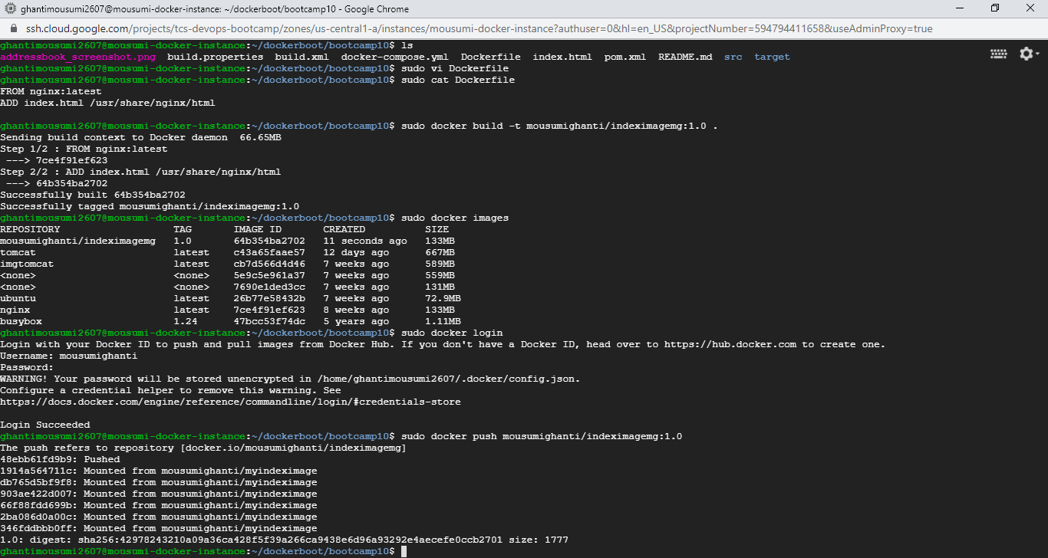

4.

The image got pushed successfully in Docker hub .

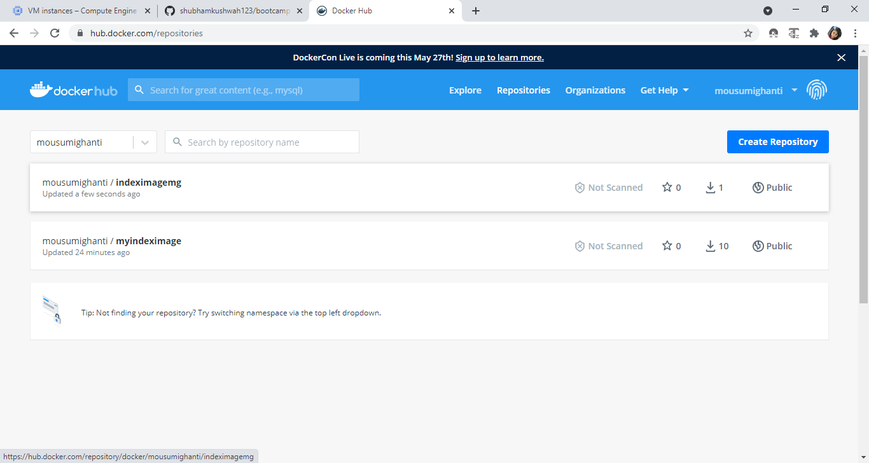

5.

Provisioned new VM instance and installed Docker.

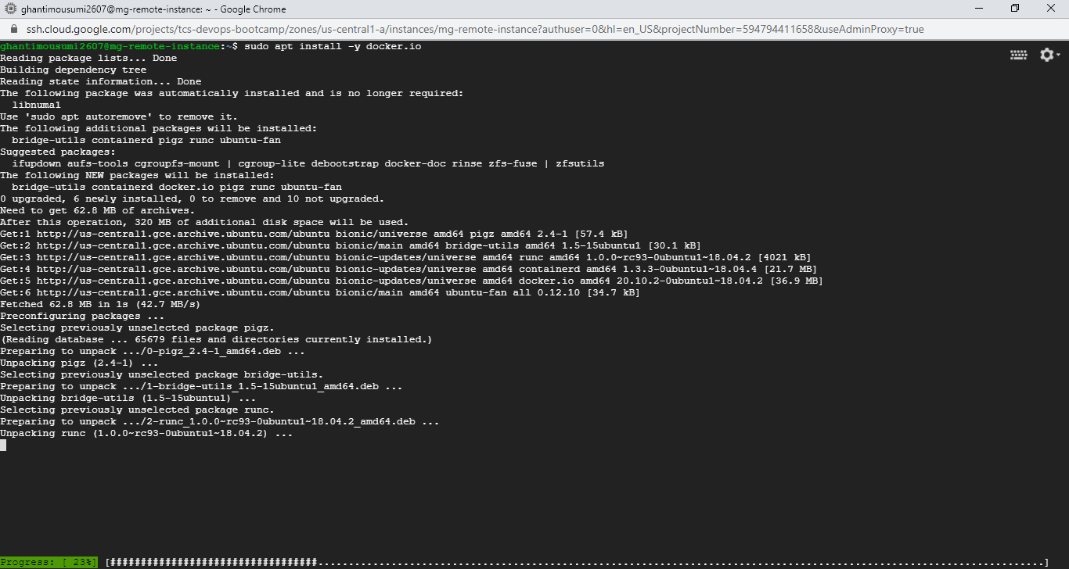

6.

Pulled the image from Dockerhub which got pushed recently. After that ran the image.

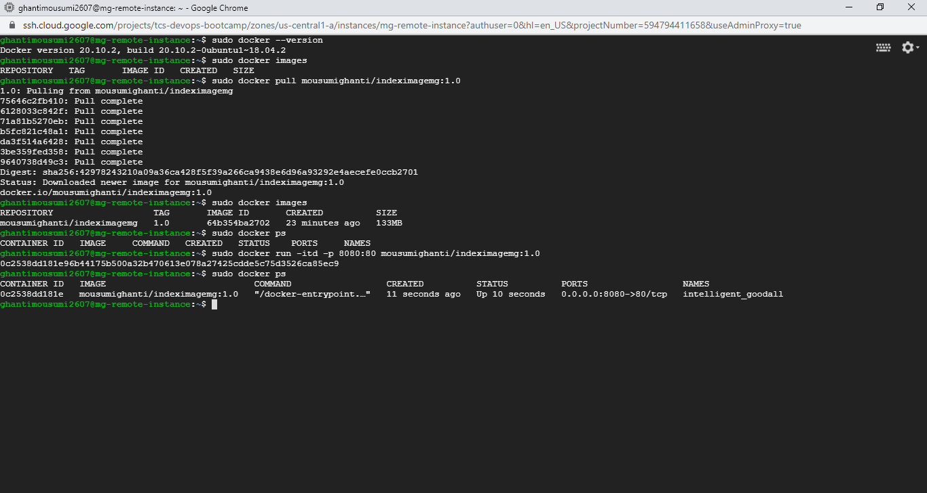

7.

Container is runing successfully.

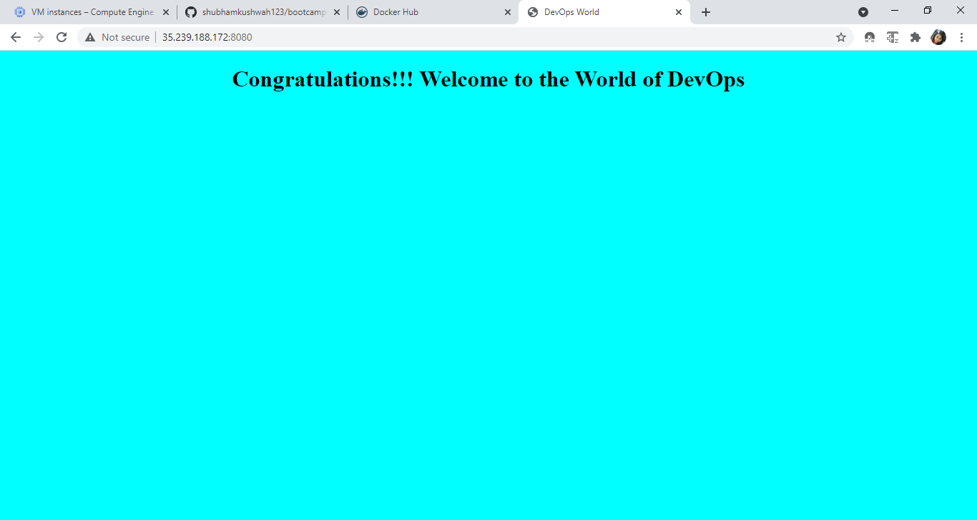

8.

This is docker-compose file for the previous app and mysql.

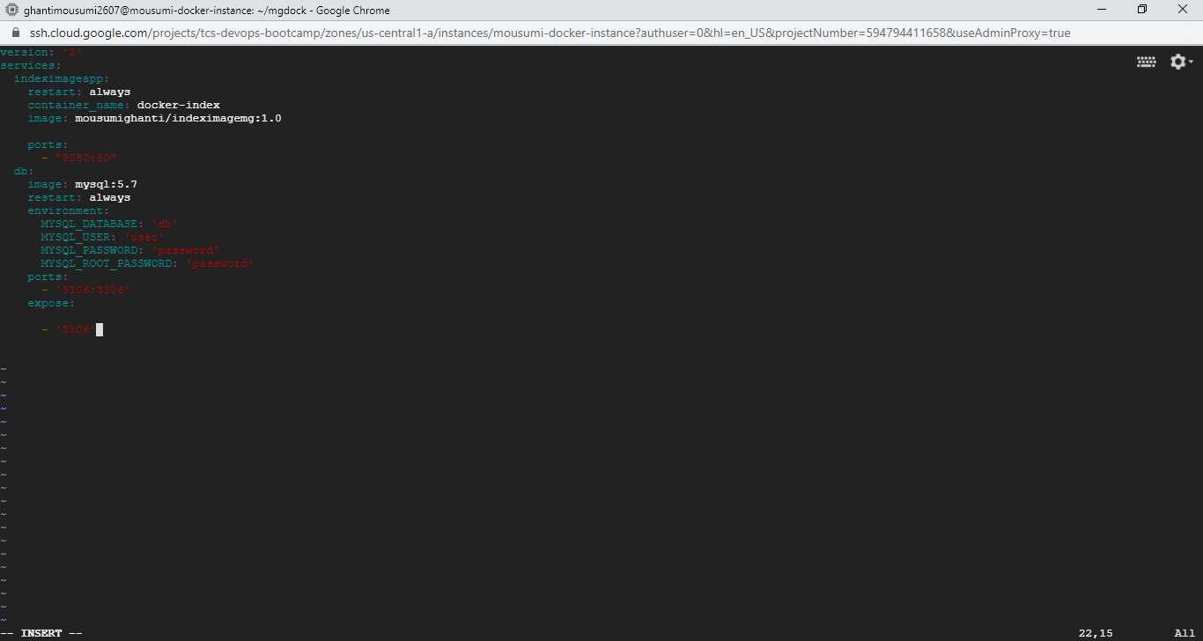

9.

After creating docker-compose file, brought up the docker-compose.

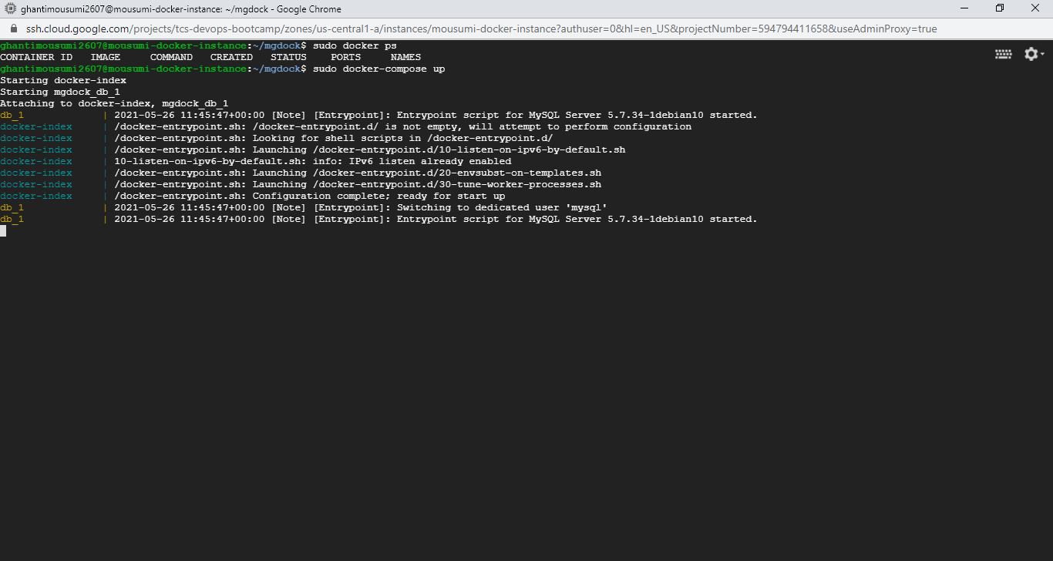

10.

‘docker-compose up’ is running..

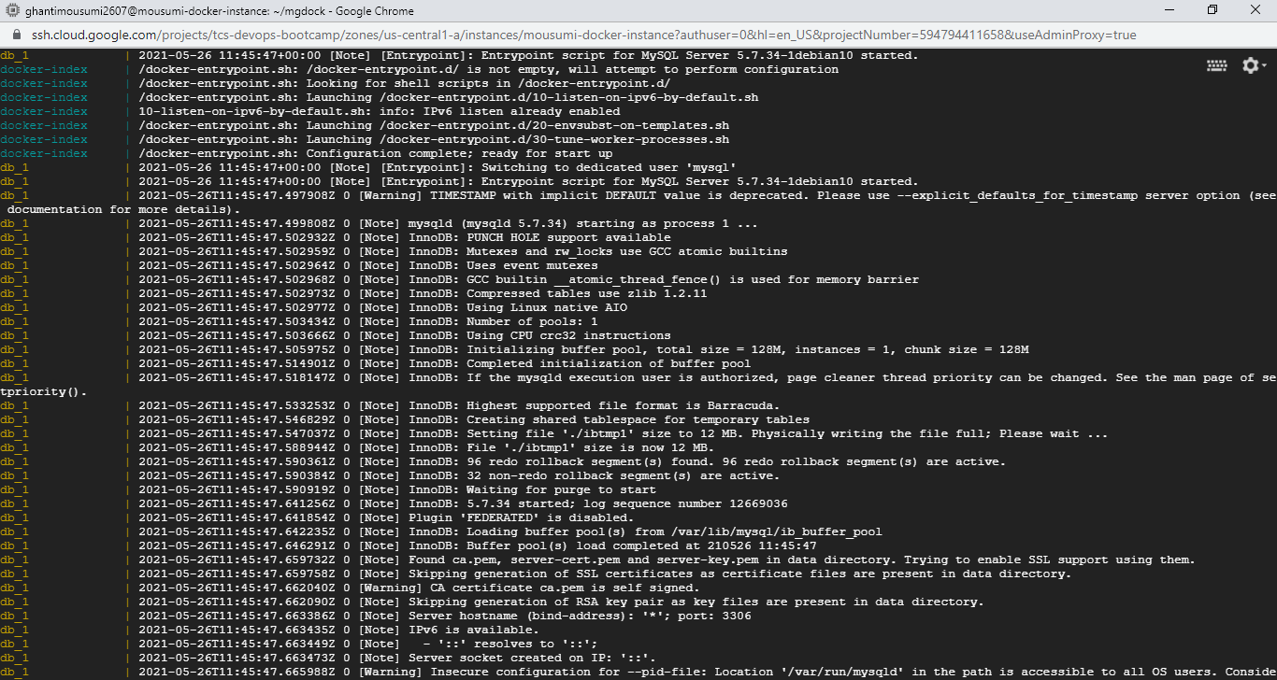

11.

Docker-compose brought up and the app is running successfully.

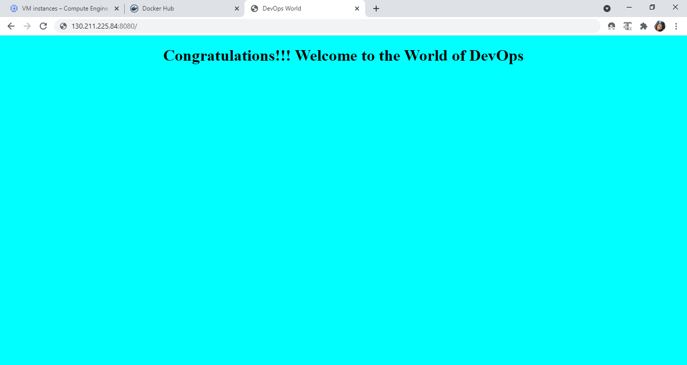

12.

Connected to mysql in –it mode with user id password and checked databases.

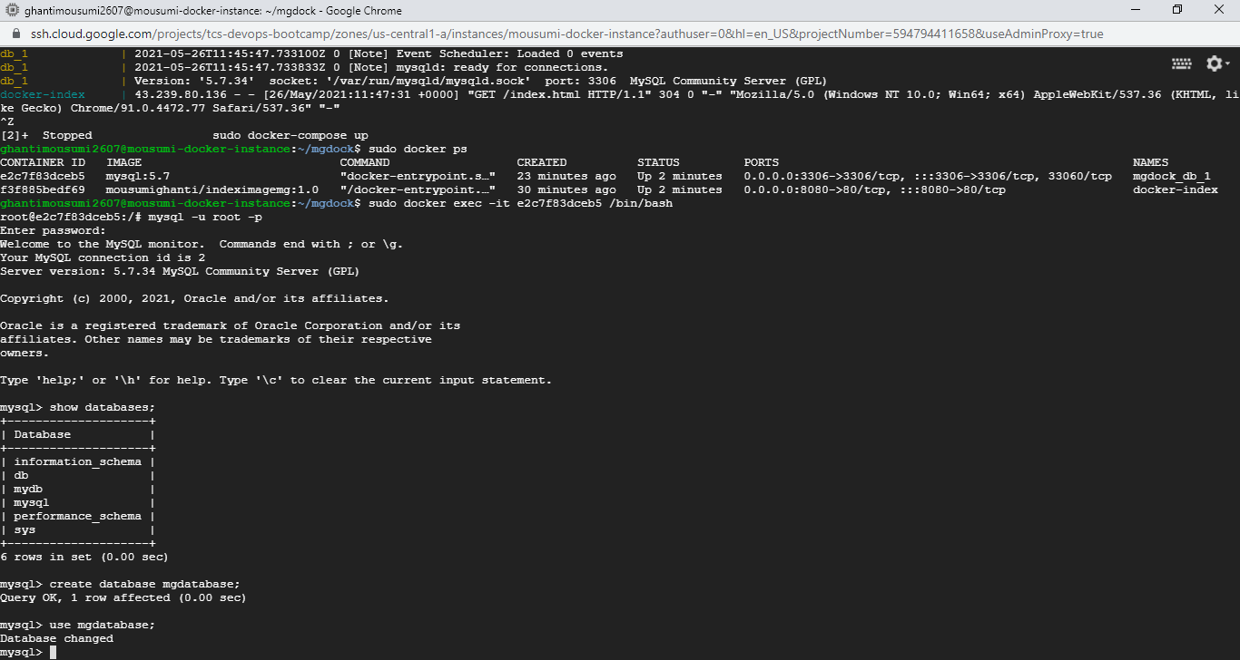

13.

Created database and table with specified attributes and displayed the table.

