1. Copied pem file through scp.

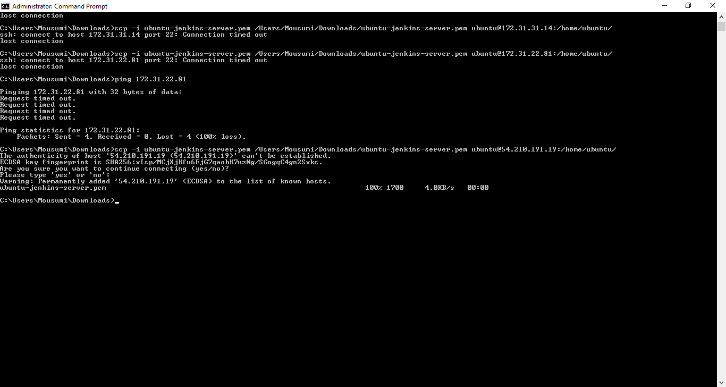

2.Checked if pem file is there and started ssh agent. Returned Agent id 10457.

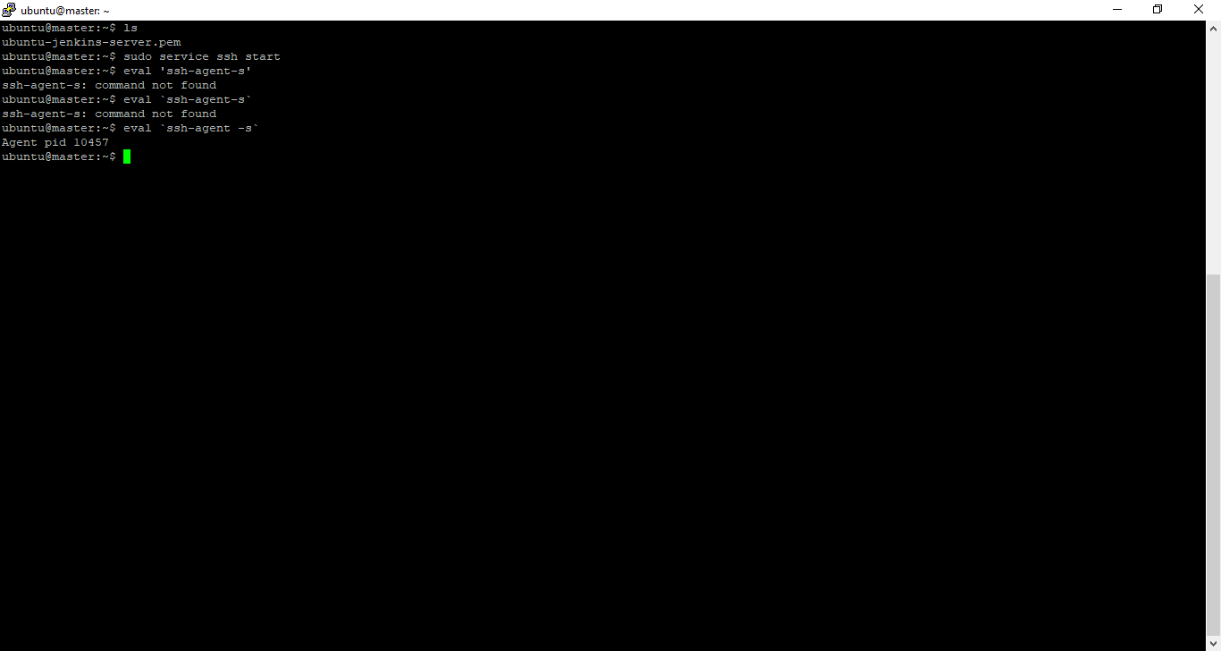

3.Modified permission of pem file and added it in ssh so that we can connect to machine.

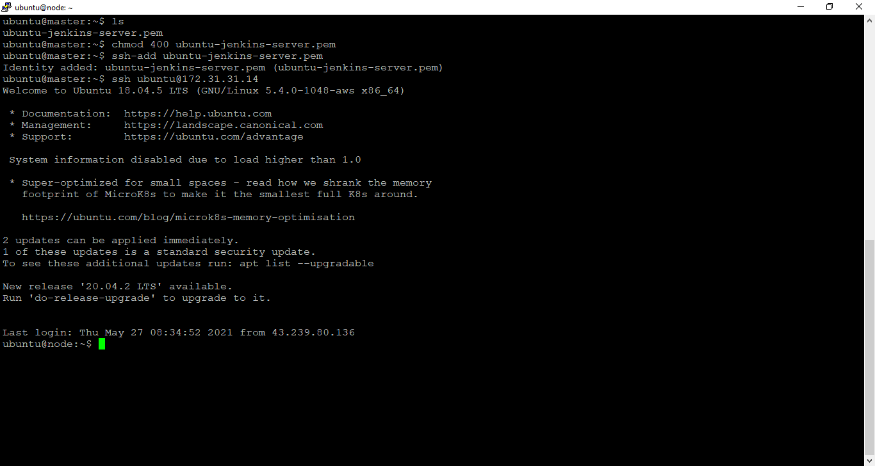

4.Modified .bashrc file for passwordless authentication.

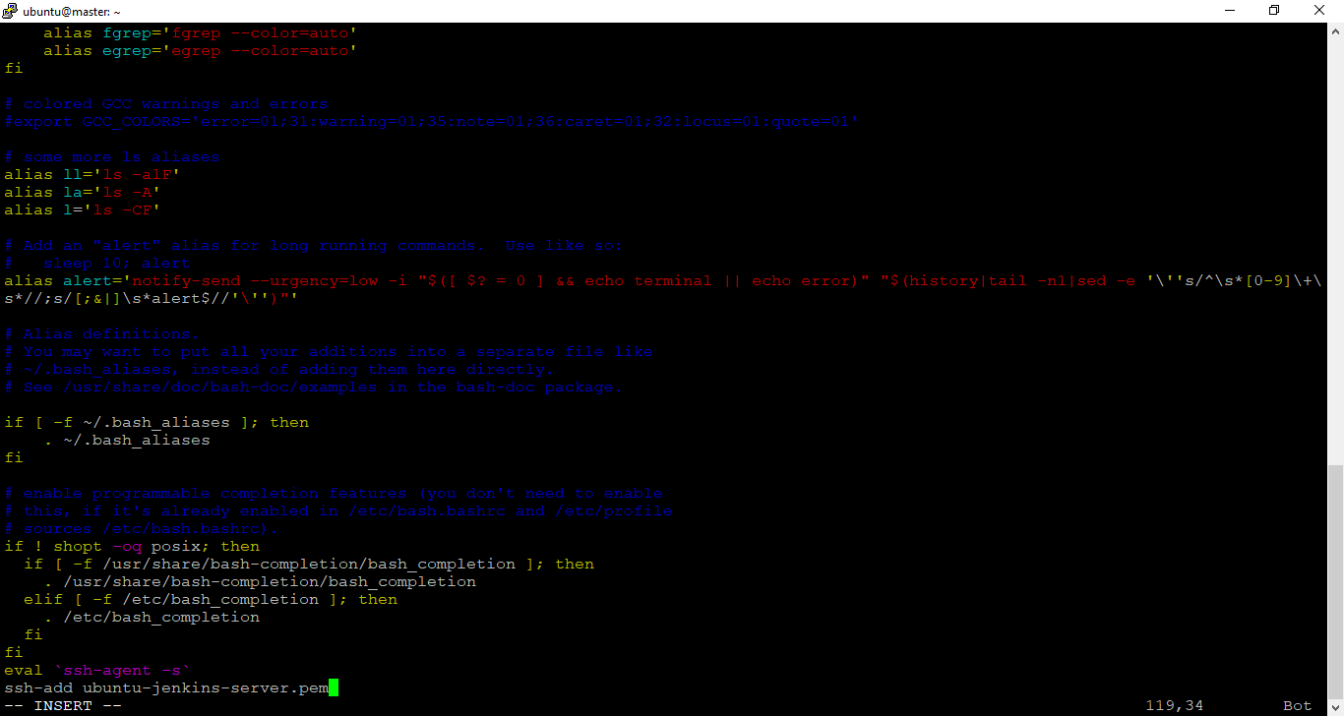

5.Installed ansible.

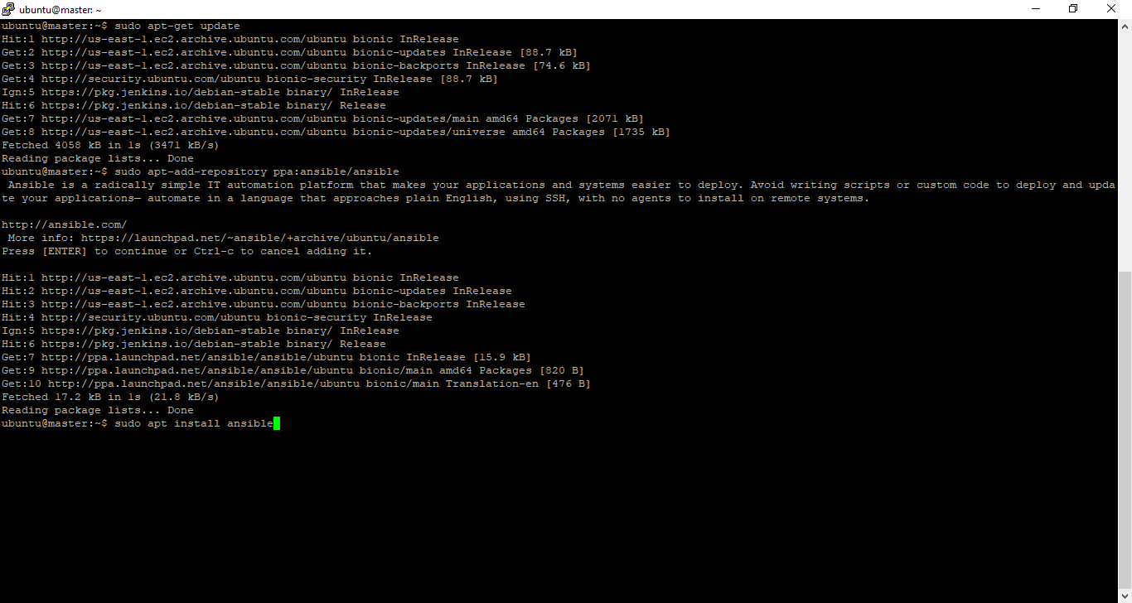

6.Checked version of Ansible.

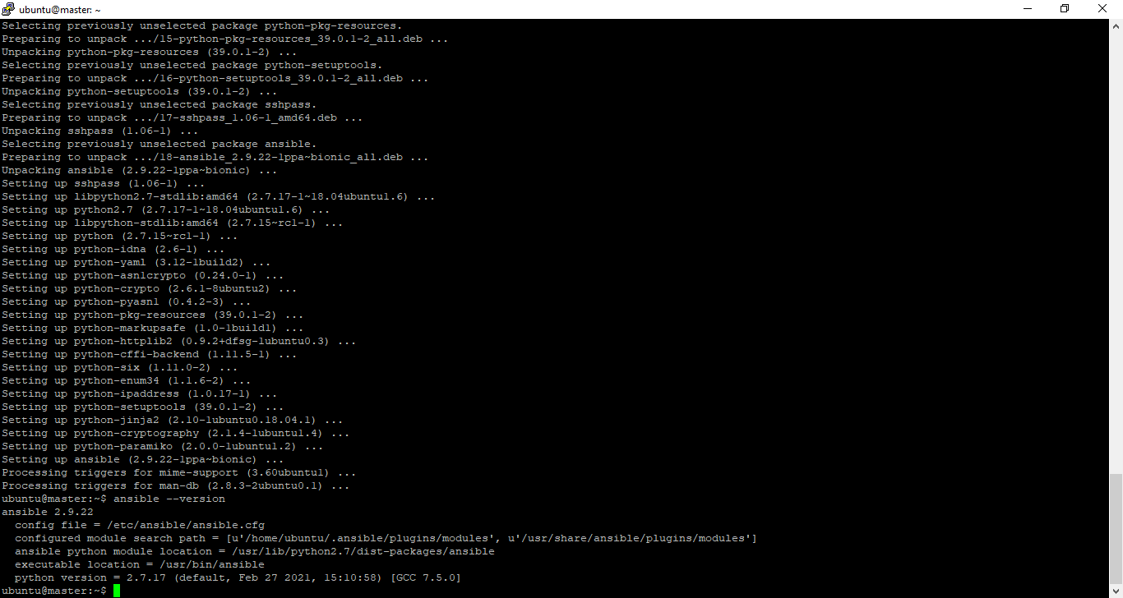

7.Added private ip of node machine in /etc/ansible/hosts file.

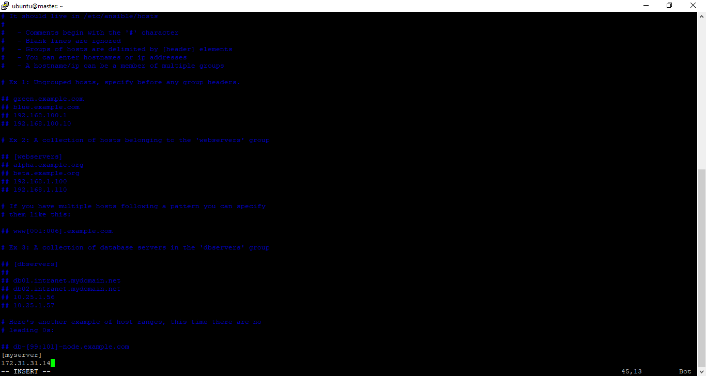

8.Modified permission with chown command and pinged the host to check reachability.

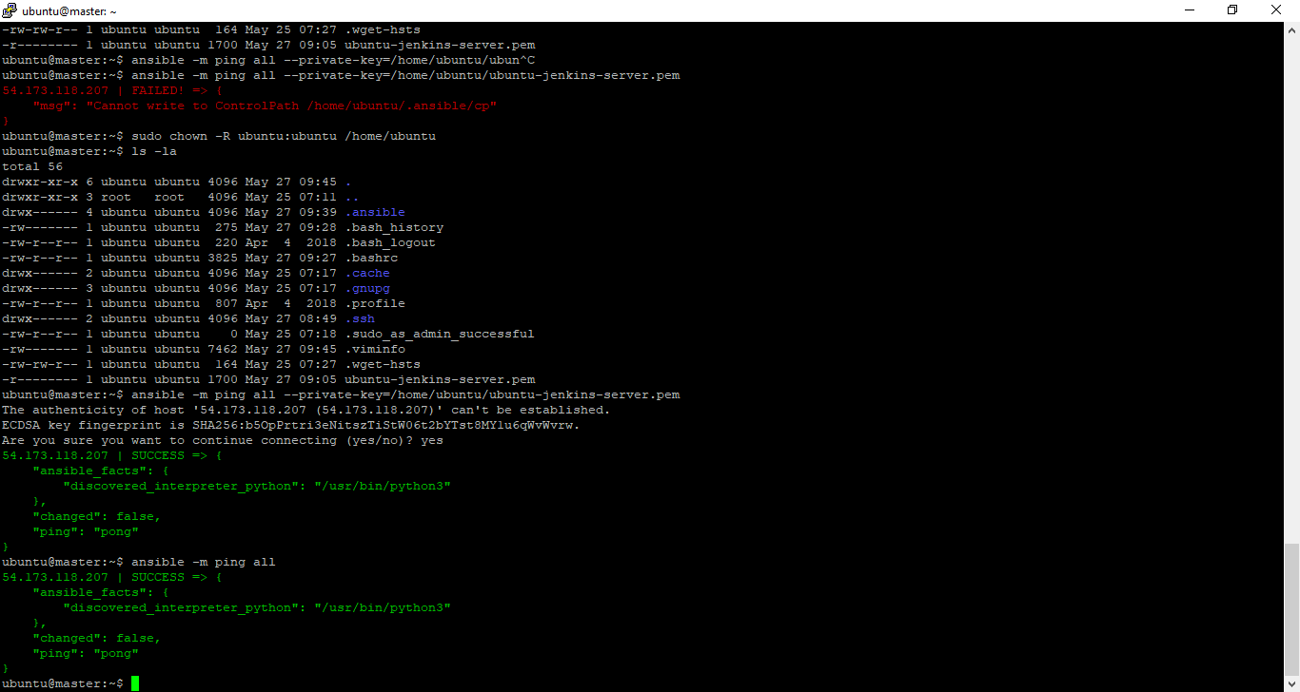

9.Playbook to install multiple packages and deploy application.

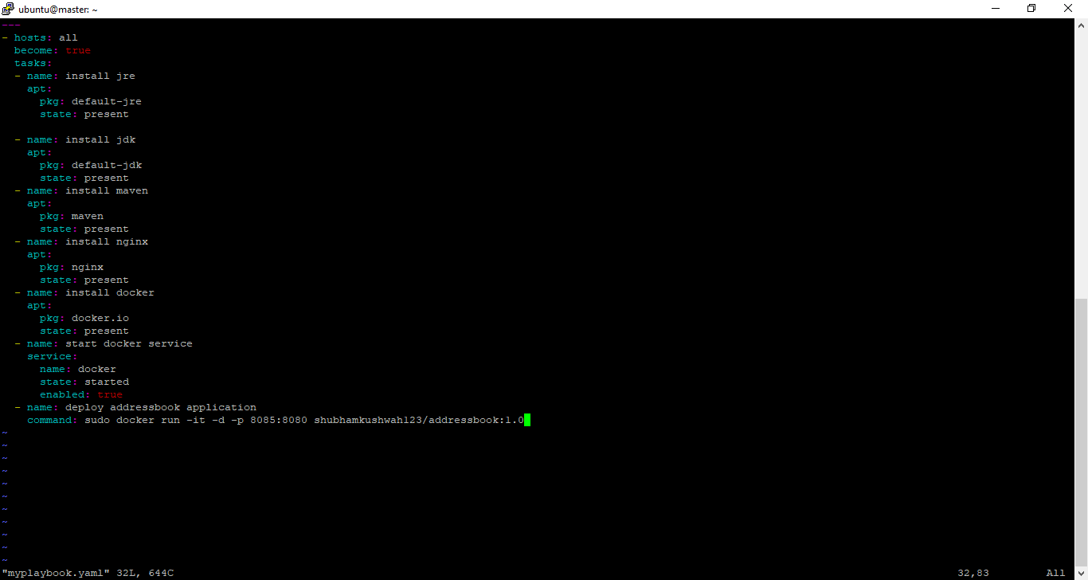

10.Output of playbook run.

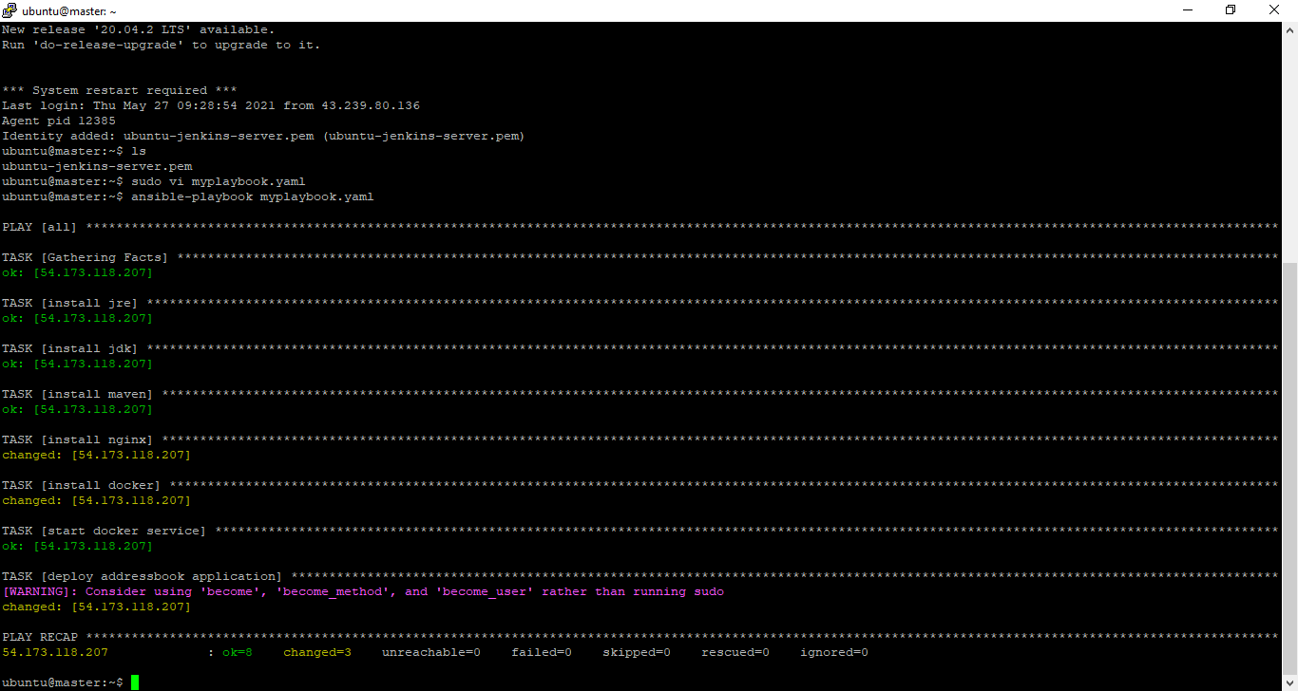

11.The web Application is running as container in node machine successfully.

