**Title**: Scarecrow AI: An Adaptive Solution for Mitigating Human-Animal Conflicts using YOLOv9 and Machine Learning

**Abstract**: The escalating incidences of human-animal conflicts necessitate innovative solutions for safeguarding agricultural lands and urban spaces. In response to this challenge, we present Scarecrow AI, an adaptive system leveraging YOLOv9 for object detection and machine learning technologies. Scarecrow AI utilizes a 360-degree camera to capture the surrounding environment, and employs YOLOv9 for real-time object detection. A machine learning model further classifies detected objects into three categories: Animal, Bird, and Human. Upon identification of animals or birds, tailored deterrence mechanisms are activated, including the emission of high-frequency audio to deter animals and birds, and the alerting of owners in case of human presence. The system's architecture facilitates real-time processing on Raspberry Pi, ensuring scalability and versatility. Through continuous monitoring and feedback-driven improvement, Scarecrow AI represents a promising approach to mitigate human-animal conflicts, preserving agricultural integrity and enhancing urban coexistence.

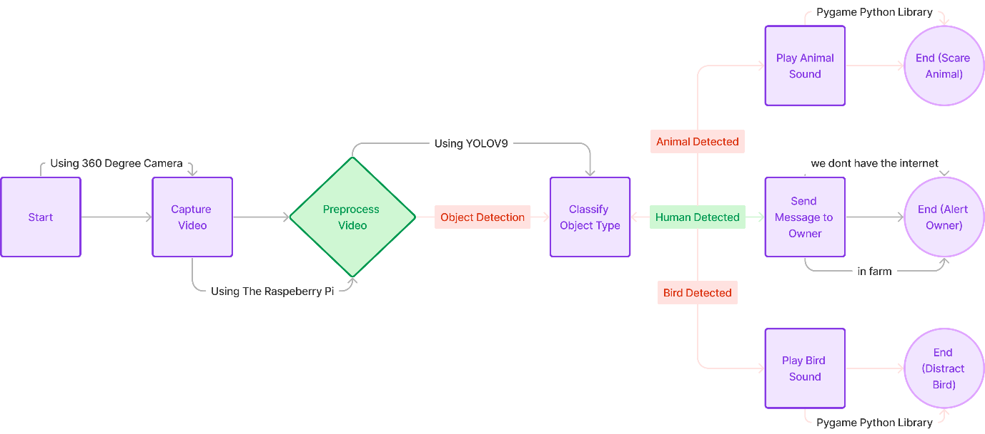

1. **Start:** Begin the process.
2. **Capture Image/Video:** Use the 360 camera to capture the surrounding environment.
3. **Preprocess Image/Video:** Prepare the captured image or video for object detection.
4. **Object Detection:** Use the machine learning model to detect objects in the image or video.
5. **Classify Object Type:** Classify the detected object into one of three classes: Animal, Bird, or Human.
6. **Animal Detected?**: If an animal is detected, proceed to play a high-frequency sound to scare it away.
7. **Bird Detected?**: If a bird is detected, proceed to play a different high-frequency sound to distract it.
8. **Human Detected?**: If a human is detected, proceed to send images to the owner for further action.
9. **End (Scare Animal/Distract Bird/Alert Owner)**: End the process after taking appropriate action based on the detected object type.