Behavioural Data Playmore EEG

Marta Topor

8/10/2021

# Demographic Information

|  |  |  |
| --- | --- | --- |
|  | Touch Screen | Eye Tracker |
| N | 9 | 9 |
| Age Mean | 7 | 6 |
| Age Min | 6 | 6 |
| Age Max | 8 | 7 |
| Male % | 44 | 78 |
| Female % | 56 | 22 |
| Year 0 % | 33 | 67 |
| Year 1 % | 67 | 33 |
| Bilingual % | 22 | 22 |
| Right Handed % | 78 | 100 |
| Left Handed % | 22 | 0 |

**Comments:** There are a couple of issues with the demographics of both groups:

* In the eye-tracker group, most participants are boys
* In the touch-screen group, most participants are from grade 1 and in the eye-tracker group, from grade 0. We have tried to balance this out as well as we could.

Statistical comparisons of intervention data will be adjusted for age using a GLM approach that is consistent with the model that is used to regress out confounds in Fieldtrip.

# Intervention Details

Two participants were removed from the RT and DT comparisons because of Touch Screen failure and responses being pressed with the mouse. This led to inaccurate RTs. Thereofre, for RT and DT measures, there are 7 participants in the touch-screen group and 10 participants in the eye-tracker group.

|  |  |  |
| --- | --- | --- |
|  | Touch Screen | Eye Tracker |
| Training Accuracy Mean | 98.89 | 91.67 |
| Training Accuracy Min | 92.50 | 80.00 |
| Training Accuracy Max | 100.00 | 100.00 |
| Training Correct RT | 2774.00 | 2347.57 |
| Training Correct DT | 1890.02 | 1975.24 |

#### Intervention Accuracy Comparison

##   
## Wilcoxon rank sum test with continuity correction  
##   
## data: int_acc_TS and int_acc_ET  
## W = 67, p-value = 0.02094  
## alternative hypothesis: true location shift is not equal to 0

Corrected p-value: 0.0628309

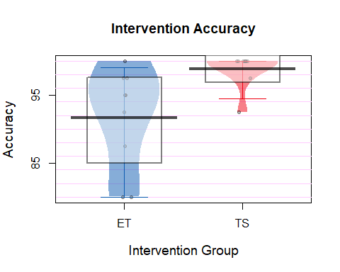

**Comments:** There is a significant statistical difference in participant accuracy during the last 40 trials of intervention. This might be to some extent driven by the outlier in the eye-tracker group. The effect could also be exacerbated by age differences between the two groups (the touch screen group is mostly from grade 1 and the eye-tracker group is mostly from grade 0). Older children might just perform better regardless of what the intervention was.

#### Intervention Correct Answer Reaction Time Comparison

This is the time from stimulus onset to response.

##   
## Wilcoxon rank sum exact test  
##   
## data: int_RT_TS and int_RT_ET  
## W = 51, p-value = 0.04178  
## alternative hypothesis: true location shift is not equal to 0

Corrected p-value: 0.1253497

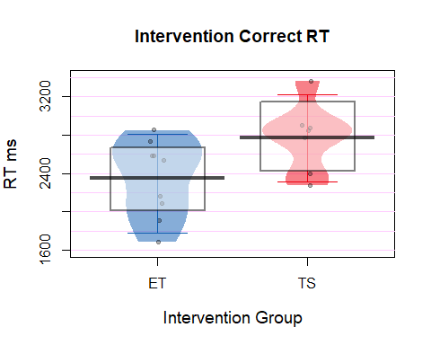

**Comments:** The touch screen group seems to have slower reaction times which is fair enough because they perform movements. This is not significant though.

#### Intervention Correct Answer Decision Time Comparison

This is the time from stimulus onset to space bar release.

##   
## Wilcoxon rank sum exact test  
##   
## data: int_DT_TS and int_DT_ET  
## W = 26, p-value = 0.6065  
## alternative hypothesis: true location shift is not equal to 0

Corrected p-value: 1.8194056

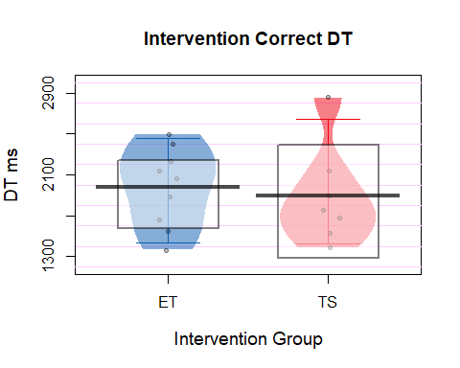

**Comments:** Decision time seems to be comparable between the two groups.

# b/d Test Results

One participant was removed from RT analyses in the eye-tracker group as it was not possible to correctly record their RT in the post test.  
One participant was removed from Accuracy analyses in the eye-tracker group as it was not possible to correctly record their responses with the eye-tracker.

|  |  |  |
| --- | --- | --- |
|  | Touch Screen | Eye Tracker |
| Pre Test Accuracy | 92.71 | 87.43 |
| Post Test Accuracy | 96.94 | 88.61 |
| Accuracy Improvement | 4.23 | 1.18 |
| Pre Test RT | 780.12 | 991.94 |
| Post Test RT | 756.02 | 875.96 |
| RT Improvement | -24.10 | -115.98 |

**Comments:** From the table it is evident that children in the eye tracker group were generally less accurate and slower in the pre-test which might be due to the fact that they were generally younger. This means that there is more room for improvement in this group as well.

#### Accuracy Change

##   
## Wilcoxon rank sum test with continuity correction  
##   
## data: test_acc_TS and test_acc_ET  
## W = 46, p-value = 0.6585  
## alternative hypothesis: true location shift is not equal to 0

Corrected p-value: 1.317026

An individual plot for accuracy change.

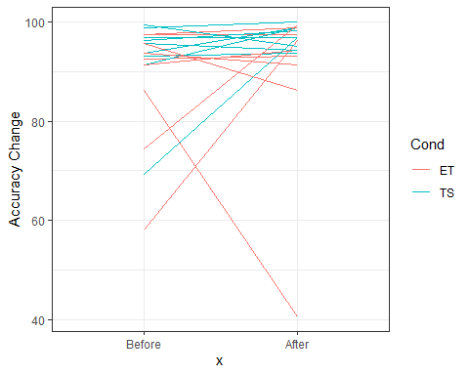

**Comments:** From the individual plot, we can see that the eye-tracker group is much more variable in their performance before and after, whereas the touch-screen group are pretty consistent. The overall change in accuracy is pretty similar between the two groups and not statistically different.

#### Reaction Time Changes

##   
## Wilcoxon rank sum exact test  
##   
## data: test_rt_TS and test_rt_ET  
## W = 47, p-value = 0.6048  
## alternative hypothesis: true location shift is not equal to 0

Corrected p-value: 1.2096257

An individual plot for RT change.

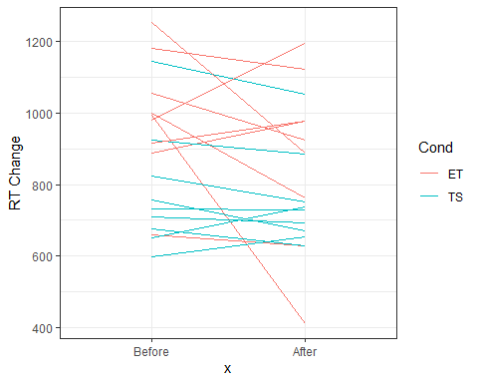

**Comments:** Here again, the eye-tracker group is more variable compared to the touch-screen group. They seem to make a better improvement in their reaction times but they also had more room for improvement compared to the touch-screen group. The difference is however non significant and this is probably due to the outlier that had longer reaction time in the post-test in the eye-tracker group.

# Confounds - correlations

The effects of confounds are not corrected with Bonferroni Correction because this is a check to understand the characteristics of the data (rather than to make assumptions about the population).

|  |  |  |  |
| --- | --- | --- | --- |
|  | Correlation | p-value |  |
| Intervention Accuracy & Grade | 0.087 | 0.732 |  |
| Intervention Accuracy & Sex | -0.010 | 0.969 |  |
| Intervention RT & Grade | 0.373 | 0.155 |  |
| Intervention RT & Sex | -0.468 | 0.068 |  |
| Pre-Post Accuracy & Grade | 0.288 | 0.247 |  |
| Pre-Post Accuracy & Sex | -0.259 | 0.299 |  |
| Pre-Post RT & Grade | 0.292 | 0.240 |  |
| Pre-Post RT & Sex | -0.389 | 0.111 |  |

**Comments** Age is a significant confound for RT during the intervention. Girls are significantly slower than boys. Plot below. Females were also generally older.

