Selective Letter Attention 2D Application

Andreas Wulff-Abramsson   
*Dept. of Nutrition, Exercise and Sports  
Copenhagen University*Copenhagen Denmark  
[awa@nexs.ku.dk](mailto:awa@nexs.ku.dk)

Anne Husted Hensriksen  
*Dept. of Nutrition, Exercise and Sports  
Copenhagen University*Copenhagen Denmark  
[xbn434@alumni.ku.dk](mailto:xbn434@alumni.ku.dk)  
  
Marta Katarzyna Topor  
*Dept. of Nutrition, Exercise and Sports  
Copenhagen University*Copenhagen Denmark  
[mt@nexs.ku.dk](mailto:mt@nexs.ku.dk)

Rasmus Ahmt Hansen  
*Dept. of Nutrition, Exercise and Sports  
Copenhagen University*Copenhagen Denmark  
[sfk384@alumni.ku.dk](mailto:sfk384@alumni.ku.dk)

Jacob Wienecke  
*Dept. of Nutrition, Exercise and Sports  
Copenhagen University*Copenhagen Denmark  
[wienecke@nexs.ku.dk](mailto:wienecke@nexs.ku.dk)

*Abstract*—In this paper we present the technical underpinning and setup behind the selective letter attention test. It is created with the PsychoPy Framework, it is composed of three different scenarios where the distractor is visual, audiovisual and audio only. Each of the scenarios are composed by 1000ms Fixation cross, 200ms stimuli with filler letters and distractor, 5000ms whitespace, where the subject is able to answer what letter they have seen. Lastly, 500ms is used to provide feedback. Each of the scenarios are shown 12 times. In each trial the subject have to tell the system whether or not he/she has seen “p” or “b”, while being distracted by “p”,”b” or “g”. To avoid making the task too easy three filler letters together with the target letter are randomly assigned a predetermined position.

Keywords—Selective Attention, Letter Recognition, Python, 2D, PsychoPy)

# Introduction

Selective attention is the mechanism of selecting one elements out of many possible (**reference**). This process can be challenged by many factors (**reference**). In the context of letter recognition it will be other letters, which could influence the selective attention processes of the subjects. In the context of our studies, we have developed this test to closely match the look and feel of the following article (**reference** to article with numbers). Just like them, we intent to get a better understand of the developing selective attention processes in children. More so are we curious about this process in the context of letter recognition as it is newly acquired skill for children in the lower grades (**reference**). In the following sections we will dive into the development of the program behind the Selective Letter Attention test.

# Implementation

First the program is programmed in Python 3.0(**reference**) using the PsychoPy Framework (**reference**). The Psychopy Graphical User Interface (GUI) allows us to iteratively prototype, develop and test the experiment. The development consist of five distinctive sections called Routines: Intro, FixationCross, Stimuli (visual, audiovisual or audio), Feedback and Pause.

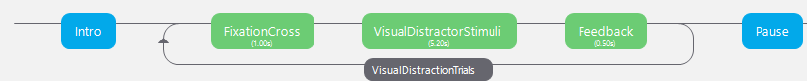

## Intro

The intro is comprised of an introduction text, which explains how to behave during the experiment:

*“Velkommen til Opmærksomheds testen.*

*Du vil blive præsenteret for bogstaver*

*hold øje med b og p.*

*En af dem vil være i højre eller venstre side af skærmen.*

*Hvis du ser p klik til venstre på musen*

*Hvis du ser b klik til højre på musen*

*Klik så snart du ved hvilke bogstav der kom frem”*

The text appears at the beginning of the experiment. It is before the subject as long as the subject desires. He/she can press the return key (Enter) to progress to the next part of the experiment

## FixationCross

In this routine a black X is shown in the middle of the screen surrounded by a white background. The System progresses by itself further to the Stimuli Stage.

## Stimuli

In the stimuli routine the stimuli is present together with either visual, audiovisual or audio only distractor.

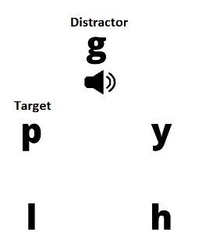

It is present for 200ms continued by 5000ms of blank white canvas. In all 5200ms the subject is able to press a mouse button corresponding to the target letter he/she saw. Left mouse click if it was “p” and right mouse click if it was “b”. The most interesting part of the stimuli is that it has to be shown 12 times within each of the conditions, within those 12 trials 6 different configurations have to be shown 2 times. But, the order is random and positioning of the letters within the 5 different places are random. The 6 different configurations are:

1. Stimuli Configurations

| Configurations | | |
| --- | --- | --- |
| Target | Distractor | Category |
| p | p | Congruent |
| p | b | Incongruent |
| p | g | Neutral |
| b | b | Congruent |
| b | p | Incongruent |
| b | g | Neutral |

In order to accommodate the random, yet controlled nature of the stimuli the following algorithm was devised.

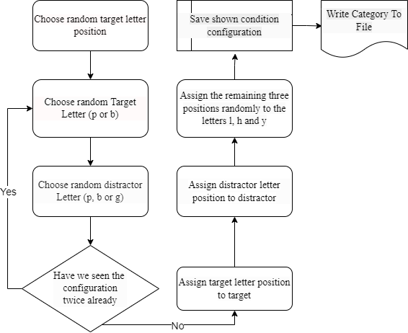

In figure XX it shows that every time the stimuli is presented it ensures the configuration is saved in the program, thus after 12 trials all the wished stimuli configurations are shown.

After the stimuli has been chosen by the program it listens to the mouse for user input in order to determine how quickly the user responses to the 200ms stimuli, and whether or not it is correct. The flow of the program looks like the following :

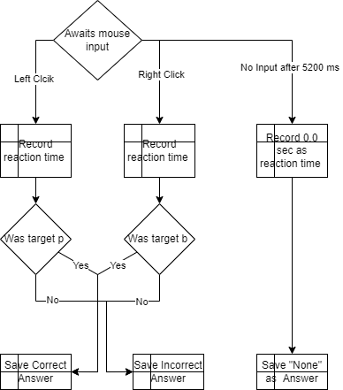

From the diagram it is noteworthy to understand if the subject does not react within the time window of 5200ms the reaction will be recorded as “None” which will tell the system to prompt the user with a message expressing that the subject’s reaction shall be faster.

## Feedback

Based on the correctness of the reaction, recorded during the stimuli Routine. The feedback is present on the screen for 500ms. The following table elucidates the different feedback permutations:

1. Feedback permutations

| Permutations | | |
| --- | --- | --- |
| Answer | Feedback |  |
| Correct | C:\psychoPy\SelectiveAttention\graphic\happyface.png |  |
| Incorrect | C:\Users\tvh307\AppData\Local\Microsoft\Windows\INetCache\Content.Word\sadface.png |  |
| None | “Hurtigere” (Faster in Danish) |  |

If we look at figure XX we see that FixationCross, Stimuli and Feedback are embedded in a loop, which after 12 runs continuous to Pause

## Pause

This Routine is a break between two routine loops. It occurs after the first (visual distractor) and second routine loop (audiovisual distractor), but not after the third (audio distractor). When the third has ended the whole program stops and the data is saved as a CSV file ready to be interpreted. The pause routine is a simple text stating:

*“Pause*

*tryk på en tast når du er klar til at fortsætte”*

Which means that the subject can press any button in order to continue.

# Pilot Results

To confirm that the program indeed provided the data the study needs several initial pilot sessions where conducted between the researchers

## Maintaining the Integrity of the Specifications

The template is used to format your paper and style the text. All margins, column widths, line spaces, and text fonts are prescribed; please do not alter them. You may note peculiarities. For example, the head margin in this template measures proportionately more than is customary. This measurement and others are deliberate, using specifications that anticipate your paper as one part of the entire proceedings, and not as an independent document. Please do not revise any of the current designations.

# Prepare Your Paper Before Styling

Before you begin to format your paper, first write and save the content as a separate text file. Complete all content and organizational editing before formatting. Please note sections A-D below for more information on proofreading, spelling and grammar.

Keep your text and graphic files separate until after the text has been formatted and styled. Do not use hard tabs, and limit use of hard returns to only one return at the end of a paragraph. Do not add any kind of pagination anywhere in the paper. Do not number text heads-the template will do that for you.

## Abbreviations and Acronyms

Define abbreviations and acronyms the first time they are used in the text, even after they have been defined in the abstract. Abbreviations such as IEEE, SI, MKS, CGS, sc, dc, and rms do not have to be defined. Do not use abbreviations in the title or heads unless they are unavoidable.

## Units

* Use either SI (MKS) or CGS as primary units. (SI units are encouraged.) English units may be used as secondary units (in parentheses). An exception would be the use of English units as identifiers in trade, such as “3.5-inch disk drive”.
* Avoid combining SI and CGS units, such as current in amperes and magnetic field in oersteds. This often leads to confusion because equations do not balance dimensionally. If you must use mixed units, clearly state the units for each quantity that you use in an equation.
* Do not mix complete spellings and abbreviations of units: “Wb/m2” or “webers per square meter”, not “webers/m2”. Spell out units when they appear in text: “. . . a few henries”, not “. . . a few H”.

Identify applicable funding agency here. If none, delete this text box.

* Use a zero before decimal points: “0.25”, not “.25”. Use “cm3”, not “cc”. (*bullet list*)

## Equations

The equations are an exception to the prescribed specifications of this template. You will need to determine whether or not your equation should be typed using either the Times New Roman or the Symbol font (please no other font). To create multileveled equations, it may be necessary to treat the equation as a graphic and insert it into the text after your paper is styled.

Number equations consecutively. Equation numbers, within parentheses, are to position flush right, as in (1), using a right tab stop. To make your equations more compact, you may use the solidus ( / ), the exp function, or appropriate exponents. Italicize Roman symbols for quantities and variables, but not Greek symbols. Use a long dash rather than a hyphen for a minus sign. Punctuate equations with commas or periods when they are part of a sentence, as in:

*a*  *b*    

Note that the equation is centered using a center tab stop. Be sure that the symbols in your equation have been defined before or immediately following the equation. Use “(1)”, not “Eq. (1)” or “equation (1)”, except at the beginning of a sentence: “Equation (1) is . . .”

## Some Common Mistakes

* The word “data” is plural, not singular.
* The subscript for the permeability of vacuum **0, and other common scientific constants, is zero with subscript formatting, not a lowercase letter “o”.
* In American English, commas, semicolons, periods, question and exclamation marks are located within quotation marks only when a complete thought or name is cited, such as a title or full quotation. When quotation marks are used, instead of a bold or italic typeface, to highlight a word or phrase, punctuation should appear outside of the quotation marks. A parenthetical phrase or statement at the end of a sentence is punctuated outside of the closing parenthesis (like this). (A parenthetical sentence is punctuated within the parentheses.)
* A graph within a graph is an “inset”, not an “insert”. The word alternatively is preferred to the word “alternately” (unless you really mean something that alternates).
* Do not use the word “essentially” to mean “approximately” or “effectively”.
* In your paper title, if the words “that uses” can accurately replace the word “using”, capitalize the “u”; if not, keep using lower-cased.
* Be aware of the different meanings of the homophones “affect” and “effect”, “complement” and “compliment”, “discreet” and “discrete”, “principal” and “principle”.
* Do not confuse “imply” and “infer”.
* The prefix “non” is not a word; it should be joined to the word it modifies, usually without a hyphen.
* There is no period after the “et” in the Latin abbreviation “et al.”.
* The abbreviation “i.e.” means “that is”, and the abbreviation “e.g.” means “for example”.

An excellent style manual for science writers is [7].

# Using the Template

After the text edit has been completed, the paper is ready for the template. Duplicate the template file by using the Save As command, and use the naming convention prescribed by your conference for the name of your paper. In this newly created file, highlight all of the contents and import your prepared text file. You are now ready to style your paper; use the scroll down window on the left of the MS Word Formatting toolbar.

## Authors and Affiliations

**The template is designed for, but not limited to, six authors.** A minimum of one author is required for all conference articles. Author names should be listed starting from left to right and then moving down to the next line. This is the author sequence that will be used in future citations and by indexing services. Names should not be listed in columns nor group by affiliation. Please keep your affiliations as succinct as possible (for example, do not differentiate among departments of the same organization).

### For papers with more than six authors: Add author names horizontally, moving to a third row if needed for more than 8 authors.

### For papers with less than six authors: To change the default, adjust the template as follows.

#### Selection: Highlight all author and affiliation lines.

#### Change number of columns: Select the Columns icon from the MS Word Standard toolbar and then select the correct number of columns from the selection palette.

#### Deletion: Delete the author and affiliation lines for the extra authors.

## Identify the Headings

Headings, or heads, are organizational devices that guide the reader through your paper. There are two types: component heads and text heads.

Component heads identify the different components of your paper and are not topically subordinate to each other. Examples include Acknowledgments and References and, for these, the correct style to use is “Heading 5”. Use “figure caption” for your Figure captions, and “table head” for your table title. Run-in heads, such as “Abstract”, will require you to apply a style (in this case, italic) in addition to the style provided by the drop down menu to differentiate the head from the text.

Text heads organize the topics on a relational, hierarchical basis. For example, the paper title is the primary text head because all subsequent material relates and elaborates on this one topic. If there are two or more sub-topics, the next level head (uppercase Roman numerals) should be used and, conversely, if there are not at least two sub-topics, then no subheads should be introduced. Styles named “Heading 1”, “Heading 2”, “Heading 3”, and “Heading 4” are prescribed.

## Figures and Tables

#### Positioning Figures and Tables: Place figures and tables at the top and bottom of columns. Avoid placing them in the middle of columns. Large figures and tables may span across both columns. Figure captions should be below the figures; table heads should appear above the tables. Insert figures and tables after they are cited in the text. Use the abbreviation “Fig. 1”, even at the beginning of a sentence.

1. Table Type Styles

| Table Head | Table Column Head | | |
| --- | --- | --- | --- |
| Table column subhead | Subhead | Subhead |
| copy | More table copya |  |  |

1. Sample of a Table footnote. (*Table footnote*)
2. Example of a figure caption. (*figure caption*)

Figure Labels: Use 8 point Times New Roman for Figure labels. Use words rather than symbols or abbreviations when writing Figure axis labels to avoid confusing the reader. As an example, write the quantity “Magnetization”, or “Magnetization, M”, not just “M”. If including units in the label, present them within parentheses. Do not label axes only with units. In the example, write “Magnetization (A/m)” or “Magnetization {A[m(1)]}”, not just “A/m”. Do not label axes with a ratio of quantities and units. For example, write “Temperature (K)”, not “Temperature/K”.

##### Acknowledgment *(Heading 5)*

The preferred spelling of the word “acknowledgment” in America is without an “e” after the “g”. Avoid the stilted expression “one of us (R. B. G.) thanks ...”. Instead, try “R. B. G. thanks...”. Put sponsor acknowledgments in the unnumbered footnote on the first page.

##### References

The template will number citations consecutively within brackets [1]. The sentence punctuation follows the bracket [2]. Refer simply to the reference number, as in [3]—do not use “Ref. [3]” or “reference [3]” except at the beginning of a sentence: “Reference [3] was the first ...”

Number footnotes separately in superscripts. Place the actual footnote at the bottom of the column in which it was cited. Do not put footnotes in the abstract or reference list. Use letters for table footnotes.

Unless there are six authors or more give all authors’ names; do not use “et al.”. Papers that have not been published, even if they have been submitted for publication, should be cited as “unpublished” [4]. Papers that have been accepted for publication should be cited as “in press” [5]. Capitalize only the first word in a paper title, except for proper nouns and element symbols.

For papers published in translation journals, please give the English citation first, followed by the original foreign-language citation [6].

1. G. Eason, B. Noble, and I. N. Sneddon, “On certain integrals of Lipschitz-Hankel type involving products of Bessel functions,” Phil. Trans. Roy. Soc. London, vol. A247, pp. 529–551, April 1955. *(references)*
2. J. Clerk Maxwell, A Treatise on Electricity and Magnetism, 3rd ed., vol. 2. Oxford: Clarendon, 1892, pp.68–73.
3. I. S. Jacobs and C. P. Bean, “Fine particles, thin films and exchange anisotropy,” in Magnetism, vol. III, G. T. Rado and H. Suhl, Eds. New York: Academic, 1963, pp. 271–350.
4. K. Elissa, “Title of paper if known,” unpublished.
5. R. Nicole, “Title of paper with only first word capitalized,” J. Name Stand. Abbrev., in press.
6. Y. Yorozu, M. Hirano, K. Oka, and Y. Tagawa, “Electron spectroscopy studies on magneto-optical media and plastic substrate interface,” IEEE Transl. J. Magn. Japan, vol. 2, pp. 740–741, August 1987 [Digests 9th Annual Conf. Magnetics Japan, p. 301, 1982].
7. M. Young, The Technical Writer’s Handbook. Mill Valley, CA: University Science, 1989.

**IEEE conference templates contain guidance text for composing and formatting conference papers. Please ensure that all template text is removed from your conference paper prior to submission to the conference. Failure to remove template text from your paper may result in your paper not being published.**